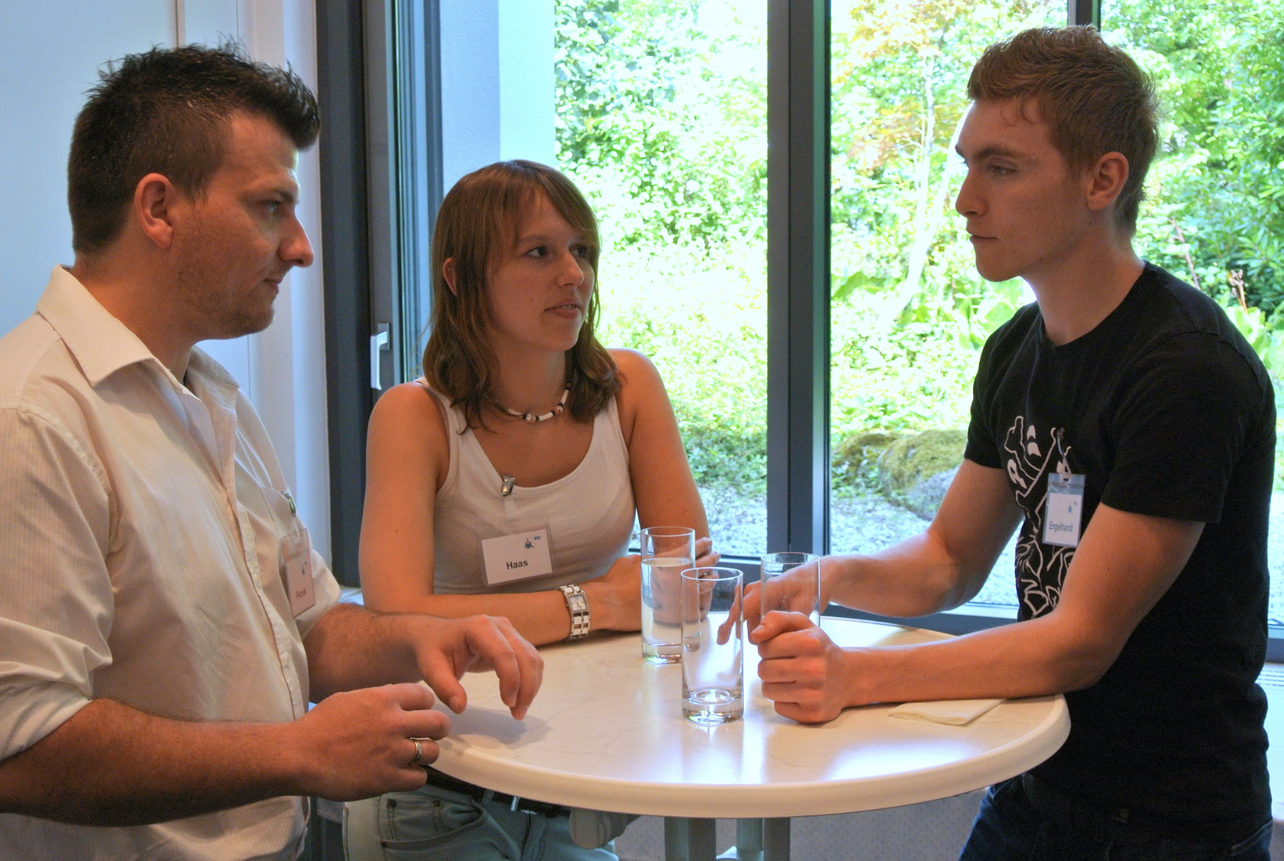
Abbildung 1:"Responsible Care Preis Baden-Württemberg 2013" by ChemieBW is licensed under CC BY 2.0

Umfrage: Gemeinsamer Austausch

Wie sieht die Situation in deinem Ausbildungsunternehmen aus?

1. In meinem Ausbildungsbetrieb ist die Ware bereits jetzt sinnvoll einsortiert.

☐ Ja

☐ Nein

2. Ich habe Ideen, wie man Ware sinnvoller einräumen kann.

☐ Ja

☐ Nein

Reflexion Umfrage © 2024 by Natalie Bachmann; Kevin Hetterich; Franziska Julius; Martin Löffler is licensed under CC BY-SA 4.0

