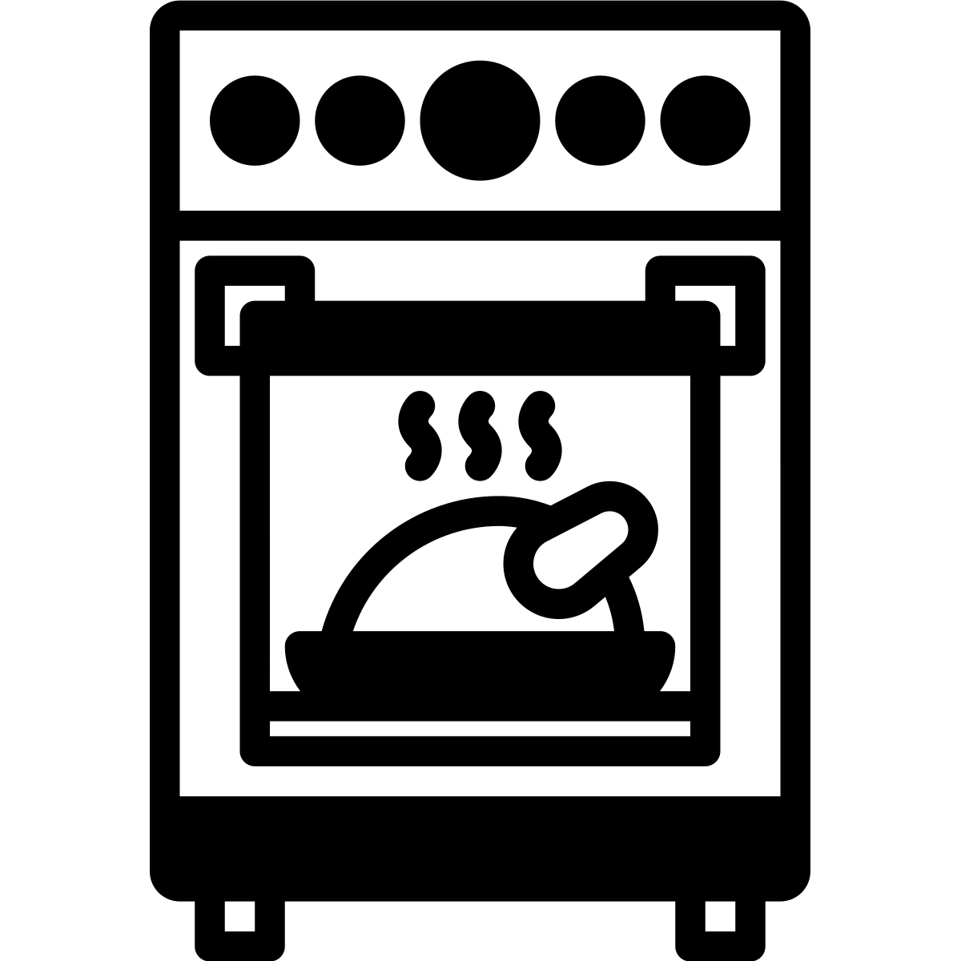

Backofen

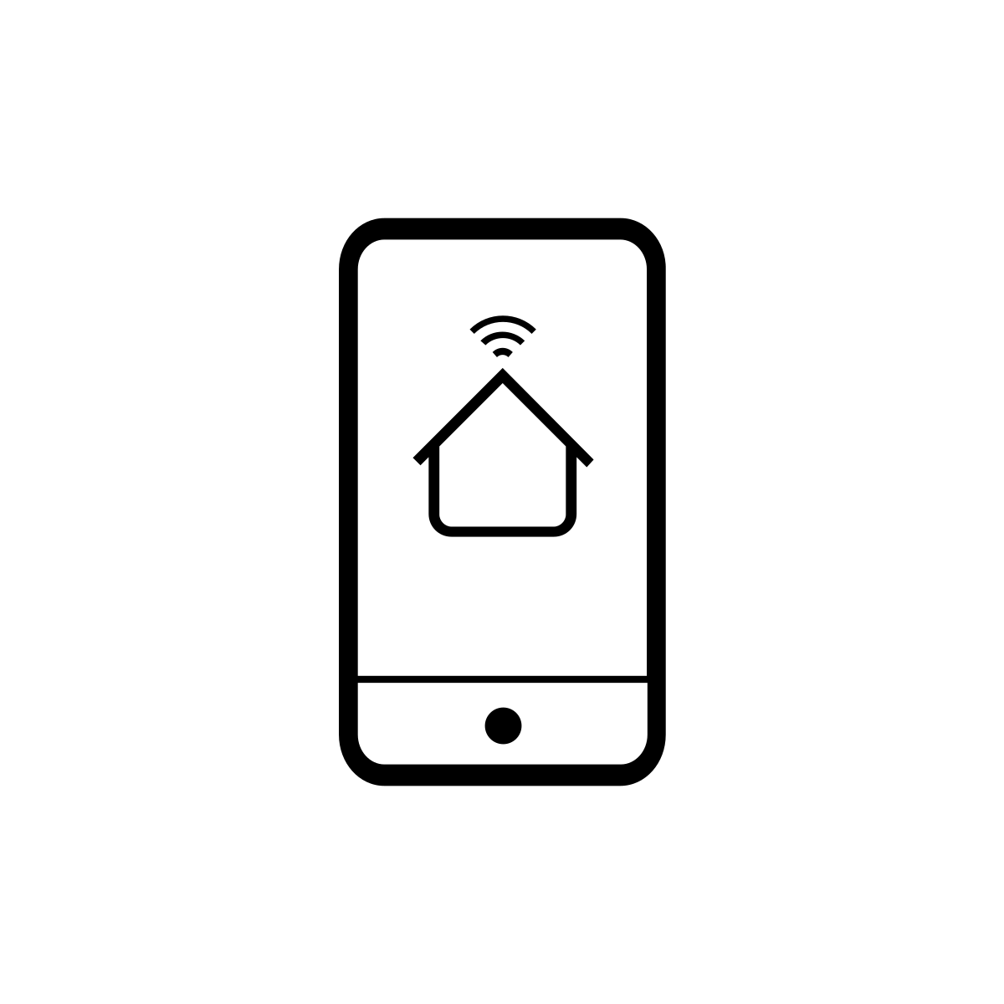

Handy



Hochhaus

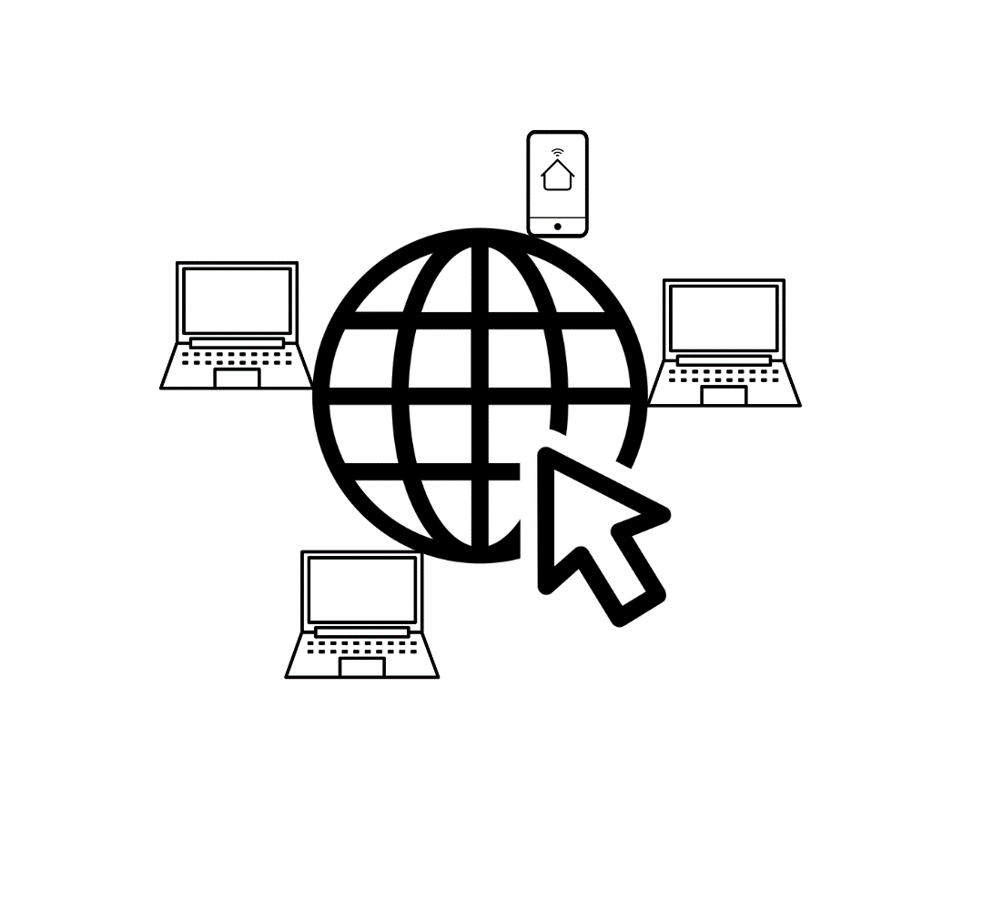

Internet weltweit



Rechen-Zentrum
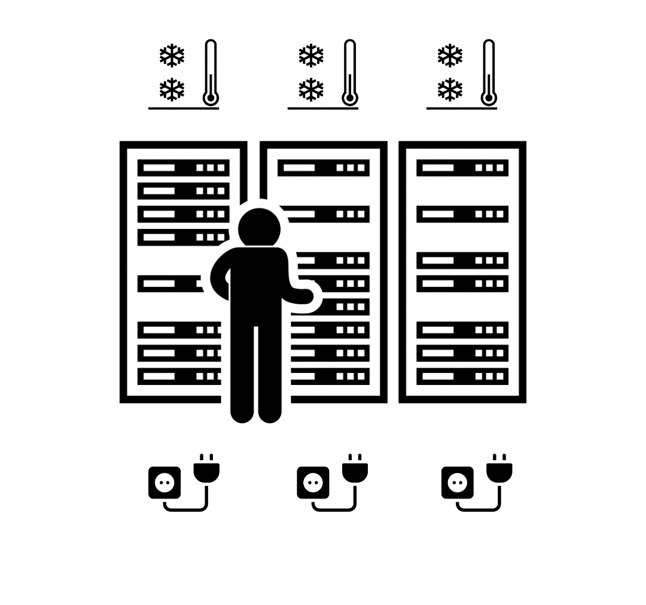

Strom-Verbrauch Rechen-Zentrum

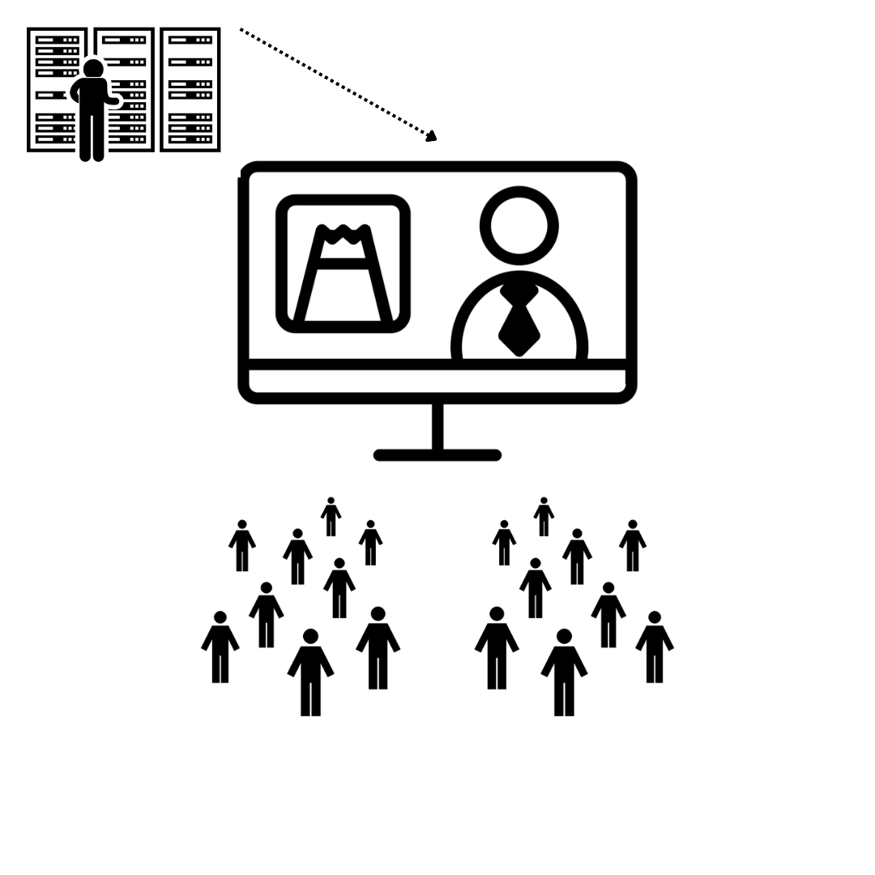

gleichzeitig fernsehen

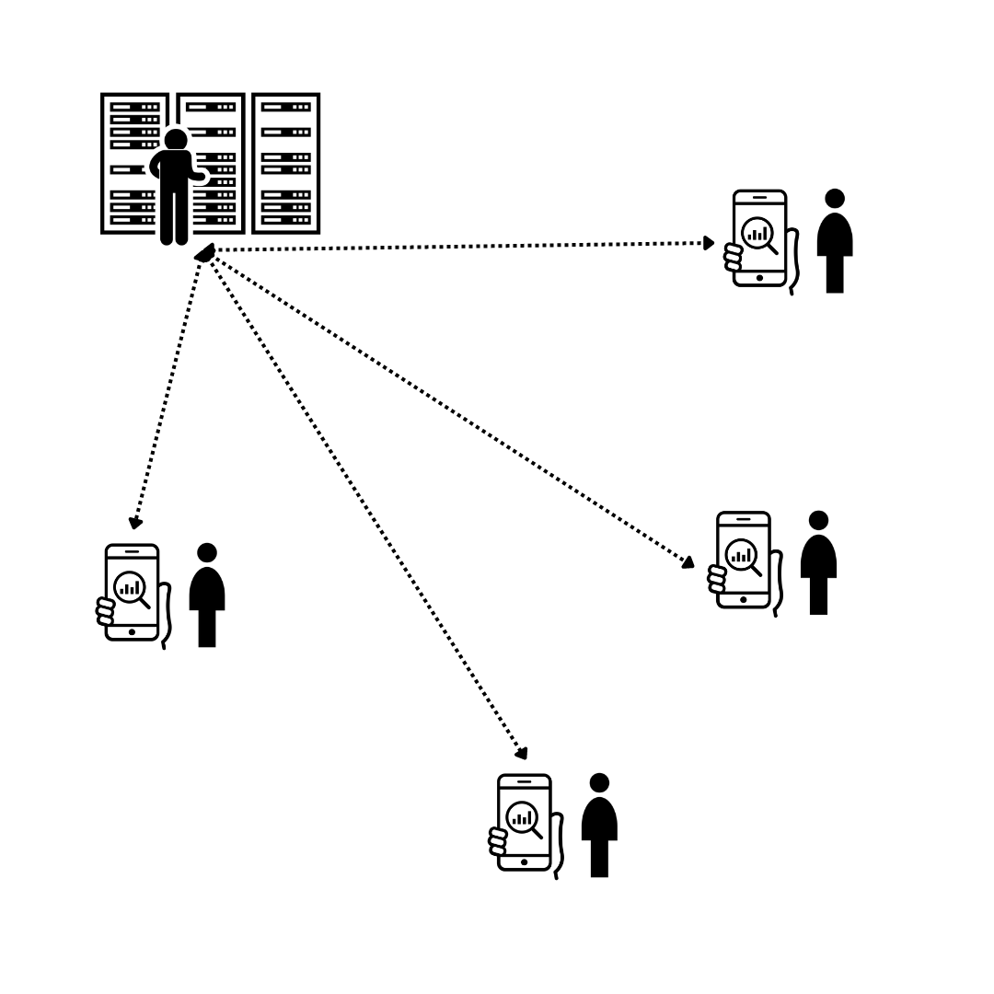

alleine streamen



Computer



Internet



Strom



Daten

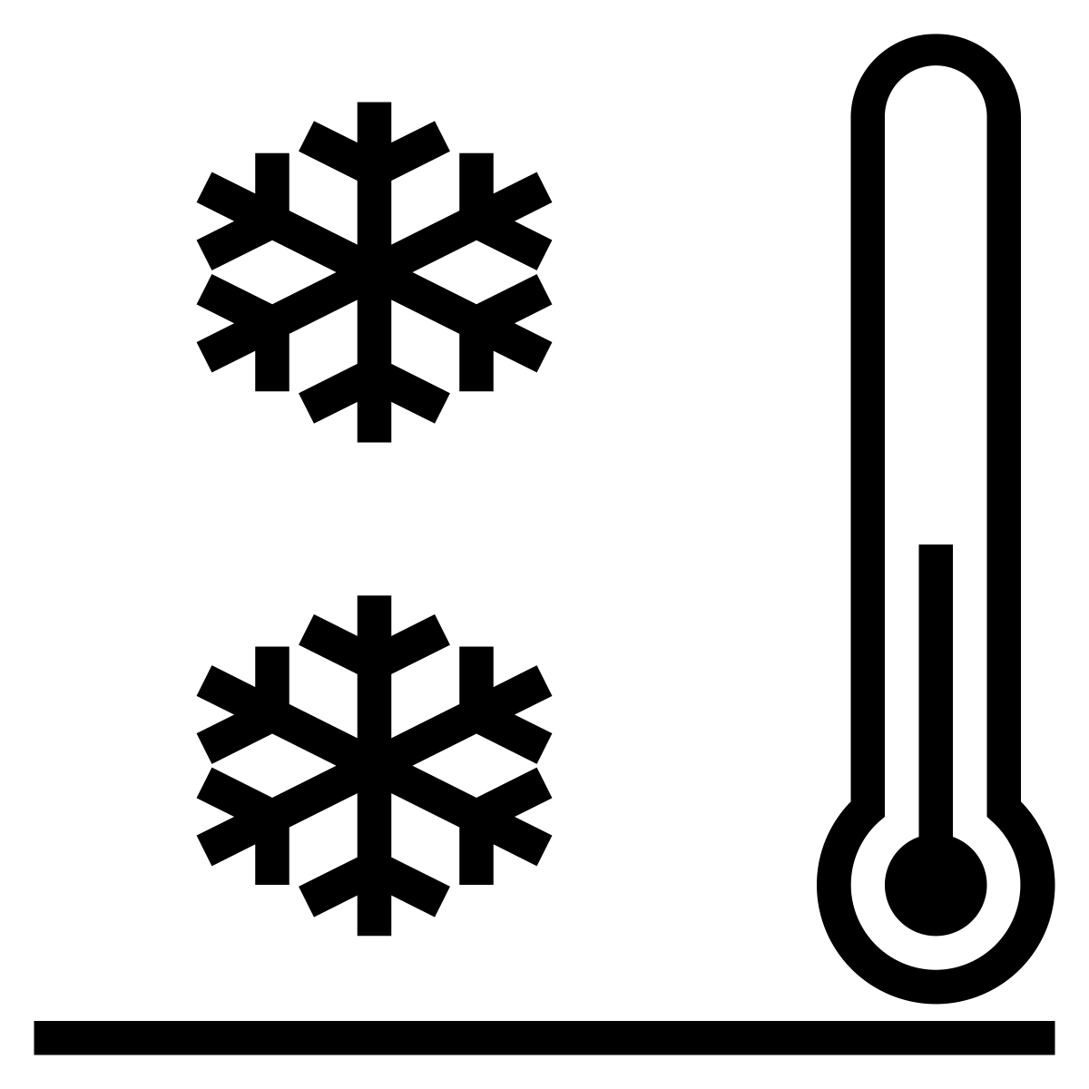

Kühlung



Fernseher



Menschen-Gruppe



Person

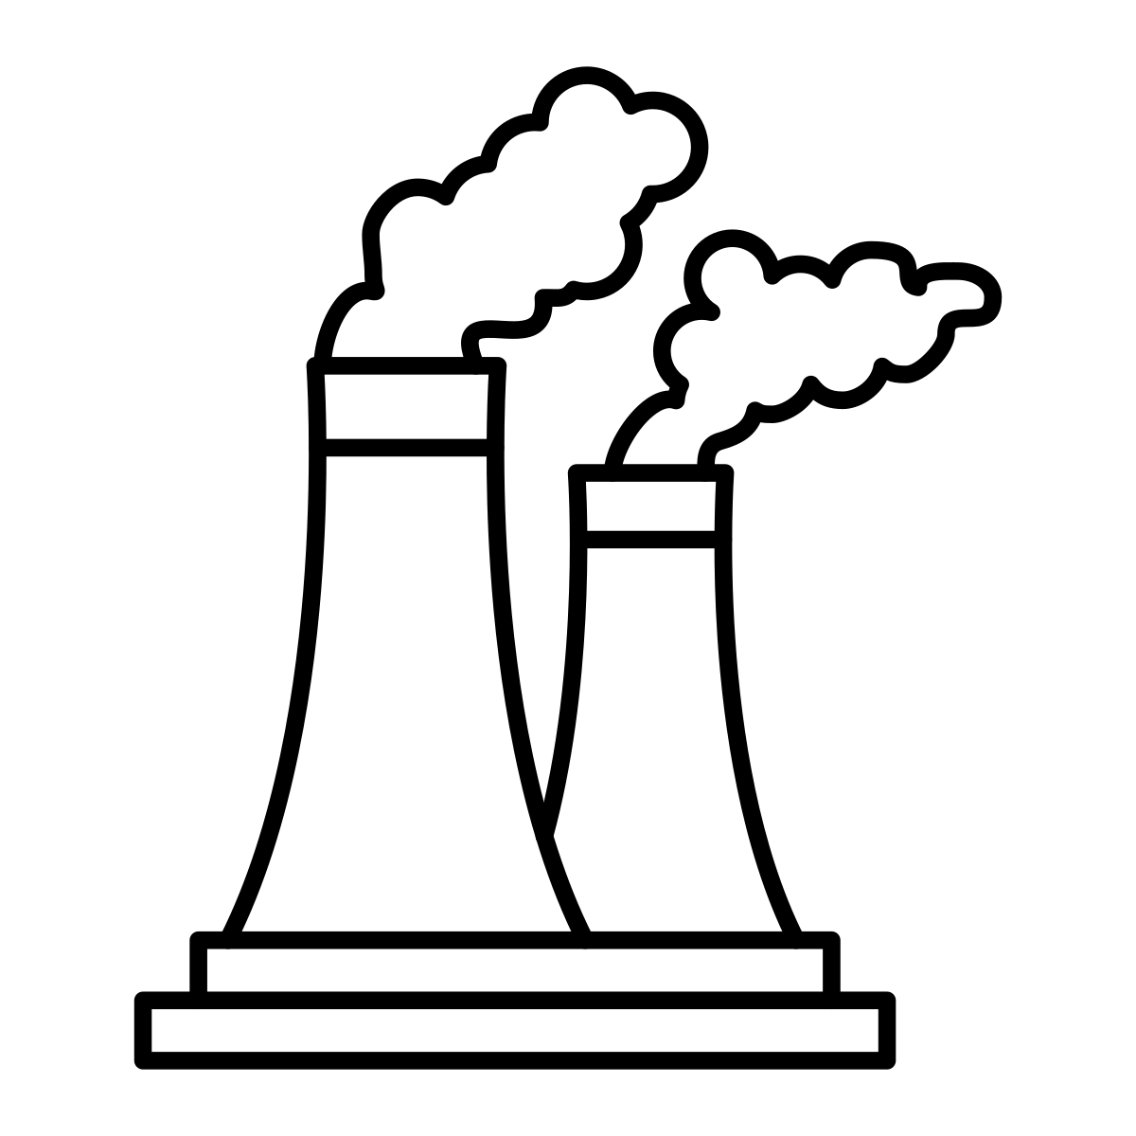

Kraft-Werk



Kohle



Erdgas

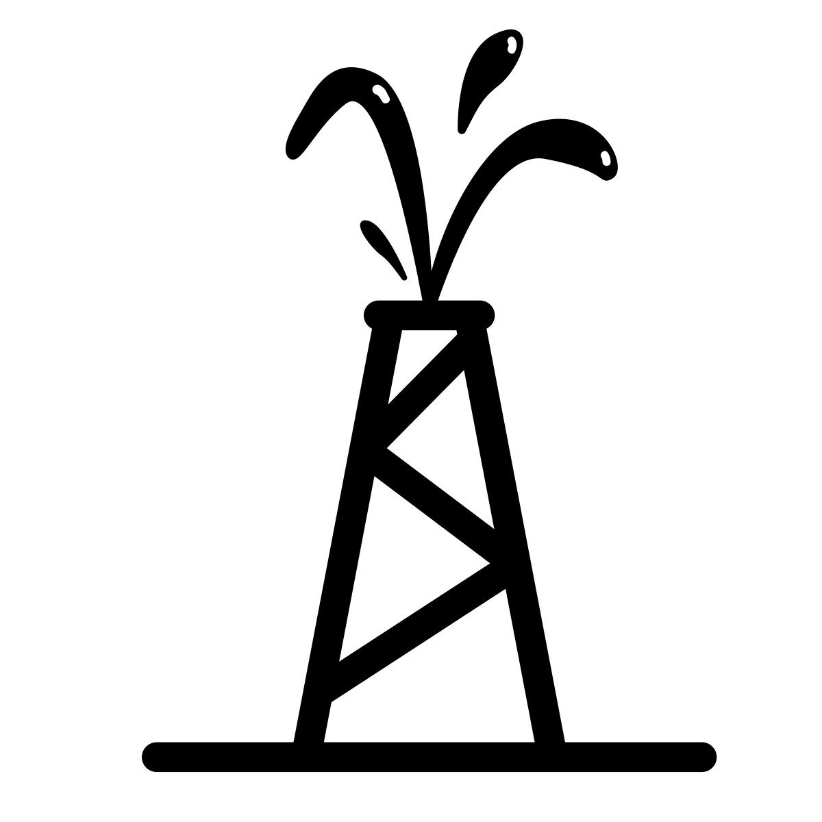

Öl

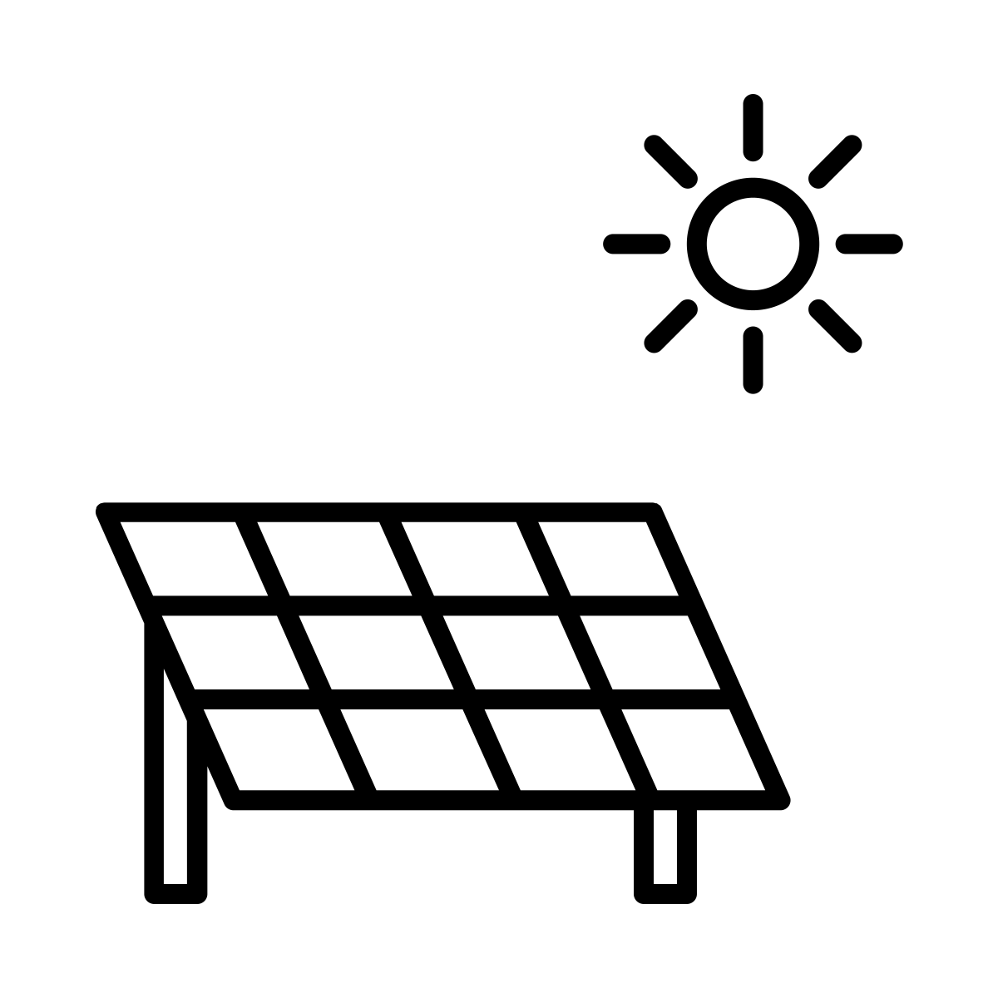

Solar-Energie

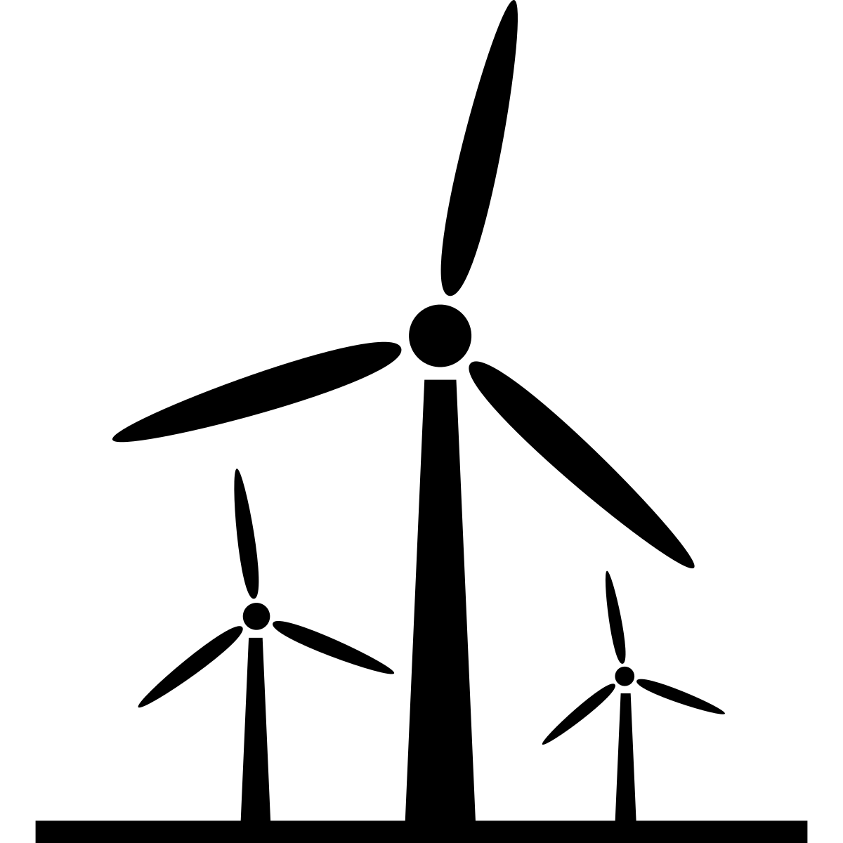

Wind-Energie


Wasser-Kraft

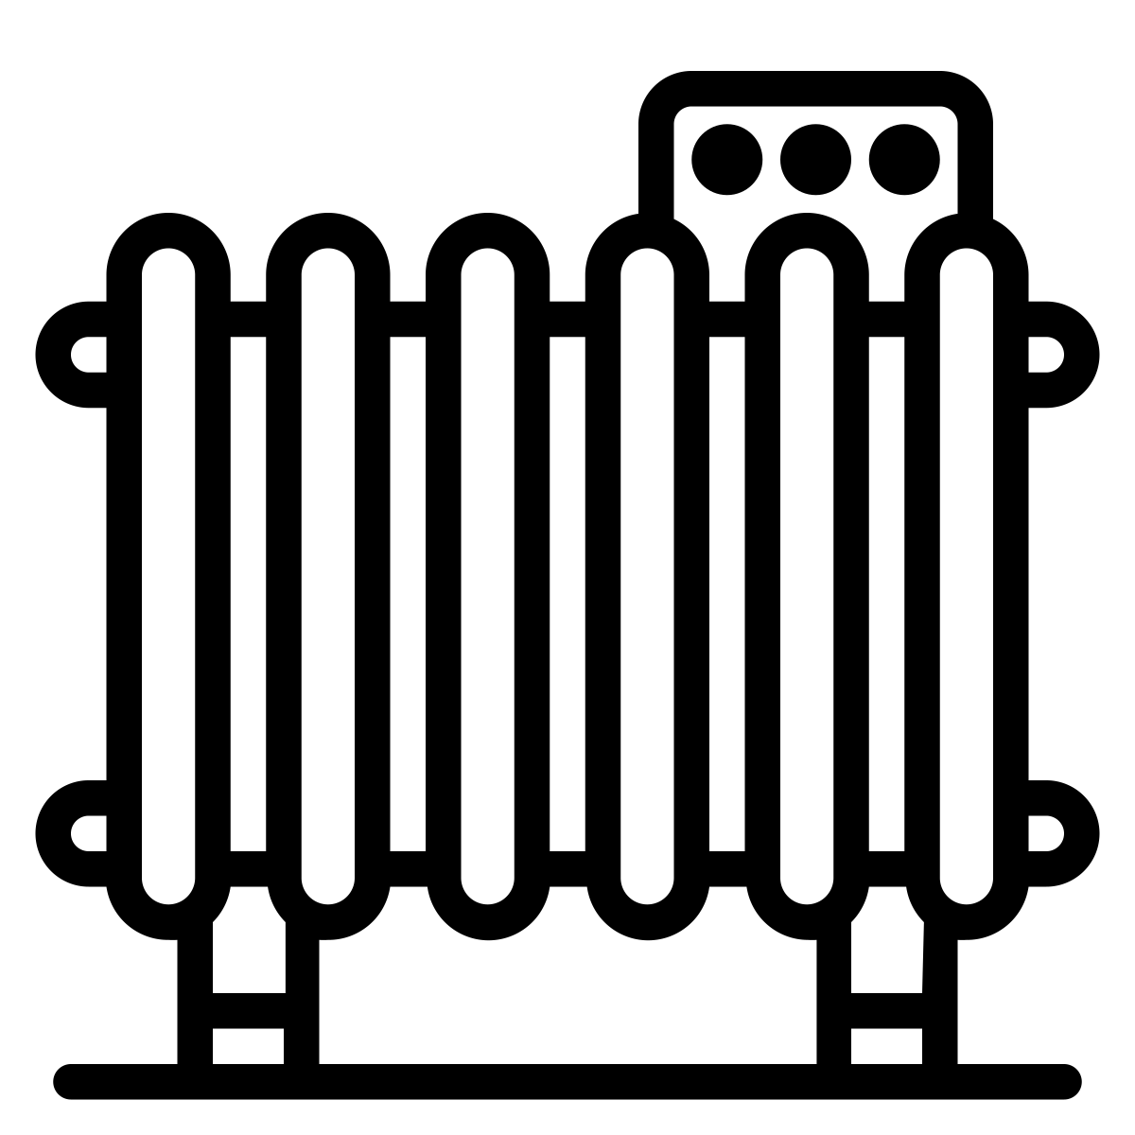

Heizung



Auto

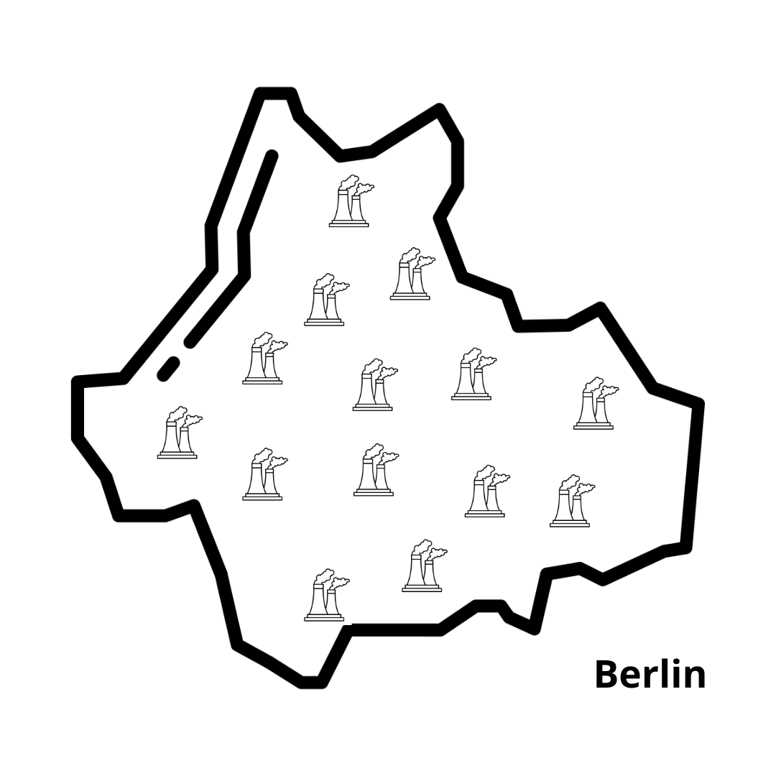

Berlin
etwa 4 Mio. Einwohner*innen

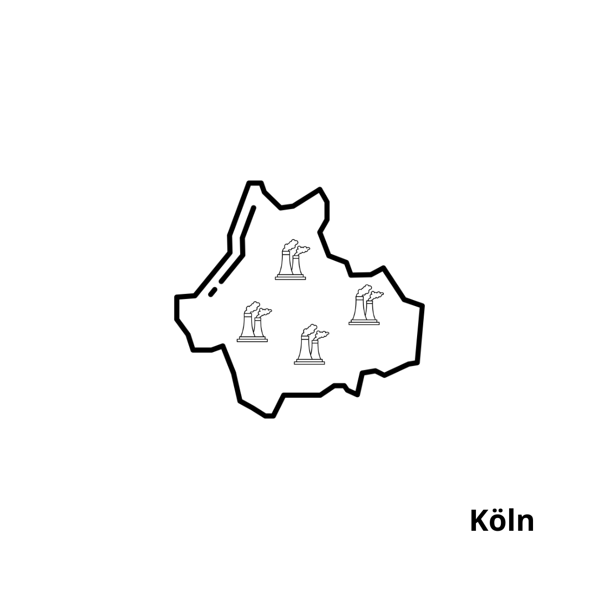

Köln
etwa 1 Mio. Einwohner*innen

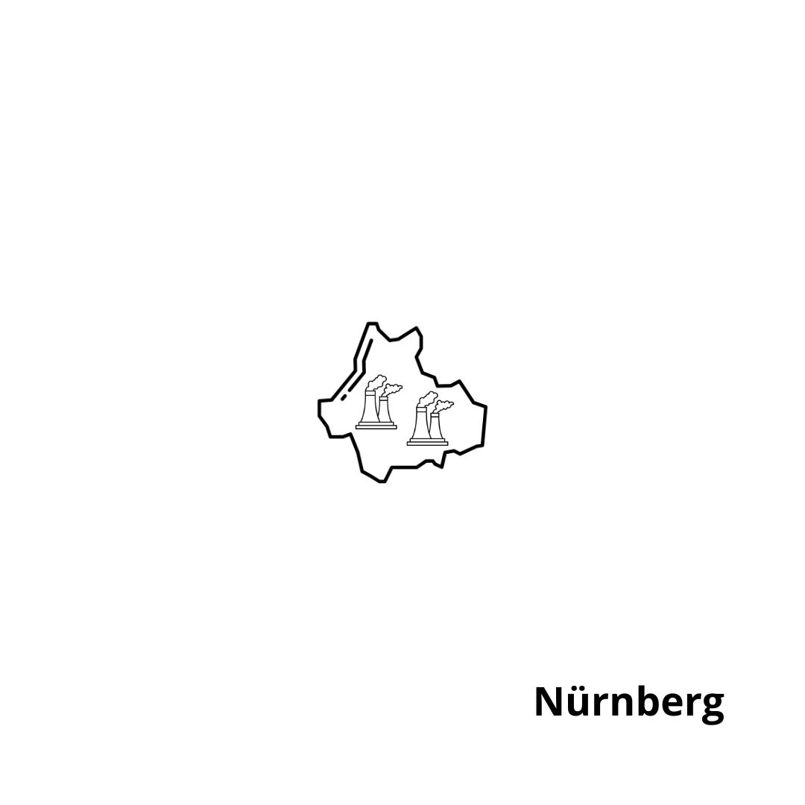

Nürnberg
etwa ½ Mio. Einwohner*innen



Flugzeug



Konsum

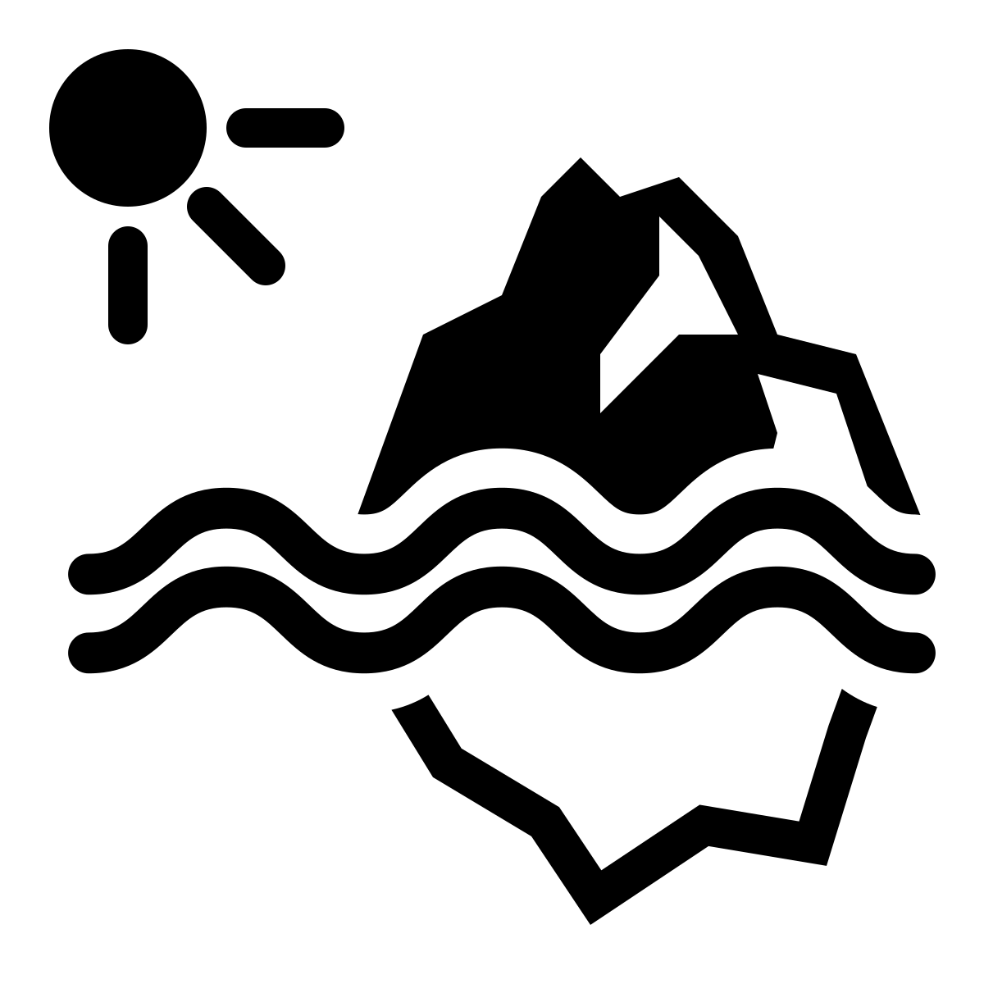

Schmelzende Pole

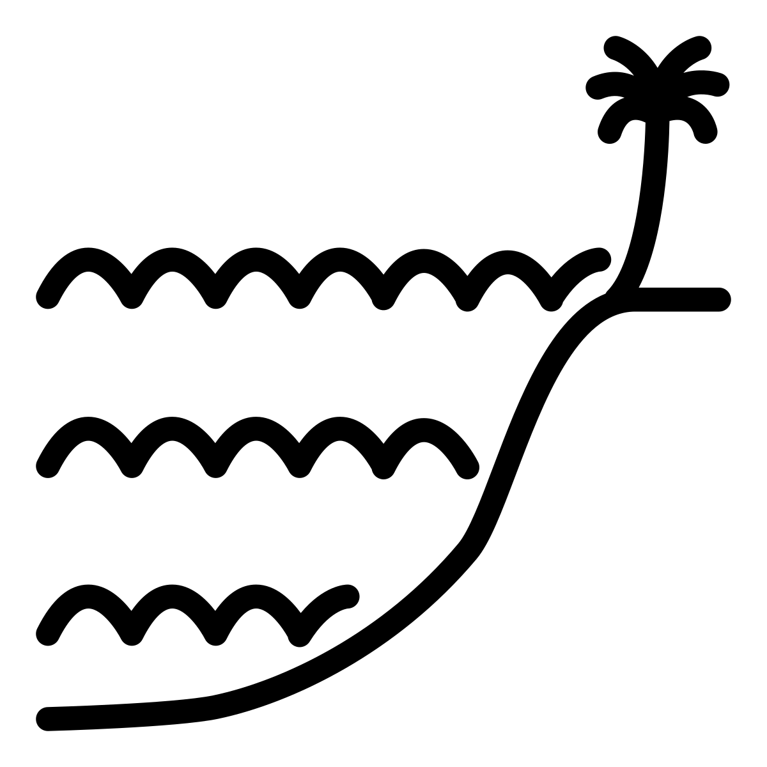

Meeres-Spiegel steigt
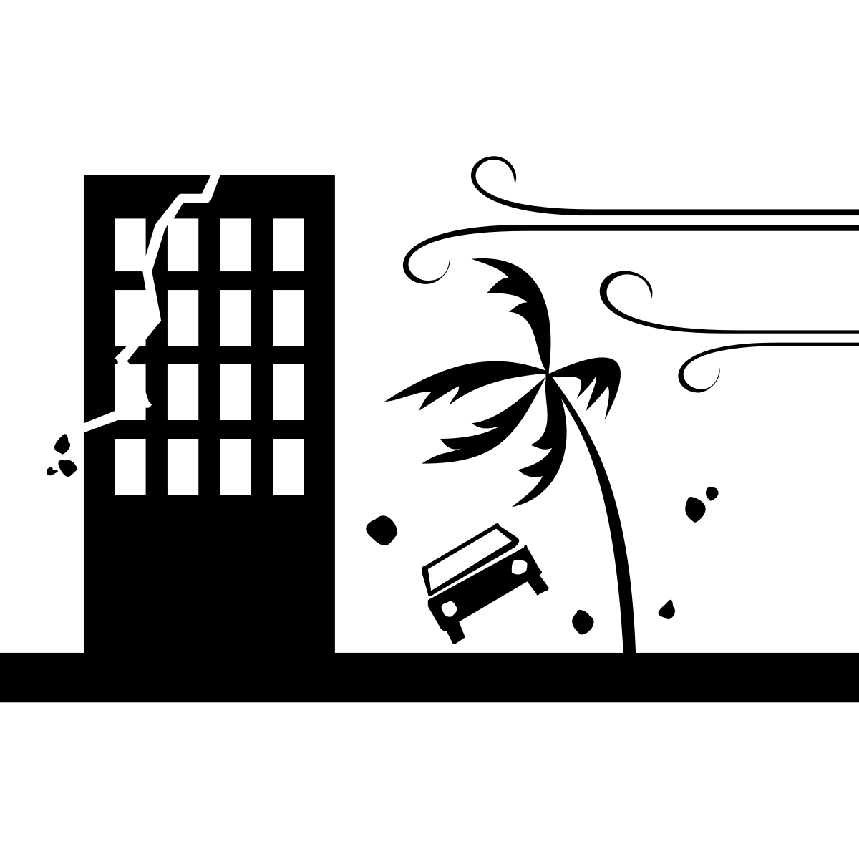

Stürme

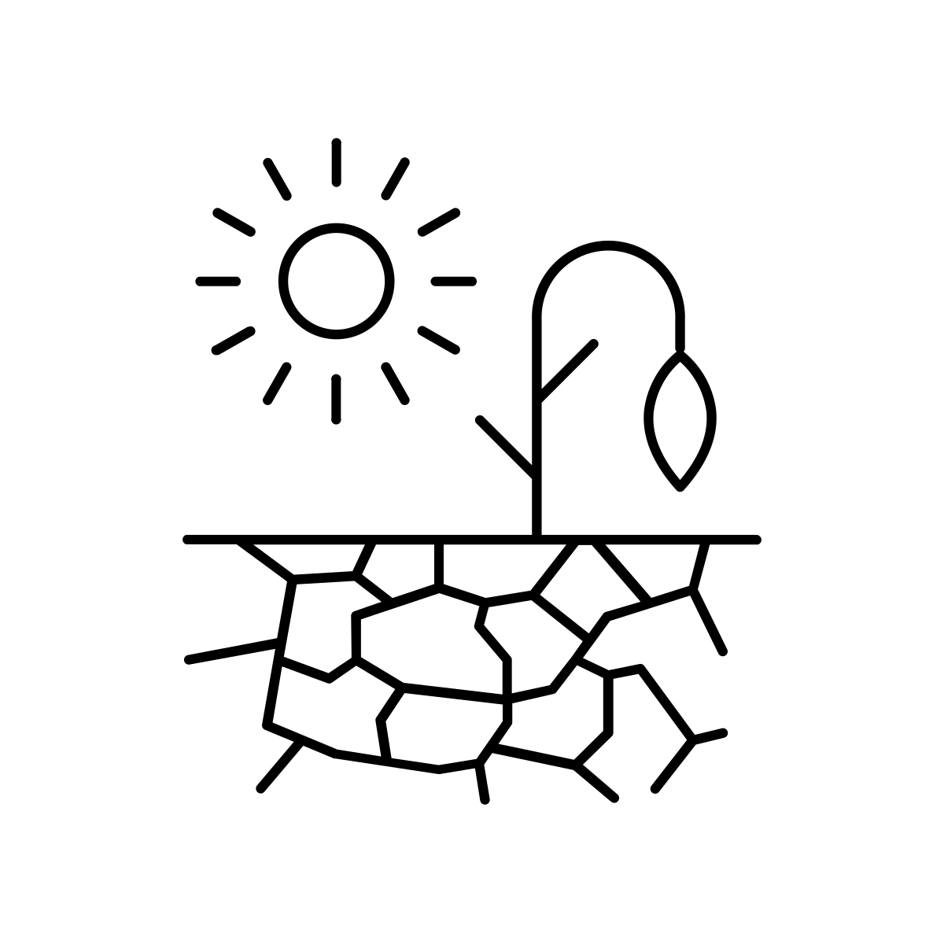

Dürre



Über-
schwemmung

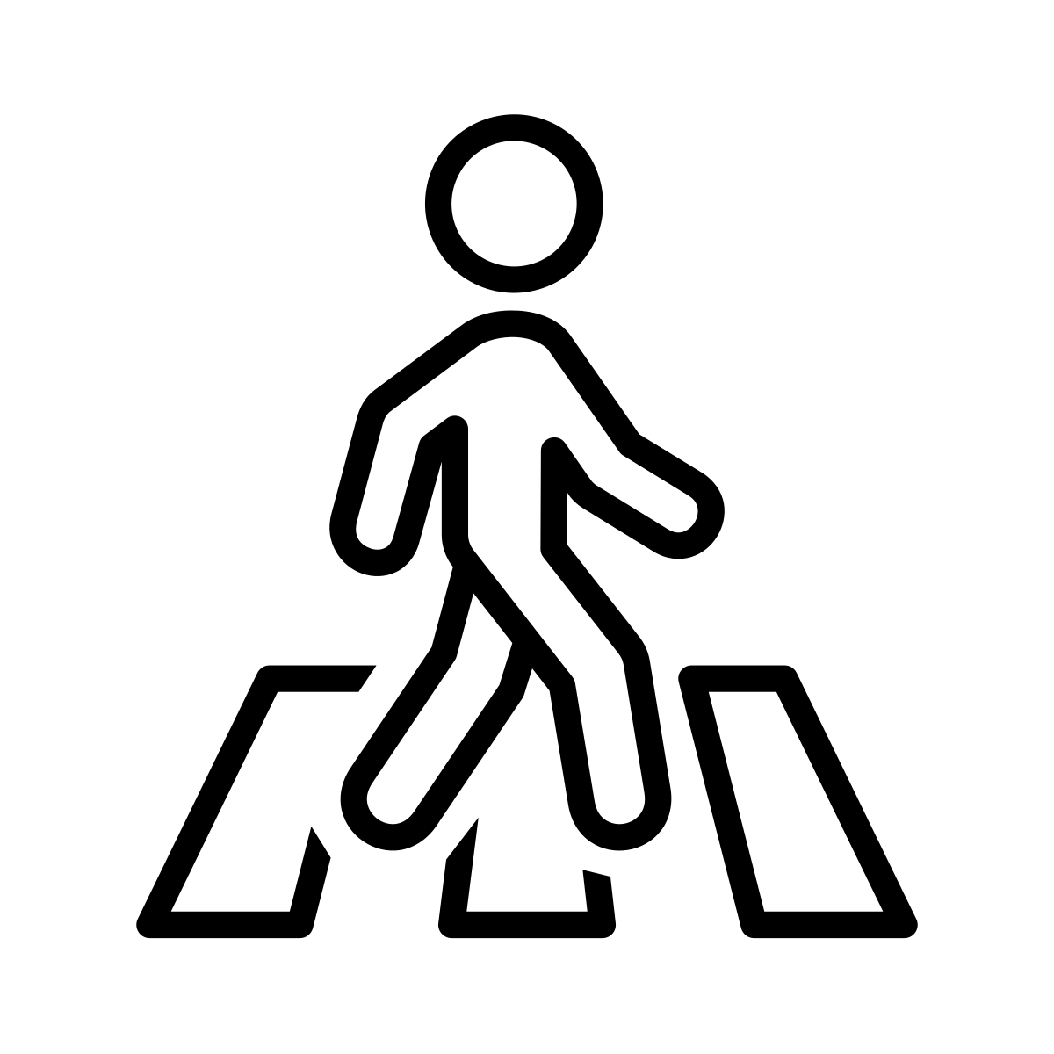

Fußgänger*in

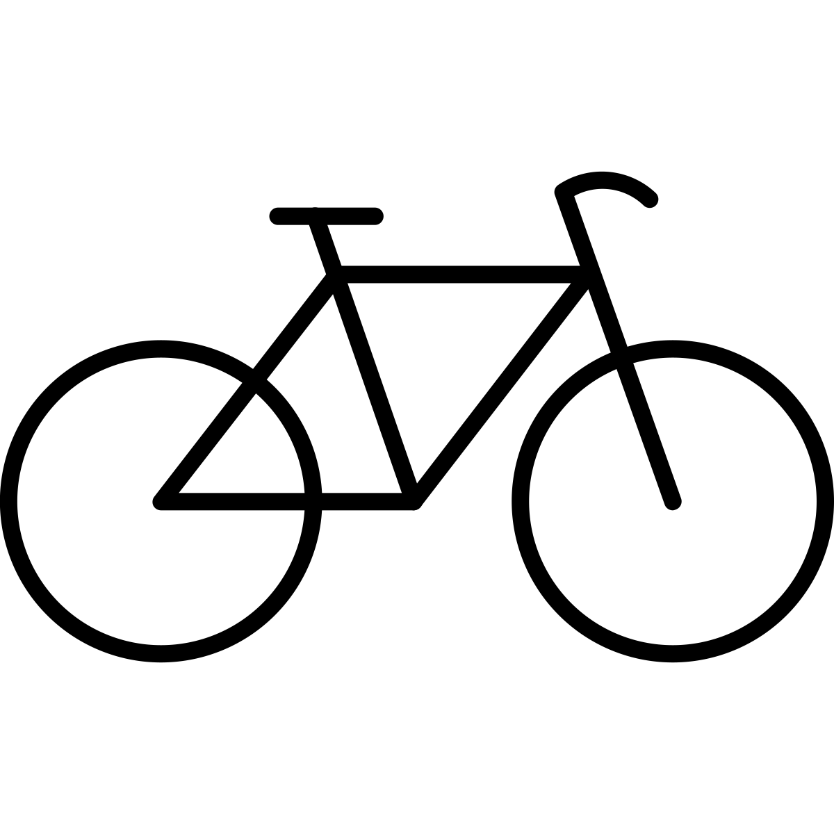

Fahrrad



Rollstuhl



Bus



Bahn

Strom-Verbrauch
- China
- USA
- EU
- Indien
- Japan
- Internet

Weltweiter Stromverbrauch 2012
Quelle: Schneider, Andreas (10.02.2021): So viel Energie verbraucht das Internet, in: Quarks.de, verfügbar unter: https://www.quarks.de/technik/energie/so-viel-energie-verbraucht-das-internet/ (letzter Zugriff am 03.01.2023).



Land

Lizenz
Die Bildungsmaterialien und Methodenbeschreibungen aus dem Projekt #digital_global vom F3_kollektiv sind lizenziert unter einer Creative Commons Namensnennung - Weitergabe unter gleichen Bedingungen 4.0 International Lizenz mit der Ausnahme: Die hier verwendeten Icons wurden für das Projekt zur lizenzfreien Nutzung erworben (Royalty-Free License).
Die Icons können auf der Website https://thenounproject.com/ aber auch unter der Creative Commons-Lizenz CC By frei runtergeladen werden (mit Angabe der Credits). Deshalb hat das F3_kollektiv zusätzlich ein Verzeichnis mit den Credit-Angaben erstellt:
- Backofen: oven by TOZIcon TH from the Noun Project, URL: https://thenounproject.com/icon/oven-5194881/
- Handy: Smartphone by Christopher Holm-Hansen DK from the Noun Project, URL: https://thenounproject.com/icon/smartphone-193978/
- Hochhaus: Skyscraper by nareerat jaikaew TH from the Noun Project, URL: https://thenounproject.com/icon/skyscrapper-3504973/
- Computer: personal computer by Grafix Point from the Noun Project, URL: https://thenounproject.com/search/?q=2961764&i=2961764
- Internet: web by Adrien Coquet from the Noun Project, URL: https://thenounproject.com/icon/web-4211377/
- Rechenzentrum: Date Center by Gan Khoon Lay from the Noun Project, URL: https://thenounproject.com/icon/data-center-968730/
- Daten: Research by Aneeque Ahmed from the Noun Project, URL: https://thenounproject.com/icon/research-2516048/
- Kühlung: cool by Nithinan Tatah TH from the Noun Project, URL: https://thenounproject.com/icon/cool-1468288/
- Fernseher: Television by sachan JP from the Noun Project, URL: https://thenounproject.com/icon/television-136271/
- Menschengruppe: crowd by Magicon HU from the Noun Project, URL: https://thenounproject.com/icon/crowd-317385/
- Person: person by ngamlerdlek.design TH from the Noun Project, URL: https://thenounproject.com/icon/person-1162016/
- Kohle: Coal by Vectorstall PK from the Noun Project, URL: https://thenounproject.com/icon/coal-3724431/
- Erdgas: natural gas by Amir Ali from the Noun Project, URL: https://thenounproject.com/icon/natural-gas-5129874/
- Öl: Oil extraction by Lucas Helle CL from the Noun Project, URL: https://thenounproject.com/icon/oil-extraction-3608385/
- Solarenergie: solar panel by Florent B BE from the Noun Project, URL: https://thenounproject.com/icon/solar-panel-3340438/
- Windenergie: Windmill by Gan Khoon Lay from the Noun Project, URL: https://thenounproject.com/icon/windmill-1926236/
- Wasser-Kraft: Turbine by Zaman Khan from th noun Project, URL: https://thenounproject.com/icon/turbine-4594963/
- Kraftwerk: Power Plant by Muhammad Atiq PK from the Noun Project, URL: https://thenounproject.com/icon/power-plant-4232183/
- Heizung: heater by Pause08 TH from the Noun Project, URL: https://thenounproject.com/icon/heater-1541329/
- Auto: car by paytren from the Noun Project, URL: https://thenounproject.com/icon/car-5182436/
- Flugzeug: Airplane by Chanut is Industries TH from the Noun Project, URL: https://thenounproject.com/icon/airplane-492582/
- Konsum (Waren kaufen): shopping by Fatkhul Hadi ID from the Noun Project, URL: https://thenounproject.com/icon/shopping-5178588/
- schmelzende Pole: Climate Change by Darin S from the Noun Project, URL: https://thenounproject.com/icon/climate-change-168034/
- Meeresspiegel steigt: High Tide by M.Oki Orlando ID from the Noun Project, URL: https://thenounproject.com/icon/high-tide-3495301/
- Stürme: Hurricane by RULI ID from the Noun Project, URL: https://thenounproject.com/icon/hurricane-1066603/
- Dürre: Drought by Nice and Serious GB from the Noun Project, URL: https://thenounproject.com/icon/drought-1673868/
- Überschwemmungen: Flood by WEBTECHOPS LLP IN from the Noun Project, URL: https://thenounproject.com/icon/flood-3859088/
- Fußgänger*in: Pedestrian by Cuputo ID from the Noun Project, URL: https://thenounproject.com/icon/pedestrian-4548969/
- Fahrrad: Bike by Bern Lakenbrink DE from the Noun Project, URL: https://thenounproject.com/icon/bike-4730647/
- Rollstuhl: wheelchair by Weltenraser from the Noun Project, URL: https://thenounproject.com/icon/wheelchair-1436536/
- Bus: Bus by paytren from the Noun Project, URL: https://thenounproject.com/icon/bus-5182437/
- Bahn: Train by andriwidodo ID from the Noun Project, URL: https://thenounproject.com/icon/train-1009443/
- Welt: world by rivercon from the Noun Project, URL: https://thenounproject.com/icon/world-5253775/
- Strom: power cable by Tauficon ID from the Noun Project https://thenounproject.com/icon/power-cable-2956033/
- Stadtumriss: nonsan city map by Ary Prasetyo from the Noun Project, URL: https://thenounproject.com/icon/5332635/

