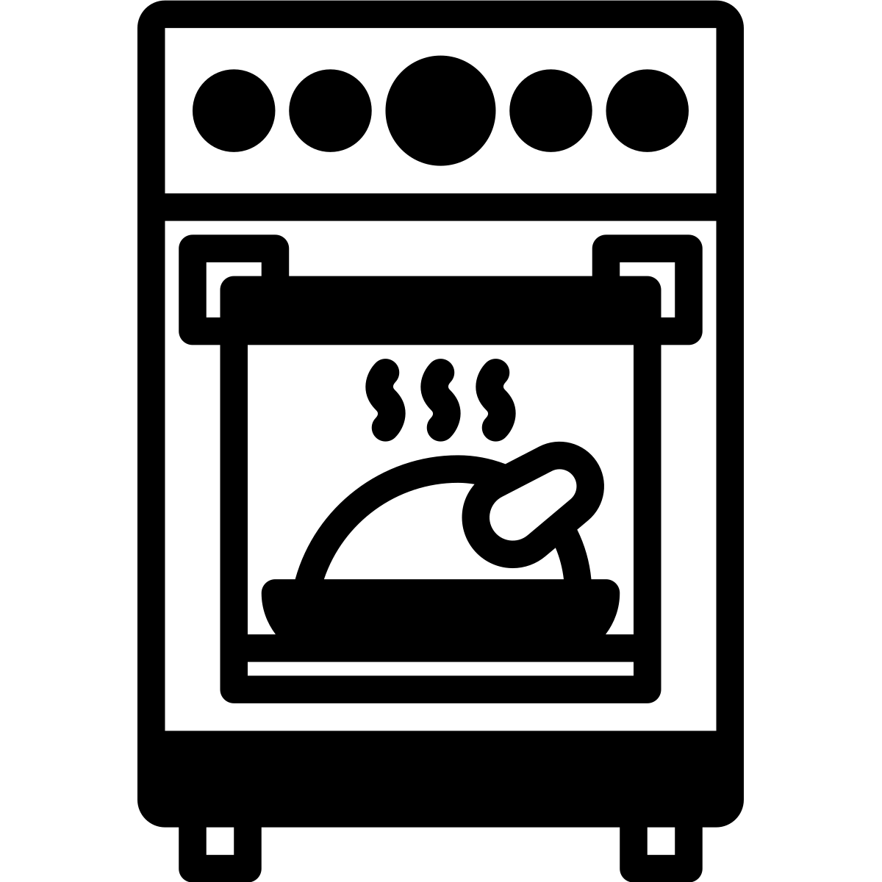

Backofen

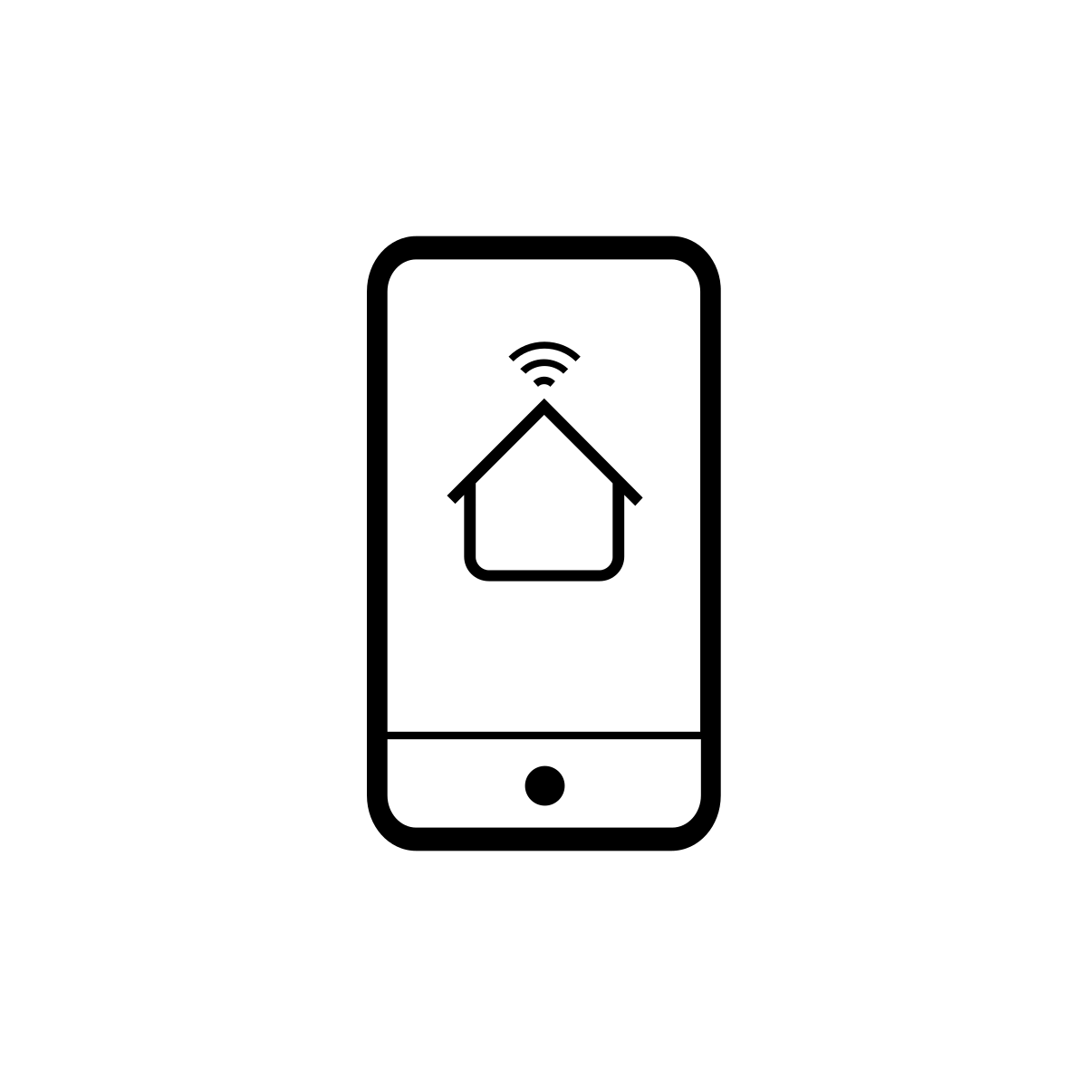

Handy



Hochhaus

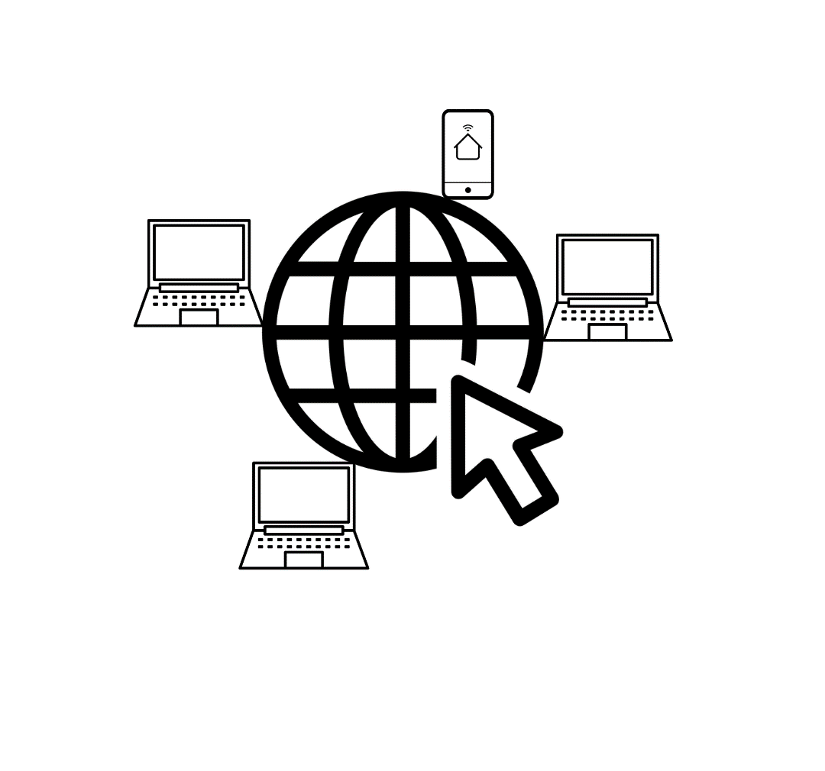

Internet weltweit



Rechen-Zentrum

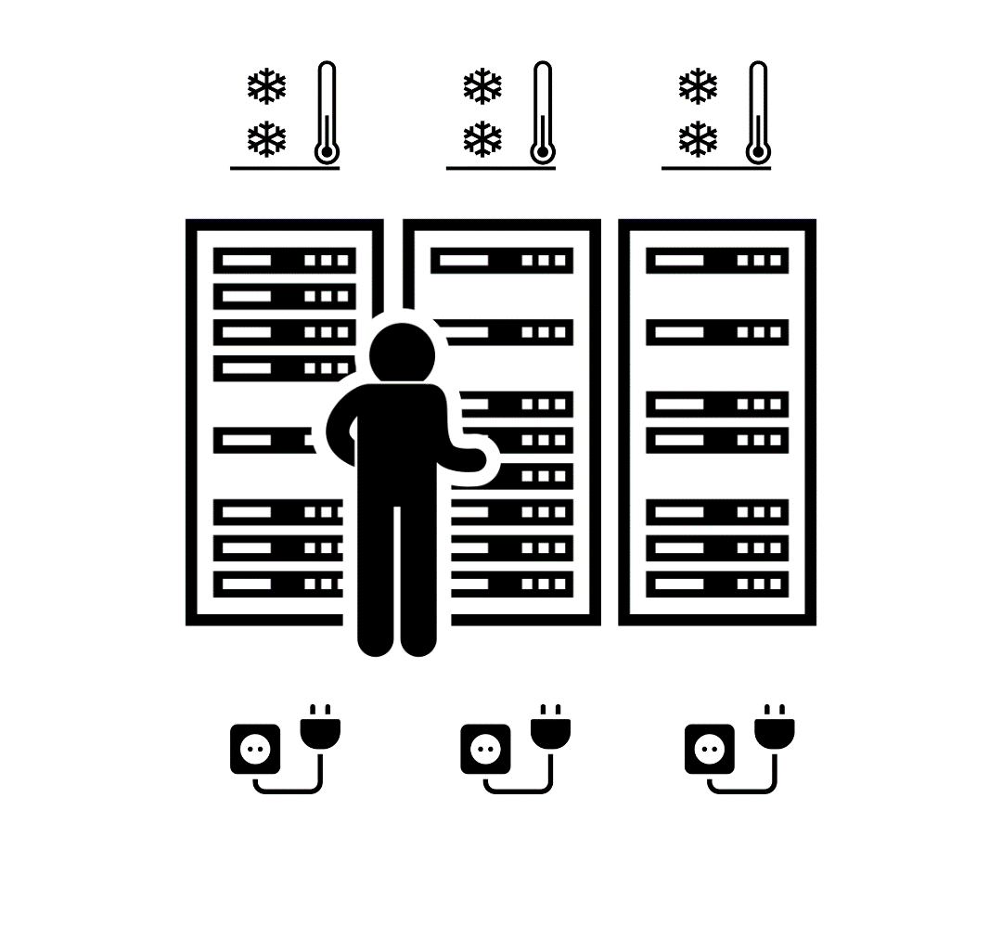

**Strom-Verbrauch Rechen-Zentrum**

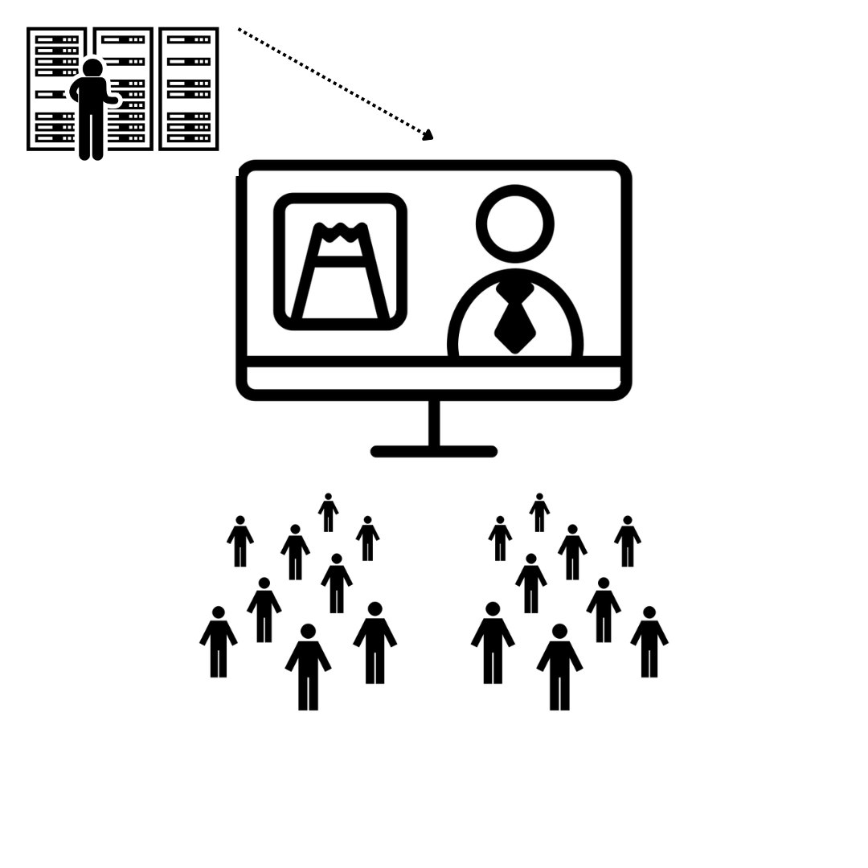

**gleichzeitig fernsehen**

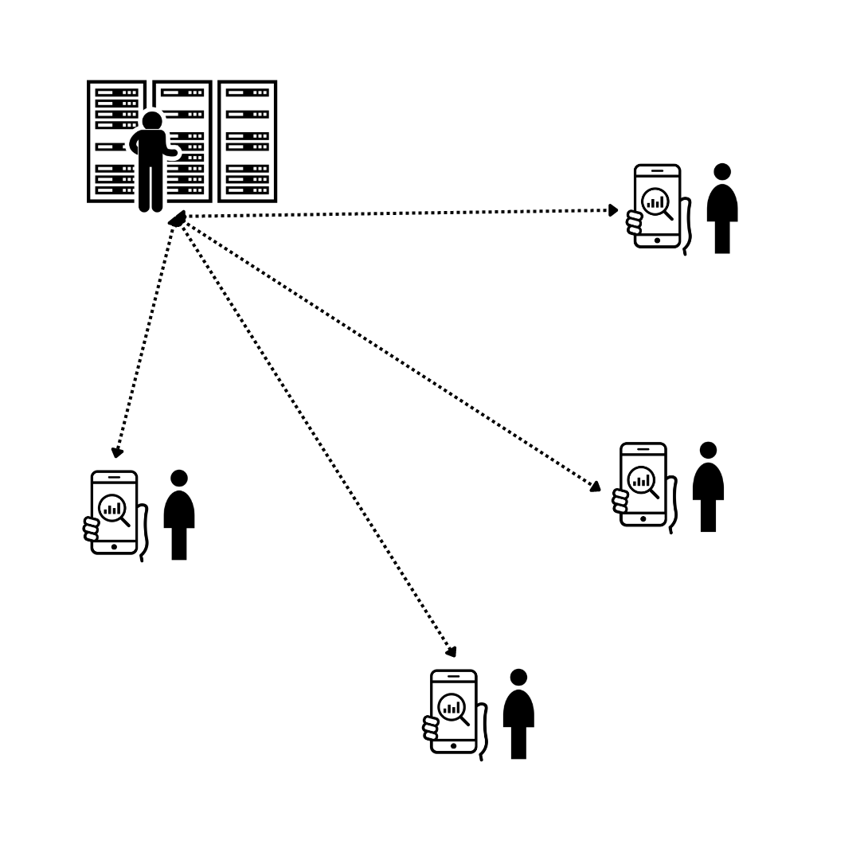

**alleine streamen**



Computer



Internet



Strom



Daten

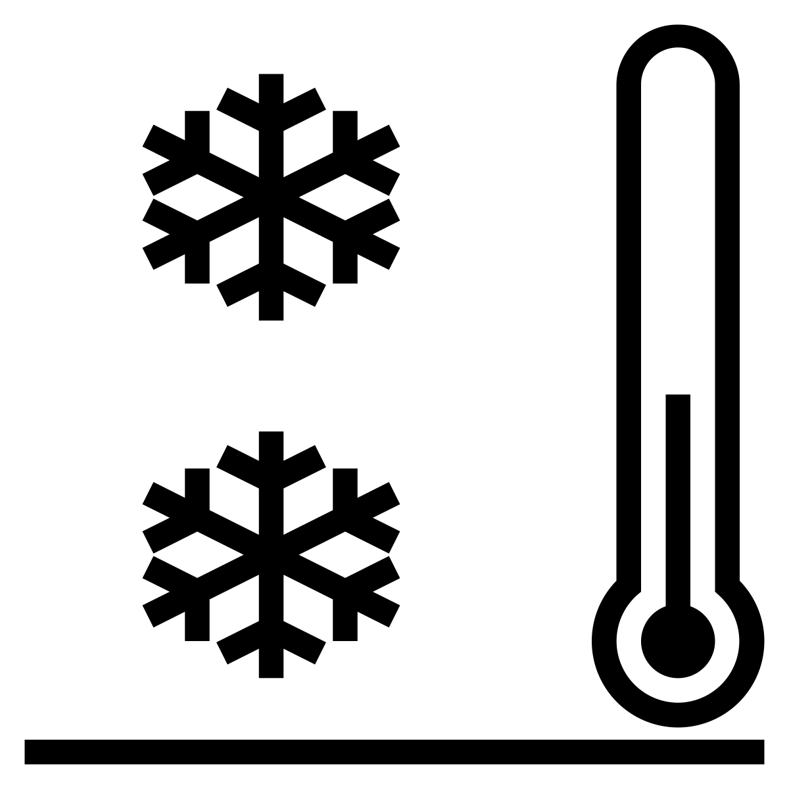

Kühlung



Fernseher

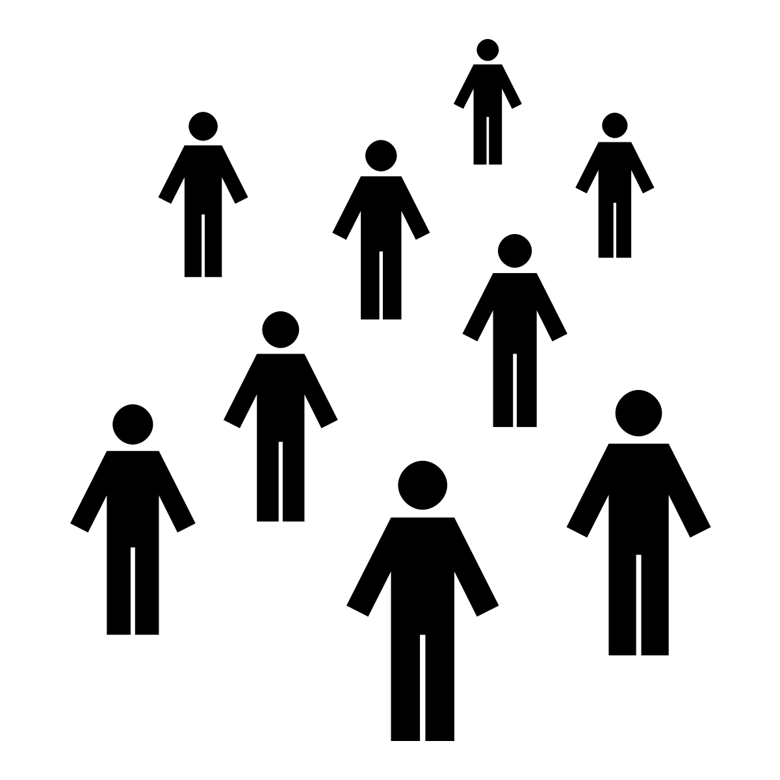

Menschen-Gruppe



Person

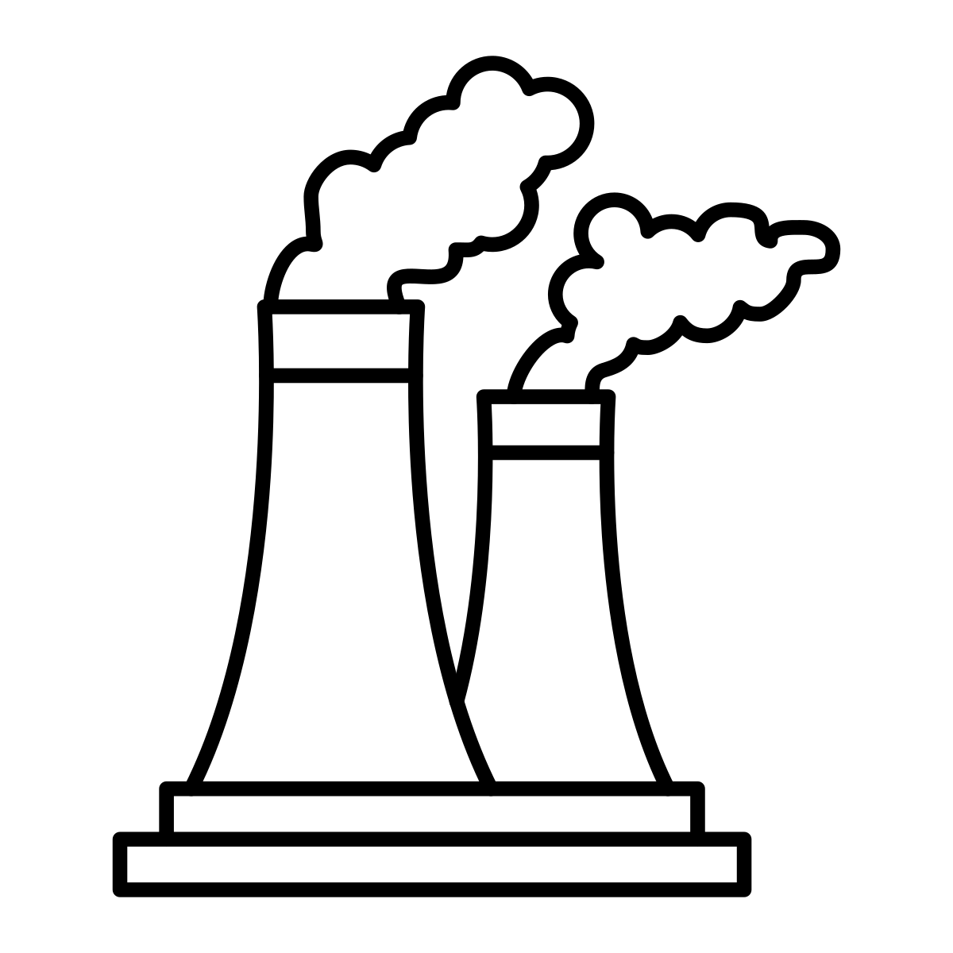

Kraft-Werk



Kohle



Erdgas

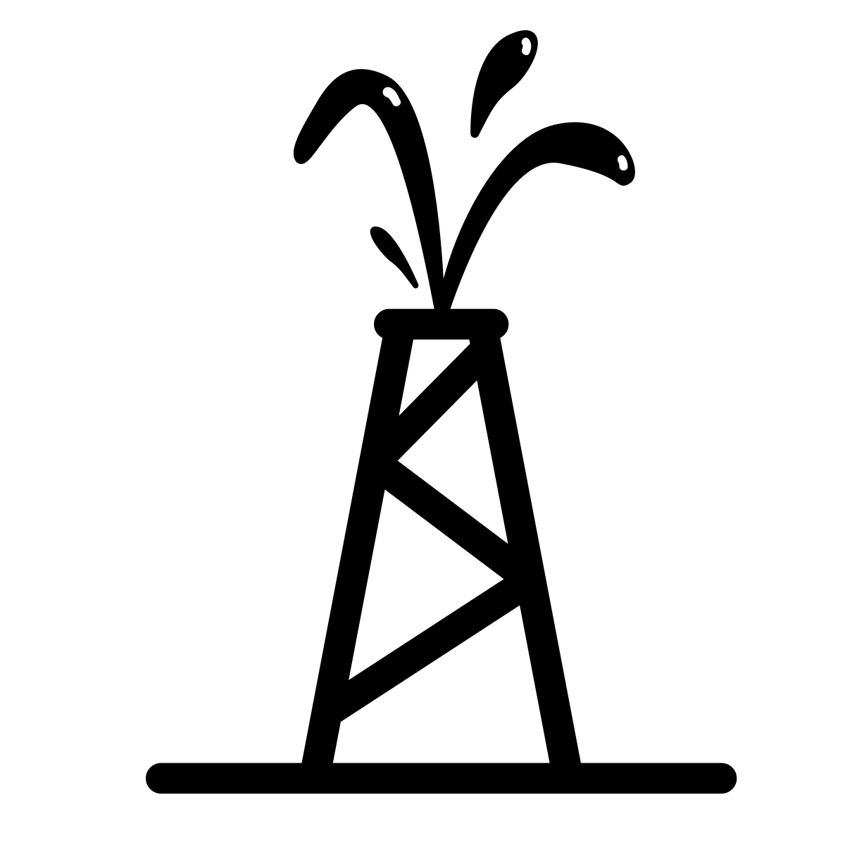

Öl

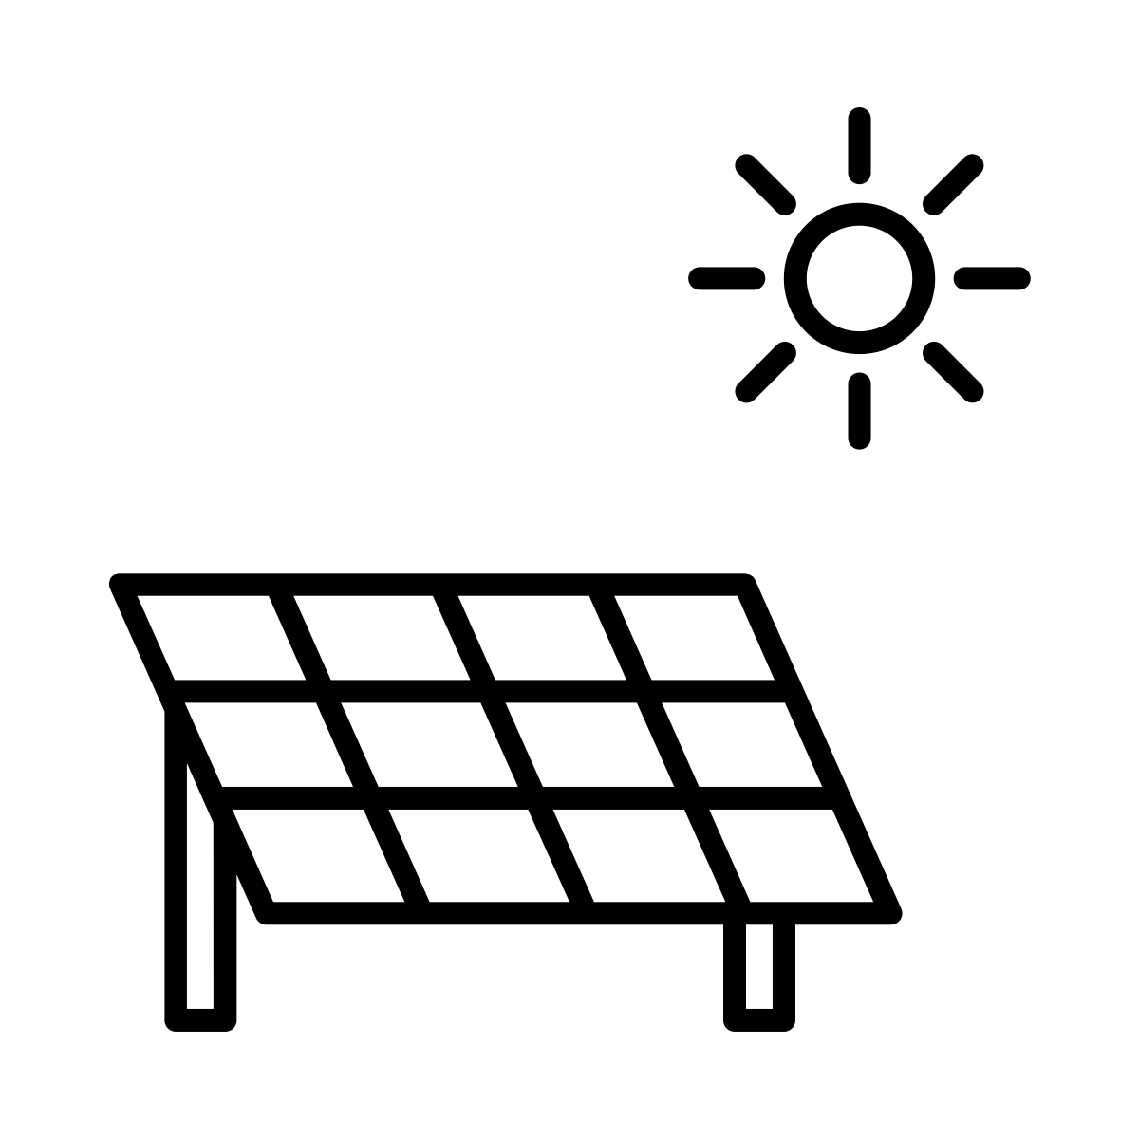

Solar-Energie

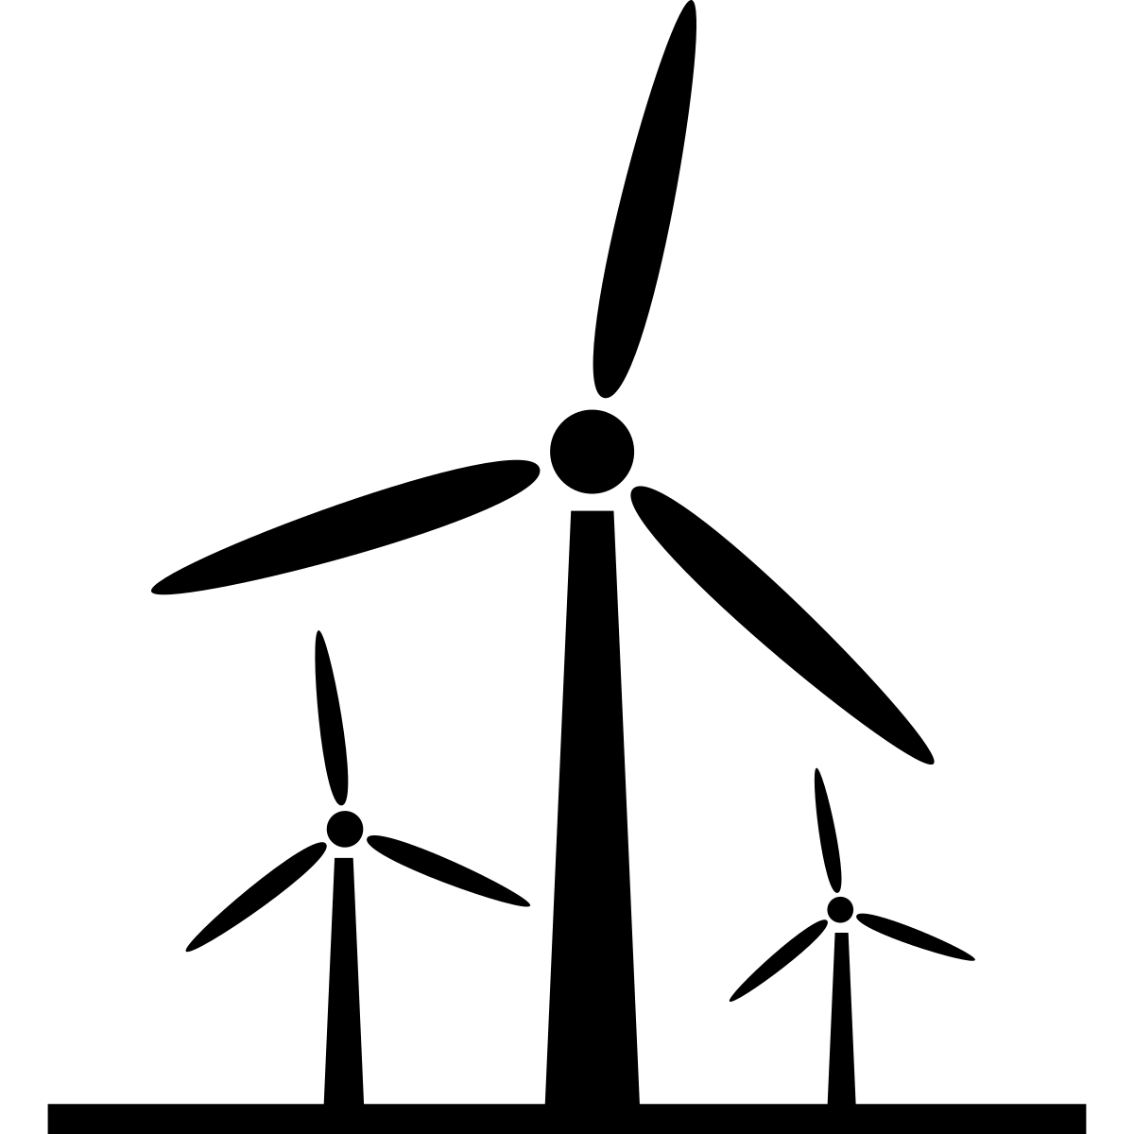

Wind-Energie



Wasser-Kraft

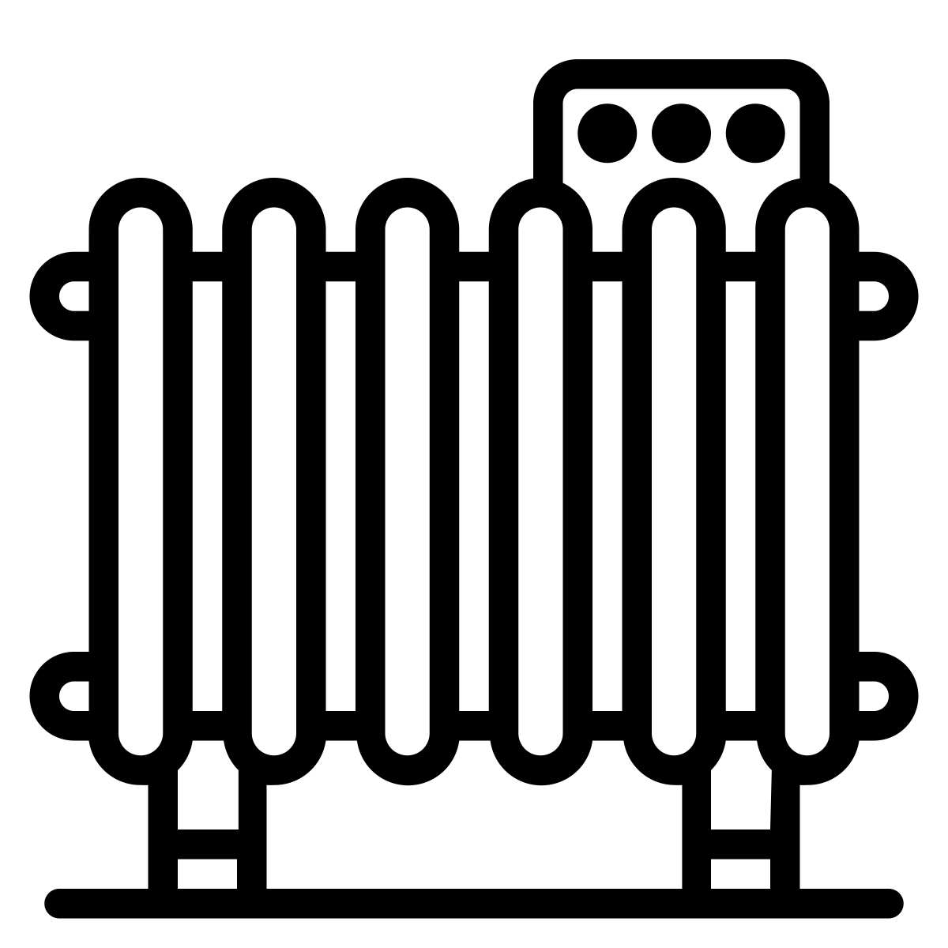

Heizung



Auto

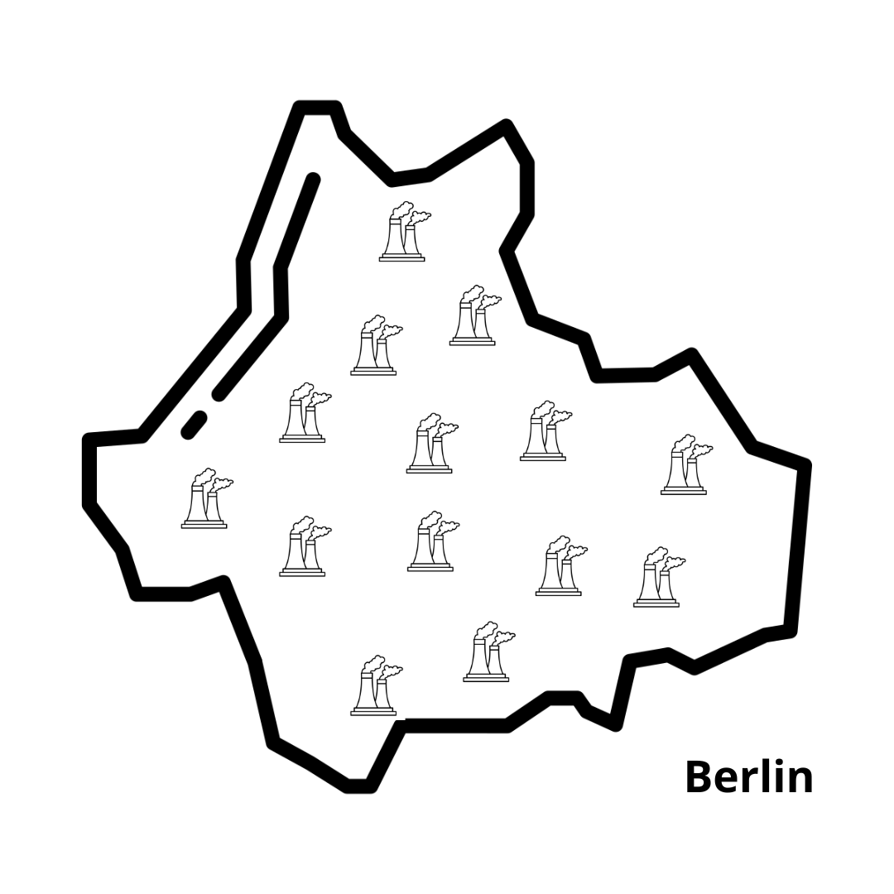

Berlin

**etwa 4 Mio. Einwohner*innen**

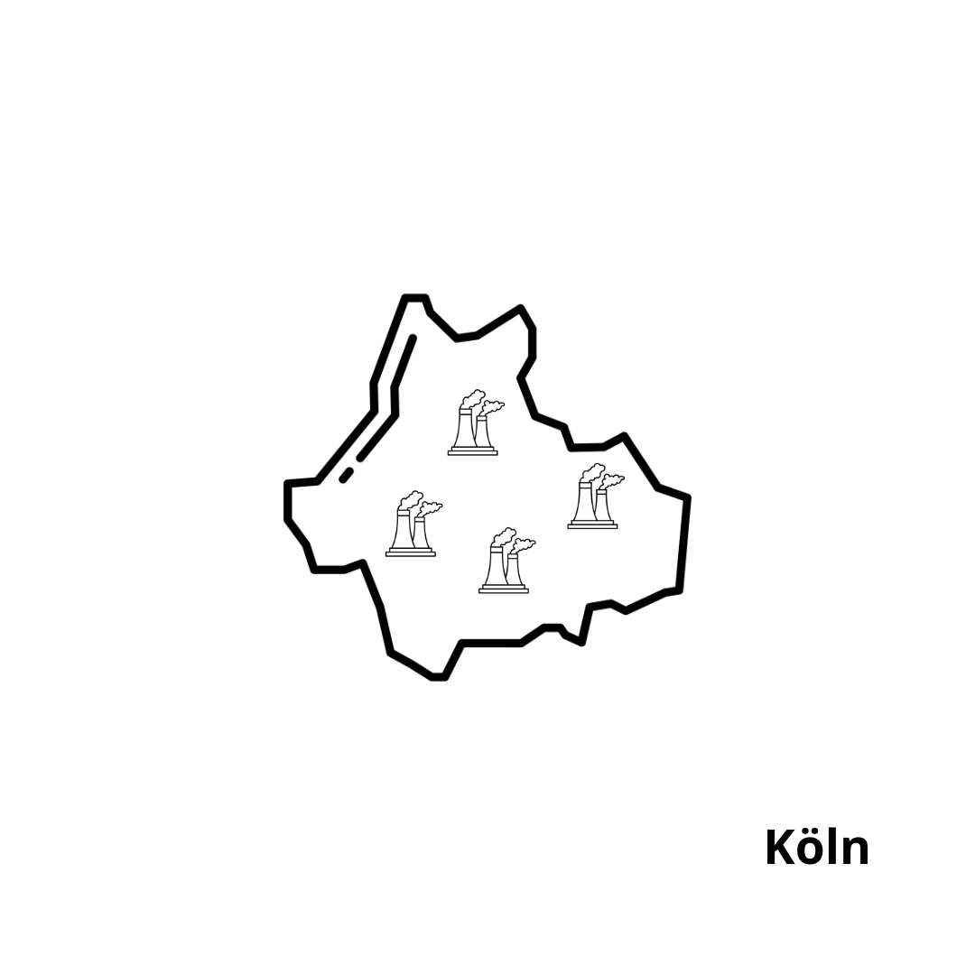

Köln

**etwa 1 Mio. Einwohner*innen**

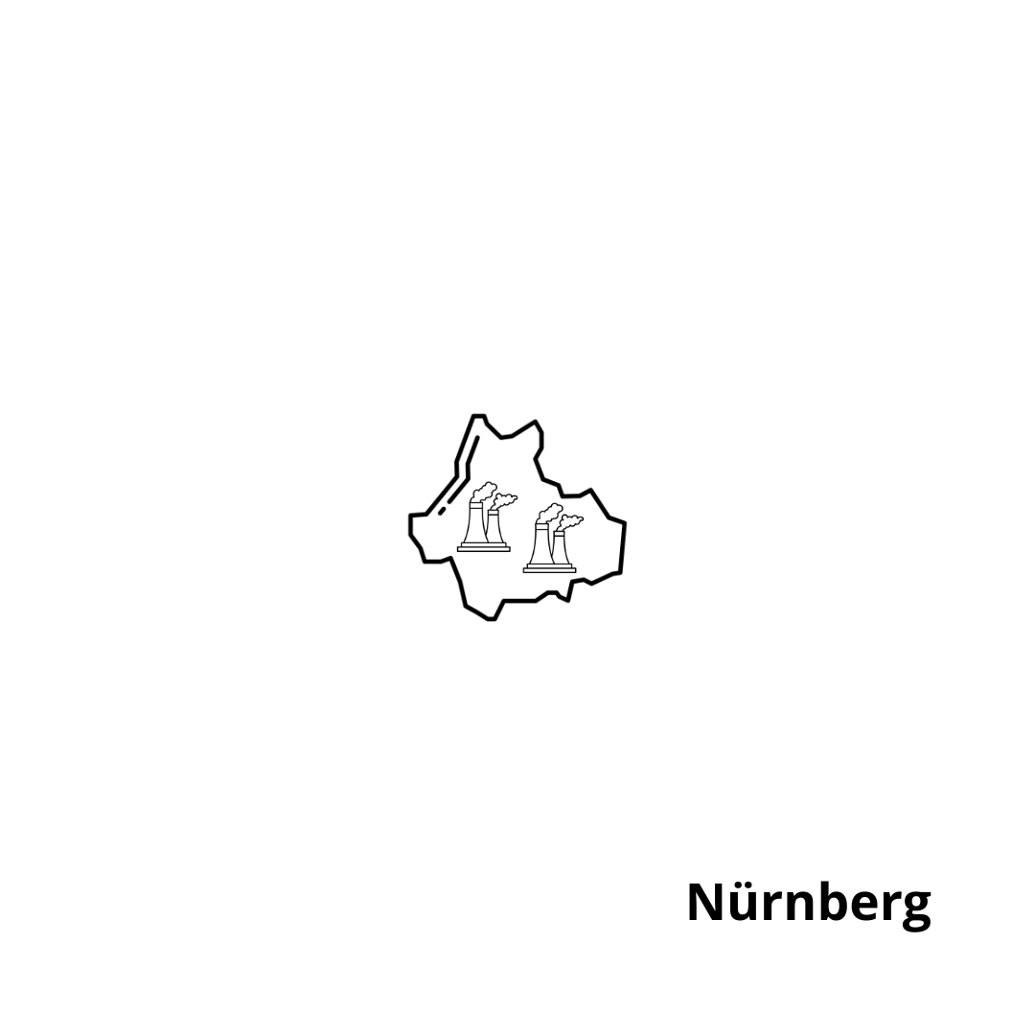

Nürnberg

**etwa ½ Mio. Einwohner*innen**



Flugzeug



Konsum

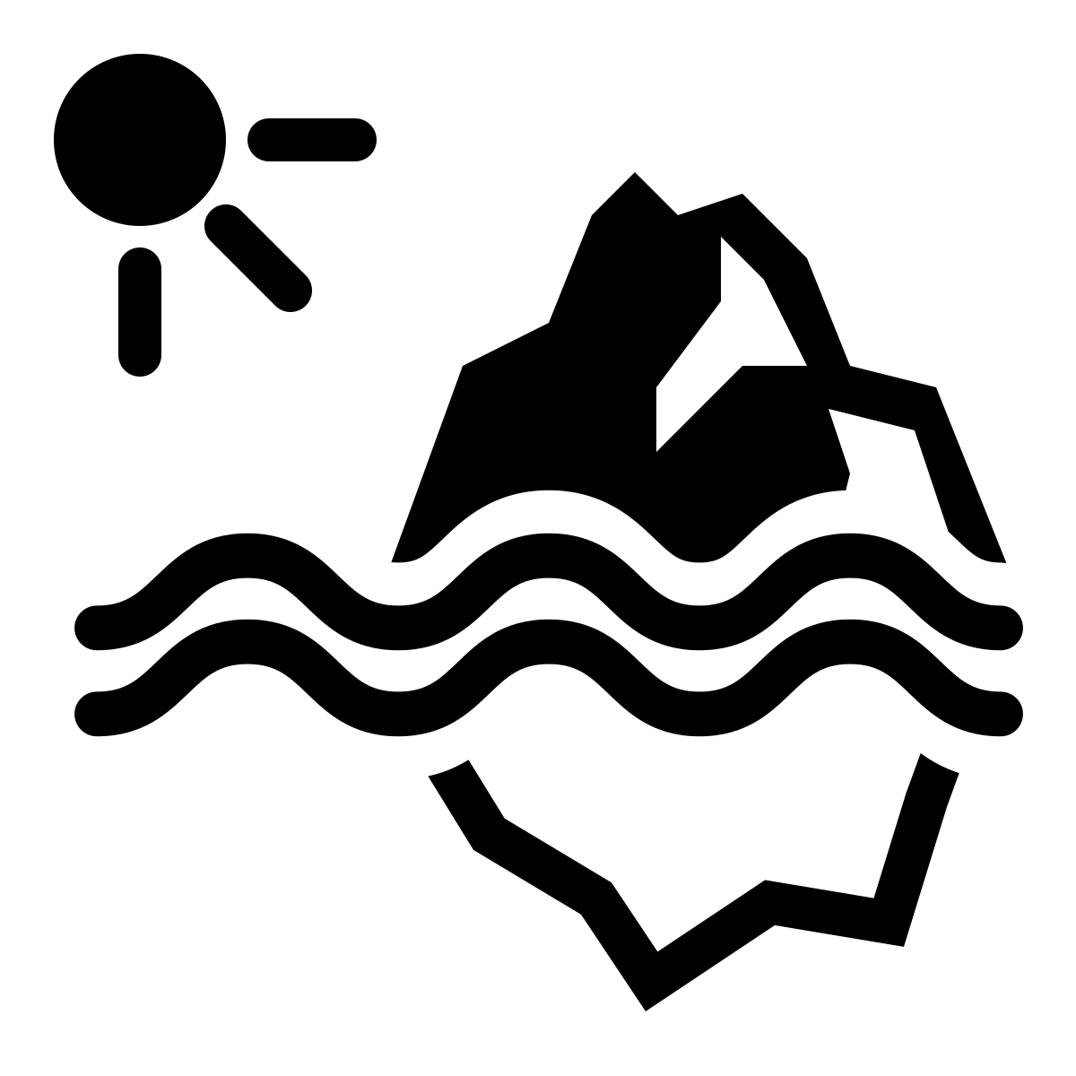

Schmelzende Pole

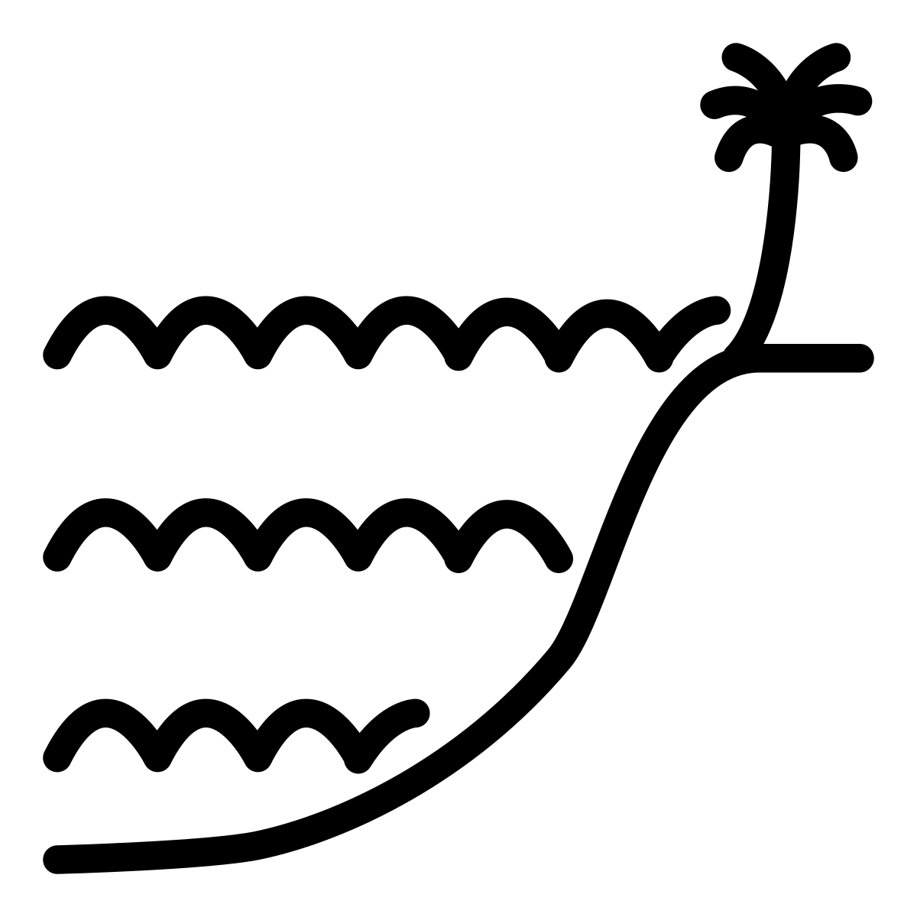

Meeres-Spiegel steigt

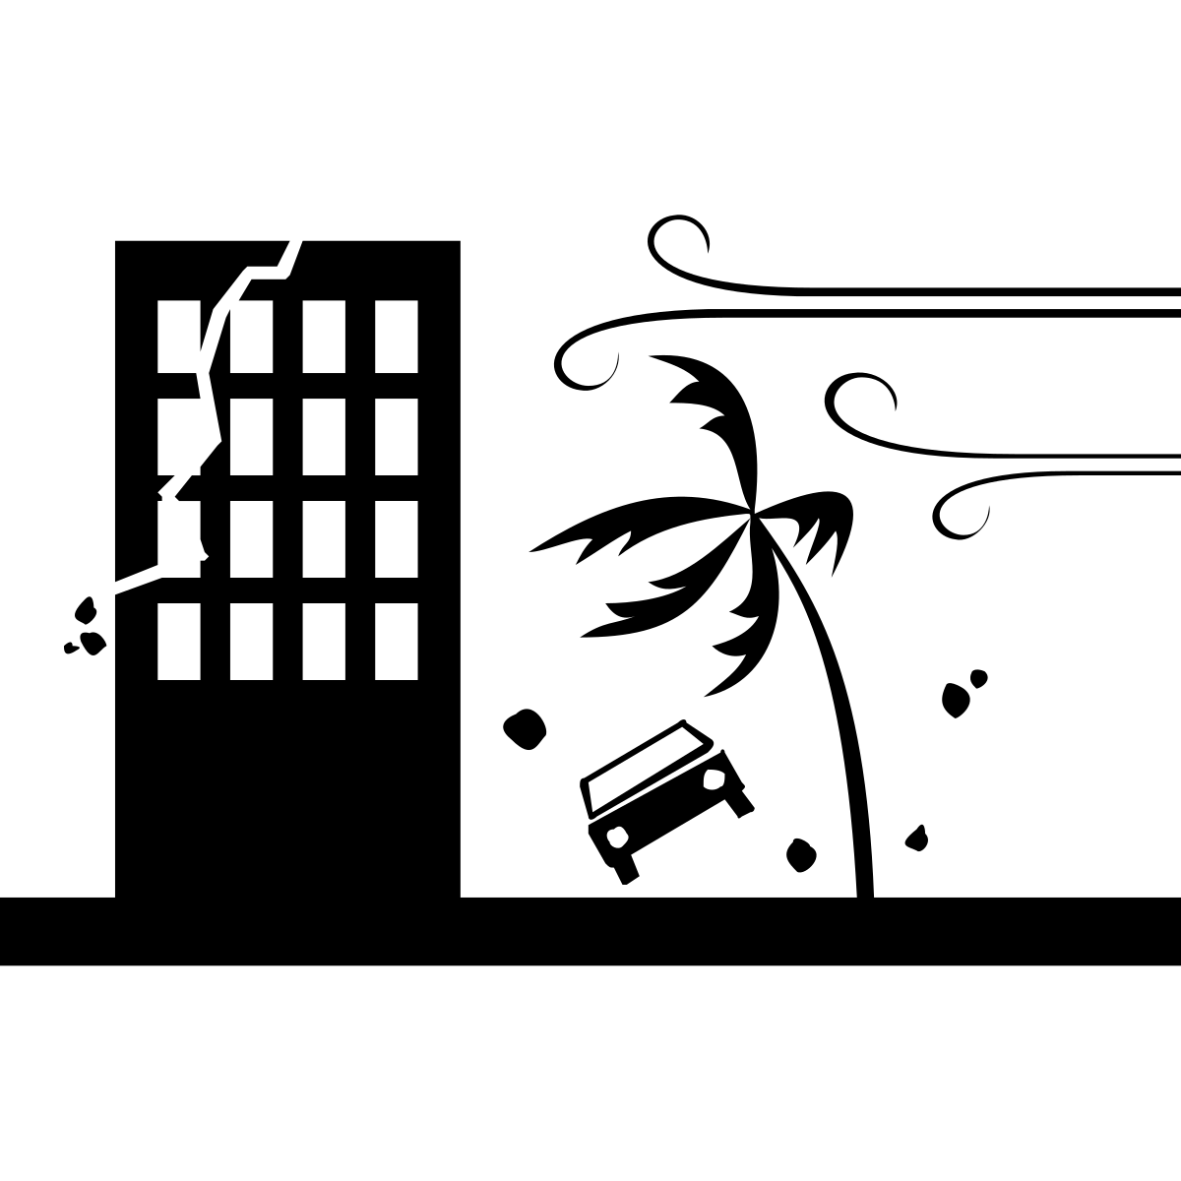

Stürme

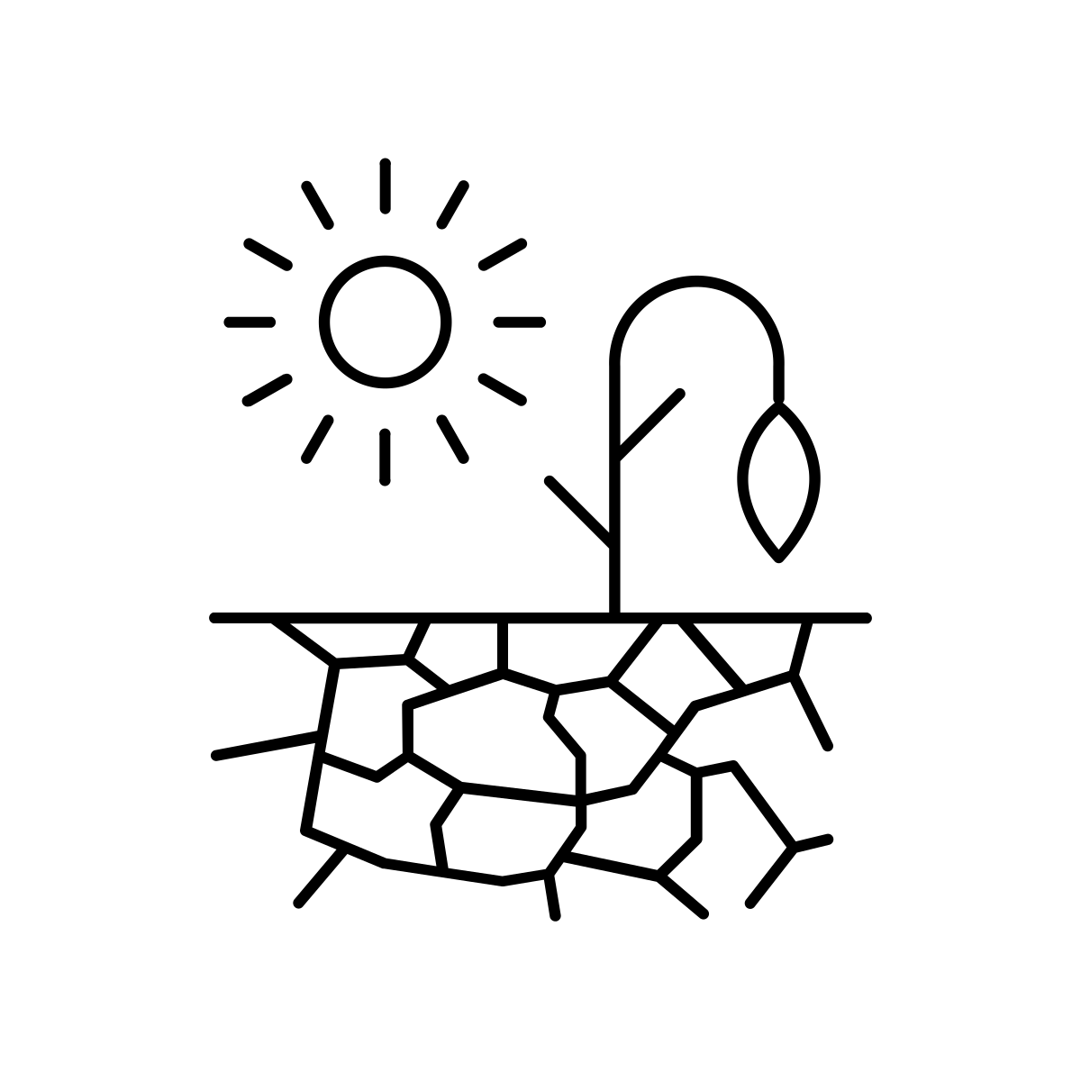

Dürre



Über-

schwemmung

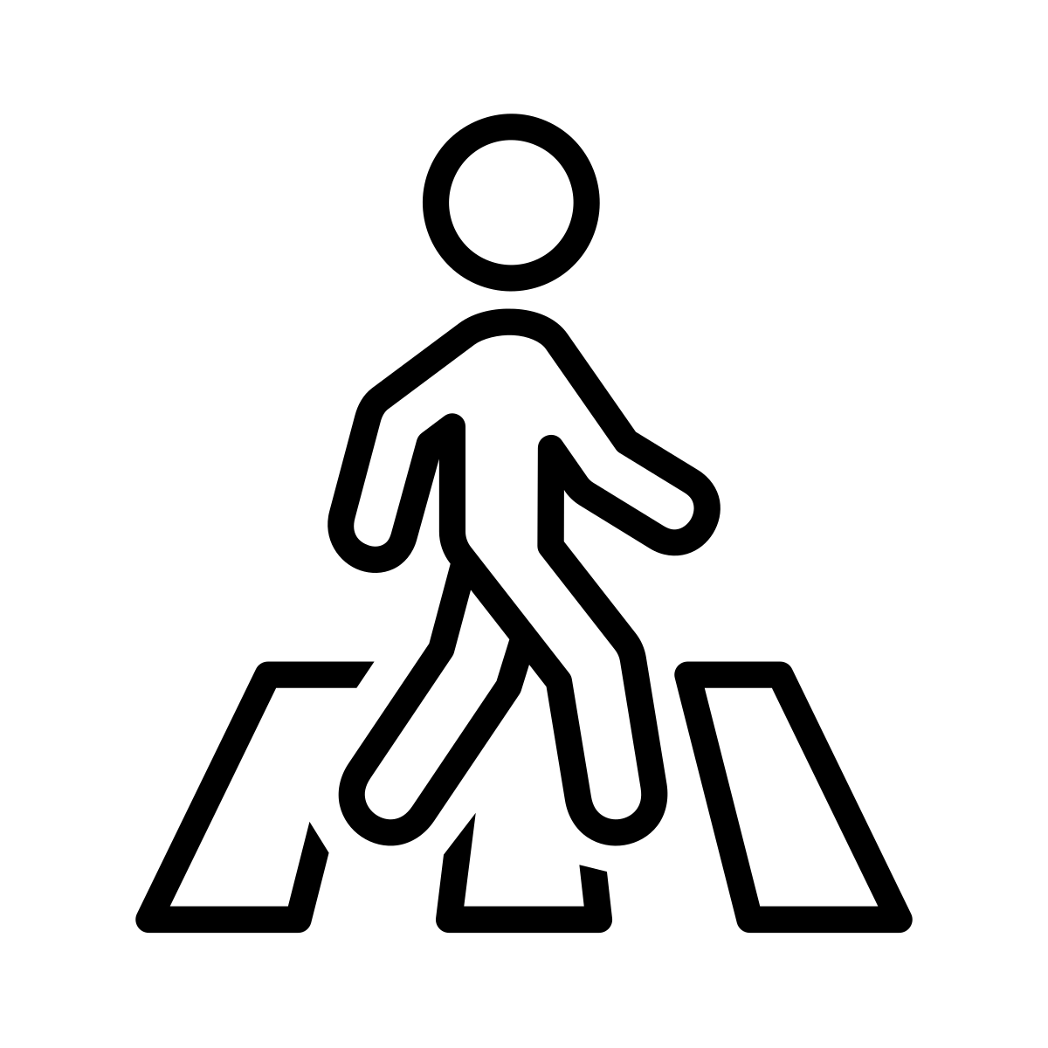

Fußgänger*in

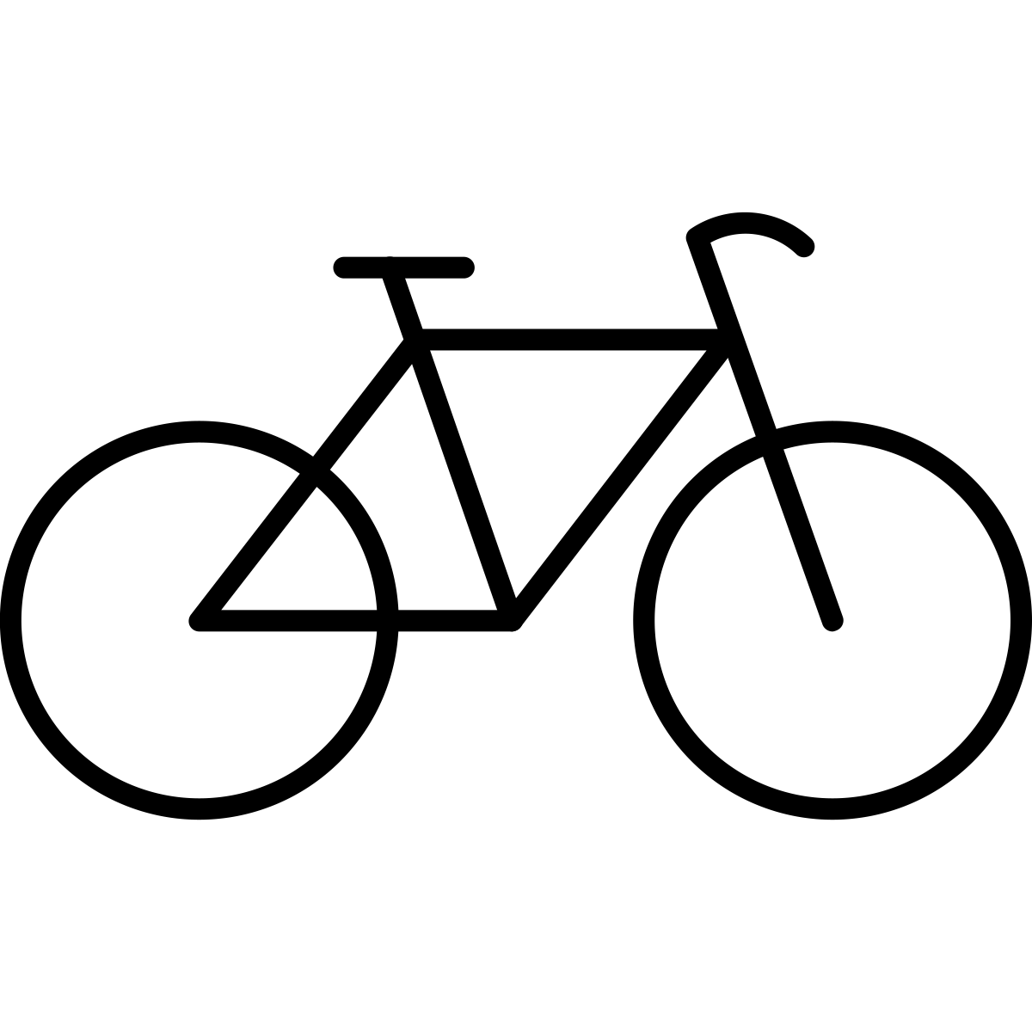

Fahrrad



Rollstuhl



Bus



Bahn

**Strom-Verbrauch**

1. China
2. USA
3. EU
4. Indien
5. Japan
6. **Internet**

**Weltweiter Stromverbrauch 2012**

Quelle: Schneider, Andreas (10.02.2021): So viel Energie verbraucht das Internet, in: Quarks.de, verfügbar unter: <https://www.quarks.de/technik/energie/so-viel-energie-verbraucht-das-internet/> (letzter Zugriff am 03.01.2023).



Land

**Lizenz**

Creative Commons Lizenzvertrag  
Die Bildungsmaterialien und Methodenbeschreibungen aus dem [Projekt #digital_global](https://www.digital-global.net/) vom [F3_kollektiv](https://www.f3kollektiv.net/) sind lizenziert unter einer [Creative Commons Namensnennung - Weitergabe unter gleichen Bedingungen 4.0 International Lizenz](https://creativecommons.org/licenses/by-sa/4.0/) mit der Ausnahme: Die hier verwendeten Icons wurden für das Projekt zur lizenzfreien Nutzung erworben ([Royalty-Free License](https://thenounproject.com/legal/terms-of-use/" \l "icon-licenses)).

Die Icons können auf der Website <https://thenounproject.com/> aber auch unter der Creative Commons-Lizenz CC By frei runtergeladen werden (mit Angabe der Credits). Deshalb hat das F3_kollektiv zusätzlich ein Verzeichnis mit den Credit-Angaben erstellt:

* **Backofen:** oven by TOZIcon TH from the Noun Project, URL: <https://thenounproject.com/icon/oven-5194881/>
* **Handy:** Smartphone by Christopher Holm-Hansen DK from the Noun Project, URL: <https://thenounproject.com/icon/smartphone-193978/>
* **Hochhaus:** Skyscraper by nareerat jaikaew TH from the Noun Project, URL: <https://thenounproject.com/icon/skyscrapper-3504973/>
* **Computer:** personal computer by Grafix Point from the Noun Project, URL: <https://thenounproject.com/search/?q=2961764&i=2961764>
* **Internet:** web by Adrien Coquet from the Noun Project, URL: <https://thenounproject.com/icon/web-4211377/>
* **Rechenzentrum:** Date Center by Gan Khoon Lay from the Noun Project, URL: <https://thenounproject.com/icon/data-center-968730/>
* **Daten:** Research by Aneeque Ahmed from the Noun Project, URL: <https://thenounproject.com/icon/research-2516048/>
* **Kühlung:** cool by Nithinan Tatah TH from the Noun Project, URL: <https://thenounproject.com/icon/cool-1468288/>
* **Fernseher:** Television by sachan JP from the Noun Project, URL: <https://thenounproject.com/icon/television-136271/>
* **Menschengruppe:** crowd by Magicon HU from the Noun Project, URL: <https://thenounproject.com/icon/crowd-317385/>
* **Person:** person by ngamlerdlek.design TH from the Noun Project, URL: <https://thenounproject.com/icon/person-1162016/>
* **Kohle:** Coal by Vectorstall PK from the Noun Project, URL: <https://thenounproject.com/icon/coal-3724431/>
* **Erdgas:** natural gas by Amir Ali from the Noun Project, URL: <https://thenounproject.com/icon/natural-gas-5129874/>
* **Öl:** Oil extraction by Lucas Helle CL from the Noun Project, URL: <https://thenounproject.com/icon/oil-extraction-3608385/>
* **Solarenergie:** solar panel by Florent B BE from the Noun Project, URL: <https://thenounproject.com/icon/solar-panel-3340438/>
* **Windenergie:** Windmill by Gan Khoon Lay from the Noun Project, URL: <https://thenounproject.com/icon/windmill-1926236/>
* **Wasser-Kraft:** Turbine by Zaman Khan from th noun Project, URL: <https://thenounproject.com/icon/turbine-4594963/>
* **Kraftwerk:** Power Plant by Muhammad Atiq PK from the Noun Project, URL: <https://thenounproject.com/icon/power-plant-4232183/>
* **Heizung:** heater by Pause08 TH from the Noun Project, URL: <https://thenounproject.com/icon/heater-1541329/>
* **Auto:** car by paytren from the Noun Project, URL: <https://thenounproject.com/icon/car-5182436/>
* **Flugzeug:** Airplane by Chanut is Industries TH from the Noun Project, URL: <https://thenounproject.com/icon/airplane-492582/>
* **Konsum (Waren kaufen):** shopping by Fatkhul Hadi ID from the Noun Project, URL: <https://thenounproject.com/icon/shopping-5178588/>
* **schmelzende Pole:** Climate Change by Darin S from the Noun Project, URL: <https://thenounproject.com/icon/climate-change-168034/>
* **Meeresspiegel steigt:** High Tide by M.Oki Orlando ID from the Noun Project, URL: <https://thenounproject.com/icon/high-tide-3495301/>
* **Stürme:** Hurricane by RULI ID from the Noun Project, URL: <https://thenounproject.com/icon/hurricane-1066603/>
* **Dürre:** Drought by Nice and Serious GB from the Noun Project, URL: <https://thenounproject.com/icon/drought-1673868/>
* **Überschwemmungen:** Flood by WEBTECHOPS LLP IN from the Noun Project, URL: <https://thenounproject.com/icon/flood-3859088/>
* **Fußgänger*in:** Pedestrian by Cuputo ID from the Noun Project, URL: <https://thenounproject.com/icon/pedestrian-4548969/>
* **Fahrrad**: Bike by Bern Lakenbrink DE from the Noun Project, URL: https://thenounproject.com/icon/bike-4730647/
* **Rollstuhl**: wheelchair by Weltenraser from the Noun Project, URL: <https://thenounproject.com/icon/wheelchair-1436536/>
* **Bus:** Bus by paytren from the Noun Project, URL: <https://thenounproject.com/icon/bus-5182437/>
* **Bahn:** Train by andriwidodo ID from the Noun Project, URL: <https://thenounproject.com/icon/train-1009443/>
* **Welt:** world by rivercon from the Noun Project, URL: <https://thenounproject.com/icon/world-5253775/>
* **Strom:** power cable by Tauficon ID from the Noun Project <https://thenounproject.com/icon/power-cable-2956033/>
* **Stadtumriss:** nonsan city map by Ary Prasetyo from the Noun Project, URL: <https://thenounproject.com/icon/5332635/>