

Sustainable Fashion Curriculum at Textile Universities in Europe
–
Development, Implementation and Evaluation of a Teaching Module for Educators

Project: 2020-1-DE01-KA203-005657

Title of the Teaching Unit:
“Make-Do and Mend” – Repairing and
Upcycling as Cultural Phenomena

Author: Dr. Dorit Köhler
Contact Data: University of Education Freiburg
Institute of Everyday Culture, Sports and Health
Department Fashion and Textile
E-mail: dorit.koehler@ph-freiburg.de




Introduction to the Teaching and Learning Materials

Short Description of the Content:

The focus is on the concept of mending clothes as a way of consciously consuming clothes, which preserves their value, raises awareness of their worth and prevents new purchases. This appears in the context of the lack of raw materials and finished goods with different cultural references and in connection with the abundance of fast fashion, whose downsides are becoming increasingly apparent.

Competences and Learning Objectives:

After this unit the student should be able to …

- describe the process of repairing as a cultural phenomenon.
- recognise that repairing and recycling can have scarcity and sustainability aspirations in abundance as a starting point.
- recognise that repairing and thus avoiding the consumption of textiles is a way of acting in the sense of sustainability.
- recognise that a (necessary) repair technique can become a decorative element.
- apply different textile techniques (sewing, embroidery, felting) for repair and as decoration from different cultural areas.

Overview of Working Materials

Lesson module 1:
Topic: “Make-Do and Mend”
Worksheets: A1 Lack of raw materials in and after World War II

Lesson module 2:
Topic: Abundance! - The dark side of fast fashion
Worksheets: A2/1, A 2/2

Lesson module 3:
Topic: I’ll make something out of it – Upcycling
Worksheets: A3/1, A3/2
Working materials: Trouser leg, sewing machine, possibly leftover cotton fabric for lining, thread

Lesson module 4:
Topic: Stuffing and visual mending
Worksheets: A4 Oh, a hole in my jumper!
Working materials: Worksheets, textiles with damage, yarn, darning needle, possibly felting needle and unspun wool

Lesson module 5:
Topic: And what does it look like somewhere else? - Boro and Sashiko from Japan
Worksheets:
A5 Information text: And what does it look like somewhere else? - Boro and Sashiko from Japan
A6 Cushion in Boro style
A7 Sashiko from Japan - postcards with sashiko motifs
Working materials: Worksheets, fabric, embroidery thread, needle, marking pen, ruler

Sources

Briscoe, S. (2020). The Book of Boro: Techniques and Patterns Inspired by Traditional Japanese Textiles. David & Charles.

Clark, L. & Rockefeller, R. (2020). The Buy Nothing, Get Everything Plan: Discover the Joy of Spending Less, Sharing More, and Living generously. Aria Books.

Clay, J. (2019). Sashiko: 20 Projects Using Traditional Japanese Stitching. ‎GMC Publications.
Herrberg, A. (2021, 26. November). Atacama-Wüste in Chile: Müllhalde für Fast-Fashion. tagesschau. https://www.tagesschau.de/ausland/amerika/muellhalde-atacama-wueste-101.html
Klymkiw, S. (2020). Fashion Conscious: Change the World with a Change of Clothes. Illustration: Kim Hankinson. Red Shed.

Koren, L. (2008). Wabi-Sabi for Artists, Designers, Poets & Philosophers. Imperfect Publishing.

Lewis-Fitzgerald, E. (2020). Modern Mending: How to Minimize Waste and Maximize Style. Affirm Press.

Misumi, N. (2020). Joyful Mending. Visible Repairs for the Perfectly Imperfect Things We Love! Tuttle Publishing.

Mullett-Bowlsby, J., & Mullett-Bowlsby, S. (2020). Boro & Sashiko. Harmonious Imperfection: The Art of Japanese Mending & Stitching. Stash Books.

Norman, J. (Preface) (2014). Make Do and Mend: Keeping family and home afloat on war rations. Reproductions of official second world war instruction leaflets (2nd ed.). Michael O´Mara Books.

Rodabauch, K. (2018). Mending Matters: Stitch, Patch, and Repair Your Favorite Denim & More. Abrams & Chronicle Books.

Thompson, H. (2012). Mach neu aus alt – Kleidung und Accessoires. Welt retten, Geld sparen, Style haben. Kleidung und Accessoires [Make new from old: Save the world, save money, have style. Clothing and accessories]. Edel.

Whittington, N., & Thompson, H. (2012). Mach neu aus alt - Kleidung und Accessoires: Welt retten, Geld sparen, Style haben [Make new from old: Save the world, save money, have style]. Edel.

Tutorials

START SASHIKO WITH THESE TWO SIMPLE KNOTS | Mend or DIY your clothes! SASHIKO FOR BEGINNER’S. (2019, 16. May). [Video]. Youtube. Last accessed on September 13th, available at: https://www.youtube.com/watch?v=vVV7UVL8kJM

Top 5 Basic Sashiko Tips | To enjoy Sashiko Stitching more - 刺し子を始めるにあたってのヒントのまとめ英語版. (2018, 18. October). [Video]. Youtube. Last accessed on September 13th, available at: https://www.youtube.com/watch?v=H464u4q_JGk

THIS IS HOW I REPAIRED MY JEANS WITH SASHIKO!!! | Repair or DIY your clothes!! 💚🌍. (2019, 17. May). [Video]. Youtube. Last accessed on September 13th, available at: https://www.youtube.com/watch?v=B7IEDvAGeWo

Visible Mending: 10 Basic Principles to Get You Started Mending Your Clothes. (2020, 11. July). [Video]. Youtube. Last accessed on September 13th, available at: https://www.youtube.com/watch?v=IKlKEbkbX_M

Worksheet 1: Lack of raw materials in and after World War II

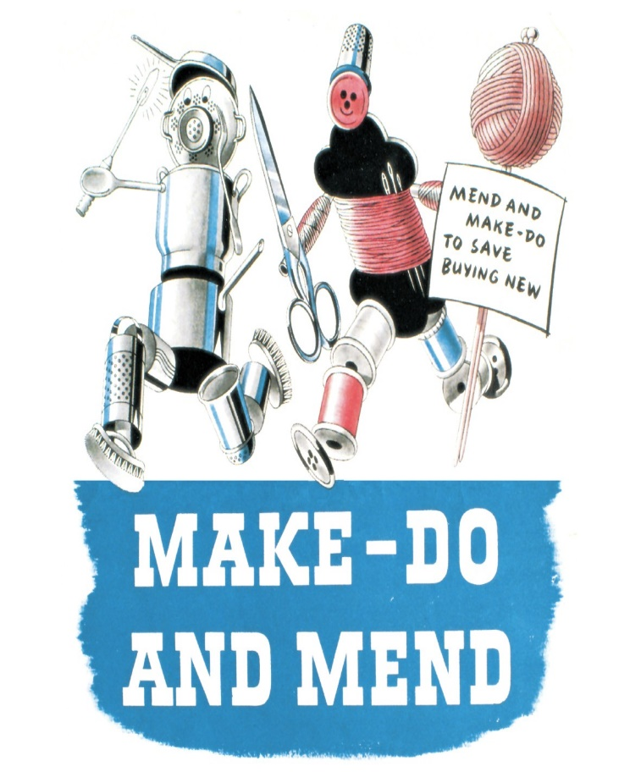

Image Source: http://vitiworks.blogspot.com/2012/12/make-do-and-mend.html

“Make-Do and Mend” was a pamphlet issued by the British Ministry of Information in the midst of WWII. It was intended to provide housewives with useful tips on how to be both frugal and stylish in times of harsh rationing. With its thrifty design ideas and advice on reusing old clothing, the pamphlet was an indispensable guide for households. Readers were advised to create pretty ‘decorative patches’, to cover holes in warn garments; unpick old jumpers to re-knit chic alternatives; turn men’s clothes into women’s; as well as darn, alter and protect against the ‘moth menace’. An updated version of the book was recently released to coincide with the economic recession, offering similar frugal advice for 21st century families.

Source: British Library (n.d.). Make Do and Mend. 1943. Shelfmark: BS 41/484. http://www.bl.uk/learning/timeline/item106365.html

Tasks:

1a) Describe the intention of the British Ministry's "Make-Do and Mend" initiative during World War 2.
1b) Do you see parallels to the current situation in dealing with textiles? Make references and formulate them in writing.
Worksheet 2: The dark side of fast fashion – too much of everything (1/2)

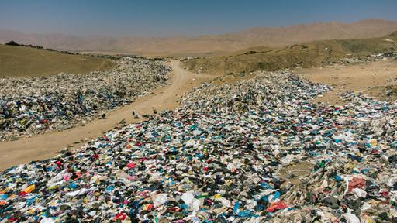
Picture 1: Atacama Desert in Chile

Status: 26th of November 2021 02:38 o’clock
Image Source: https://www.tagesschau.de/ausland/amerika/muellhalde-atacama-wueste-101.html

Task 1: Describe what is in the picture and make guesses about what it is.

__________________________________________________________________________________________________________________________________________________________________________________________________________________________________________________________________________________________________________________________________________________________________________________________________________________________________________________________________

Worksheet 2: The dark side of fast fashion – too much of everything (2/2)

Task 2: Read the text and then answer the questions:

The unique Desierto de Atacama in Chile is degenerating into a dumping ground for fast fashion clothing. The regional secretary of the Ministry of Environment is quoted: “No doubt, these landfills and textile waste are a big problem for the environment. They often cause fires, which pollutes the air. And this affects local residents as well because the dumps are very close to populated areas.”
The textiles are as toxic as plastic or tyres. They contain many pollutants, for example through dyeing, bleaching, or printing. According to a recent study by Greenpeace, the textile industry uses more than 70 chemicals that are hazardous to health and the environment. The polyester contained needs up to 200 years to degrade, and even then, so-called microplastic particles remain.
Normal landfills do not even accept this kind of hazardous waste, says Franklin Zepeda. He has founded a company that processes the discarded clothing. "The textile waste is generated by importing the used clothes. In the free trade zone, it is sorted into high-value and secondary garments and waste. It all used to go to the desert, we now use it as raw material for our thermal insulation panels."
The founder of Ecocitex, Rosario Hevia from Santiago, also recycles the weathered textiles and makes yarn from them. But these remain isolated initiatives in the fight against a global problem: the overproduction of the textile industry. According to a UN report published in 2019, between 2000 and 2014, global textile production doubled. Meanwhile, the industry is responsible for around 20 per cent of water consumption worldwide.

Environmental organisations like Greenpeace are calling for more pressure on the textile industry: “There should be an obligation to recycle properly. People need to rethink,” says entrepreneur Hevia, “and question their own consumption behaviour.” (Herberg, 2021)

Questions:

2a) Why are these mountains of clothing considered as trash and who are the culprits behind them?
2b) What problems arise from this dumping of textiles?
2c) What solutions are there to avoid this problem? (Please also name those that are not mentioned in the text).

Worksheet 3: I'll make something out of it – Upcycling

Project 1: Utensilo from trouser legs

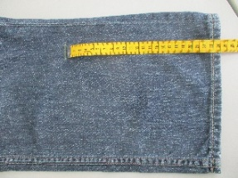 | - Cut off the trouser leg according to the desired length.
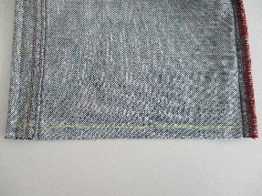 | - Close the bottom seam.
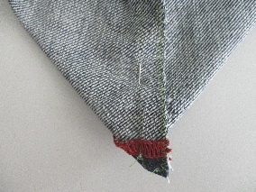 | - Sew the bottom: Place the bottom seam on the side seam.
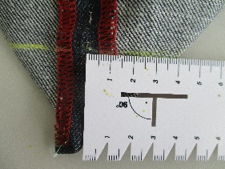 | - Mark the desired depth (3-4 cm on each side).
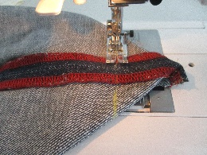 | - Sew the line with a straight stitch; you can cut off the outer part or leave it if the fabric is thin.
 | - Turn over; finished!

Photos: CC BY-SA-ND Köhler

Project 2: Utensilo made from lined trouser legs

This project is good for the upper parts of the leg, which have cut edges on both sides.

 | 1 - 4. Refer to the steps from project no. 1 from the trouser leg.
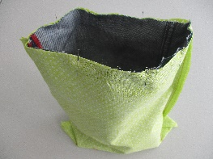 | - Cut a rectangle from thinner cotton fabric with the measurements of the leg unfolded.
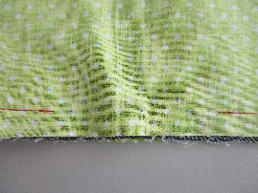 | - Close the seams at the sides and at the bottom.
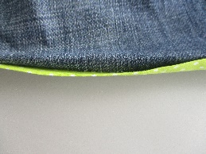 | - Sew bottom: refers to project no. 1 steps 3 and 4.
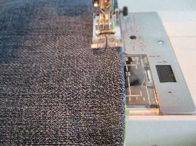 | - Place trouser part and fabric bag with right sides together at the top edge; sew 1cm wide, leaving a gap of approximately 7cm.
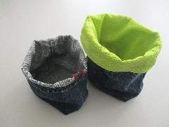 | - Turn over, smooth out upper edge, open seam allowances  a) fold inwards,  b) place on top of each other and  c) stitch the whole edge; finished!

Photos: CC BY-SA-ND Köhler

Worksheet 4: Oh, a hole in my jumper - Visual Mending

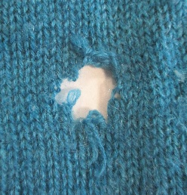 | Who has not experienced this: a hole in your favourite knitted jumper?  These instructions explain how to make holes not only disappear, but also become eye-catchers. And this is how it works:
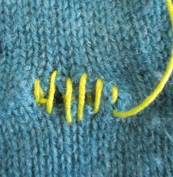 | Visual Mending through darning  Material: embroidery needle, embroidery floss or wool yarn  - Thread the thread (e.g., embroidery floss or wool yarn) into a darning needle.  - Secure the stitches by passing the thread through the open stitches and tensioning the warps.
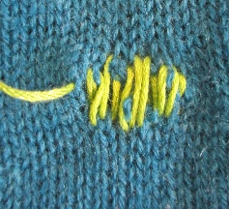 | - Add more warps.
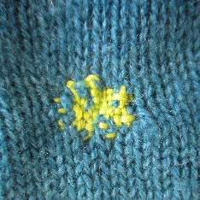 | - Pass the thread in horizontal direction always once over and under the warps. In the following row you must do it the other way round (plain weave).

Photos: CC BY-SA-ND Köhler

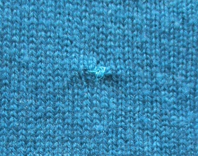 | Visual Mending through embroidery motifs  Material: embroidery needle, embroidery floss or wool thread  - Carefully pick up the stitches with a sewing thread and pull them together.
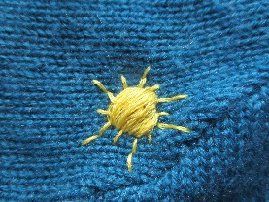 | - Embroider a motif on the created area.
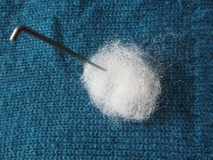 | Visual Mending through Needle Felting  Material: sewing needle and thread, loose sheep's wool, felting needle, suitable mat e.g., foam material  - Carefully pick up the stitches with a sewing thread and pull them together.  - Place loose sheep's wool (dyed or undyed) in the desired shape, place mat under the surface and stitch into the surface with the felting needle from top to bottom until the knitted fabric and the loose fibres join.
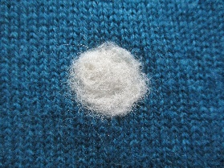 | Make sure that the contours of the desired motif remain in place.
Photos: CC BY-SA-ND Köhler

Worksheet 5: And what does it look like elsewhere? - Boro and Sashiko from Japan

Boro and sashiko are traditional textile techniques from Japan that have been used to repair textiles for centuries and thus preserve them. Both are based on the Japanese principle of wabi-sabi. This is based on its own idea of aesthetics: the reduction to the essential. Moreover, it is about appreciating the beauty of imperfection, destruction and the ageing process as an aesthetic value in their own right. These traces remain visible, and the objects gain in significance and sublimity as a result. Crooked seams, faded colours, wear and tear increase the appreciation of the object.

In the Boro technique, worn-out and worn kimonos are torn apart and used to make blankets, mats and other items. Additionally applied embroidery stitches tone-on-tone are used to work on tears and holes in such a way that a stable surface is recreated.

The embroideries become an artistic decoration, on the one hand, through the composition of the motifs and, on the other hand, through the Do. In the traditional Japanese sense, the Do is the path that becomes the goal and gives the work an emotional and symbolic meaning beyond its actual result.

In sashiko, parallel lines, crosses, arcs and staircase-shaped lines, which in turn form further shapes, are pre-drawn and embroidered in the pre-stitch. The traditional colours for sashiko embroidery are white and blue. Either a blue thread is embroidered on white fabric or a white thread on blue fabric.

The patterns are not random and not just chosen for aesthetic reasons. Each pattern has traditional roots and a symbolic meaning, often related to the world of the gods in Shintoism. According to the traditional understanding, the meaning of the pattern should be transferred to the wearer of the garment and his or her everyday life.

Tasks:

Task 1: Research for more information on the history and significance of the techniques of boho and sashiko on the internet. Present similarities and differences to the use of textiles in the context of fast fashion.

Task 2: Find three patterns of the sashiko, draw them and note their meaning.

Worksheet 6: Boro-style cushion

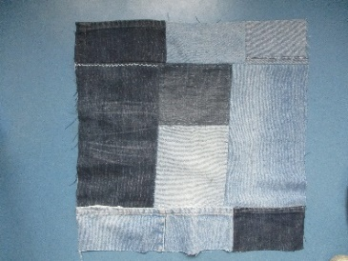 | - Assemble rectangles of desired size into a cushion panel (seam allowance 1cm).
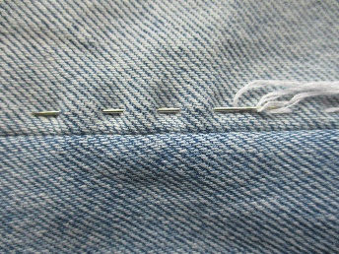 | - Accentuate the seam with a running stitch.
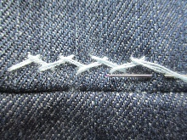 | - Accentuate the seam with a herringbone stitch.
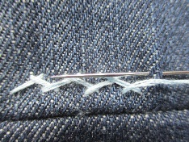
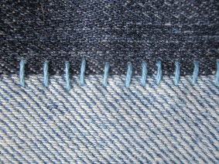 | - Overstitch the seam with stitches at a right angle.

Photos: CC BY-SA-ND Köhler

Worksheet 7: Sashiko from Japan - Postcards with Sashiko Motifs

Materials: Fabric or garment to embroider / mend; long sewing needle, embroidery thread in your desired colour, ruler for drawing the pattern, tailor’s chalk, pins, pencil for tracing, pattern template (self-drawn or copy), fabric scissors

Procedure:

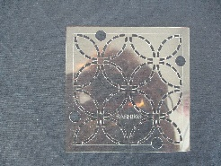  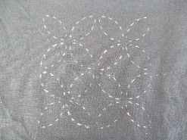 | Transfer the pattern: place the pattern on the fabric, trace the pattern lines with a needle, rub tailor's chalk over the pattern so that the chalk is visible through the holes on the fabric.  Trace the pattern with chalk. / Alternatively, you can directly draw the patterns on the fabric with chalk.
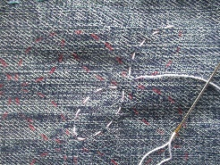 | Stitch the design with a small, regular pre-stitch (approx. length of a grain of wheat); it should look like a dotted line. The stitches on the front must not touch at the crossing points of the lines.
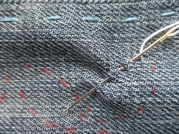 | Running stitch (a characteristic of sashiko is this way of working the running stitch): The long needle is passed up-down-up-down through the fabric several times and the thread is then pulled through.
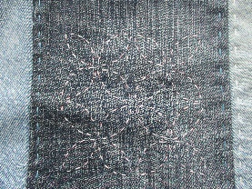 | Smaller motifs are done in this way and then the pieces of fabric are presented behind a piece of cardboard as if behind a passepartout.

Photos: CC BY-SA-ND Köhler

