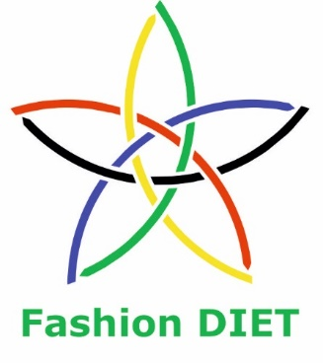

Sustainable Fashion Curriculum at Textile Universities in Europe
–
Development, Implementation and Evaluation of a Teaching Module for Educators
Project: 2020-1-DE01-KA203-005657

Title of the Lesson: Design Approaches in Upcycling in Fashion

Authors: Prof. Dr. Antonela Curteza
The “Gheorghe Asachi” Technical University of Iasi
Faculty of Industrial Design and Business Management
Department of Knitting and Clothing Engineering
E-mail: ACurteza@gmail.com

Andreea Sofronea
Co-manager and Designer
REDU
E-mail: andreea@maibine.eu
https://www.redu.org.ro/about#team

Elvys Sandu Prisecaru
Co-manager and Designer
REDU
E-mail: elvys@maibine.eu
https://www.redu.org.ro/about#team



Introduction to the Teaching and Learning Materials
Short Description of the Content:

Fashion is a fascinating and successful industry, but, at the same time, it contributes to the biggest pollution in the world, as its activities and the consumption of products generate massive garment and textile waste [1]. The fast-fashion products have affordably prices, are produced at large scales, have a shorter lifespan, allowing the customers to buy more products in a very short time [2], and all these have significant negative environmental, social, and economic implications [1].

Circular business models are concrete solutions in lowering the negative impact of the fashion industry, and among these can be mentioned renting, sharing clothes, and also repurposing clothes (EEA 2020). Some concrete ways to repurpose clothes are recycling and upcycling, which have started to become an emerging trend [1].

The upcycling process (reusing, repairing, and remanufacturing) can extend both product and the component materials life cycle, and as a consequence, upcycling supports sustainability. The upcycling methods and techniques are more structured and accessible to everyone, and can be employed in the design development of garments (old or new) to extend their life cycle [1].

Competences and Learning Objectives:

After this unit the student should be able to:

- have an understanding of different definitions and the creative nature of upcycling in fashion;
- comprehend the importance of upcycling in the fashion industry;
- understand the differences between upcycling and downcycling;
- evaluate the challenges and limitations in the upcycling process;
- analyse different approaches in design in upcycling fashion;
- study success stories and practices in upcycling at REDU;
- apply different creative techniques in upcycling textile products.

Overview of Working Materials

Lesson module 1:
Topic: Towards a circular economy
Worksheet: About Upcycling in fashion

Lesson module 2:
Topic: Why upcycling?
Worksheet: The importance of upcycling in the fashion industry

Lesson module 3:
Topic: Challenges in upcycling.
Worksheet: The process of upcycling fashion, challenges and limitations

Lesson module 4:
Topic: The design process in upcycling.
Worksheets: Approaches in upcycling and design in fashion

Lesson module 5:
Topic: Success stories – REDU
Worksheet: Approaches of upcycling at REDU

Sources

1. Christabel Annora Paramita Parung, C., A., P., et all, (2022). Upcycling Design Process and Classification of Upcycling Method as Innovation to Extend Product Lifecycle, Proceedings of the International Conference on Industrial Engineering and Operations Management, Istanbul, Turkey, March 7-10, 2022, IEOM Society International, pp.58-68

2. Chang, J., Rynhart, G. and Huynh, P., (2016) ASEAN in transformation. Bureau for Employers’ Activities (ACT/EMP), Working Paper No 14 International Labour Office

3. Yi Sora, Lee Hisun, Lee Jeongmin, Kim Woong. Upcycling strategies for waste electronic and electrical equipment based on material flow analysis. Environmental Engineering Research 2019; 24(1): 74-81. Published online: June 18, 2018 DOI: https://doi.org/10.4491/eer.2018.092 http://eeer.org/journal/view.php?number=932

4. Dam, R. F., and Siang, T. Y. 5 stages in the design thinking process. Interaction Design Foundation. Retrieved April 10, 2020, from https: //www.interaction-design.org/literature/article/5-st ages-in-the-design-thinking-proces, 2020.

5. Beth Stewart (May 8, 2014). "Upcycling: The New Wave of Sustainable Fashion".

6. Flora Macdonald Johnston (Jan 31, 2020). "1/Off Paris — the French label making upcycling sexy". Financial Times.

7. Fiona Zublin (Dec 14, 2020). "Ksenia Schnaider Knows How To Make Upcycled Fashion Beautiful". Forbes.

8. Fiona Zublin (Jun 25, 2018). "The Next Big Thing In Fashion: Scraps".

9. Weber, Sabine; Lynes, Jennifer; Young, Steven B. (March 2017). "Fashion interest as a driver for consumer textile waste management: reuse, recycle or disposal". International Journal of Consumer Studies. 41 (2): 207–215. doi:10.1111/ijcs.12328.

10. Claudia E. Henninger; Panayiota J. Alevizou; Helen Goworek; Daniella Ryding, eds. (2017). Sustainability in Fashion. doi:10.1007/978-3-319-51253-2. ISBN 978-3-319-51252-5.
11. Ana Pires (2018). Sustainable Solid Waste Collection and Management. Springer. ISBN 978-3-319-93200-2.

12. William, McDonough; Michael Braungart (2002). North Point Press (ed.). Cradle to Cradle: Remaking the Way We Make Things. North Point Pr. pp. 56–57. ISBN 978-0-86547-587-8.

13. Art. 16/18 - Din https://www.paris.edu/fashion-design-sustainable-fashion-challenging-the-design-process-with-upcycling/ - PUBLISHED: APRIL 9, 2021

14. https://www.greenhive.io/blog/upcycling-fashion - 13 iul.2023

15. https://www.revibe-upcycling.com/blog/news/upcycling-the-hottest-trend-in-fashion STAIN – NEWS, MARCH 24, 2022

Worksheet 1: About Upcycling in fashion

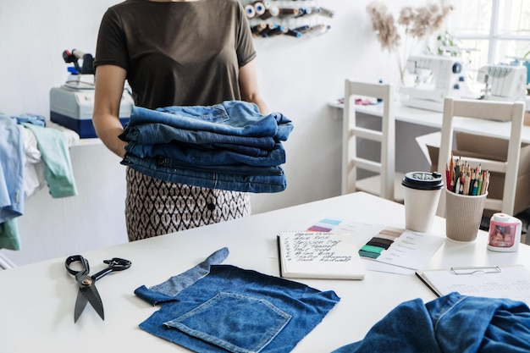

Image Source: https://www.freepik.com/

Upcycling, also known as creative reuse, is the process of transforming by-products, waste materials, useless, or unwanted products into new materials or products perceived to be of greater quality, such as artistic value or environmental value [https://en.wikipedia.org/wiki/Upcycling].

In Richardson’s paper, upcycling is defined as a way by which “designers can directly reduce the net volume of household solid waste entering the waste stream; and more broadly, net material volumes in the global product market” [2].

Yi et. al. defines upcycling as “the conversion of waste materials to something useful or valuable, underlining is it a useful concept that can be applied not only to the waste design industry but also to waste recycling and resource circulation” [3].

Upcycled clothing refers to garments that have been created by reusing and repurposing the same fabric materials, such as old clothes, textiles, and deadstock fabrics. The entire process involves transforming these materials in something with an added value, resulting in unique fashion items. Upcycling clothes contributes to the reduction of the need for virgin materials in garment production, and helps in minimizing the textile waste, which is a significant issue in the fashion industry [4]. The primary aim of upcycling is to refashion and integrate discarded components and materials into a new range of diverse products within open or closed-loop cycles [5]. Upcycling processes use less energy than recycling processes, and is considered the most effective way to repurpose old clothing [1].
Upcycling is the opposite of downcycling, which is another part of the recycling process. Downcycling involves converting materials and products into new materials of lower quality and functionality than the original ones. [3, 6, 7, 8, 9].

Upcycling in fashion is a sustainable practice because it prolongs the life of materials, reduces waste material, and decreases the need for new resources. The upcycling process contributes to a circular economy by diverting textile waste from landfills and finding creative reuse for post-consumer waste. [https://en.wikipedia.org/wiki/Upcycling]

In Circular Economy resources are used as long as possible, getting the most value out of them while in use, then restored and repurposed when their use is over. This has also been known as the cradle-to-cradle principle that states a product should be designed either to have multiple life cycles or be biodegradable [10, 11].

Designers have begun to use both industrial textile waste and existing clothing for creating new products. In upcycling is used either pre-consumer or post-consumer waste, or a combination of the two. Pre-consumer waste is made in the factory, such as fabric left over from the cutting process. Post-consumer waste refers to the finished product when it’s no longer useful to the consumer [12] Textile upcycling has an official certification process, namely UPMADE® [6]. Some fashion designers have applied the upcycling philosophy in designing entire collections from scraps [7, 8].

Tasks:

Task 1a: Search for other definitions and opinions about upcycling. Form your own opinion.
Task 1b: Point out the differences between upcycling and downcycling.
Task 1c: Study what the circular economy is.
Worksheet 2: The importance of upcycling in the fashion industry

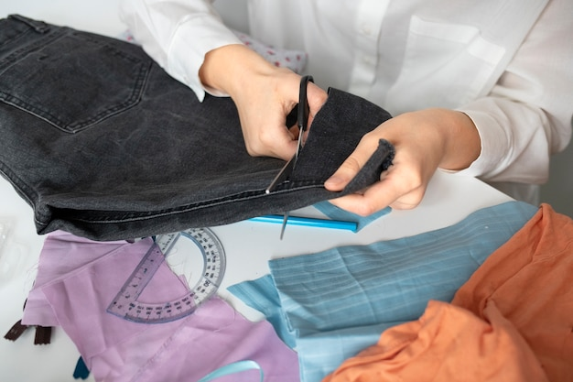
Image Source: https://www.freepik.com/

The upcycling process addresses the environmental issues associated with fast fashion by reducing the waste and conserving the resources. The consumers become more aware of the environmental impact of their choices, and are increasingly seeking for sustainable alternatives, including upcycled clothing. Upcycling also offers unique creative opportunities for fashion designers. [13]

Upcycling supports local communities and small businesses, being represented by small enterprises that work closely with local artisans and craftspeople. The consumers can contribute to the growth of local economies and also promote ethical practices in the fashion industry, by buying the products made by these enterprises [13].

Upcycling has the potential to significantly reshape the fashion industry and contribute to a more sustainable world by [13]:
- encouraging the transition to sustainable practices;
- driving innovation and creativity;
- fostering collaboration between the main players and creating a more diverse and inclusive fashion ecosystem;
- reducing the demand for new materials, promoting the creative reuse of existing resources, and lowering the environmental impact of the fashion industry;
- changing the consumer attitudes, stimulating purchase decisions to more sustainable, ethically-produced garments over fast fashion;
- encouraging the development of a circular economy and fostering an environmentally responsible approach in the fashion industry.

Task 2: Carefully study the text, do additional studies and present which you consider to be the essential aspects that reflect the importance of upcycling in the fashion industry.

__________________________________________________________________________________________________________________________________________________________________________________________________________________________________________________________________________________________________________________________________________________________________________________________________________________________________________________________________

Worksheet 3: The process of upcycling fashion, challenges and limitations

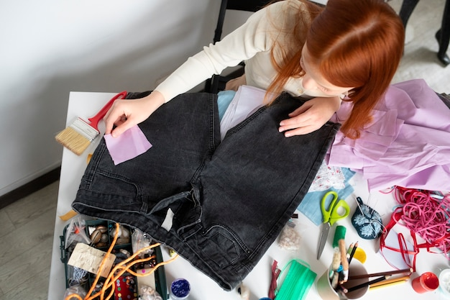
Image Source: https://www.freepik.com/

The process of upcycling fashion for short
The process of upcycling involves taking existing garments or textile waste and transforming them into new products. This can be done through various techniques, such as: patch works, embroidery, dyeing, screen printing, or even combining different fabrics and materials, which allow designers to personalize and embellish upcycled garments, giving them a distinctive look. It also requires a creative approach, as designers need to envision new possibilities for the development of innovative and value-added textile products. Upcycled garments and accessories can take different forms, such as from repurposed t-shirts and jeans to unique handbags. [13, 14]

Challenges and limitations
Upcycling fashion offers numerous benefits and has a huge potential, but it also faces several challenges and limitations [13]:
- Scale: upcycling is a labour-intensive and time-consuming process, which can make it difficult to scale up production.
- Material limitations: the quality and availability of materials used for upcycling are very different which affects the whole process.
- Consumer perception: Some consumers may perceive upcycled fashion as less fashionable or of lower quality compared to traditionally produced garments, which can limit the growth and mainstream acceptance of upcycling.
- Economic viability: Due to the labour-intensive nature of the process and the use of premium materials, the cost of upcycled fashion products can be higher than mass-produced ones. This can make upcycled products less accessible to a wider consumption.

The upcycling process is difficult to be standardized, because every piece of garment is unique. In this context, the teams working in the factories follow a very specific training and process development. So, the entire process, from building the stock after collecting garments, to the quality check of the end products, is very long and requires a lot of different expertise. The selection of the initial garments has to be done very carefully, to ensure upcycled clothes of a good quality and interesting end products [15].

Task 3: Read the text, do further studies and then try to:

3a) Present your view about the upcycling process.
3b) Describe other possible challenges and limitations in the upcycling process.

Worksheet 4: Approaches in upcycling and design in fashion

Upcycling is used in design fields nowadays. Creating ‘new’ products from old or unsold or unused materials or garments, upcycling is considered an innovative way to determine a more ethical consumption and change the production processes. Upcycling involves a design thinking model with 5 stages: empathize, define, ideate, prototype, and test [4]. It requires different combinations of people, knowledge, ideas, needs, creativity, etc., which makes it unique. Figure 1 shows the process of upcycling based on Design Thinking stages according to Dam & Siang (2020).

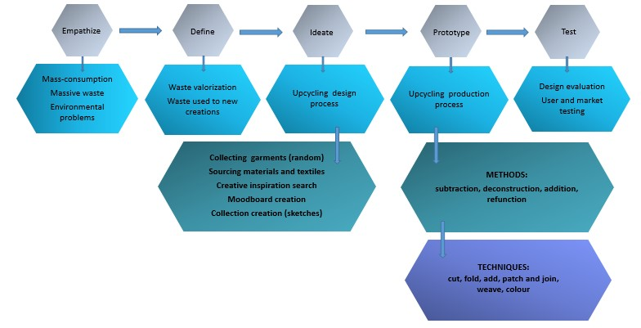

Figure 1. Process of upcycling based on design thinking stages (adapted after Dam & Siang) [4]

Upcycling design process involves collecting used or unsold garments/textile, analysing the products collected, followed by the process of finding creative inspiration, moodboard creation, sketching, and production process. Designing upcycle products is an iterative process that requires ‘trial and error’. Therefore, “Prototype” and “Test” stages can be done several times before obtaining interesting and valuable results [1].

Figures 2 and 3 present a comparison of upcycling design process and standard fashion design process. The standard fashion designing process usually starts by creating creative inspiration and mood boards and then determining the colour palette, the textile materials used and the collection; the upcycling process is done otherwise [1, 14]. The designers need to adapt their design to the textile products available. Regarding the production process, the upcycled garment is one of a kind, and it is impossible to create the exact same product [1].

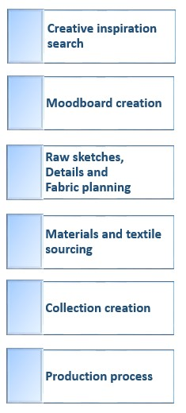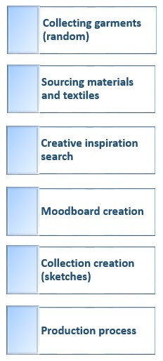
Figure 2. A standard design process [1] Figure 3. Upcycling design process [1]

Task:

Research for more information and recommendations regarding the practice of design in upcycling?

Worksheet 5: Success stories – REDU (https://www.redu.org.ro/)

At REDU, since its foundation (April 2015) until now, we have been giving new life to post-industrial and post-consumer textile waste by creating new products. Whether it is clothing, household or accessories, we try to offer a sustainable consumption alternative. Thus, from the very beginning we have been manufacturing bags and pouches for shopping purposes - different shapes, sizes and materials (Elvys Sandu & Andreea Sofronea).

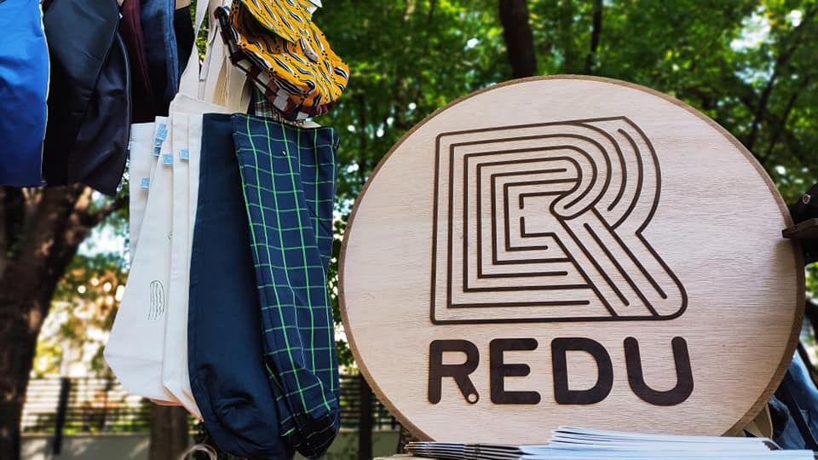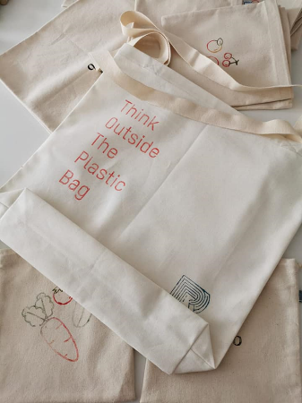
Image credit: Elvys Sandu Image credit: Gabriela Stoica

We design and produce two types of bags, described for short below.

ONENINA Tote bag

Because we had been storing around 30 crocheted doilies made by a friend's grandmother in our workshop for several years, we have constantly kept trying to find a use for them and implicitly to extend their life. The only time they were brought to light was around 2019, when we used them to decorate the event hall. The rest of the time we kept moving them from one shelf to another in the workshop. Doilies are objects that were present and still can be found in almost every home, the creation of which requires a lot of meticulousness, talent and time; however, in recent years, they have unfortunately ended up being discarded. For this reason, we really want to explore their potential and inspire the community with ideas to extend their life by integrating them in various garments and bags.

For the ONENINA bags we used
- For the white ones, some cotton fabric purchased 5 years ago from a local manufacturer, Iasitex
- For the black ones, we used some organic cotton fabric left as surplus from a backpack order made for Social Fabric, Switzerland.
- For the red ones, some cotton fabric for upholstery purchased from an industrial textile waste dump in Iasi.
- Cotton rep-weave tape produced locally by TEXTOR, Vaslui.
- Crochet doilies manufactured by ONENINA.
- For the lining, we used cotton samples printed with various patterns, purchased from a second-hand store.

The process of making the ONENINA bags:
After cutting the bags to fit a size of 41 cm/96 cm, we ironed the 41 cm edges at a distance of 1 cm and then 2.5 cm (inwards) thus creating 2 hems of 2.5 cm in which were inserted the barrettes, i.e. the band cut strip (measuring 3 cm/75 cm).
The ends of the folded band are inserted into the hem created at a distance of 9 cm from the edge, sewn together with a seam along the entire hem and fixed in an X or Z shape over the barrettes.
After we join the straps (rep-weave strips), we attach the doily with fabric pins and sew it over the entire surface, following its pattern (string). For the coloured bags, we used white sewing thread for the needle and thread similar in colour with the bag for the spool.
After fixing the doily, fold the material in the middle so that the straps are aligned; sew the edges on the inside then overcast them. The last operation is to sew the corners (the bottom of the bag), by overlapping the middle of the bag with the sides and sewing diagonally at a distance of 4 cm from the top.
For bags made of natural cotton, we opted for dyeing with acrylic paints to better highlight the pattern of the doily - the colour of the bag being very similar to that of the doily.

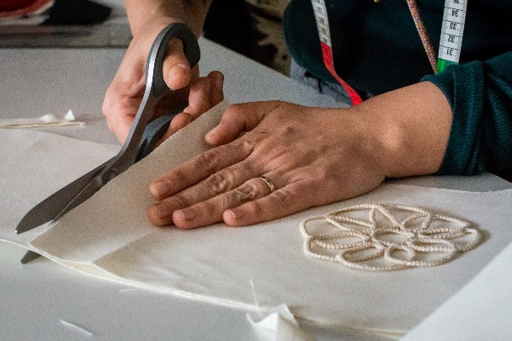 | CC-BY-SA-NC-ND Andreea Sofronea & Elvys Sandu  Photo credit: Stefan Prepelita
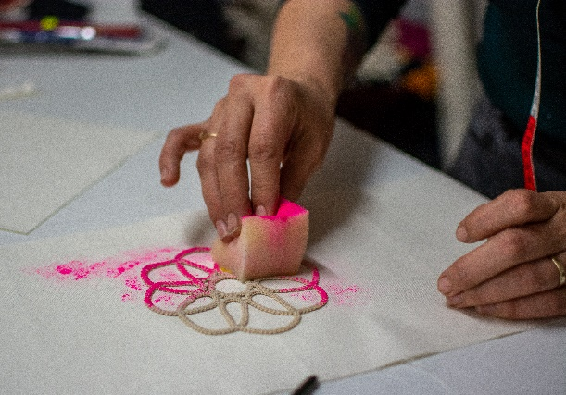 | CC-BY-SA-NC-ND Andreea Sofronea & Elvys Sandu  Photo credit: Stefan Prepelita
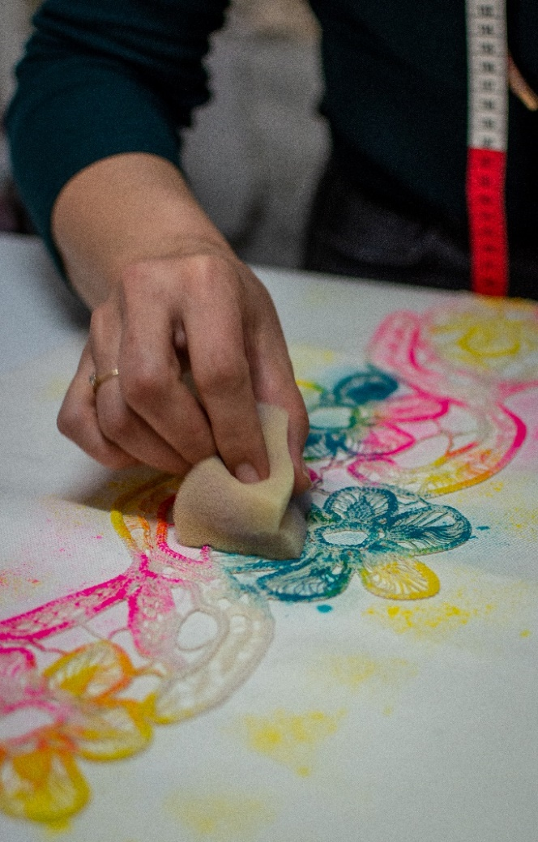 | CC-BY-SA-NC-ND Andreea Sofronea & Elvys Sandu  Photo credit: Stefan Prepelita
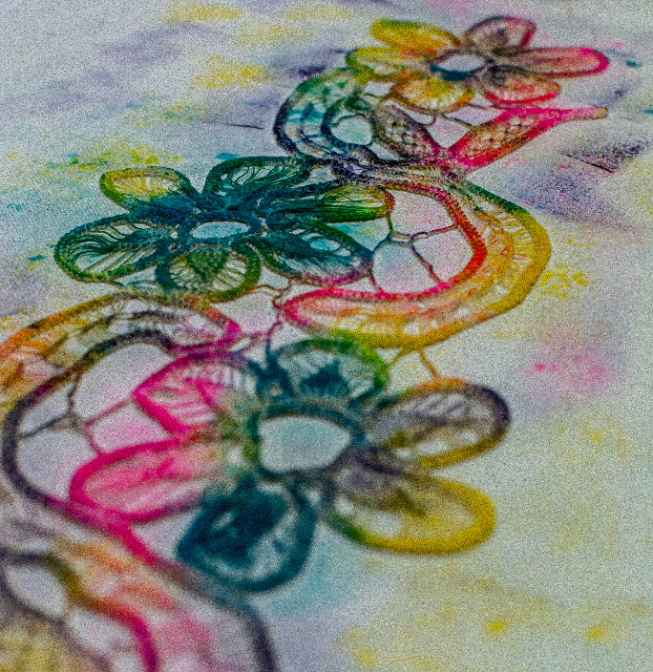 | CC-BY-SA-NC-ND Andreea Sofronea & Elvys Sandu  Photo credit: Stefan Prepelita
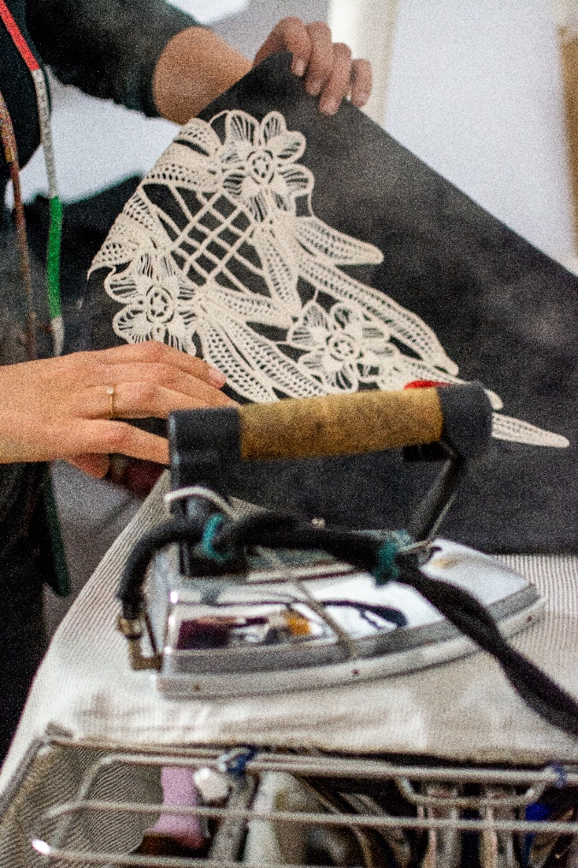 | CC-BY-SA-NC-ND Andreea Sofronea & Elvys Sandu  Photo credit: Stefan Prepelita
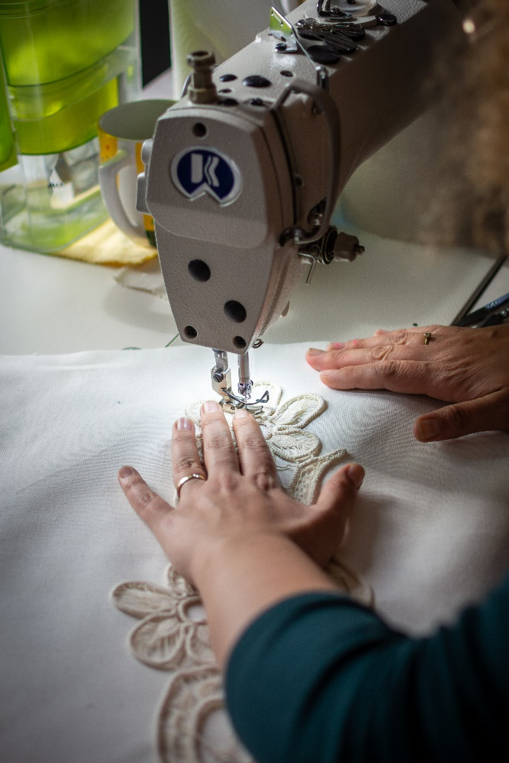 | CC-BY-SA-NC-ND Andreea Sofronea & Elvys Sandu  Photo credit: Stefan Prepelita
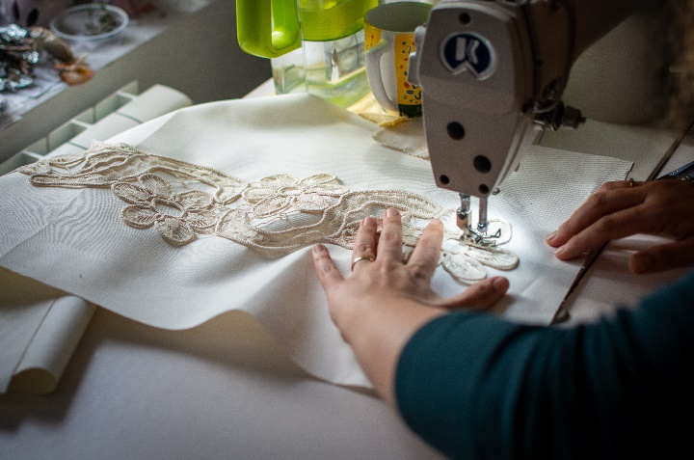 | CC-BY-SA-NC-ND Andreea Sofronea & Elvys Sandu  Photo credit: Stefan Prepelita
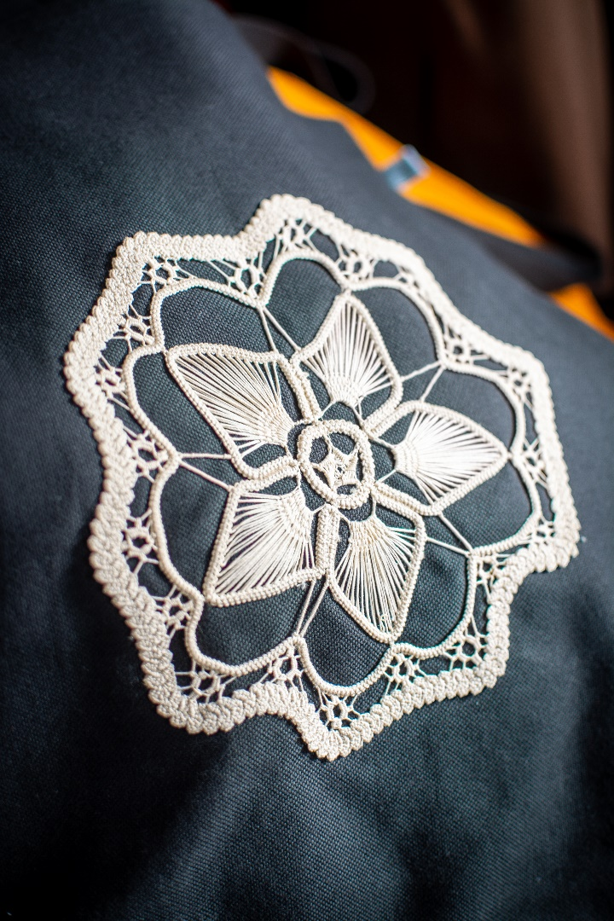 | CC-BY-SA-NC-ND Andreea Sofronea & Elvys Sandu  Photo credit: Stefan Prepelita
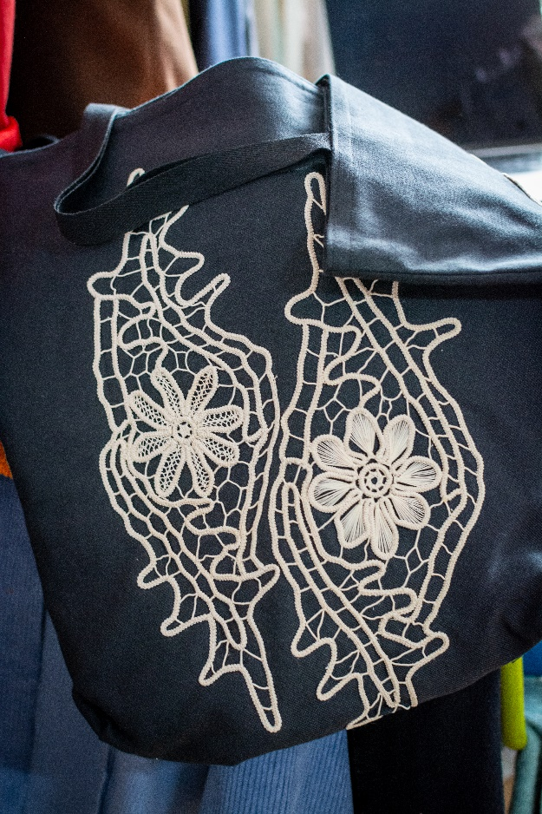 | CC-BY-SA-NC-ND Andreea Sofronea & Elvys Sandu  Photo credit: Stefan Prepelita
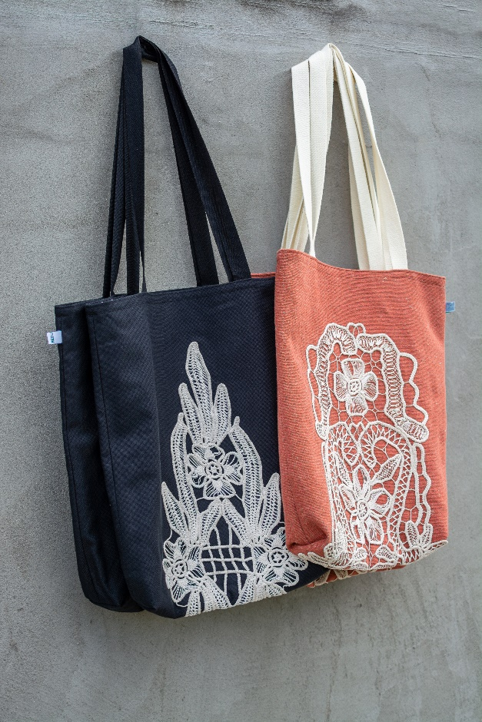 | CC-BY-SA-NC-ND Andreea Sofronea & Elvys Sandu  Photo credit: Stefan Prepelita
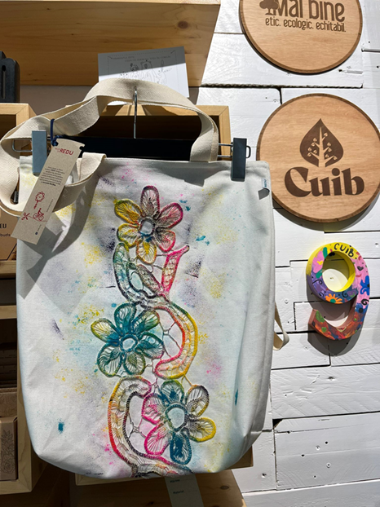 | CC-BY-SA-NC-ND Andreea Sofronea & Elvys Sandu  Photo credit: Andreea Sofronea
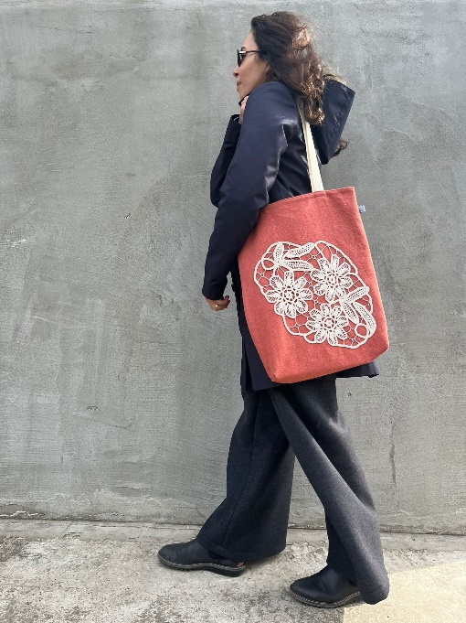 | CC-BY-SA-NC-ND Andreea Sofronea & Elvys Sandu  Photo credit: Andreea Sofronea
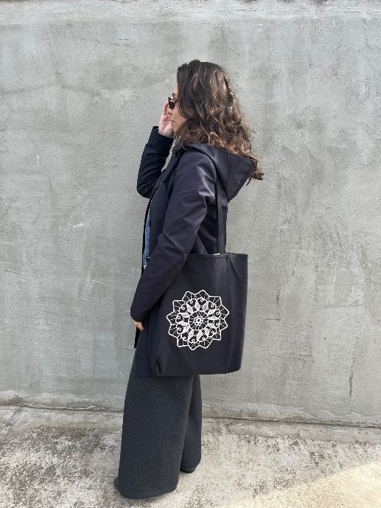 | CC-BY-SA-NC-ND Andreea Sofronea & Elvys Sandu  Photo credit: Andreea Sofronea
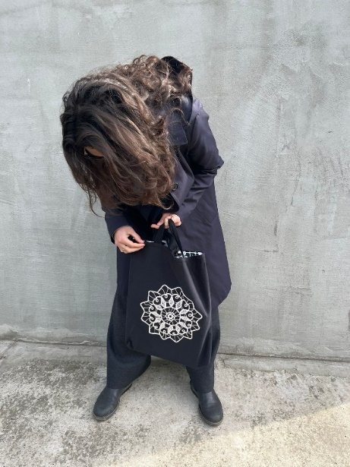 | CC-BY-SA-NC-ND Andreea Sofronea & Elvys Sandu  Photo credit: Andreea Sofronea
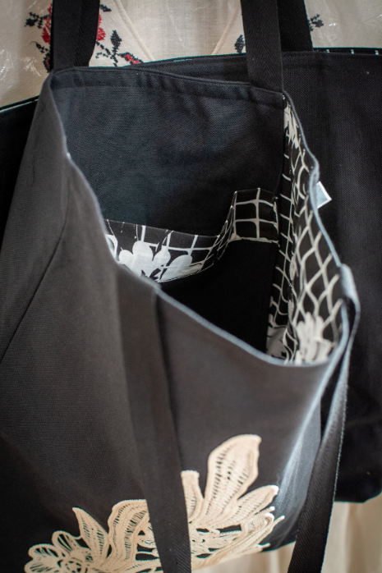 | CC-BY-SA-NC-ND Andreea Sofronea & Elvys Sandu  Photo credit: Stefan Prepelita
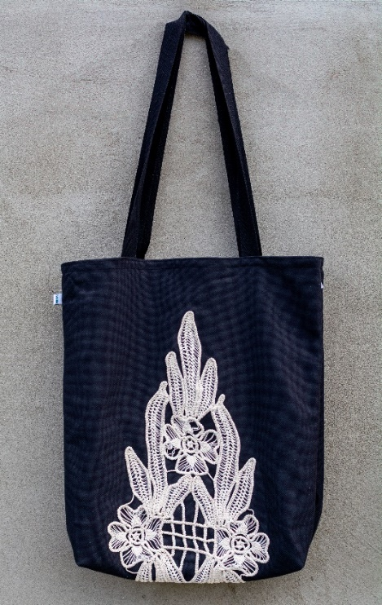 | CC-BY-SA-NC-ND Andreea Sofronea & Elvys Sandu  Photo credit: Gabriela Stoica

The REDU bags

About our work: https://www.youtube.com/watch?v=qXor_Vw_KCQ

The classic REDU bag follows the same manufacturing steps, except for the insertion/sewing of the doily. We accessorize it with a print made using the Blockprinting technique and we apply acrylic paints for textiles. The blockprinting technique actually represents the use of wooden or rubber stamps of different shapes and sizes made with a laser cutter.

The bag made from shirts:
During the first 3 years of activity REDU had been collecting used clothes from the local community. Throughout the sorting process we noticed that the most often donated clothing item was the men's shirt, therefore we looked for solutions to turn this waste into a resource. We did some research on Pinterest and this is how the REDU bag made from shirts became reality. Our classic satchel pattern fits perfectly most sizes, but we've taken it upon ourselves to vary/adapt a satchel's dimensions based on that of the shirt. Currently, REDU only collects men's shirts from the community.

How to make REDU bags:
From the moment they arrive in the workshop, the shirts are sorted and washed.
The bags thus obtained have a lining that can be made from any fabric or from another shirt - most of the time we use this method of work: we create the outer part of the bag by using coloured shirts or shirts with a more special print and the inner part (lining) from plain or dull-coloured shirts.
From the long sleeves of the shirts, we make the straps - their dimensions being 6cm/65cm-75 cm, and when we need more fabric (for various reasons such as: stains, long sleeves, flaws or simply for adding some colour) we use pieces of short sleeves from other shirts.
The bag is sewn on the edge and we repeat the process for the lining
The straps are fixed on the outer part of the bag 9 cm from the edges and we insert the bag into the lining turned inside out. We sew all around leaving the last 10 cm (on the side) unsewn. Through this 10 cm space, we will turn the bag again with its outer side showing, after which we will make another seam 0.5 cm from the edge to close and attach the straps better.

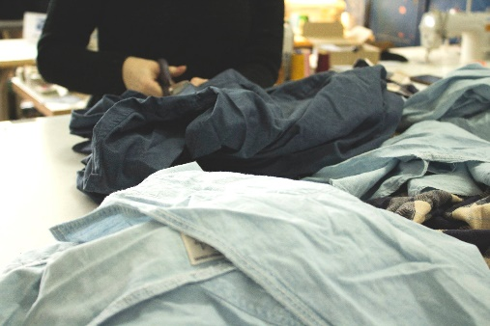 | CC-BY-SA-NC-ND Andreea Sofronea & Elvys Sandu  Photo credit: Gabriela Stoica
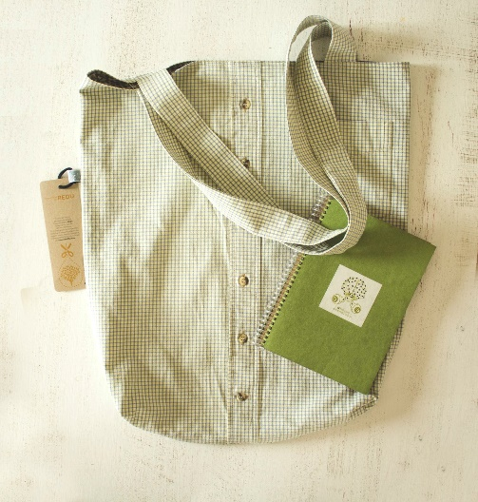 | CC-BY-SA-NC-ND Andreea Sofronea & Elvys Sandu  Photo credit: Gabriela Stoica
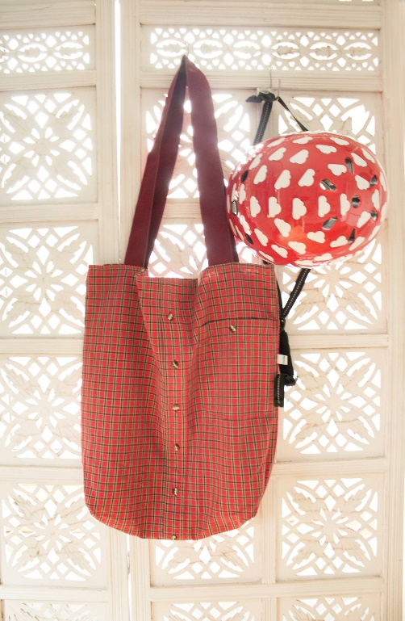 | CC-BY-SA-NC-ND Andreea Sofronea & Elvys Sandu  Photo credit: Gabriela Stoica
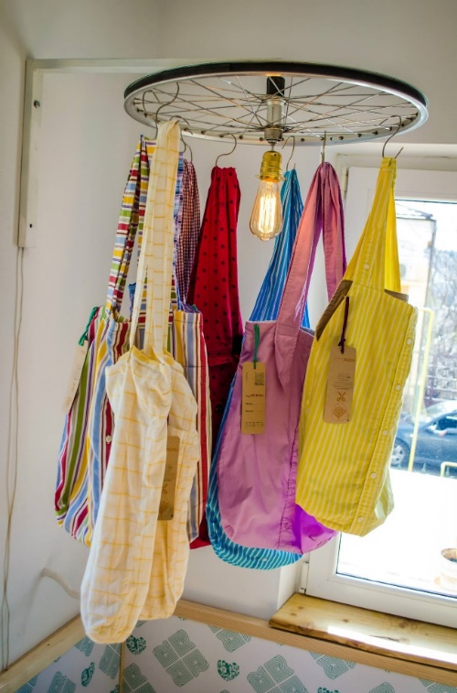 | CC-BY-SA-NC-ND Andreea Sofronea & Elvys Sandu  Photo credit: Gabriela Stoica
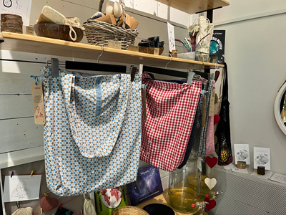 | CC-BY-SA-NC-ND Andreea Sofronea & Elvys Sandu  Photo credit: Andreea Sofronea
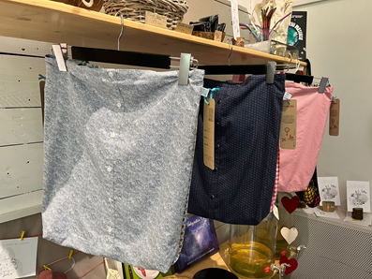 | CC-BY-SA-NC-ND Andreea Sofronea & Elvys Sandu  Photo credit: Andreea Sofronea
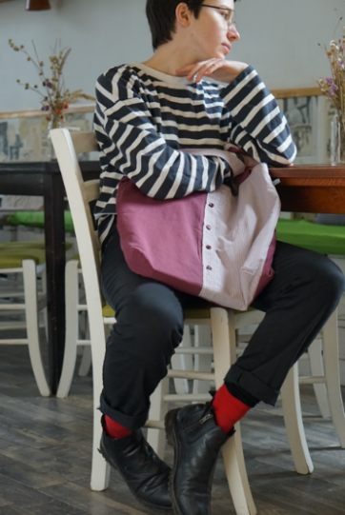 | CC-BY-SA-NC-ND Andreea Sofronea & Elvys Sandu  Photo credit: Caterina Pruteanu
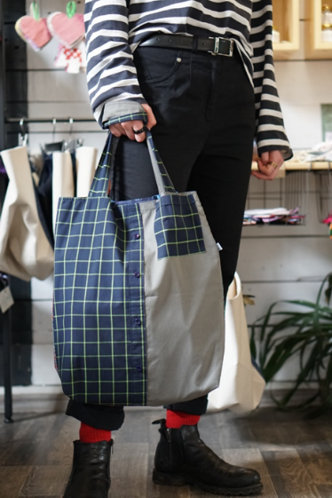 | CC-BY-SA-NC-ND Andreea Sofronea & Elvys Sandu  Photo credit: Caterina Pruteanu

Task 5: Try to put in practice an approach of designing upcycled garments or other textile products.

