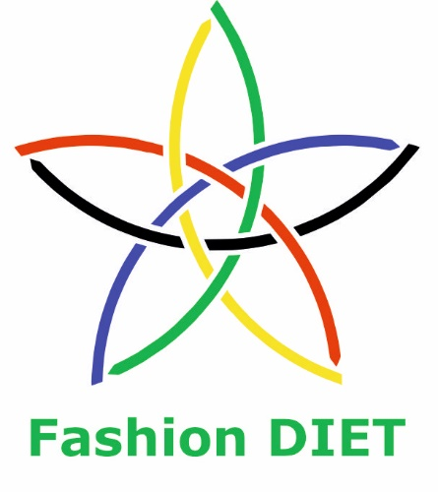

Sustainable Fashion Curriculum at Textile Universities in Europe
–
Development, Implementation and Evaluation of a Teaching Module for Educators

Project: 2020-1-DE01-KA203-005657

Title of the Lesson: Designing for a circular fashion system – How can design influence our development towards more sustainability regarding circular fashion?

Authors: Maleika Schmidbleicher (Stud. päd.)
Prof. Dr. Anne-Marie Grundmeier
Contact Data: University of Education Freiburg
Institute of Everyday Culture, Sports and Health
E-mail: grundmeier@ph-freiburg.de


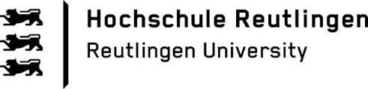

Short Description of the Context:

At the beginning of this unit, the pupils learn the difference between a linear and a circular fashion system. Therefore, half of the class get a worksheet that explains the linear fashion system (No. 1) while the other half receive a worksheet that explains the circular fashion system (No. 3). They also get a worksheet with a diagram that either shows the linear (No. 2) or the circular (No. 4) fashion system and some cut out symbols as well as terms.

The pupils are asked to read the text in the speech bubbles and to fill out the diagram individually. As some might need more micro-scaffolding than others the diagram can be adjusted to the learners’ individual needs by adding or removing symbols and terms in the worksheets (No. 2 and No. 4). Then the pupils should form groups of three with other pupils who all had the same fashion system, discuss their findings in the group and define the term linear/circular fashion system.
The worksheets (No. 1 and No. 3) ask the pupils to go back to their neighbours, explain their fashion system to one another and compare both systems.

In the next step the pupils learn more about the different sustainable design strategies. Therefore, the class needs to be divided into four groups. Each group gets a worksheet about a sustainable design strategy (No. 5, 6, 7 and 8). The pupils should read the text individually, take notes and compare them to their group members’ notes. The groups create a glossary for their classmates with all the important words from the text. Afterwards, the groups create a poster and prepare a short presentation in which they focus on the challenges and aims of their design strategies. For support teachers can hand out tip cards (No. 9) to their pupils. These tip cards can be adjusted to the learners’ individual needs by removing or adding sentences.

In the unit’s last sequence, the pupils create pieces out of old garments they no longer wear. To enable the pupils to work creatively with textiles the teacher needs to provide some virgin materials and sewing instructions. After creating their own pieces, the learners present their garments and justify their design decisions in front of the class. In these presentations the pupils should say which sustainable design strategies they have implemented.
Competences and Learning Objectives:

After this unit the students should be able to …

- understand the difference between a linear and a circular fashion system.
- compare the linear and the circular fashion system.
- describe different sustainable design strategies.
- create and present a poster about sustainable design strategies.
- design and justify a self-made garment based on sustainable design strategies.
- reflect sustainable design strategies on a theoretical and practical basis.

Overview of Working Materials

Lesson module 1:
Topic: Linear fashion system
Worksheet 1: Linear fashion system
Worksheet 2: Linear fashion system (diagram)

Lesson module 2:
Topic: Circular fashion system
Worksheet 3: Circular fashion system
Worksheet 4: Circular fashion system (diagram)

Lesson module 3:
Topic: Design strategies for low waste
Worksheet 5: Design strategies for low waste

Lesson module 4:
Topic: Design strategies for low-impact materials and processes
Worksheet 6: Design strategies for low-impact materials and processes

Lesson module 5:
Topic: Design strategies for recyclability and disassembly
Worksheet 7: Design strategies for recyclability and disassembly

Lesson module 6:
Topic: Design strategies for longevity and durability
Worksheet 8: Design strategies for longevity and durability,

Lesson module 7:
Topic: Presenting and justifying own design decisions
Worksheet 9: Tip cards for the presentation

Sources

Circular.fashion (n.d.). Let’s Enable the Products of Today to Become the Resources of Tomorrow. https://circular.fashion/tools/

Cooper, T., Hill, H., Kininmonth, J., Townsend, K., & Hughes, M. (2013). Design for Longevity: Guidance on increasing the active life of clothing. Final Report. Nottingham Trent University.

Ellen MacArthur Foundation (2017). A new textiles economy: Redesigning fashion’s future. https://ellenmacarthurfoundation.org/a-new-textiles-economy

Ellen MacArthur Foundation (n.d.). Redesigning the future of fashion. https://ellenmacarthurfoundation.org/topics/fashion/overview

Fletcher, K. (2014). Sustainable Fashion and Textiles: Design Journeys (2nd ed.) Earthscan.

Fontell, P., & Heikkilä, P. (2017). Model of circular business ecosystem for textiles. Juvenes Print. https://publications.vtt.fi/pdf/technology/2017/T313.pdf

Goldsworthy, K. (2017). The Speedcycle: a design-led framework for fast and slow circular fashion lifecycles. The Design Journal, 20(1), 1960-1970. https://doi.org/10.1080/14606925.2017.1352714

Hemkhaus, M., Hannak, J., Malodobry, P., Janßen, T., Griefahn, N., & Linke, C. (2019). Circular Economy in the Textile Sector. Study for the German Federal Ministry for Economic Cooperation and Development (BMZ) Deutsche Gesellschaft für Internationale Zusammenarbeit GmbH. https://circulareconomy.europa.eu/platform/sites/default/files/giz_report_circular_economy_textile_sector_2019_final.pdf

Khanna, P., Kanayala, J., Parker, G., Borst, C., Van den Bergen, J., & Lönnqvist, J. (2020). The State of Circular Innovations in the Indian Fashion and Textile Industries. https://reports.fashionforgood.com/report/state-of-the-circular-innovations-in-the-indian-fashion-and-textile-industry/

Niinimäki, K. (Ed.) (2013). Sustainable fashion: New approaches. Aalto University.

Niinimäki, K. (Ed.). (2019). Sustainable Fashion in a Circular Economy. Aalto University.

Pervez, W. (2017). Design for Disassembly - A Circular Approach. Doctoral dissertation, Virginia Commonwealth University, Richmond.

Rissanen, T. (2013). Zero-waste fashion design: A study at the intersection of cloth, fashion design and pattern cutting. Doctoral dissertation, University of Technology, Sydney.

Waste & Resources Action Programme (WRAP) (2017). Sustainable clothing guide. https://wrap.org.uk/resources/guide/sustainable-clothing-guide
Tutorials

Waste & Resources Action Programme (WRAP) (2017). Introducing durability. https://youtu.be/G879BnWGOUY

Image Sources

Worksheet No. 2, No. 4. and No. 6:

Cotton, surang, CC0, https://www.flaticon.com/free-icon/cotton_5742001
Disposal, Flipper, CC0, https://www.flaticon.com/free-icon/garbage-bin_5681314?term=disposal&page=1&position=29&origin=search
Fashion shop, Prettycons, CC0, https://www.flaticon.com/free-icon/shop_1563400?term=fashion+shop&page=1&position=6&origin=search&related_id=1563400
Spinning Wheel Spinning Yarn, OpenClipart-Vectors, https://pixabay.com/service/license, https://pixabay.com/vectors/spinning-wheel-spinning-yarn-154120/

Worksheet No. 5:

Male Character - Clothes and Hair, sapenton8821, Creative Commons, CC BY 4.0, https://search.openverse.engineering/image/62f41901-ccdf-444d-9267-bd1d3c1d04c2

Worksheet No. 15:

Circular Economy CC BY-SA-ND Grundmeier

Worksheet No. 9:

Notizen, TBIT, https://pixabay.com/de/service/terms/, https://pixabay.com/de/vectors/notizen-klebenotiz-erinnerung-memo-1014547/

Worksheet 1: Linear fashion system

Read the text in the speech bubbles to learn more about the linear fashion system.

We were created in a linear fashion system. Do you know how it works? Let us explain it to you.
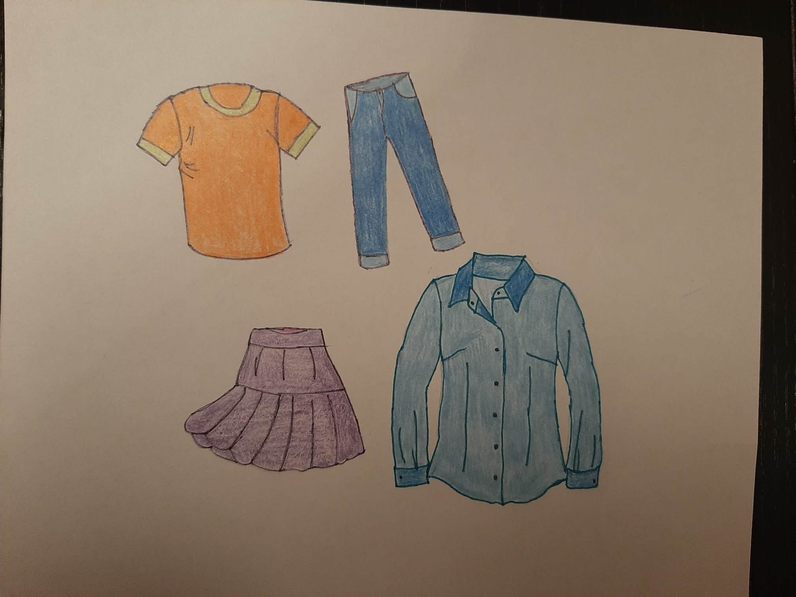

First, raw materials were produced and extracted because they are needed to create textiles like fabrics and yarns – they did not look much like we do.

In the third step we were designed. In this very important step, designers decided how we should look, what we should be able to do, and which materials should be used to create us.

Then we got produced in a factory according to the designers’ ideas.

After we looked as fashionable as we do now, we travelled a very long way to finally arrive in this shop. Here we are waiting for you to buy us.

When you bought us, you will use us, and we hope that you will like us and take good care of us.

But what happens to us after we are worn out? What happens when you don’t want to wear us any more because we are out of fashion or damaged?

In a linear fashion system, you will then dispose us. Most likely, we will end in a landfill.

Illustrations: CC BY-SA-ND Schmidbleicher

Discuss the following questions in the plenary:

- What are the different steps of the linear fashion system?
- What happens after the use phase?
- Which alternatives do you see for the jeans and the T-shirt after they are worn out?
Worksheet 2: Linear fashion system (diagram)
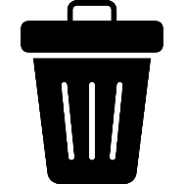
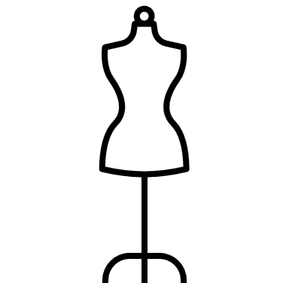

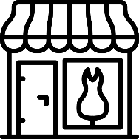
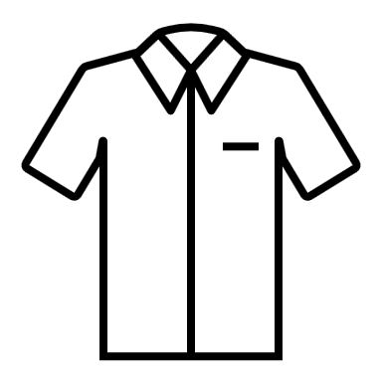
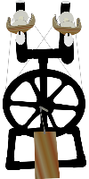
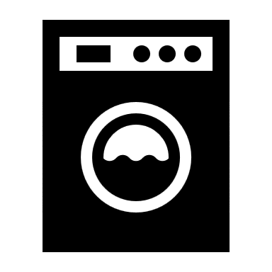
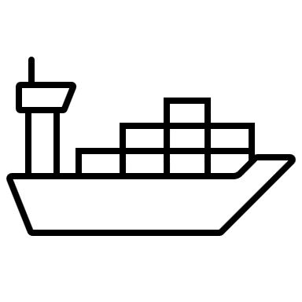

Tasks:
- Bring the words into the right order and write them into the diagram: Consumer use, Disposal, Shop, Garment production, Fashion design, Transportation, Textile production
- Draw a line between the suitable symbols and words in the diagram. Use a pencil so that you can correct them.

Worksheet 3: Circular fashion system
Read the text in the speech bubbles to learn more about the circular fashion system.

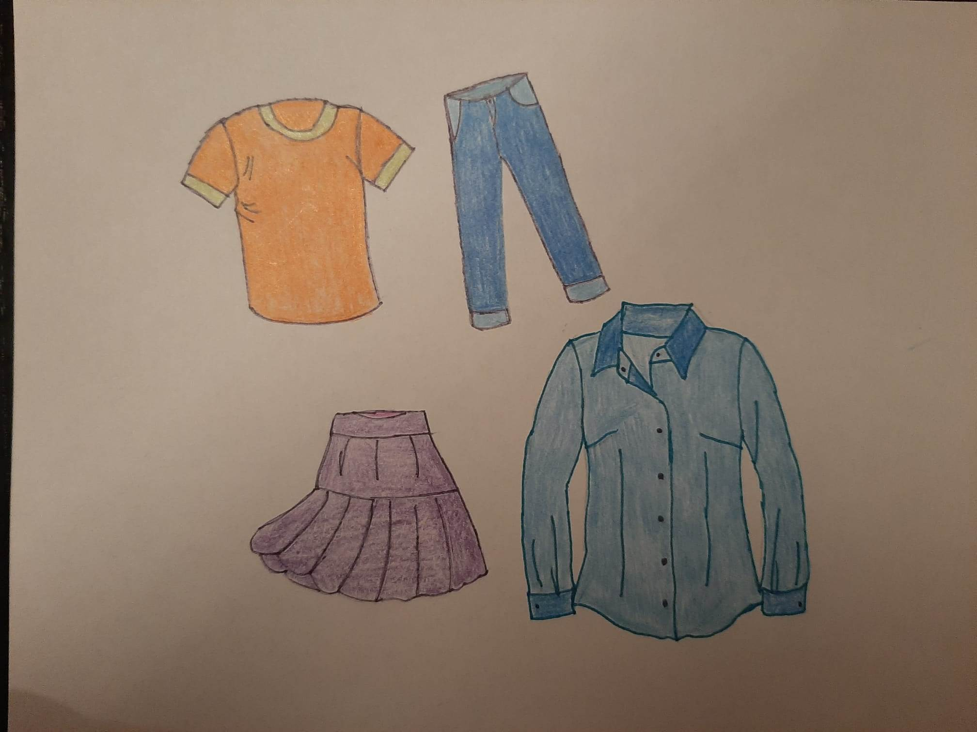
We are created for a circular fashion system. Do you know how it works? Let us explain it to you.

First, materials were recycled, and raw materials were produced and extracted because they are needed to create textiles like fabrics and yarns – they did not look much like we do.

In the third step we were designed. Designers decided how we should look, what we should be able to do, and which materials should be used to create us.

Then we got produced in a factory according to the designers’ ideas.

After we looked as fashionable as we do now, we travelled a very long way to finally arrive in this shop. Here we wait for you to buy us.

When you bought us, you will use us, and we hope that you will like us and take good care of us.

But what happens to us after we are worn out? What happens when you don’t want to wear us anymore because we are out of fashion or damaged?

In a circular fashion system, the goal is to extract the maximum value from us. When we are no longer needed, the aim is to recover and regenerate the used materials into something else that is useful. So, we are not being wasted.

Illustrations: CC BY-SA-ND Schmidbleicher

Discuss the following questions in the plenary:

- What are the different steps of the circular fashion system?
- What happens after the use phase?
- Which alternatives do you see for the skirt and the shirt after they are worn out?
- Form a group with classmates that had the linear fashion system. Explain the fashion systems to each other and compare both systems. How do they differ?

Worksheet 4: Circular fashion system (diagram)

Tasks:
- Bring the words into the right order and write them into the diagram: Consumer use, Disposal, Shop, Garment production, Fashion design, Transportation, Textile production.
- Draw a line between the suitable symbols and words in the diagram. Use a pencil so that you can correct them.
- Explain a circular fashion system in your own words and write it down:

A circular fashion system is …

Worksheet 5: Design strategies for low waste
Read the text and take notes.

The most common method of making clothes involves cutting fabrics and assembling the pieces into clothes. During this process up to 15% of the fabric is being wasted.

This waste can be reduced through the zero-waste pattern design approach. The approach aims to create clothes without generating fabric waste. To achieve this aim, the length of the fabric must be calculated. Then all cutting pieces are placed next to each other like a puzzle. To use all the fabric, they need to interlock perfectly.

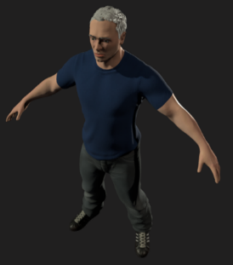
A second approach to reduce pre-consumer waste is 3D design. Due to 3D design, physical prototypes and samples are unnecessary since designers can see garments instantly. This reduces pre-consumer waste and makes communication between designers, brands and manufacturers easier.

Another solution to reduce waste within a circular fashion system is the mass customisation. It enables personalised, tailored and made-to-measure services for mass production. Data about consumer preferences, behaviour and demand is being collected. Then the products can be adjusted to better fit the consumer tastes and wants. This strategy leads to less unsold clothes.

Tasks:
- Form a group with your classmates that also had “design strategies for low waste”. Talk about your notes with your group members.
- Create a glossary for your classmates with words from the text. Your glossary should include the term and a description of the word.
- Create a poster about the design strategies for low waste.
Do not write whole sentences on posters.
- Prepare a short presentation in which you present and explain these design strategies to the class. For support, you can have a look at the tip cards on the table.
Worksheet 6: Design strategies for low-impact materials and processes
Read the text and take notes.

It is estimated that more than half of the environmental footprint of the textile industry is created in the state in which fabric, yarns and fibres are produced. Therefore, there is the need for alternative, lower impact materials and improved manufacturing processes.
When a designer chooses the materials for garments, the materials’ attributes and how they suit the wearing practices must be considered carefully. Thereby it is also important to evaluate the materials’ aging processes so that the materials do not look old too fast.
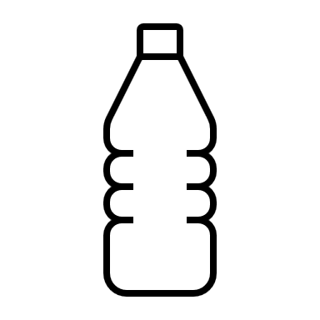

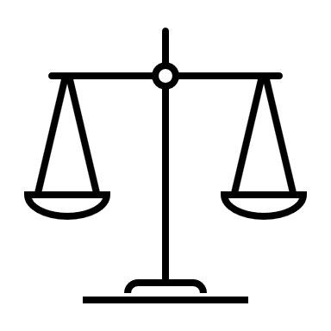
Recycled materials such as PET from bottles are available for textile production. But even with an increased use of recycled materials, some virgin material input will likely always be required.
Choosing materials for garments is considered one of the most problematic phases in the sustainable fashion design process because each fibre has its own environmental burden. It is impossible to decide whether natural fibres or manufactured fibres are environmentally friendly.
During the processing stage, the yarns, fibres and fabrics or garments must go through multiple steps to achieve the desired performance and aesthetics. These steps can broadly be categorised into pre-treatment, dyeing, printing and finishing treatments. All of them have much potential to have a negative health and environmental impact. To combat these impacts, a growing number of innovative environmentally friendly technologies are emerging in the market. These innovations can have a significant impact in reducing water, dyes, chemical consumption and energy requirements.

Tasks:
- Form a group with your classmates that also had “design strategies for low-impact material and processes”. Talk about your notes with your group members.
- Create a glossary for your classmates with words from the text. Your glossary should include the term and a description of the word.
- Create a poster about the design strategies for low-impact materials and processes. Do not write whole sentences on posters.
- Prepare a short presentation in which you present and explain these design strategies to the class. For support, you can have a look at the tip cards on the table.
Worksheet 7: Design strategies for recyclability and disassembly
Read the text and take notes.

All clothes should first be cycled through the technical loop of reusing, repairing and remaking. Recycling is the last option in a circular economy since the materials are recovered but their product functionality is lost. Nevertheless, the recyclability is also a prerequisite for products when the extension of their usefulness is no longer possible. A major concern for chemical and mechanical recycling methods is the complexity of textile products, due to the use of material blends, the layering of different materials, the presence of prints, elastane and trims which include chemicals, colours and dyes as well as other harmful substances.
The circularity of materials is enabled by keeping different technical materials separate or easily separable since not doing so can hinder recycling. This is described by the term design for disassembly, which is a design strategy that enables the product to be taken apart in a way that allows to reuse, remake, or recycle the materials and components. This includes the use of fewer parts and fasteners, as well as the avoidance of glues. Using recycled materials rather than virgin ones offers an opportunity to drastically reduce non-renewable resource inputs and the negative impacts of the industry.

Tasks:
- Form a group with your classmates that also had “design strategies for recyclability and disassembly”. Talk about your notes with your group members.
- Create a glossary for your classmates with words from the text. Your glossary should include the term and a description of the word.
- Create a poster about the design strategies for recyclability and disassembly. Do not write whole sentences on posters.
- Prepare a short presentation in which you present and explain these design strategies to the class. For support, you can have a look at the tip cards on the table.
Worksheet 8: Design strategies for longevity and durability
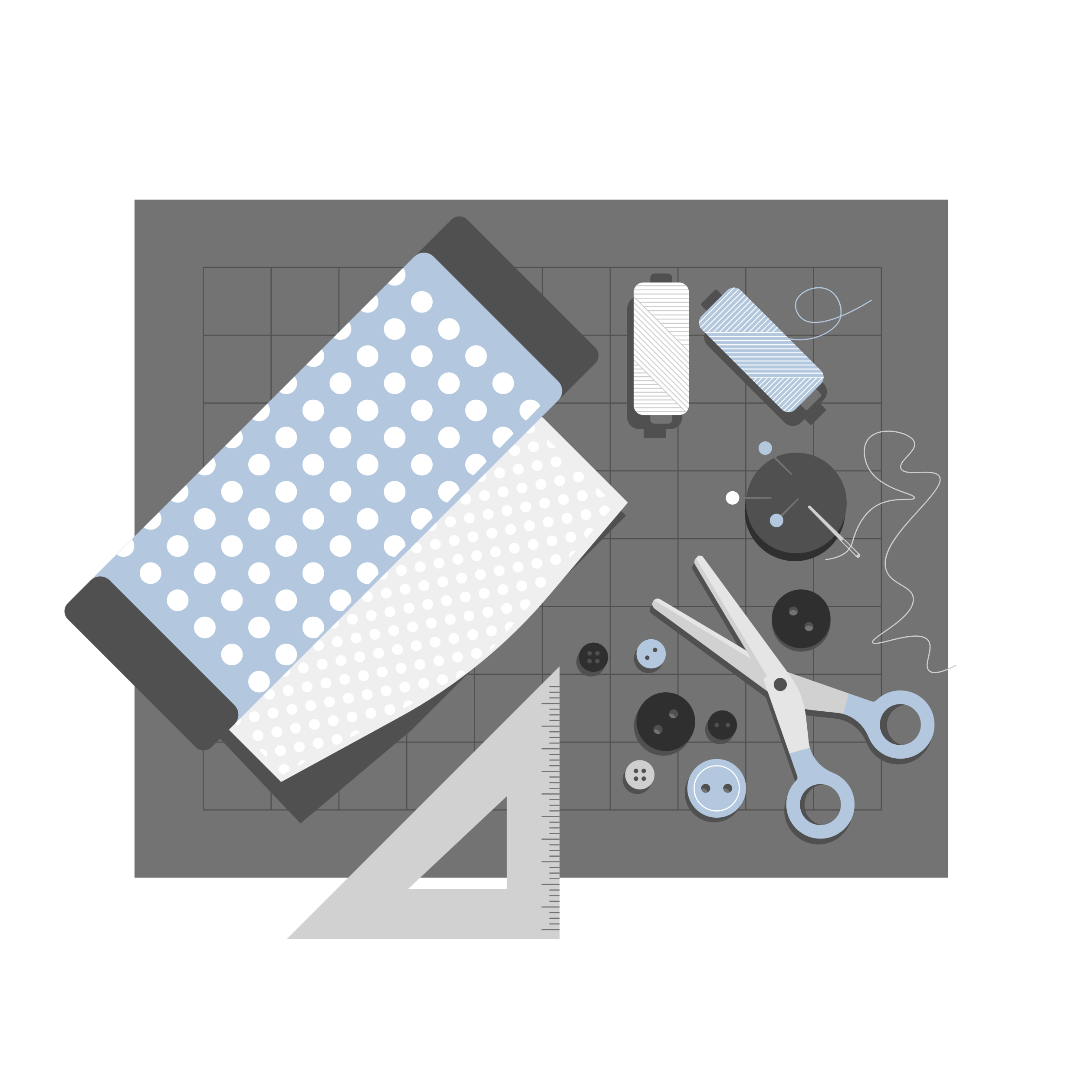
Read the text and take notes.

Good quality and durability of fabrics and fibres means that they can be used over a longer period of time. Longevity can be considered from either the product or the material perspective. The material longevity focuses on enabling the repeated use of material resources through efficient recycling. The product longevity, on the other hand, focuses on extending the useful lifetime of products through physical and emotional durability.
The physical durability considers the garment’s design and construction. It might be enhanced by blending different fibres, which improves the durability of the fabrics and the comfort of the final product. A high yarn twist generally improves the strength of the fabric and reduces the pilling.
Finishing processes improve the look, performance and feeling of clothing. They therefore affect the performance and durability or help extend the active use of a garment. Dyes, prints, as well as the selection of dyeing methods, have a huge impact on the colour fastness, colour fading and consequently on the durability of a garment. Each manufacturing technique is best suited to a particular fabric or garment type and can help to achieve greater durability.
A very important design factor in extending a garment’s life expectancy is its cut. An option to maximise the longevity of garments is designing garments that can be adapted over time such as adjusting the size to an individual’s various shapes. Oversized shapes that can be worn with a belt could potentially be worn for a longer period of time. Garments that are adaptable and upgradeable allow one piece to match several outfits.

Tasks:
- Form a group with your classmates that also had “design strategies for longevity and durability”. Talk about your notes with your group members.
- Create a glossary for your classmates with words from the text. Your glossary should include the term and a description of the word.
- Create a poster about the design strategies for longevity and durability.
Do not write whole sentences on posters.
- Prepare a short presentation in which you present and explain these design strategies to the class. For support, you can have a look at the tip cards on the table.
Worksheet 9: Tip cards for the presentation


Structure:

Our presentation is divided into … parts.
In our presentation we will focus on …
We will start with … Then we will
look at …
Summary and conclusion:

I/We would like to conclude by …
That brings us to the end of our presentation.
Thank you for your
attention/listening.

Graphs and images:

Let me use a graphic to explain this …
The graph/picture shows how/that…
If you look at this chart/picture, you can see that …
Transition:

I would now like to give the word to …
Now I will pass you over to …
This leads me over to …
rpose of this presentation is …
The goal of this presentation is …
Introduction and
goals:
Today we are going to talk about …
I/we want to give a presentation about …
The purpose/goal of this presentation is …
Starting point:

Let’s start with …
Let’s start by explaining why/how …
I/we would like to give you some background information about …

