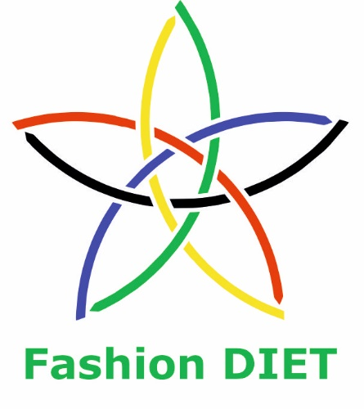

Sustainable Fashion Curriculum at Textile Universities in Europe
–
Development, Implementation and Evaluation of a Teaching Module for Educators

Project: 2020-1-DE01-KA203-005657

Title of the Lesson: How is the microplastic in the environment connected to my clothing? Microplastics through textiles – Independent investigation of the entry pathways of microplastics from textiles and avoidance strategies.

Authors: Maleika Schmidbleicher (Stud. päd.)
Prof. Dr. Anne-Marie Grundmeier
Contact Data: University of Education Freiburg
Institute of Everyday Culture, Sports and Health
E-mail: grundmeier@ph-freiburg.de

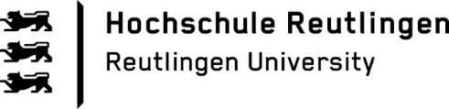

Short Description of the Context:

Before the lesson begins, the teacher prepares the learning environment by setting up the stations and placing a little box, which has sand and textile microplastics in it, on each pupil's seat. It might be helpful to also have a visible stopwatch in the classroom so that the pupils can always check how much time they have left during the group work.
At the beginning of the lesson, the teacher plays an audio file that asks the pupils to touch the content of their boxes. By asking the pupils if they know what microplastic is, the teacher simultaneously asks them about their previous knowledge and thereby activates it. The teacher might add to the descriptions and explains the term textile microplastic. Then, (h)she should explain the lesson’s topic, its schedule and rules as well as the procedure of forming the groups.

After the groups have been formed, the work phase takes place. In this phase the pupils work in their groups on the learning stations one to three and then on the learning station number four. Each station has mandatory tasks and a rewarding additional task, which helps to meet the pupil's different learning levels and builds in a time buffer. By working on the tasks in the booklet, the pupil's newly gained knowledge is already being secured.
In order to recall what they have just learned the teacher asks the pupils to either draw a picture or write a sentence that they consider to be particularly important. After the pupils have written their statement or drawn their picture, a circle of chairs is being formed. The pupils then should present their statement/picture in the plenary and explain why they have chosen it. As this last phase of the lesson takes place in the plenary, the teacher can assess the pupil's understanding/learning process and end the lesson in a concise manner.

Competences and Learning Objectives:

After this unit the pupils should be able to …

- describe the terms microplastic and textile microplastic.
- describe primary and secondary microplastics.
- analyse the connection between synthetic textiles and the occurrence of microplastics in the environment.
- deduce that textiles made from synthetic fibres produce microplastics directly and indirectly.
- know that besides the type of washing machine and its load, the use of fabric softener and detergent determine the number of emitted fibres.
- know that electric laundry dryers lead to the release of microfibres.
- know that online retailing generates more plastic waste than traditional retailing.
- know that there are products that can help to reduce the pollution from textile microplastics and become aware of how to avoid creating an impact-shift.
- know that avoiding consumption can effectively contribute to tackling the problem of microplastics.
- derive selected strategies for the avoidance of synthetic microfibres and evaluate these regarding their feasibility.

Overview of Working Materials

Lesson module 1:
Topic: Introduction to the topic of textile microplastics
Worksheet 1: Introduction to the topic and rules for a successful station work

Lesson module 2:
Topic: Station 1 – Textile production
Worksheet 2: Station 1: Textile production with audio transcript
Worksheet 3: Station 1: Textile production – Solutions

Lesson module 3:
Topic: Station 2 – Textile care
Worksheet 4: Station 2: Textile care
Worksheet 5: Station 2: Textile care – Solutions
Worksheet 6: Station 2: Textile care – Card matching
Worksheet 6: Station 2: Textile care – Card matching – Solutions

Lesson module 4:
Topic: Station 3 – Textile disposal
Worksheet 7: Station 3: Textile disposal

Lesson module 5:
Topic: Station 4 – Avoidance strategies
Worksheet 8: Station 4: Avoidance strategies
Worksheet 9: Station 4: Avoidance strategies – Solutions

Sources

Belzagui, F., & Gutiérrez-Bouzán, C. (2022, May). Review on alternatives for the reduction of textile microfibers emission to water. Journal of Environmental Management, 317, 115347. https://doi.org/10.1016/j.jenvman.2022.115347

Bendt, E., Rabe, M., Klinkhammer, K., Kolbe, S., Ratovo, K., Brandt, S., Obermann, M., Küppers, S., & Berns, M. (2021). Materialentwicklung: Neue Flächenkonstruktionen: Garn- und Maschinenparameter. In Bundesverband der Deutschen Sportartikel-Industrie e. V. (Ed.), Textiles Mikroplastik reduzieren: Erkenntnisse aus einem interdisziplinären Forschungsprojekt (pp. 35–39). https://nachhaltigkeitsbericht.vaude.com/gri-wAssets/pdf/BPC-2020/TEXTIL-1.PDF

Damayanti, D., Wulandari,L. A., Bagaskoro, A., Rianjanu, A., & Wu, H.S. (2021). Possibility Routes for Textile Recycling Technology. Polymers, 13, 3834. https://doi.org/10.3390/polym13213834

De Falco, F., Di Pace, E., Cocca, M., Avella, M. (2019). The contribution of washing processes of synthetic clothes to microplastic pollution. Scientific Reports, 9, 6633. https://doi.org/10.1038/s41598-019-43023-x

Fath, A. (2019). Mikroplastik: Verbreitung, Vermeidung, Verwendung. Springer Spektrum. https://doi.org/10.1007/978-3-662-57852-0

Flanders, DC (n. d.). Close the Loop. A Guide towards a Circular Fashion Industry. https://www.close-the-loop.be/en/phase/3/end-of-life

Henry, B., Laitala, K., & Klepp, I. G. (2018). Microplastic pollution from textiles: A literature review. Project report no 1 – 2018. Consumption Research Norway – SIFO Oslo and Akershus University of Applied Sciences. https://oda.oslomet.no/oda-xmlui/bitstream/handle/20.500.12199/5360/OR1%20-%20Microplastic%20pollution%20from%20textiles%20-%20A%20literature%20review.pdf

Jepsen, D., Zimmermann, T., Spengler, L., Rödig, L., Bliklen, R., Wagner, J., & Struck, K. (2020). Kunststoffe in der Umwelt – Erarbeitung einer Systematik für erste Schätzungen zum Verbleib von Abfällen und anderen Produkten aus Kunststoffen in verschiedenen Umweltmedien (No. 198/2020). Umweltbundesamt. https://www.umweltbundesamt.de/sites/default/files/medien/5750/publikationen/2020_11_24_texte_198_2020_kunststoffe_in_der_umwelt.pdf

Kapp, K. J., & Miller, R. Z. (2020). Electric clothes dryers: An underestimated source of microfiber pollution. PLOS ONE, 15(10). e0239165. https://doi.org/10.1371/journal.pone.0239165

Periyasamy, A. P., & Tehrani-Bagha, A. (2022, May). A review on microplastic emission from textile materials and its reduction techniques. Polymer Degradation and Stability, 199, 109901. https://doi.org/10.1016/j.polymdegradstab.2022.109901
Science Advice for Policy by European Academies (SAPEA) (2019). A Scientific Perspective on Microplastics in Nature and Society. SAPEA. https://doi.org/10.26356/microplastics

Textile Exchange (2022). Preferred Fiber and Materials Market Report. October 2022. https://textileexchange.org/wp-content/uploads/2022/10/Textile-Exchange_PFMR_2022.pdf

Tornow, M., Koch, J., Frommeyer, B., von Gehlen, K., & Schewe, G. (2021). Business Case: Eine betriebswirtschaftliche Analyse des Vermeidungspotentials von Kunststoffverpackungen in der textilen Lieferkette. Forschungsbericht. FATM – Forschungsstelle für Allgemeine und Textile Marktwirtschaft. https://www.fatm.de/sites/fatm/files/downloads/eine_betriebswirtschaftliche_analyse_des_vermeidungspotenzials_von_kunststoffverpackungen_entlang_der_textilen_lieferkette.pdf

Image Sources

Worksheet No. 2 and No. 3:
Preisschild Preis Symbol Etikett Markenzeichen, Memed_Nurrohmad, https://pixabay.com/service/license, https://pixabay.com/de/vectors/preisschild-preis-symbol-etikett-1673586/
Aufhänger Hölzern Braun Kleidung Mantel Holz, Clker-Free-Vector-Images, https://pixabay.com/service/license,
https://pixabay.com/de/vectors/aufh%c3%a4nger-h%c3%b6lzern-brown-kleidung-29414/
Glühbirne Idee Erleuchtung Plan, Conmongt, https://pixabay.com/service/license, https://pixabay.com/de/vectors/gl%c3%bchbirne-idee-erleuchtung-plan-1926533/

Worksheet No. 4:
Kleid Orange Kleidung Frauen Kleiderbügel Ärmellos, Clker-Free-Vector-Images, https://pixabay.com/service/license, https://pixabay.com/de/vectors/kleid-orange-kleidung-frauen-293977/
Waschmaschine Kleidung Wäscherei, SourceAndPixel, https://pixabay.com/service/license, https://pixabay.com/de/vectors/waschmaschine-kleidung-w%c3%a4scherei-1994661/

Worksheet No. 5:
Kleid Orange Kleidung Frauen Kleiderbügel Ärmellos, Clker-Free-Vector-Images, https://pixabay.com/service/license, https://pixabay.com/de/vectors/kleid-orange-kleidung-frauen-293977/

Worksheet No. 6:
Waschmaschine Kleidung Wäscherei, SourceAndPixel, https://pixabay.com/service/license, https://pixabay.com/de/vectors/waschmaschine-kleidung-w%c3%a4scherei-1994661/

Worksheet No. 7:
Müll Deponie Verschmutzung Müllentsorgung, bakhrom_media, https://pixabay.com/service/license, https://pixabay.com/de/photos/m%c3%bcll-deponie-verschmutzung-6967967/
Scarf Polyester Ticket Clothes, MARKY_OREL, https://pixabay.com/service/license, https://pixabay.com/photos/scarf-polyester-ticket-clothes-930185/
Damayanti, D., Wulandari,L. A., Bagaskoro, A., Rianjanu, A., & Wu, H.S. (2021). Possibility Routes for Textile Recycling Technology. Polymers, 13, 3834. https://doi.org/10.3390/polym13213834
The iritical point of CE, CC BY 4.0, https://www.researchgate.net/publication/355982160_Possibility_Routes_for_Textile_Recycling_Technology/figures?lo=1

Worksheet No. 8:
Like Facebook Social Media Icon Thumbs Up Up Pro, raphaelsilva, https://pixabay.com/service/license, https://pixabay.com/vectors/like-facebook-social-media-icon-3000958/

Worksheet No. 9:
Iphone icons, Freepik – Flaticon, </a>, https://www.flaticon.com/free-icons/iphone
Like Facebook Social Media Icon Thumbs Up Up Pro, raphaelsilva, https://pixabay.com/service/license, https://pixabay.com/vectors/like-facebook-social-media-icon-3000958/

Worksheet 1: Introduction to the topic and rules for a successful station work

Audio transcript:

Please open the box on your table. Now close your eyes - we will go on a little journey together.
…
Imagine you are on holiday.
The sun is shining and you are taking a walk on the beach. You hear the waves come and go (play wave sound) and feel more relaxed than you have in a very long time.
You watch the surfers and the small boats on the sea.
While you are walking, you find something on the ground. It must be a shell. It shimmers beautifully in the sunlight, and you decide to pick it up. You want to look at it more closely. So, you bend down.
You now touch the content of your box to lift up the shell. (different pitch)
But in the sand, you feel something completely different....

What's that?

Rules for a successful station work:

 We handle the materials with care. When we leave a station, we put everything back as it was.

We speak as quietly as possible so that we do not disturb our classmates.

If I / we struggle with a task, I / we ask our teacher for help. (S)he is happy to help.

We only leave our station when the time is up and our tasks are accomplished. We do not jump back and forth between stations.

We only check our results when we are done with all tasks at the station. If something is wrong, we correct it on our own. If we have any questions, we can always turn to our teacher.

Worksheet 2: Station 1: Textile production


Station 1: Textile production
Listen to the audio and answer the following questions. If necessary, listen to the audio or parts of it again.
1.) Which problems are addressed in the audio?
___________________________________________________________________________________________________________________________________________________________________________________________________
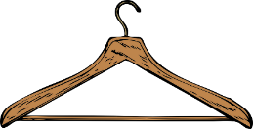
2.) What solutions are mentioned?
___________________________________________________________________________________________________________________________________________________________________________________________________

3.) Can you think of other solutions that have not been mentioned?

___________________________________________________________________________________________________________________________________________________________________________________________________
Additional task for the early finishers:
Have you answered all the questions, checked your results and improved or added to them if necessary? Great! Now do the crossword on the next page.

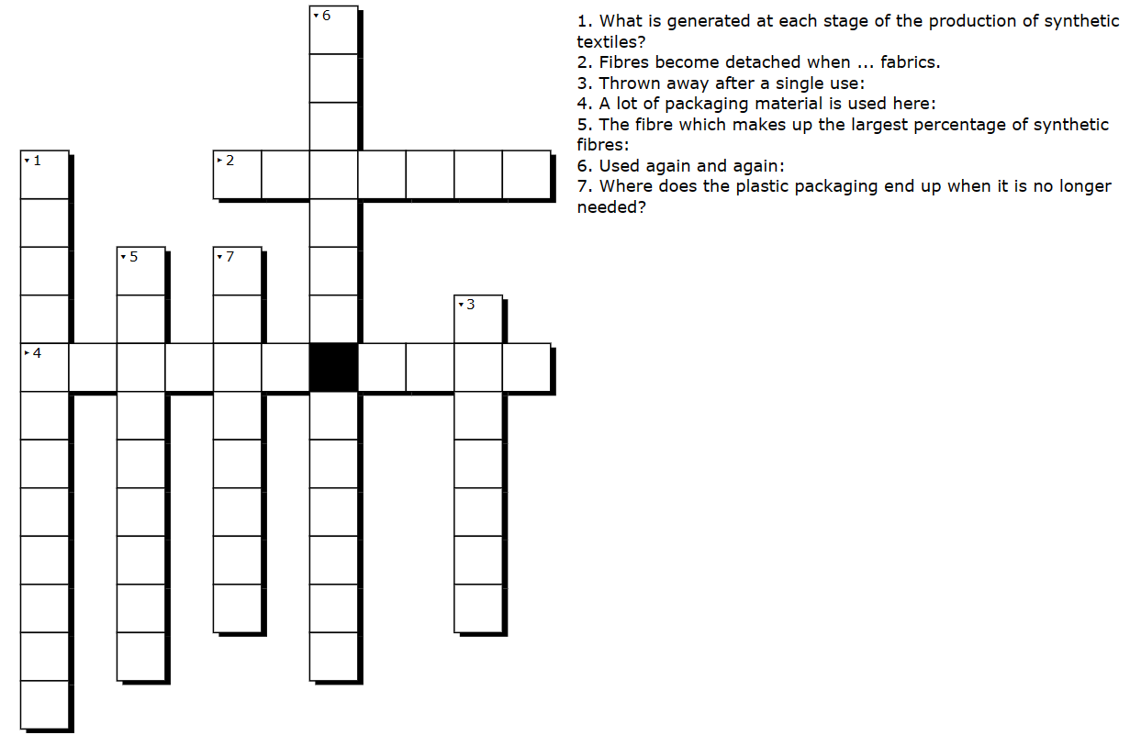
Worksheet 3: Station 1: Textile production – Solutions

Station 1: Textile production - Solutions
Listen to the audio and answer the following questions. If necessary, listen to the audio or parts of it again.
1.) Which problems are addressed in the audio?
Textile microplastics are generated in every production stage of a textile made from synthetic fibres.
Packaging waste is generated throughout the supply chain of a textile.

2.) What solutions are mentioned?
Natural fibres do not produce microplastics.
Along the textile supply chain, the plastic is partly reused (e.g., clothes hangers).
Reusable boxes are used; polybags are avoided as much as possible.
Avoid buying clothes from online retailers; rather buy them in traditional stores.

3.) Can you think of other solutions that have not been mentioned?
I bring my own bag when I go shopping.
__________________________________________________________________________________________________________________________________
Additional task for the early finishers:
Have you answered all the questions, checked your results and improved or added to them if necessary? Great! Now do the crossword on the next page.
Audio Transcript:

Good morning, everybody!

Thank you very much for inviting me to your school. That gives me the opportunity to talk about the textile and fashion industry and its impact on the release of microplastics into the environment. Since I work for a sportswear company, I am very interested in this topic. My company relays heavily on polyester because of its great properties. Did you know that polyester is the most important fibre in the world? About 55 percent of all fibres worldwide are made from polyester. If the fibers are less than 5 millimeters long – that is about the size of a sesame seed – they are called microplastics. These microplastics are produced at every stage of textile production no matter whether they are natural or man-made fibres.
There are of course differences in the discharge of fibres. An important factor is the textile construction, whether it is a woven or knitted fabric or a fibre compound. But this is all rather theoretical and complicated, so I will not bother you with it...
Maybe you already noticed that a lot of fibres are loosened during the textile care process at home. But did you know that in all processes of textile finishing, in other words in the steps in which the clothes are made beautiful and trendy - e.g., during dyeing – a much higher amount of fibrous microplastics is discharged, than during the washing at home?
That doesn't only sound shocking, it is! Especially when we consider that most of our clothing is produced in countries where the sewage system is less developed than in Europe. This means that even more microplastic ends up in the environment. Shocking, isn't it?
Of course, not everything is good in Europe either. During production a lot of synthetic microfibres are also discharged here.
Unfortunately, this is further compounded by the fact that packaging is constantly produced throughout a textile's entire supply chain. The packaging is mainly made of paperboard and plastics. It primarily fulfils a protective, transport and labelling function. The packaging might appear in the form of polybags, protective films, tags and hangers.
Some of the plastic is reused. This is the case for some clothes hangers and most polybags. Polybags are these transparent packages in which textiles that you can buy in the supermarket are usually packed.
In a multi-stage production, there is even more plastic waste. Because then the clothes must be repacked for the transport of half-finished products. This means: the more production stages, the more packaging waste is generated. That's logical, isn't it?
By the way, not only the half-finished textiles are packaged, but also the "ingredients" such as buttons and zippers. That means even more packaging waste!!!
In the textile and fashion industry we partly use reusable boxes and try to avoid polybags. Unfortunately, it's not that easy. The textiles must not be soiled or damaged. So, unfortunately, we can't completely do without polybags.
Finally, we come to a very interesting point: online shopping. I'm sure you've all ordered something online at some point. Compared to traditional retail - i.e., the clothes shop around the corner - the use of packaging materials is greatly increased in online retail. This is because the clothes are usually repackaged in smaller units. If there are returns, the use of packaging material increases even more. This is because most of the packaging cannot be used again as it is often damaged.
But when it comes to returns there is an even bigger problem: The returned clothes. Often they get destroyed and are not being sold again as this appears to be cheaper and faster for the sellers. Since the return rate is very high, these practices create tremendous amounts of waste that end up in landfills. The textiles made from synthetic fibres break down over time into smaller and smaller components and become microplastics, which end up in the environment.
I hope you now understand why microplastics are one of the main problems in the textile and fashion sector. In any case, stay tuned to this topic. It is not only interesting but will probably keep us busy for the upcoming decades.

Thank you for your attention and for listening.

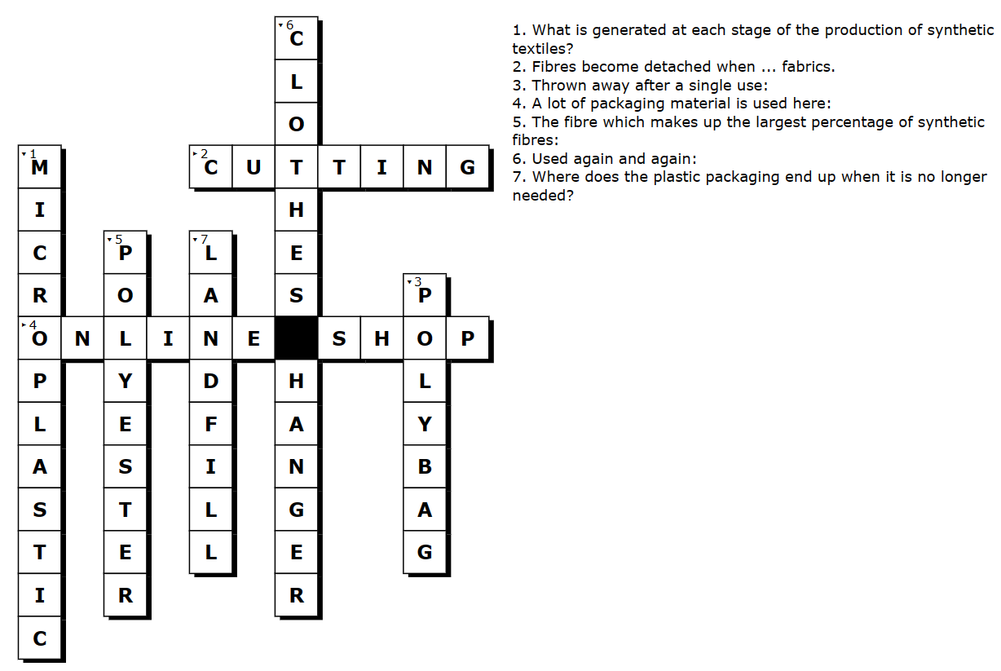
Worksheet 4: Station 2: Textile care
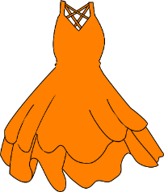
Station 2: Textile care
Answer the following questions individually.

- What comes to your mind when you hear the term textile care?
___________________________________________________________________________________________________________________________________________________________________________________________________

- How many times per week do you do the laundry at home?
□ Every day.
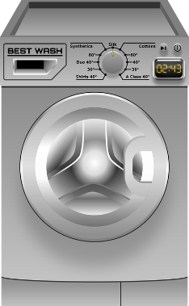
□ Approximately every second day.
□ Approximately three times a week.
□ Approximately twice a week.
□ Approximately once a week.
□ Approximately every fortnight.
□ Not regularly.
□ I do not know.

- Do you use fabric softener?
□ Yes. □ No. □ I do not know.

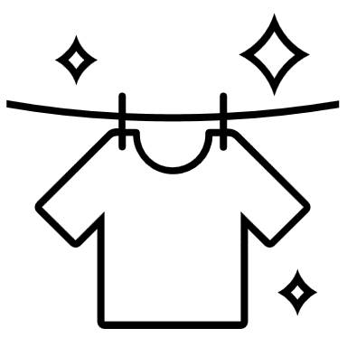
- How is your laundry being dried?
□ On the clothesline (air drying).
□ In an electric tumble dryer.
□ Other solution: _____________________________
□ I do not know.

Read the article on the next page. While reading, mark important parts with a highlighter.
How Textile Care Contributes to Microplastic Pollution
Plastic is the most prevalent type of marine debris in our oceans. Plastic debris can come in all shapes and sizes, but those that are less than 5 millimeters in length are called microplastics. Microfibres released during washing range from 124 to 308 mg per kg washed fabric depending on the textile construction.¹ The fibre release is mainly caused by the spinning process and by the contact of the textiles with each other. If detergent and fabric softener are used, the number of detached fibres increases additionally.

The type of washing machine also plays a role in fibre release. Another important factor is the load of the washing machine. As a rule of thumb, the lower the load, the higher the mechanical stress on the textiles.

The fibres released through the washing process enter the sewage treatment plants via the domestic wastewater. The sewage treatment plants, however, can only retain about 90% of the microplastics from the wastewater. This means that about 10% of the microplastics end up in rivers. From there, the microplastics find their ways into the oceans.

The wastewater treatment in the sewage treatment plants produces so-called sewage sludge. This contains the microfibres that are retained by the sewage treatment plant. Although sewage sludge can be incinerated, it is often used as a fertiliser in agriculture. Worldwide, several hundred thousand tonnes of microplastics are released into the soil every year through the spreading of sewage sludge. Microplastics are an environmental hazard. How to deal with the contaminating plastic waste in our natural waters and landscapes is therefore a critical topic. Another central question is how to reduce and monitor the current emissions.

Once the textiles have been washed, they must also be dried. If this gets done with the help of an electric tumble dryer, the release of microfibres increases even more. This is because electric tumble dryers - just like washing machines - loosen fibres through mechanical stress. Larger fibres are filtered out of the air by a filter. Smaller fibres, on the other hand, are released with the dryer’s exhaust air. They can potentially be transported over longer distances and be released into the environment. (1) Source: de Falco et al., 2019)
Main Source : De Falco et al. (2019)
Answer the following questions in your group and write down your results. If necessary, read certain parts of the text again.

- What influences the number of discarded fibres during textile care?
____________________________________________________________________________________________________________________________________________________________________________________________________________________________________________________________________

- How can the number of discarded fibres be reduced during the textile care process?

____________________________________________________________________________________________________________________________________________________________________________________________________________________________________________________________________

- What do you (not) find particularly easy to implement? Why?

____________________________________________________________________________________________________________________________________________________________________________________________________________________________________________________________________
Additional task for the early finishers:
Have you answered all the questions, checked your results and improved or added to them if necessary? Great! Now match the cards on textile care.

Worksheet 5: Station 2: Textile care – Solutions
Station 2: Textile care – Solutions

Answer the following questions in your group and write down your results. If necessary, read certain parts of the text again.

- What influences the number of discarded fibres during textile care?
  - The use of detergents and fabric softeners.
  - The type of washing machine.
  - The load of the washing machine.
  - The use of a tumble dryer.

- How can the number of discarded fibres be reduced during the textile care process?

  - Loading the washing machine fully. Only wash when the machine is full.
  - Avoid using fabric softener.
  - Choose a washing machine that loosens fewer fibres.
  - Do not use an electric tumble dryer. Dry the laundry on the line.

- What do you (not) find particularly easy to implement? Why?

Individual answer. An example:
I would find it difficult to wash less because I am used to wearing a T-shirt only once. …

Worksheet 6: Station 2: Textile care – Card matching
Connect the matching cards on the right side with arrows.

The lower the load of the washing machine, ... | 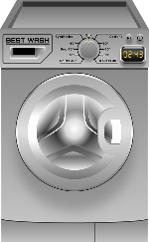
Influence the number of released fibres | ... filters large fibres out of the air.
Washing machine | ... the higher the mechanical stress on the textiles and thus also the number of released fibres.
This is how much microplastic the sewage treatment plants can retain from the wastewater: | ... the microfibres that were retained by the sewage treatment plant.
This is produced in the sewage treatment plant and is often used as a fertiliser: | ... the higher the mechanical stress on the textiles and thus also the fibre discharge.
The lint filter in the tumble dryer ... | Use of detergents and fabric softeners.  Type of washing machine.  Load of the washing machine.
The lower the load of the washing machine, ... | Sewage sludge
The sewage sludge contains ... | Approximately 90 %
Worksheet 6: Station 2: Textile care – Card matching – Solutions
Connect the matching cards with arrows.
(A) The lower the load of the washing machine, ... | (A) ... the higher the mechanical stress on the textiles and thus also the number of released fibres.
(B) Influence the number of released fibres | (B) Use of detergents and fabric softeners.  Type of washing machine.  Load of the washing machine.
(C) Washing machine | (C)
(D) This is how much microplastic the sewage treatment plants can retain from the wastewater: | (D) Approximately 90 %
(E) This is produced in the sewage treatment plant and is often used as a fertiliser: | (E) Sewage sludge
(F) The lint filter in the tumble dryer ... | (F) ... filters large fibres out of the air.
(G) The lower the load of the washing machine, ... | (G) ... the higher the mechanical stress on the textiles and thus also the fibre discharge.
(H) The sewage sludge contains ... | (H) ... the microfibres that were retained by the sewage treatment plant.
Worksheet 7: Station 3: Textile disposal

Station 3: Textile disposal 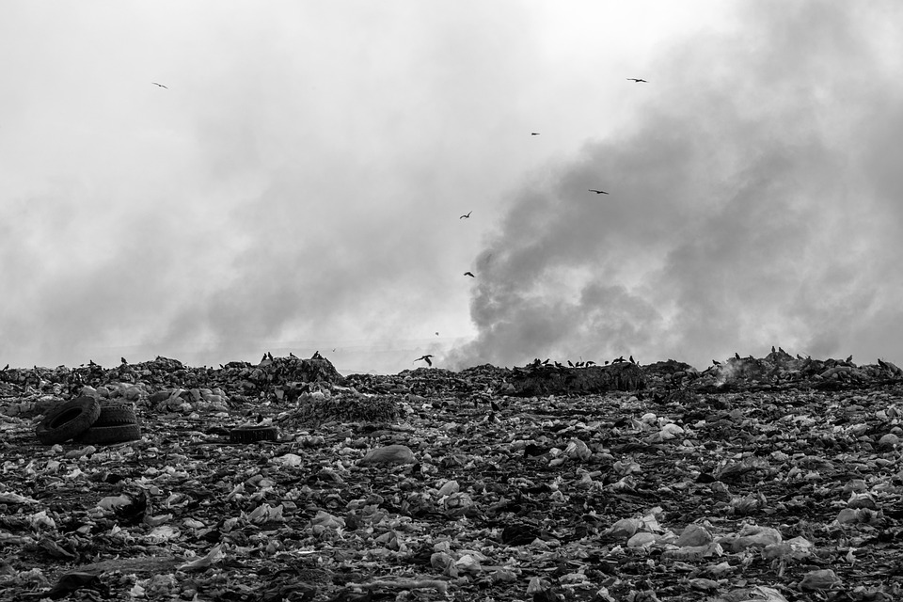
Look at the picture. What could it be about? Write down your thoughts in bullet points.

- ________________________________________________________________________________________________________________________
- ________________________________________________________________________________________________________________________
- ________________________________________________________________________________________________________________________
- ________________________________________________________________________________________________________________________
Read the following text carefully. While reading, mark important parts / words with a highlighter.
What happens to our clothes when we no longer wear them?
We all have favourite clothes that we feel comfortable and beautiful in, which is why we would like to wear them every day. But at some point, we stop wearing them.

What happens to our clothes we once loved?
Some people give their thrown out clothes to friends and family members, others sell them and others redesign these garments. In these ways, our favourite items make someone else happy and they get a new life. But no matter how long we try to keep a piece of clothing, we have to admit that at some point it will no longer be used.
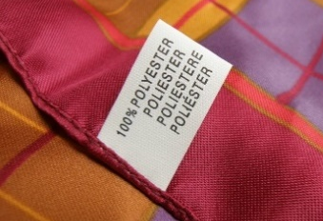
What happens to our clothes once they are thrown away?
Via some detours, our favourite pieces then end up in landfills. This happens to all clothes – no matter whether they are made of natural and cellulosic fibres (like cotton, wool and viscose) or synthetic fibres (like polyester, polyamide and elastane).

Is there a difference between the fibres?
The only difference is that garments made of natural and cellulosic fibres decompose as they are biodegradable. This means that over time microorganisms can dissolve the respective material into its elementary components, such as carbon, oxygen, hydrogen and other minerals. This process is different for synthetic textiles. They are likely to sit in landfills for up to 200 years and decompose into ever smaller plastic particles over decades. Unlike natural fibres, they are not broken down into their components. The result is textile microplastics.

Why are microplastics harmful to the environment?
Microplastic particles do not stay in place. They are carried to many different places by winds and rain. Depending on where the microscopic fibres land, they can potentially cause environmental damage. Partly they are eaten by animals, what harms them. Pollutants can adhere to them and enter our food chain.

What remains to be done? To say it with Vivienne Westwood: Buy less, choose well, make it last!
Read the blog carefully. Clarify unknown words and questions in the group. If you need help, contact your teacher.
What are the problems we face with textile waste and what can we do about it? Use the information from the text and have a look at the graph.

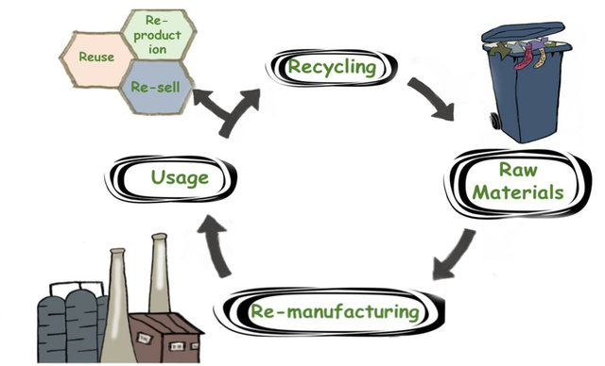

The critical point of CE,
© Damayanti, Wulandari, Bagaskoro, Rianjanu & Wu, CC-BY 4.0

CE (Circular Economy) utilises resources to produce, use, and dispose of in favour of as much reuse and recycling as possible including fabric waste and post-consumer waste. Re-manufacturing describes the process of reconstructing textile waste to create new garments. The question is where you come in:

____________________________________________________________________________________________________________________________________________________________________________________________________________________________________________________________________
Additional task for the early finishers:
Now use your mobile phone to find out more about the Atacama Desert in Chile and the environmental impact of textile waste. Discuss your findings with your group.
Worksheet 8: Station 4: Avoidance strategies

Station 4: Avoidance strategies
Read the blog post on the next page carefully. Then answer the following questions and do research on the internet if needed.

- What does Amy suggest to tackle textile microplastics?
___________________________________________________________________________________________________________________________________________________________________________________________________

- What can you find out about the gadgets that are mentioned?
___________________________________________________________________________________________________________________________________________________________________________________________________

- Why does Amy recommend using the clothesline instead of an electric tumbler?
___________________________________________________________________________________________________________________________________________________________________________________________________

- Which textiles do not emit any or less plastic due to their raw materials?
___________________________________________________________________________________________________________________________________________________________________________________________________

Blog post: Me Against Microplastics
Hi people! Have you heard about microplastics? It's all over the media now. I just found out that microplastics are created when we wash our textiles.
Both detergent and fabric softener cause more fibres to come out. Washing without detergent seems to be difficult, but from now on I will ditch the fabric softener. That’s a real shame because I like it super cosy. But I like our planet even more. 😉 One simple trick to reduce textile microplastic is loading a washing machine to the full. As a rule of thumb: More load means less fibre output and less work.
I also found some innovative gadgets on the internet. One of them is a ball that is designed to retain the microfibres that have already been created. Another one is a bag in which you put the clothes before washing. However, a key issue remains: the final disposal of the retained textile microplastics. 🙄 So, it is better that textile microplastics don't even occur! That’s why I decided to no longer use an electric tumble dryer. In the future, I will simply use the good old clothesline. I also thought about using textiles that do not emit any or less plastic due to their raw materials.
In the long run, I think that the only solution is to satisfy our greed for new textiles. We need high-quality textiles which are less likely to loosen fibres when being washed and can be used for a long time. They must also be compatible with recycling at the end of their lives.
That means: Consume less! Or in other words:
Go on a fashion DIET! 
XOXO Amy
- Group work: Think about further strategies to avoid / reduce textile microplastics.
____________________________________________________________________________________________________________________________________________________________________________________________________________________________________________________________________


- Individual work: Which of the strategies are feasible for you? Would you use them? Why?
____________________________________________________________________________________________________________________________________________________________________________________________________________________________________________________________________

Additional task for the early finishers:
Have you answered all the questions, checked your results and improved or added to them if necessary? Great! Now you can use your mobile phone to search for further strategies to avoid microplastics (not only textile microplastics). Note them down and present them in class:
____________________________________________________________________________________________________________________________________________________________________________________________________________________________________________________________________

Worksheet 9: Station 4: Avoidance strategies – Solutions

Station 4: Avoidance strategies – Solutions
Read the blog post on the next page carefully. Then answer the following questions and do research on the internet if needed.

- What does Amy suggest to tackle textile microplastics?
  - Avoid using fabric softener.
  - Load the washing machine to a full.
  - Use a clothesline instead of a tumble dryer to dry clothes.
  - Use textiles that do not emit any or less plastic due to their raw materials.
  - Buy less new clothing.

- What can you find out about the gadgets that are mentioned?
Guppy Friend:
It is a bag in which you put the clothes before putting them into the washing machine. The bag protects clothes against mechanical stress during the washing process and thus aims to reduce the creation of microfibres.

Cora Ball:
The Cora Ball is a laundry ball that catches microfibers which shed off from clothing in the washing machine.

Studies show very different results regarding the gadgets’ retention capacity. Additionally, the final disposal of the retained textile microplastics still remain an unsolved problem.

- Why does Amy recommend using the clothesline instead of an electric tumbler?
Electric tumble dryers - just like washing machines – put textiles under mechanical stress. Therefore, the textiles lose fibres. The clothesline, on the other hand, does not put the textiles under such stress and additionally does not require electricity, which makes it more environmentally friendly.

- Which textiles do not emit any or less plastic due to their raw materials?
Textiles made from natural fibres, such as cotton, silk and hemp, do not emit any plastic. However, it must be ensured that ecological risks are not created at any other point. In other words, that no impact shift occurs. Cotton cultivation, for example, is extremely water-intensive and requires a lot of pesticides.

- Group work: Think about further strategies to avoid / reduce textile microplastics.
Individual answers.
  - …

- Individual work: Which of the strategies are feasible for you? Would you use them? Why?
Individual answers.
  - Prefer textiles without synthetic fibres if possible.
  - ...

