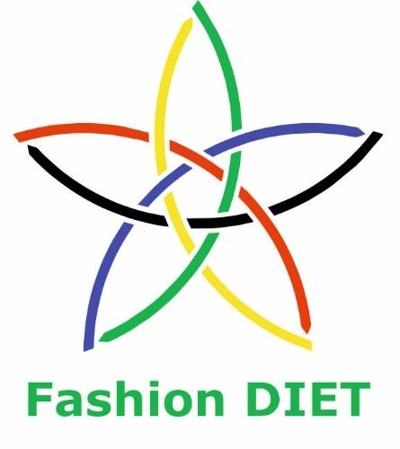

Sustainable Fashion Curriculum at Textile Universities in Europe
–
Development, Implementation and Evaluation of a Teaching Module for Educators

Project: 2020-1-DE01-KA203-005657

Title of the Lesson: Natural Dyeing and Shibori Technique

Authors: Asst. Prof. Dr. Petya Dineva,
Assoc. Prof. Dr. Zlatin Zlatev
Contact Data: Trakia University of Stara Zagora, Faculty of Technics and Technologies, Yambol, Bulgaria
E-mail: petya.dineva@trakia-uni.bg, zlatin.zlatev@trakia-uni.bg



Introduction to the Teaching and Learning Materials

Short Description of the Content:

Today's textile industry faces increasing pressure to adopt sustainable practices while meeting consumer demands. Natural colorants from plant, animal, or mineral sources offer an eco-friendlier alternative to synthetic dyes. This topic explores their potential to enhance sustainability in textiles, considering benefits, challenges, and the path to a more environmentally conscious industry. By embracing natural colorants, we can create beautiful and eco-friendly fabrics, reducing harm to the planet.
Shibori, a traditional Japanese dyeing technique, has gained popularity for its captivating designs and eco-friendliness. By using natural dyes sourced from plants and environmentally friendly materials, Shibori embodies a sustainable approach to textile production, highlighting the importance of natural colorants in creating both beautiful and environmentally conscious fabrics.

Competences and Learning Objectives:

After this unit the student should be able to …

- gain knowledge about different sources of natural colorants used in the textile industry, including plants, animals, and minerals. They will learn how to categorize these colorants based on their origin and properties.
- explore the environmental issues associated with synthetic dyes, such as water pollution, chemical waste, and energy consumption. They will develop an understanding of why the textile industry needs sustainable alternatives.
- analyze the sustainability aspects of natural colorants, considering factors such as renewable sourcing, biodegradability, and reduced environmental impact during production and disposal. They will learn to assess the ecological footprint of natural colorants compared to synthetic dyes.
- examine the performance characteristics of natural colorants, including color fastness, lightfastness, and wash ability. They will understand the limitations of natural colorants, such as variations in color intensity and limited color range, and how to address these challenges.
- various techniques for dyeing textiles with natural colorants, such as vat dyeing, mordant dyeing, and eco-printing. They will gain practical knowledge of dyeing processes and learn to apply these techniques in a sustainable and efficient manner.

- explore market trends and consumer demand for sustainable textiles. They will learn to analyze consumer preferences for natural colorants and understand the market potential for eco-friendly textile products. They will also consider factors such as cost, availability, and scalability of natural colorant production.
- develop strategies for incorporating natural dyes into textile production. They will consider factors such as dye selection, process optimization, waste management, and product labeling to ensure a holistic approach to sustainability.
- effectively communicate the benefits of natural colorants and sustainable dyeing practices to various stakeholders, including manufacturers, consumers, and policymakers. They will develop persuasive arguments and engage in discussions to promote the adoption of sustainable practices in the textile industry.
- be equipped with the knowledge and skills necessary to contribute to the sustainable transformation of the textile industry through the utilization of natural colorants in textile materials.

Overview of Working Materials

Lesson module 1:
Topic: What is natural dyeing?
Worksheet 1: What is natural dyeing?

Lesson module 2:
Topic: The natural dyeing in contemporary fashion
Worksheet 2: The natural dyeing in contemporary fashion

Lesson module 3:
Topic: The natural dyeing in sustainable fashion
Worksheet 3: The natural dyeing in sustainable fashion
Work materials: white cotton fabrics, natural dyers, ultrasonic bath
In presented Lesson:
Raw materials used
The textile material used is white cotton fabric (100%), "Tesuti Bulgaria" EOOD, Sofia, Bulgaria. The textile fabric has a density of 123 g/m². 46 threads/cm². Samples with dimensions of 5x10 cm were prepared.
In the present work, as dyes for textile materials, waste products, offered in the form of flour, were used in the commercial network. They are obtained after mechanical extraction of essential oils from the respective plants. Soy flour, TIT Tenyo Tenev S.T, Kameno, Bulgaria. Rose hip flour, Balevski & Kirov Ltd., Tryavna, Bulgaria. Almond flour, Sosa Ltd., Barcelona, Spain. Pumpkin seed flour, Balcho Agro Product Ltd., Sofia, Bulgaria. Flax flour, TIT Tenyo Tenev S.T, Kameno, Bulgaria.
Technical means used
Ultrasonic bath HQ-JC50 (HQ Electronics Ltd., Shenzhen, Guangdong, China), capacity 610 ml, emitter power 35 W, emitter frequency 42 kHz. Serial number 1403270915.
Water bath. It consists of a heater, with an electric power of 2 kW, the control is with a PID controller, with an output for SSR. The heater is controlled by a Solid state relay (SSR). The temperature sensor is a Type K thermocouple. The container is 3 l. The glass containers with the dye are placed in a metal basket so that they do not come into direct contact with the heater.
The amount of raw materials was determined with a Pocket Scale MH-200 (ZheZhong Weighing Apparatus Factory, Yongkang City, Zhejiang Province, PR China), maximum determined mass 200g, with a resolution of 0.02g.

Lesson module 4:
Topic: Shibori technique
Worksheet 4A: Shibori technique. Theoretical background
Worksheet 4B: Let’s make a shibori!
Working materials: cotton fabric with good plasticity; iron for ironing and folding the fabric; line, triangle and pencils for measuring and drawing the desired shapes; sewing needles and polyester threads, not allowing dye penetration and with good strength (twist threads may be thicker); PVC pipe with a diameter of up to 10 cm for twisting the fabric; tape providing fabric support when twisting on the tube and until the final twist of the thread; rubber bands for tying, metal and PVC clips; wooden or plastic triangle or square shapes (wooden forms should be varnished or, as in this case, wrapped in household foil to better insulate the surfaces); rubber gloves, aluminum containers for the dye; choice of turmeric and beetroot dye powder, black tea, rooibos tea, indigo or others
For cotton fabrics, it is necessary that the water has a PH of 10.5 to 11.5.

Lesson module 5:
Topic: And it is time for your design!
Worksheet 5A: Sketch your idea
Worksheet 5B: Sustainability of your design
Working materials: graphic pencils, color pencils, pen

Sources

Adeel, S., Rehman, F., Zuber, M., Batool, F., Habib, N., Hussaan, M., Amin, N. (2021). Environmental friendly application of ultrasonic rays for extraction of natural colorant from Harmal (P. harmala) for dyeing of bio-mordanted silk. Journal of Engineered Fibers and Fabrics, 16: 1-8.

Arora, J., Agarwal, P., Gupta, G. (2017). Rainbow of Natural Dyes on Textiles Using Plants Extracts: Sustainable and Eco-Friendly Processes. Green and Sustainable Chemistry, 7: 35-47.

Irodori, A. Instagram Profile Ayaosuka. https://www.instagram.com/ayaosuka/.

Bara, E. (2020). Moda Primavera Estate 2020: il look tie dye. Vogue Italia. https://www.vogue.it/moda/gallery/moda-primavera-estate-2020-look-tie-dye (accessedon 26.10.2022).

Bara, E. (2021). La tendenza tie dye in 5 capi da inserire subito nel guardaroba dell'estate 2021. Vogue Italia. https://www.vogue.it/moda/article/moda-tie-dye-2021-estate-look-tendenza.

Batool, F., Iqbal, N., Azeem, M., Adeel, S., Ali, M. (2019). Sustainable Dyeing of Cotton Fabric Using Black Carrot (Daucus carota L.) Plant Residue as a Source of Natural Colorant. Polish Journal of Environmental Studies, 28(5): 3081-3087.

Callender, J. (2020). Gallery. Vogue. https://www.vogue.com/slideshow/jane-callender-gallery.

Che, J., Yang, X. (2022). A recent (2009-2021) perspective on sustainable color and textile coloration using natural plant resources. Heliyon, 8(10) e10979.

Chungkrang, L., Bhuyan, S., Phukan, A. (2021). Natural Dyes: Extraction and Applications. International Journal of Current Microbiology and Applied Sciences, 10(1): 1669-1677.

Ebrahim, S., Mosaad, M., Othman, H., Hassabo, A. (2022). A Valuable Observation of Eco-friendly Natural Dyes for Valuable Utilisation in the Textile Industry. Journal of Textiles, Coloration and Polymer Science, 19(1): 25-37.

Elsahida, K., Fauzi, A., Sailah, I., Siregar, I. (2019). Sustainability of the use of natural dyes in the textile industry. IOP Conference Series: Earth and Environmental Science, 399 012065.

Entwistle, J. (2015). The fashioned body: Fashion, dress and modern social theory. John Wiley & Sons, ISBN: 978-074-564-938-2.

Glassner, A. (1989). How to derive a spectrum from an RGB triplet. IEEE Computer Graphics and Applications, 9(4): 95-99.

Hidayat, J., Fatmahwaty, F. (2014). The Art and Sustainable Aspects of Natural Dyeing in KANAWIDA Hand Drawn Batik (Green Batik). IPTEK, Journal of Proceeding Series, 1: 136-143.

Islam, S., Molla, T., Bashar, A., Chandra, D., Islam, R., Ahsana, S. (2021). Ultrasound-assisted extraction of natural dye from Swietenia mahagoni and its application on silk fabric. Indian Journal of Fibre & Textile Research, 46: 69-77.

İşmal, Ö. (2016). Patterns from Nature: Contact Printing. Journal of the Textile Association, 77(2): 81-91.

Callender, J. (2019). Stitched shibori technique, innovation, pattern, design. China, ISBN: 978-1-78221-141-9.

Kaliko (2022). Plant dyeing directory: acid dyes, metal mordants or soy milk?. Kaliko. https://www.kaliko.co.

Kodžoman, D., Hladnik, A., Čuden, A., Čok, V. (2022). Exploring color attractiveness and its relevance to fashion. Color research and application, 47(1): 182-193.

Lara, L., Cabral, I., Cunha, J. (2022). Ecological Approaches to Textile Dyeing: A Review. Sustainability, 14 8353.

Moussa, A. (2021). Textile color formulation using linear programming based on Kubelka-Munk and Duncan theories. Color Research and Application, 46:.1046-1056.

NATCOL. Introduction to Natural Food Colors. NATCOL. https://natcol.org.

Ou, L., Luo, M. (2014). A review of current color preferences and their applications in fashion design. International Journal of Fashion Design, Technology, and Education, 7(3): 163-174.

Parthasarathi, V., Kumar, R. (2016). Natural colorants and dyeing techniques in textile industry: an overview. Journal of the Textile Institute, 107(4): 493-507.

Prideaux, V. (2018). A handbook of Indigo dyeing. Malaysia, 2018, ISBN:978-1-84448-767-7.

Rahman, N., Tajuddin, R., Tumin, S. (2013). Optimization of Natural Dyeing Using Ultrasonic Method and Biomordant. International Journal of Chemical Engineering and Applications, 4(3): 161-164.

Samanta, A., Konar, A. (2011). Dyeing of Textiles with Natural Dyes. Book chapter from “Natural Dyes”, Editor E. Kumbasar, DOI: 10.5772/21341.

Samanta, P. (2020). A Review on Application of Natural Dyes on Textile Fabrics and Its Revival Strategy. Chemistry and Technology of Natural and Synthetic Dyes and Pigments, IntechOpen.

Sanchiher, L., Babel, S. (2017). Eco friendly natural dyes. Asian journal of home science, 12(2): 631-635.

Shibori Patterns. https://www.pinterest.com/TextilePrint/shibori-patterns/.

Shibori. https://en.wikipedia.org/wiki/Shibori.

Tie-dye. https://en.wikipedia.org/wiki/Tie-dye.

Zhang, Y., Li, X. (2020). Models of clothing based on combinations of colors and shapes inspired by natural sources. Journal of Textile and Apparel Technology and Management, 11(4): 1-10.

Duneva, P. (2023). Investigation of Shibori Technique Applied in Sustainable Fashion Design. ARTTE Applied Researches in Technics, Technologies and Education, 10(3): 142-148.
Image Sources

Lesson modules 1 and 2

All Images: CC BY Zlatev. Images are from a dyeing research in the context of sustainability, given by Zlatin Zlatev, a co-author of this lesson, a PhD on Automation in manufacturing at the Faculty of Technics and Technologies of Yambol, Trakia University, Bulgaria.

Lesson modules 3 and 4

All Images: CC BY Dineva. Images are from a Master class on Shibori dyeing in the context of sustainability, given by Petya Dineva, a co-author of this lesson, a PhD on Fashion Design and Technology at the Faculty of Technics and Technologies of Yambol, Trakia University, Bulgaria. The Master class was organized in the frame of Fashion DIET project and was held on February 19, 2023. Using the Shibori technique, Petya Dineva presented the dyeing of textile fabric by this technique.

Worksheet 1: What is natural dyeing?

The art of dyeing textile fabrics is a vibrant and evolving process integral to their production. With a growing emphasis on eco-conscious practices, the textile industry is actively seeking alternatives to synthetic dyes, giving rise to the increasing popularity of natural dyes among top fashion brands. The shift towards "greener" production is fueled by the toxic nature of many synthetic dyes, urging a swift transition to safer and bio-based alternatives.
The utilization of natural dyes in textile production embodies a multifaceted approach to sustainability, encompassing economic, environmental, and social considerations. Several factors influence the sustainable production process, including the type of textile fabrics, their chemical composition, the chosen dyes, and dyeing techniques.
Economically, the successful application of natural textile dyes hinges on meeting consumer expectations for the final product. Brands must ensure that the color quality and durability of the dyed fabrics align with customers' desires to maintain economic efficiency.
From an environmental perspective, natural dyes offer compelling advantages. They are biodegradable, ensuring that their impact on the planet is minimal. Moreover, natural dyes are non-toxic and hypoallergenic, promoting a healthier ecosystem for both the environment and individuals who come into contact with the dyed textiles.
The social benefits of adopting natural dyes are equally significant. By eliminating the use of toxic synthetic dyes, workers in dye shops can be safeguarded from harmful exposure, preserving their health and well-being. This move towards safer practices fosters a more socially responsible industry.
An additional facet of the natural dye movement is its alignment with the principles of slow fashion. Users have the opportunity to engage in a hands-on approach to dyeing garments themselves using natural dyes, fostering a deeper connection with their clothing and reducing the demand for fast-paced, wasteful fashion trends.
Table 1 presents the key criteria for evaluating natural textile dyes, focusing on standardization, mass production viability, environmental impact, and color fastness. The table highlights the need for research in standardizing dye extraction methods from natural sources to ensure compatibility with various textile fibers and fabrics. Notably, the environmental friendliness of these dyes emerges as a significant advantage. To enhance their application, the use of natural fixatives is recommended for dyeing textile materials.

Table 1. Evaluation of natural colorants
Criterion | Description | Activities
Standardization | Low level of standardization | To conduct research on standardization
Application in mass production | They are not suitable for mass production. | Research is being done on their application for mass production
Dyeing of various textile fibers | Limited to fibers of natural origin | Research is being done on dyeing man-made fibers
Environmental friendliness | Biodegradable | Reduction of synthetic color fixatives used
Color fastness | Fasteners are used to ensure stability | Reducing the influence of the main color of the fabric

Table 2 provides a comprehensive overview of commonly used methods for extracting natural textile dyes, offering insights into their respective advantages and limitations. Extracting color pigments from natural sources poses a complex challenge, and the selection of the most suitable method depends on the specific coloring matter targeted for extraction. Achieving standardization in the extraction process and optimizing extraction variables for a particular source of natural dye material hold paramount importance, both technically and commercially. This optimization directly impacts the color yield, final extraction process cost, and the overall cost of dyeing.
Natural dyes can be obtained from a diverse range of sources, including various plant parts such as flowers, stems, roots, and bark, as well as from animal and mineral sources. Understanding the nuances of these extraction methods and their characteristics helps researchers and practitioners in the textile industry to harness the potential of natural dyes more effectively and sustainably.

Table 2. Methods for the extraction of natural textile dyes
Extraction method | Advantages | Limitations
Aquatic | Dissolving a number of substances, an accessible method | It requires a large amount of heat, the opportunity for the development of microorganisms and unwanted fermentation
Alkaline and basic | Not a complicated method | The procedure only works for acids and bases with a large difference in their solubility
Microwave | Simplified apparatus, less solvent, short process time | High cost of equipment, requires filtration
Ultrasonic | Simple method, short process time | Low extraction efficiency
Fermentation | Less water and energy used | Long time to get the dyes
Enzymatic | Less energy needed | There are many factors to consider, especially when using two or more enzymes
With solvent | Effective dissolution of a larger group of substances | Higher process cost, some extractants are flammable or toxic
Supercritical fluid | Eco-friendly, high analysis speed | Relatively high cost of analyses

Natural dyes can be categorized based on the method of application to textile materials, resulting in various types such as mordants, Vat dyes, Direct Dyes, Acid Dyes, Basic Dyes, and Disperse Dyes. Each type has its unique characteristics and properties, making them suitable for different applications and achieving diverse color effects.
In addition to the extraction methods, the fixation of color on textile materials is a crucial element in the dyeing process. While dyes of natural origin are commonly used, there are instances where synthetic fixatives, such as metal salts of aluminum, copper, and tin, are employed to enhance color permanence. However, a growing trend is to opt for fixatives of natural origin when fixing the dye on textile materials. Prominent examples include tannins or essential oils, which align with the industry's pursuit of eco-friendly and sustainable dyeing practices. By exploring and utilizing these natural fixatives, the textile industry aims to enhance the environmental compatibility and overall appeal of products dyed with natural dyes.
Rahman et al. identified a challenge in the traditional dyeing process of textile fabrics with natural dyes, which involved boiling and using fixatives containing metallic compounds. To address this issue and promote sustainability, the authors innovatively improved the dyeing process by employing ultrasound treatment on silk fabrics and adopting a biological color fixative derived from the plant Xylocarpus moluccensis. Through their research, they successfully achieved lower dyeing temperatures and enhanced color fixation compared to conventional methods. This advancement holds significant promise for eco-friendly and efficient textile dyeing practices.
In the case of Hidayat et al., their research aimed to tackle a pressing concern regarding Indonesian batik, the nation's cherished fabric. Following a ban on synthetic dye exports, the authors sought a viable solution using natural dyes. Through their diligent efforts, they uncovered valuable insights into the natural sources of color and developed effective methods for producing dyes from natural materials. Additionally, their work enriched the knowledge on implementing sustainability in domestic batik production, paving the way for environmentally responsible practices within the traditional textile industry.
İşmal proposes a novel approach to dyeing fabrics by utilizing synthetic colors derived from waste products and biomass. The author emphasizes that the outcome of the dyeing process greatly depends on the specific type of textile material it is applied to.
Sanchiher et al. shed light on the preference of environmentally conscious consumers for textiles dyed with natural dyes, creating a niche market. However, the overall share of natural dyes in the textile sector remains relatively small due to certain limitations in their production and application. While natural dyes offer sustainability benefits as they are renewable and biodegradable, they still struggle to fully meet the demands of the textile industry.
Arora et al. delve into the ecological and environmental advantages of using natural textile dyes. They explore various methods of obtaining natural dyes and their application in coloring textile fabrics. The authors highlight that the color intensity is influenced by the dye's active acidity, and effective dyeing relies on both the fabric type and the chosen dyeing technique. Additionally, the extraction process of color from plants is identified as a crucial stage in the overall dyeing process.
Elsahida et al. conduct a comprehensive assessment of the sustainability of using natural dyes in the textile industry, considering economic, environmental, and social aspects. The authors provide practical recommendations to reduce the cost of natural textile dyes and suggest the use of natural color fixatives, such as tannins, to further enhance the sustainability of the dyeing process.
Batool et al. focus their study on the dyeing of cotton using an extract from Daucus carota L. The authors determine the optimal amount of raw material needed to achieve a sufficiently dense color. However, a drawback of this study is the utilization of color fixatives of synthetic origin, which may pose environmental concerns in the context of sustainability.
Samanta highlights the need for further research in various aspects related to natural colorants. The author emphasizes the importance of investigating color stability, standardizing extraction methods, assessing the microbiological impact, and providing specialized training for experts in the application of natural colorants. These areas of research are critical for advancing the use of natural dyes in a sustainable and effective manner.
Adeel et al. contribute to the field of silk dyeing by determining suitable raw material-extracting agent ratios in ultrasound-assisted dyeing. Their study includes a comparison of natural color fixatives with synthetic ones. The research results indicate that natural dyes exhibit excellent dyeing efficiency for silk fabrics under sustainable conditions, and the addition of environmentally friendly clean fixatives further enhances the sustainability of silk dyeing while improving color fastness properties.
Islam et al. conducted a study on ultrasound-assisted extraction of natural dyes from Sweitenia mahagoni plants. They identify the main groups of compounds present in the dyes extracted from this plant and determine the optimal extraction conditions. The resulting dyes are then used to dye silk fabrics, showcasing the potential application of natural dyes in textile dyeing processes.
Chungkrang et al. conduct a comprehensive review of existing methods for dyeing textile fabrics using natural dyes. Their work focuses on evaluating the advantages and disadvantages of using natural dyes. The authors recommend that future studies should emphasize the standardization of methods for obtaining natural textile dyes, which could lead to more consistent and reliable outcomes in the dyeing process.
Rehman et al. explore the benefits of microwave-assisted dyeing of nylon fabrics. Their research findings indicate that using microwave energy in the dyeing process leads to significant time and energy savings while increasing labor efficiency. This innovative approach enhances the value of sustainable extraction of natural dyes, presenting a promising avenue for more efficient and eco-friendly textile dyeing practices.
Ebrahim et al. present a comprehensive overview and classification of different types of natural dyes, along with the various methods used for extracting colors from different types of plants. Their analysis provides valuable insights into the diverse range of natural dyes and the techniques employed in harnessing their color properties.
Similarly, Lara et al. conduct a thorough review of environmentally friendly methods for dyeing textile fabrics. The authors advocate for the implementation of regulatory measures pertaining to the use of natural dyes in the textile industry. They emphasize the need for continued research and development to explore new, eco-friendly methods, chemical products, materials, and equipment to present sustainable solutions for textile dyeing. Training and specialization of experts in the application of natural dyes are also highlighted as crucial aspects in advancing sustainable practices.
Summarizing the findings, the extraction of textile dyes from natural plant sources primarily relies on raw plant materials, with a potential shift towards utilizing waste products from plants after processing to enhance sustainability. Fixatives of natural origin are recommended for fixing the dye on textile materials, further aligning with eco-friendly practices. To improve the color extraction process from natural dyes and enhance color fixation on textile fabrics, the authors propose the use of the ultrasonic method. This approach proves advantageous as it avoids the use of waves harmful to human health, such as microwaves, making it a safer and more sustainable option.

Tasks:

Task 1a: Research for more information on the techniques of natural dyeing on the internet.
Task 1b: Describe the similarities and differences between natural and chemical dyeing.
Task 1c: Do you see connection between natural dyeing and sustainable fashion? Describe it.

Worksheet 2: The natural dyeing in sustainable fashion

Color and shape are two fundamental elements in fashion design, each playing a crucial role in enhancing consumer interest and elevating the appeal of fashion products. Color holds the power to evoke emotions, set moods, and express one's personality. On the other hand, shape contributes to the garment's overall aesthetic, encompassing its structure, silhouette, and contour. Combining these two components in fashion design can result in visually striking creations that are both captivating and expressive.
The importance of shape in fashion design lies in its ability to influence the overall aesthetics and functionality of a garment. Designers carefully consider form while creating a piece to ensure it is visually appealing and serves its purpose effectively.
Moreover, the shape of a garment can profoundly impact how the wearer and those around them perceive it. A well-fitted dress can instill confidence and a sense of attractiveness in the wearer, while a loose-fitting outfit can promote comfort and relaxation. Additionally, the shape of a garment communicates various messages. A sharp, edgy silhouette exudes strength and power, while a soft, flowing contour embodies femininity and grace.
By skillfully combining color and shape, fashion designers can create designs that not only catch the eye but also resonate with the emotions and identities of their wearers, making fashion a powerful means of self-expression and communication.
Designers wield the power of shape manipulation to their advantage by employing various techniques like pleats, gathers, and drapes to add volume to garments or using bands and bastis to achieve a more fitted look. Contrasting shapes are also utilized to create visual interest, such as pairing a fitted jacket with a wide skirt, adding depth and dynamic appeal to the ensemble.
Beyond aesthetics, the shape of a garment significantly influences its functionality. Designers carefully consider the silhouette to ensure the garment fits the body well and moves gracefully with the wearer. The shape also determines the practicality of the garment, impacting its ease of use and wearability.
While the use of natural colors in fashion design dates back centuries, their popularity declined with the advent of synthetic dyes. However, there is a resurgence of interest in natural colors due to their sustainability, health benefits, and unique aesthetic qualities.
The advantages of using natural colors in fashion design are noteworthy. They are sustainable and environmentally friendly, obtained from renewable sources, and biodegradable. In contrast, synthetic dyes often come from non-renewable sources and can have a detrimental impact on the environment.
Che et al.'s analysis of sustainable trends in using natural dyes in fashion design emphasizes that natural dyes show great promise as substitutes for synthetic dyes in specific textile product categories. Utilizing natural dyes can minimize negative impacts on health and the environment, contributing to a more eco-conscious and health-conscious fashion industry.
Natural colors offer notable benefits for human health as they are non-toxic and hypoallergenic, making them ideal for individuals with sensitive skin. Moreover, their unique aesthetic qualities provide a diverse array of colors and shades that cannot be replicated by synthetic dyes, allowing for subtle variations in color based on the textile fabric and dyeing method used.
In the realm of natural dyeing techniques, two categories prevail: traditional and modern methods. Traditional approaches involve using plant-based materials like roots, leaves, and flowers that are boiled and then used to dye fabrics. On the other hand, modern methods utilize natural colorants extracted from plants, insects, and other sources, which are processed to create dyes.
Kodžoman et al. conduct research on aesthetic dyes for fashion design, discovering that users showed a preference for colors such as black, pink, and yellow. The choice of color was also found to be influenced by factors like gender and age. However, a limitation of this study lies in its focus on individual colors rather than their representation on garments, potentially overlooking the interplay between color and garment shape in shaping preferences.
The literature review indicates a need in modern clothing design to explore new natural dyes that offer improved stability and resistance while expanding the range of available colors. Additionally, ongoing enhancements in the efficiency and cost-effectiveness of natural dyeing methods are essential. Exploring innovative combinations between color and form, inspired by nature, also holds promise for advancing fashion design.
Nonetheless, the process of selecting color and shape combinations in fashion design remains complex and subjective. Designers primarily rely on their personal taste, experience, and intuition to create appealing color combinations for consumers. While scientific research in this area is limited, the present development aims to bridge this gap by exploring the attractiveness of color and shape combinations in fashion design, offering insights to guide designers in their creative endeavors.
Table 3 provides an insightful overview of natural sources of colors suitable for textile dyeing.
The data on pigments and their resulting colors can be effectively summarized by analyzing key characteristics of each pigment. One essential characteristic is the water and fat solubility of the pigment, which significantly influences the extraction and utilization methods employed.

Table 3. Colors from natural pigments used in this study
Colorant | Main colours | Natural source | Description
Anthocyanins | Red, purple, blue | Flowers, fruits and vegetables | Water soluble pigments. They are sensitive to pH changes
Betanin | Red, purple | Beet roots | Water soluble pigment. It is not stable to light, heat and oxygen
Carmine | Red | Cochineal | Water soluble pigment. Resistant to light, heat and oxygen
Chlorophyll | Green | Alfalfa, nettle, parsley, spinach | Water soluble pigment. Relatively resistant to light, heat and oxygen
Carotenoids | Yellow, orange, red | Carrots, oranges, red peppers, saffron, tomatoes | Fat soluble, unaffected by heat and pH changes
Curcumin | Yellow, red, pink | Turmeric | Soluble in oil, stable to heat but not to light
Riboflavin | Yellow | Eggs, milk, yeast | Water soluble pigment. Heat resistant
Carbon Black | Black | Charred plant materials | Resistant to light and heat
Caramels | Brown | Melanoidins | Resistant to light and heat
Phycocyanins | Blue | Algae Spirulina | Water soluble pigment. It is not stable to light, heat and oxygen. They are sensitive to pH changes

Another vital aspect is the pigment's resistance to light, heat, and oxygen. Pigments that exhibit high resistance to these factors generally offer greater stability and longevity, while less resistant pigments may fade or deteriorate over time. Additionally, the pigment's resistance to changes in active acidity is crucial, especially when mordants are used in textile fabric dyeing.
Mordants play a pivotal role in fixing the dye in fabrics and can influence the final color of the textile material. Depending on the pigment employed, alterations in active acidity can lead to changes in the pigment's color. Therefore, a comprehensive understanding of the pigment's characteristics and its response to various mordants is essential in ensuring consistent and durable colors in the final textile fabric.
By considering these vital characteristics of the pigments used in natural dyeing, textile designers and practitioners can make informed decisions to achieve vibrant and long-lasting colors in their fabric creations.
Figure 1 provides a comprehensive overview of colors derived from natural pigments:
C1: This color originates from anthocyanins, water-soluble pigments responsible for the purple hues seen in various flowers, fruits, and vegetables, such as purple cauliflower.
C2: Obtained from the pigment betanin found in beets, this deep red color showcases the water-soluble nature of betanin.
C3: Derived from the carmine pigment sourced from female cochineal insects, C3 is a vibrant red pigment extensively used as a textile dye.
C4: Originating from chlorophyll, the pigment responsible for the green color in plant leaves, C4 plays a crucial role in photosynthesis.
C5: This color comes from carotenoid pigments responsible for the red, orange, and yellow hues found in various fruits and vegetables. Carrots, with their characteristic orange color, also contain carotenoids.
C6: Derived from the bright yellow pigment curcumin found in turmeric, C6 adds a vivid yellow hue to textiles.
C7: Obtained from the water-soluble vitamin riboflavin, C7 emanates from egg yolks, showcasing the vitamin's coloring properties.
C8: Extracted from activated carbon through high-temperature burning of plant material, C8 results in a black, powdery substance known as activated charcoal.
C9: Exhibiting a light caramel color, C9 arises from a chemical reaction when sugars and amino acids are heated together.
C10: This color is extracted from Spirulina algae pigments, known for their blue-green hue.
This comprehensive overview of natural pigments and their associated colors offers valuable insights for textile designers and dyeing practitioners seeking to harness the rich and diverse palette of nature's hues in their creations.

 |  |  |  | 
C1 | C2 | C3 | C4 | C5
 |  |  |  | 
C6 | C7 | C8 | C9 | C10
Figure 1. Natural colors used in this study

Table 4 provides a comprehensive collection of color component values for natural colors, using both the RGB and Lab color models.
In the RGB color model, the values represent the intensity of the red, green, and blue components for each color, with values ranging from 0 to 255. By combining different intensities of these three primary colors, a wide spectrum of hues can be achieved.
On the other hand, the Lab color model represents colors based on three components: L for luminance, a for the opposing color axis green-red, and b for the opposing color axis blue-yellow. The L component defines the brightness or lightness of the color, while the a and b components control the color's position along the green-red and blue-yellow axis, respectively. The values for Lab components range from -128 to 127, allowing for a versatile representation of colors in a perceptually uniform color space.
By presenting color data in both RGB and Lab color models, this table offers a comprehensive and precise understanding of the color characteristics of natural hues, facilitating their accurate representation and utilization in various applications, including design, imaging, and digital media.

Table 4. Color values of natural colors
Color component  Color | R | G | B | L | a | b
C1 | 172 | 49 | 147 | 42,87 | 59,51 | -27,02
C2 | 183 | 58 | 58 | 43,36 | 50,23 | 28,68
C3 | 255 | 0 | 56 | 53,54 | 80,95 | 45,13
C4 | 68 | 137 | 26 | 50,91 | -41,01 | 48,47
C5 | 254 | 165 | 96 | 75,34 | 26,54 | 48,71
C6 | 254 | 174 | 13 | 76,90 | 18,92 | 78,78
C7 | 255 | 223 | 63 | 89,11 | -4,72 | 76,90
C8 | 44 | 44 | 42 | 17,94 | -0,47 | 1,29
C9 | 202 | 163 | 120 | 69,55 | 8,58 | 27,77
C10 | 14 | 130 | 243 | 54,59 | 13,28 | -64,50

Tasks:

Task 2a: Research for more information on application of natural dyeing of famous designers.
Task 2b: Research for more information on the technics for natural dyeing on the internet.

Questions:

Question 2a: Which techniques are appropriate for creation of clothes, parts of garments and scarves?
Question 2b: Which dyeing techniques are appropriate for creation of bags and hats?
Question 2c: Which dyeing techniques are appropriate for creation of garments?

Worksheet 3: The natural dyeing in sustainable fashion

Obtaining dyes and dyeing textile materials. Obtaining soy milk. A ratio of 1:4 was used. 450 ml of water is heated to 100 ºC until it boils. The water has been removed from the heater. 150 g of soy flour dissolved in water was added. At 70 ºC the mixture was stirred until it thickened. After cooling, the resulting soy milk is strained. It is diluted with water at a temperature of 37 oC, in a ratio of 1:3. 150 ml of soy milk is dissolved in 300 ml of water. The cotton fabric samples were placed in the diluted soy milk for a period of 4 h.
After treating the textile fabrics, soy milk has a pH=7.8; EC=1456 µS/cm; TDS=636 ppm; ORP=65 mV. these characteristics indicate that soy milk has a neutral character.
Soy milk is not a mordant, but rather used as a binder in the present work. By treating the cellulose fibers of the cotton, they interact with the dyes, similar to protein fibers. This improves color absorption. Soy milk does not form chemical bonds between the fiber and the dye.
The pre-treatment of the textile fabrics is with Soda Bicarbonate - Sodium Bicarbonate (NaHCO₃), Bosset OOD, Plovdiv, Bulgaria. 30 g is dissolved in 5 l of distilled water heated to 37 ºC. Washing is for 2 h. The purpose of this procedure is to bleach textile fabrics.
The dyeing of the textile samples was done according to a more commonly used methodology. Textile fabrics are divided into two groups. In the first group, dyeing was done without ultrasound treatment. The second group is with treatment. Table 5 presents the methodology for obtaining dyes and the dyeing of textile fabric samples. For samples without sonication, steps (D) and (G) do not apply.

Table 5. Obtaining textile dyes from plant flours
Step | Description | Dur., h | Temp., ºC | Notes
A | Treatment with NaHCO₃ | 3 | 37 | -
B | Treatment with soy milk | 3 | 37 | -
C | Mixing flour and water | 0,5 | 37 | Soy flour/water ratio 1:25
D | Ultrasound treatment | 0,1 | 37 | -
E | Boiling the dye | 1,3 | 60-70 | In a water bath
F | Straining the colorant | 0,01 | 37 | -
G | Treatment of the fabric in the ultrasonic dyer | 0,1 | 37 | -
H | Dyeing of the textile material | 1,3 | 60-70 | In a water bath
I | Dyeing of the textile material | 12 | 37 | At room temperature

Learn how to dye fabrics! This eco-friendly technique enhances color absorption on cotton fibers and soy milk works like a binder, improving dye retention. Follow these simple steps to create beautifully dyed textiles with a neutral character, perfect for your creative projects.

Step 1: Obtaining Soy Milk
Heat 450 ml of water in a pot until it reaches 100°C (boiling point).
Remove the pot from the heat source.
Dissolve 150 g of soy flour in water, creating a smooth soy flour paste.
Add the soy flour paste to the hot water in the pot.
Stir the mixture continuously while maintaining a temperature of approximately 70°C until it thickens. This will yield soy milk.

 | 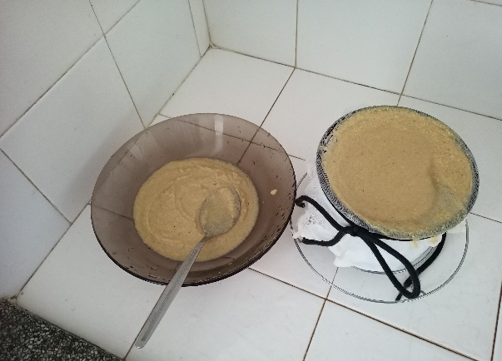
Preparation of soy milk

Step 2: Diluting Soy Milk
Allow the soy milk to cool down.
Strain the cooled soy milk through a strainer or cheesecloth to remove any solids.
Dilute 150 ml of the strained soy milk with 300 ml of water at a temperature of 37°C. This will be your dye bath.

Step 3: Pre-treatment of Textile Fabrics
Dissolve 30 g of Sodium Bicarbonate in 5 liters of distilled water, heated to 37°C.
Immerse the cotton fabric samples in the Soda Bicarbonate solution for 2 hours. This will bleach the fabric and prepare it for dyeing.

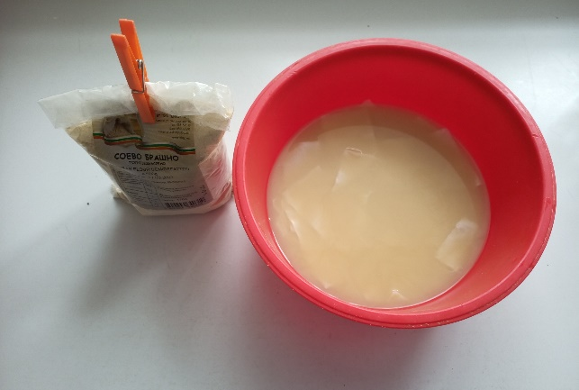
Immersing the cotton fabric samples in the Soda Bicarbonate solution

Step 4: Dyeing the Textile Fabrics
Divide the fabric samples into two groups: one for dyeing without ultrasound treatment and one for dyeing with ultrasound treatment.
For samples without ultrasound treatment, skip Steps (D) and (G) mentioned in the methodology table.
For samples with ultrasound treatment, follow the methodology table for obtaining dyes and dyeing.
Step 5: Dyeing Procedure
Place the fabric samples in the diluted soy milk dye bath from Step 2.
Allow the fabrics to soak in the dye bath for a period of 4 hours. Ensure the fabric is fully submerged.
After the dyeing period, remove the fabric samples from the dye bath and rinse them under cool running water until the water runs clear.
Hang the dyed fabric samples to dry. Avoid direct sunlight, as it may cause color fading.
Once dry, your dyed fabric is ready to use!

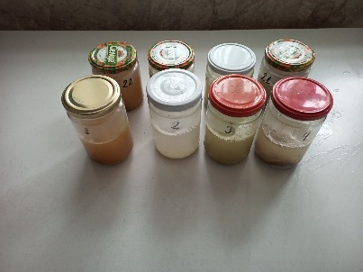 |  | 
Immersing the cotton fabric samples in the dyes | Ultrasonic treatment | Treatment in water bath

Note: The characteristics of the soy milk indicate a neutral pH and the lack of chemical bonds between the fiber and the dye. The soy milk acts as a binder, enhancing color absorption on cellulose fibers similar to protein fibers. Ultrasound treatment, if applied, may further aid in the dyeing process for some textile samples.

Tasks:

Task 3a: Research for more information on the technique of natural dyeing on the internet.
Task 3b: Describe the treatment of textile fabrics with ultrasound.

Questions:

Question 3a: Why was Soda Bicarbonate used for pre-treating the textile fabrics, and what was the concentration used?
Question 3b: Describe the methodology for dyeing the textile samples, including the steps involved and their durations.
Question 3c: What is the purpose of ultrasound treatment during the dyeing process?

Worksheet 4A: Shibori technique. Theoretical background

A sustainable approach in the fashion industry directs the use of raw materials and processes that limit the harmful impact on the environment, the use of natural dyes and, last but not least, the preservation of local traditions and interests of producers. These values strongly influence the work of designers, and in recent seasons the "tie-dye" technique is present in many of the spring-summer collections of world-famous designers and fashion houses.
From 2020-2021 Dior, Donna Karen, Tom Fort, Alexandre Voutier, Acne Studio, Proenza Schouler, Mango, Stradivarius and more. apply the technique to coats, jeans, dresses and kaftans, swimwear, including bags and shoes. Tie-dye is the most popular hand-dyeing method by tying, squishing or twisting, in which the folds are produced randomly or randomly. A very popular dyeing technique, part of the group of "sustainably dyed textiles", is the shibori technique, which has been developed in countries such as India, Malaysia, Indonesia, China, Japan, as well as in many African countries where there is a rich abundance of natural dyes and knowledge of their application to cotton, linen, wool and silk.
What is different about it is the ability to control and arrange the effects on the fabrics. By folding, sewing, twisting and tying at certain intervals, alternating the elements in rows, diagonals or circles, the technique gives opportunities to design compositions using rhythm and symmetry, which are most often applied in fabric design. This technique can be used on already made garments, single-sided on the front or back, as well as double-sided, on both parts of the garment sewn or folded together. Also, dyeing can be formed in asymmetry or combinations of different techniques can be used, which gives a rich variety in the design of clothes. For making accessories such as scarves, bags, shoes, book wear, etc. fabrics can be pre-dyed in long lengths and then sewn.
In shibori, the prevention of dye penetration is achieved by fixed pleats and folds of the fabrics, forming shapes by twisting, folding, sewing, crumpling, as well as insulating with plastic and nylon.
By sewing, pre-drawn lines, shapes, motifs, patterns and designs can be followed on the fabric, folds of different sizes can be made. Impressive effects are also obtained by application on ready-made compositions.
Despite pre-tested techniques, design and controlled stitching are not guaranteed uniform results, resulting in design uniqueness.
Famous basic shibori techniques are: Itajime, Arashi, Kanoko, Miura, Nui and Kumo. Shibori techniques: Itajime, Arashi, Kanoko, Miura, Nui, and Kumo
Mokume shibori - technique with applying stitches, Itajime shibori - folding triangles, Arashi - fixing the fabric on a tube. Kanoko shibori is an extremely precise technique of tying small knots. Miura is a technique in which small parts of the fabric drawn with a needle are tied. Nui is a technique in which stitches are passed on pre-folded fabric, which can have a variety of lines and shapes.

Tasks:

Task 4a: Describe how the designers and brands can incorporate sustainable dyeing techniques like tie-dye and shibori into their production processes. This involves sourcing natural dyes, training artisans in the techniques, and ensuring the use of environmentally friendly processes and materials.
Task 4b: Promote local traditions and interests of producers. This involves collaborating with artisans and communities who have expertise in traditional dyeing techniques, supporting their livelihoods, and incorporating their unique craftsmanship into modern fashion designs.
Task 4c: Describe how the designers will focus on creating unique and individualized designs through shibori techniques. This task involves experimenting with various folding, twisting, and tying methods to achieve distinct patterns and effects on fabrics, thereby guaranteeing the uniqueness and artistic value of each garment.

Questions:

Question 4a: How can fashion brands effectively implement sustainable dyeing techniques like tie-dye and shibori into their production processes?
Question 4b: What are the benefits of preserving local traditions and interests of producers in the fashion industry?
Question 4c: How can designers ensure the design uniqueness and individuality of garments created using shibori techniques?

Worksheet 4B: Let’s make a shibori!

The Mokume shibori effect is created by straight stitches that form vertical folds on the fabric. They can be made in different densities and arrangements, such as using alternating stitches of different sizes or a color mixing technique. Interval stitching creates rhythmic fabric effects. Seams applied after pre-folding the fabric in a circle, make it possible to form compositions with a circular symmetry.
The following graphics show the steps for making a scarf using the Mokume shibori sewing technique and dyeing with natural dyes.
The fabric is pre-cleaned with warm water and soap from the factory treatments, for easier application of the dye.

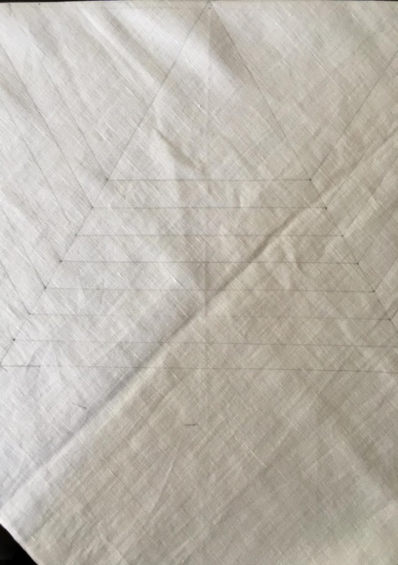 | The desired figure, in this case a hexagon, is drawn beforehand.
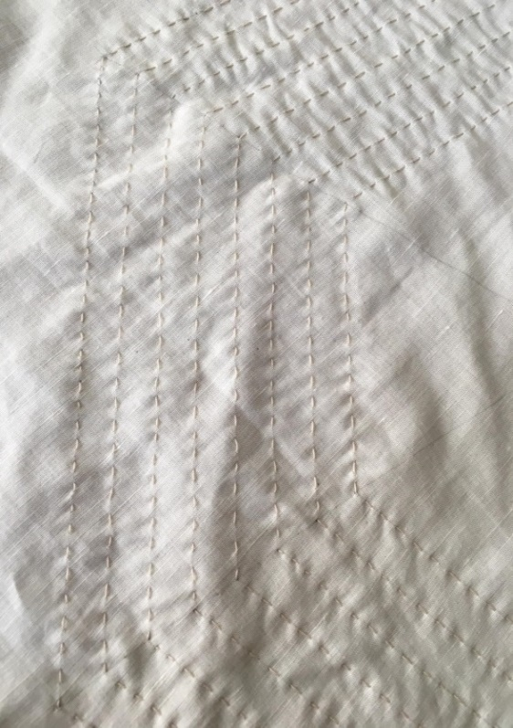 | Followed by manual passing of the seams along the outline.
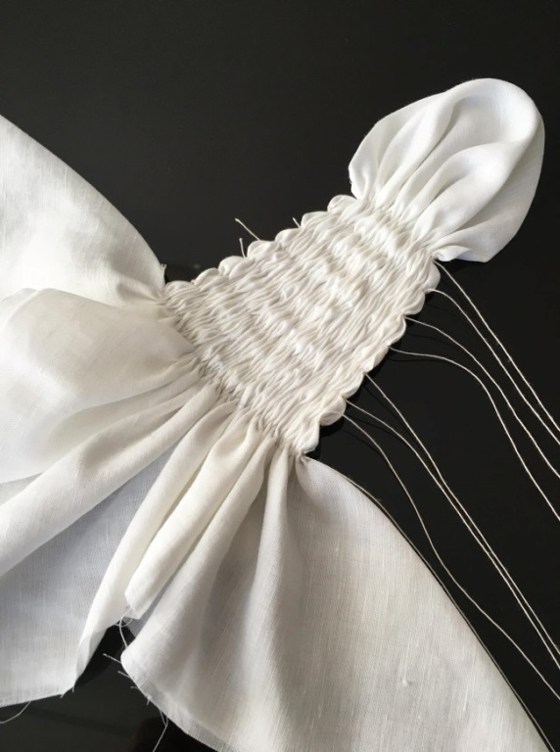 | The threads are pulled and tied tightly so that the gathered and tight seam does not allow full penetration of the dye into the fabric.  Black tea and turmeric were used for dyeing, and acetic acid was added to fix the colors in the baths.  Drying takes place in a shady and ventilated place.
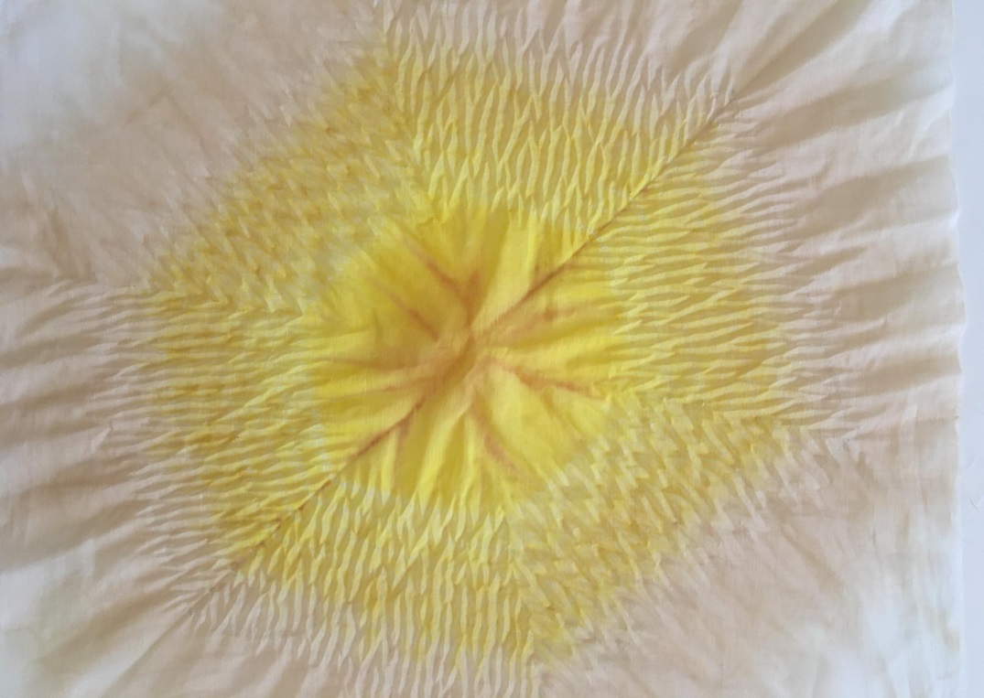 | Pulling the threads and unfolding the scarf is done after the fabric is completely dry.

Arashi shibori is the technique used to make the next turmeric dyed scarf. This variant of the presented technique has more complex shapes, but it can also be applied in an easier variant, by winding the fabric diagonally or straight in two layers, then wrapping a thread, in which striped effects are obtained.

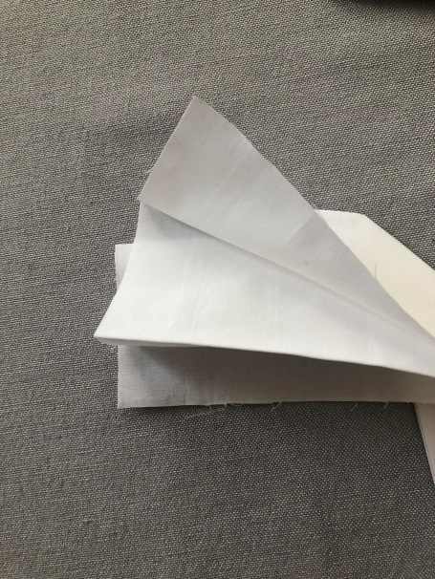 | The first step is to fold the accordion fabric of the desired width into a strip.
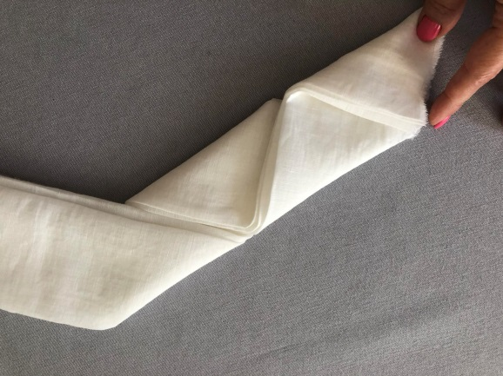 | Next, fold triangles, again obtaining a wide strip.
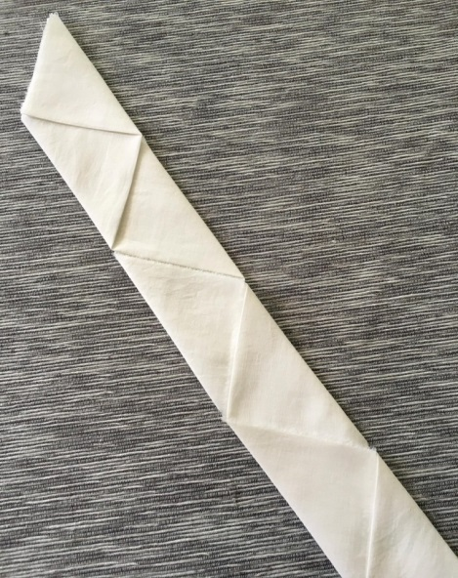 | For more precise shaping of the triangles, they can be broken with an iron.
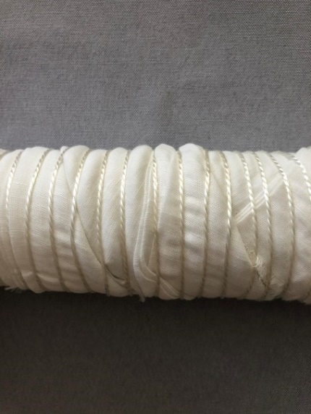 | Carefully the tape is tightly wound without a gap on a plastic tube, fixing it tightly with polyester thread at a distance of 1 cm.
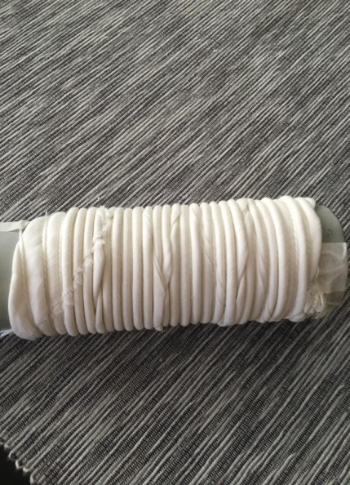 | Next is the gathering of the fabric along the tube.
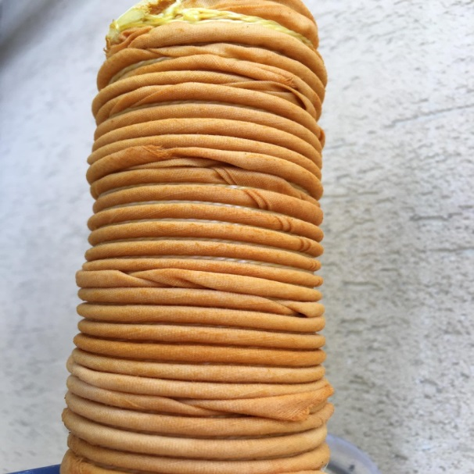 | The fabric formed in this way is immersed in the bath with the dye, where it stays for 15 to 30 minutes.
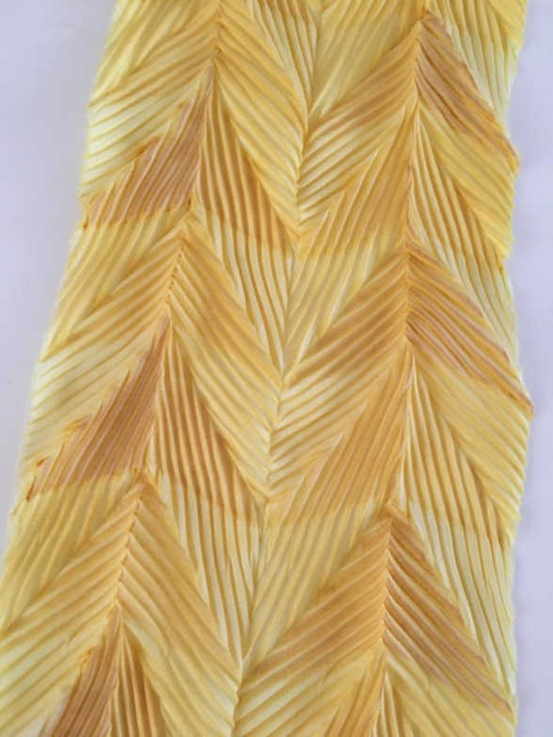 | The obtained effect after the complete drying of the fabric and release of the thread.  To fix the pleated effect longer, before releasing the thread, the fabric is wrapped in paper and cling film, then placed over boiling water for about an hour.

The Itajime shibori technique is created by pleating, folding and isolating the fabric from the dye, resulting in beautiful repeating patterns. The extremely rich variety of patterns that can be obtained with this technique makes the work very inspiring.
In the following graphics are presented only a small part of the variations that can be obtained with Itajime shibori. Two of them are dyed with natural dyes from beetroot and black tea.

 | Creasing the fabric of the pleats.
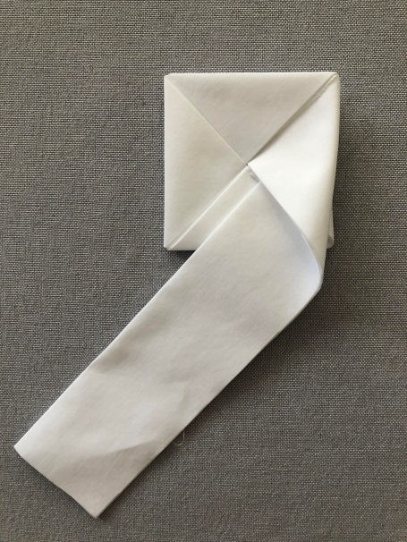 | The resulting strip is then folded into a circle.
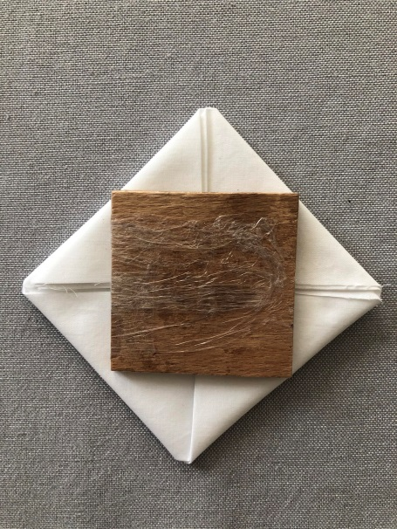 | Laying out the insulating element square diagonally.
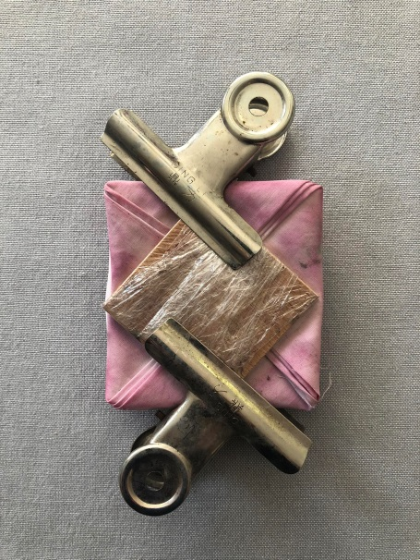 | After fixing with clips and dyeing in a beetroot bath.
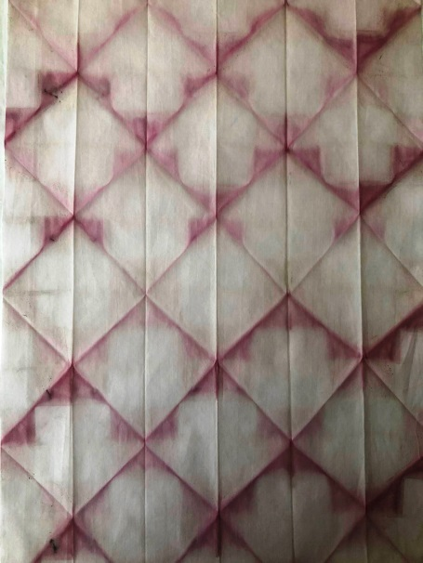 | 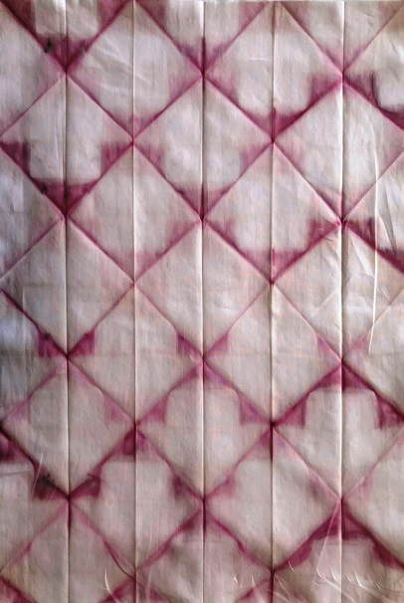
Presentation of another option of positioning the insulating element square and dyeing with black tea.

 | Creasing the fabric of the pleats.
 | The resulting strip is then folded into a circle with a size corresponding to the insulating element, in this case a square.
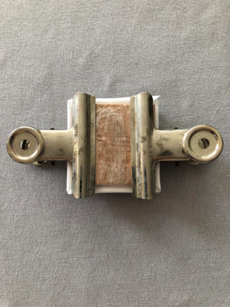 | Fixing the element, which is pre-wrapped in household film and pressing the fabric with clips before immersion in the bath.
 | After staying in the dye bath and waiting for the fabric to dry completely.

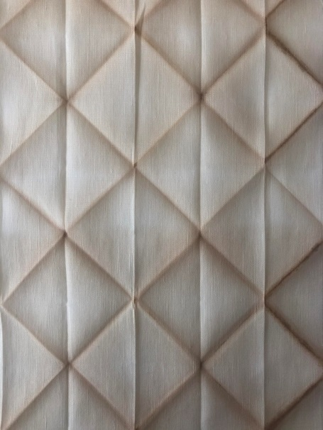 | 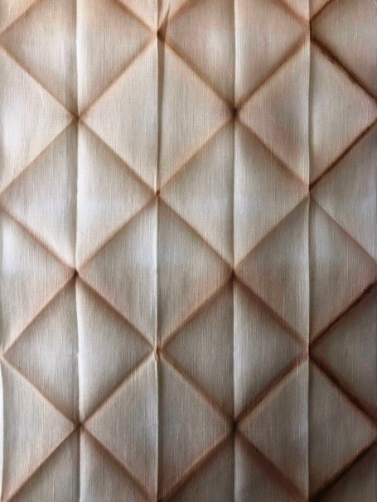
The result after unfolding.

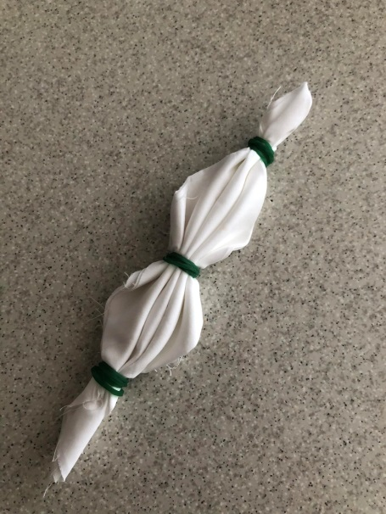 | 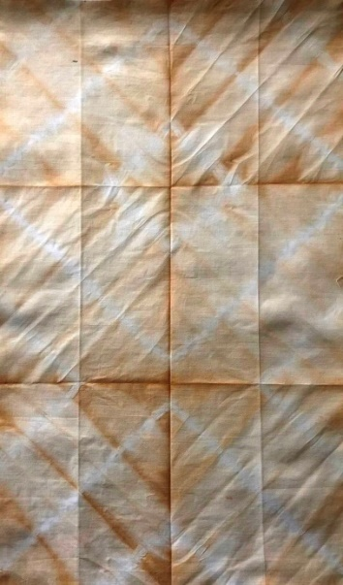
Tanning with Karkade tea.
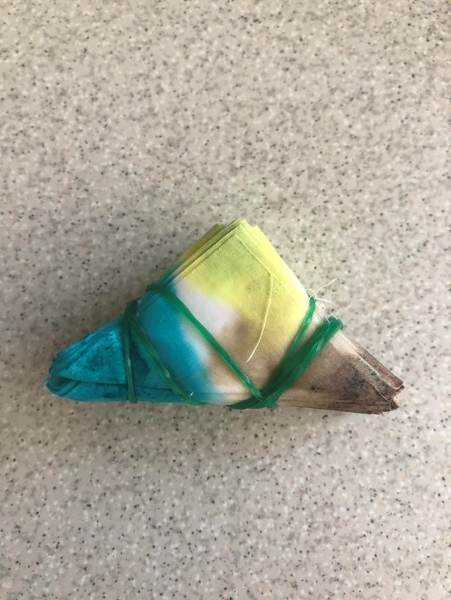 | 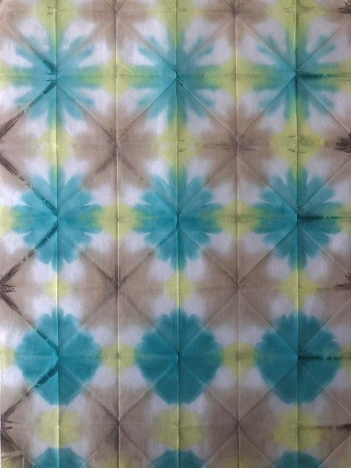
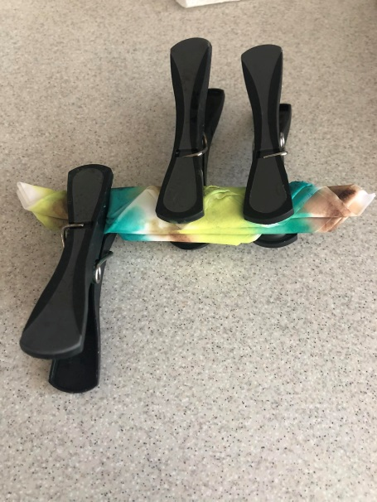 | 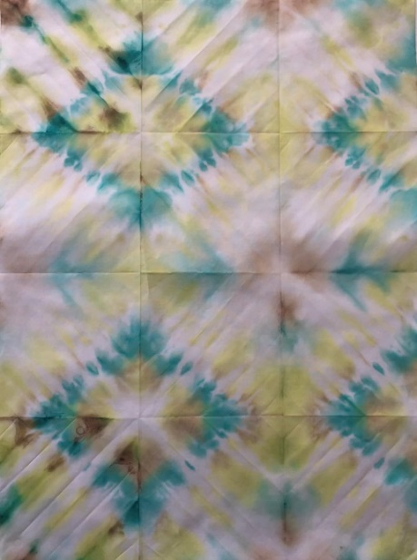
Dyeing with dyes for textiles.
The following figures show the steps for making diamond shapes by tying and dyeing with rooibos tea.

 | The first step is to fold the fabric into pleats with a width of 10 cm and more.
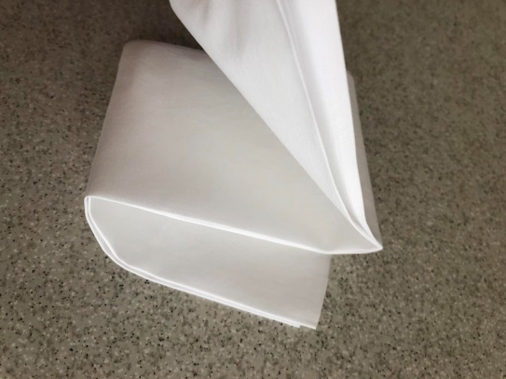 | Next is folding squares.
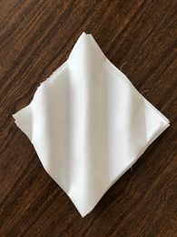 | The resulting square is smoothed with an iron along the diagonal of the square to give it a harmonica look.
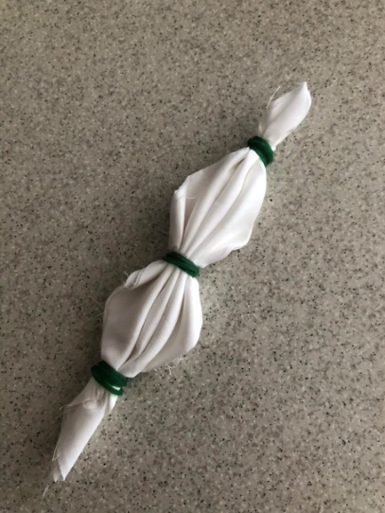 | The resulting pleats are fixed with rubber bands or thread.  Next is immersion in the dye.
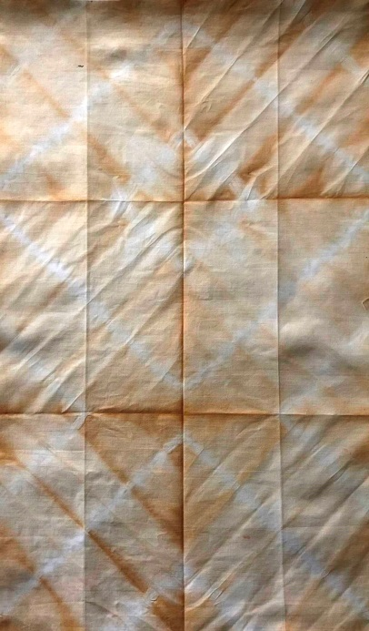 | The effect obtained after dyeing with Rooibos tea.

The Kumo (cobweb) technique suggests the effects on the figures obtained by twisting with a thread the area that we want to isolate from the dye. The most popular and common is the round shape in this technique, but the next variation shown is a square shape. Many other more complex floral, geometric and stylized animal figures can be made with the technique.

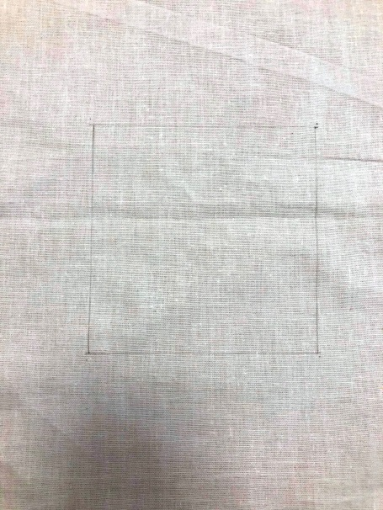 | First, we draw the desired size on the fabric and determine the location of the figure.
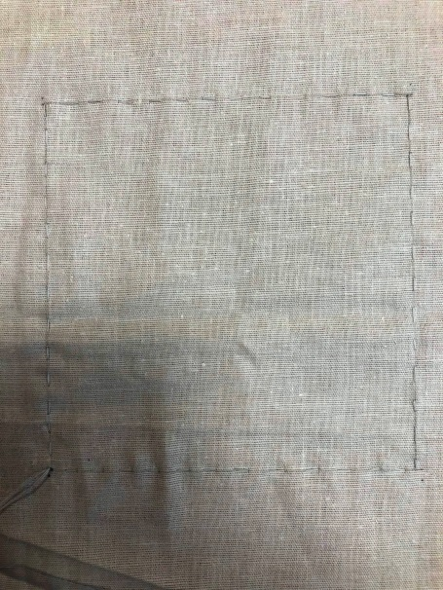 | Next, apply the stitch along the outline, with the two ends of the thread coming together at one point.
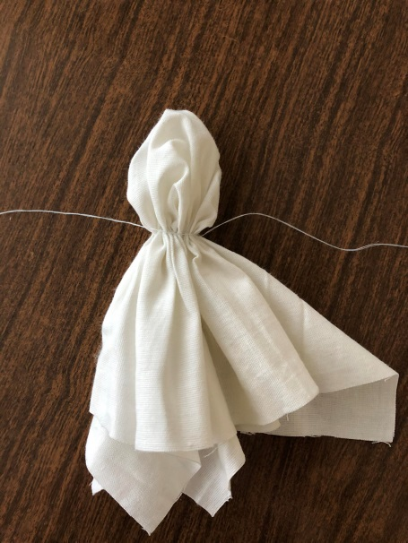 | We pull both ends of the thread at the same time and tie tightly.
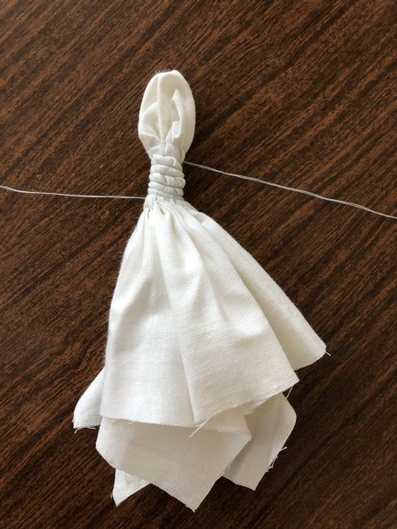 | We begin to twist tightly first with one end of the thread, and then in the opposite direction and the other end.
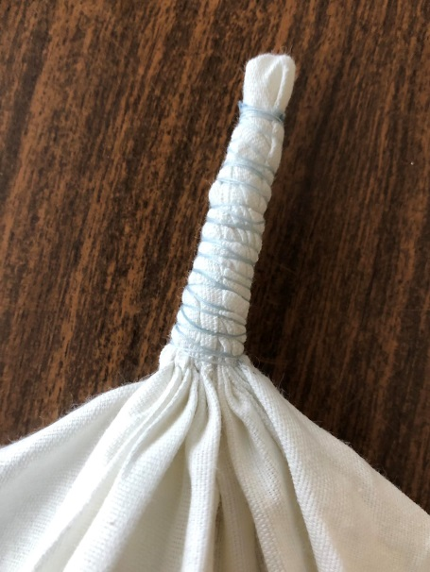 | We tie tightly at the top. Next is immersion in the dye.
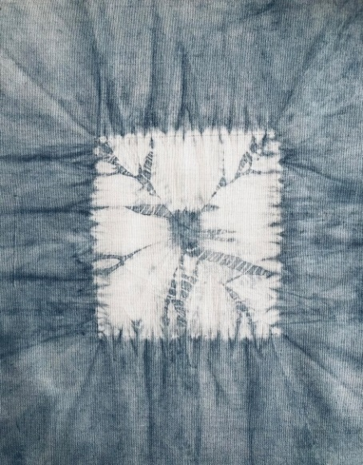 | After the fabric is completely dry, we untie the threads.  In this case, the dyeing was done with indigo.

Worksheet 5A: And it is time for your design! Sketch your idea

Make a sketch of your design idea for sustainable fashion shibori product.

Worksheet 5B: Sustainability of your design

Describe your design idea in the context of sustainable fashion.

_________________________________________________________________________________________________________________________________________________________________________________________________________________________________________________________________________________________________________________________________________________________________________________________________________________________________________________________________________________________________________________________________________________________________________________________________________________________________________________________________________________________________________________________________________________________________________________________________________________________________________________________________________________________________________________________________________________________________________________________________________________________________________________________________________________________________________________________________________________________________________________________________________________________________________________________________________________________________________________________________________________________________________________________________________________________________________________________________________________
___________________________________________________________________________

And now… Maybe it is time for realizing of your design idea. Are you ready for shibori dyeing? Try it!

