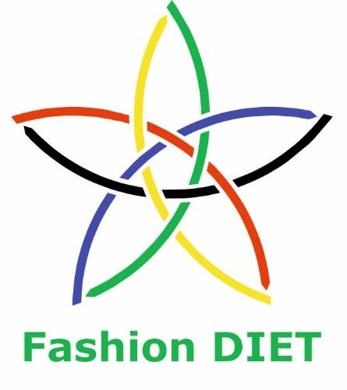

Sustainable Fashion Curriculum at Textile Universities in Europe
–
Development, Implementation and Evaluation of a Teaching Module for Educators

Project: 2020-1-DE01-KA203-005657

Title of the Lesson: Recycling and Upcycling of Knitwear

Author: Prof. Dr. Mirela Blaga
Contact Data: ‘’Gheorghe Asachi’’ Technical University of Iași, Romania
Faculty of Industrial Design and Business Management
E-mail: mirela.blaga@academic.tuiasi.ro
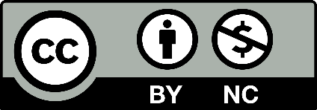


Introduction to the Teaching and Learning Materials

Short Description of the Content:

Considering the dimension and versatility of knitting as a second technique for the production of textiles, this module presents different solutions for the reuse, recycling or upcycling of knitwear. The first part of the material focuses on providing basic knowledge about knitting and the most popular knitting patterns and their trade names. Information about the main properties of knitted fabrics will also be given in order to become familiar with their behavior in the next stages of recycling or upcycling and with their possible new uses.
Another goal is to raise awareness about the possibility of choosing products made of environmentally friendly fibers or even reusing fibers to save them from a landfill where they would otherwise end up. Through the examples presented, learners can get some ideas for solutions to recycle or upcycle knitwear and be inspired by the content to make knitwear more affordable, ethical and sustainable.

Competences and Learning Objectives:

After this unit, students should be able to:

- recognize a knitted material and understand its basic properties;
- know end uses that a knitted material can have;
- understand the basic difference between the technologies used;
- recognize what type of fabric it is and which parts are reusable;
- know how to separate parts of knitted fabrics to avoid their destruction;
- investigate different solutions for recycling and upcycling knitted fabrics;
- find alternative uses for waste before or after production;
- apply these solutions to other old knitwear.

Overview of Working Materials

Lesson module 1:
Topic: Getting familiar with knitting technology
Worksheet 1: Types of knitted fabrics and products

Lesson module 2:
Topic: Environmental impact of the fashion industry
Worksheet 2: Environmentally friendly fibers for sustainable knitwear

Lesson module 3:
Topic: Recycling post- consumer knitting waste
Worksheet 3: Let’s make new products from old knitwear

Lesson module 4:
Topic: Recycling pre-consumer knitting waste
Worksheet 4: Sketch your own idea for a new product design

Lesson module 5:
Topic: Upcycling knitwear
Worksheet 5: Use your creativity to design a new product

Sources

- Ray, S. C. (2012), Fundamentals and Advances in Knitting Technology. New Delhi. Woodhead Publishing India Pvt. Ltd.
- Ray, S. (2022), Introduction to advances in knitting technology, book chapter in Advanced Knitting Technology, edited by S. Maity et. al., 2022, Elsevier, ISBN: 978-0-323-85534-1.
- Spencer D.J. (2001), Knitting technology: a comprehensive handbook and practical guide, third edition, Woodhead Publishing House, Cambridge, UK, 2001.
- Pavko Čuden, A. (2023), Knitting towards sustainability, circular economy and
Industry 4.0, Applied Research, DOI: 10.1002/appl.202200087.
- Blaga, M. (2016), CAD for flat knitting technology, Edit. Performantica, Iași, 978-606-685-459-7
- Blaga, M. (2022), Use of CAD in knitted apparels, in Advanced Knitting Technology, Editors: S. Maity, S. Rana, P. Pandit, K.Singha, 2022, Elsevier, UK, https://doi.org/10.1016/B978-0-323-85534-1.00015-5, ISBN: 978-0-323-85534-1, pp.181-201.
- Peterson, J. (2012), Customisation of Fashion Products Using Complete Garment Technology, Ph.D. thesis, Tampere University, ISSN 1459-2045
- Nakamura, M. (2014), Shima Industrial Solutions, IFKT Congress, Izmir, Turkey.
- Raz, S. (1993), Flat Knitting Technology, Westhausen - Germany. Universal Maschinenfabrik Dr. Rudolf Schieber Flachstrickmaschinen.

Websites

https://www.textileschool.com/251/knitted-fabrics-and-types/
https://www.sustainyourstyle.org

Tutorials

https://www.youtube.com/watch?v=inAL9UEGx3c
https://www.youtube.com/watch?v=NfHlI79KX6k
https://www.youtube.com/watch?v=DOJVOYX449U
https://www.youtube.com/watch?v=ao18SW-9Rg4
https://ro.pinterest.com/pin/846324954991894221/
https://ro.pinterest.com/pin/211174975293443/
https://ro.pinterest.com/pin/140806231032480/
https://werefarfromnormal.com/no-sew-sweater-pumpkins
https://truebluemeandyou.com/post/136405253735/how-to-recycle-a-whole-sweater
https://www.justthewoods.com/upcycled-sweaters/
https://www.google.com/search?q=Upcycling+old+sweaters&sa=X&ved=2ahUKEwjiwuDi8t39AhUJCewKHerHBM4Q1QJ6BAgWEAE&biw=1280&bih=609&dpr=1.5#fpstate=ive&vld=cid:2487a103,vid:yUkXS_3xDoM,st:202

Lesson module 1:
Topic: What is knitting?
Worksheet 1: Types of knitted fabrics and products

Textile fabric is defined as "a two-dimensional sheet-like structure made of textile materials (fibres or yarns or their combination) with adequate strength, elongation, flexibility, etc., for various applications, especially apparel. Weaving, the technology for making fabrics by interlacing two sets of threads (warp and weft), is the oldest technique for making fabrics, and knitting is the second oldest and second most popular technique for making fabrics or garments by interlacing one or more sets of threads. Knitted fabrics are elastic materials, made by yarns initially formed into loops and then interconnected in order to produce a textile structure. The main raw materials for knitwear are cotton, wool, silk, linen, cotton, viscose, rayon and others (Ray, 2012, 2022).
Knitted fabrics are produced by two general methods – warp knitting, and weft knitting, and each method produces a variety of types of knitted fabrics. The processes differ depending on the type of knitting. In warp knitting, each yarn has its needle, and the fabric is knit vertically. Weft knitted fabrics consist of one thread interlaced horizontally. The main characteristics of the two methods are summarized in Table 1.1 (Spencer, 2001).

Tab. 1: Comparison between weft and warp knitting

Weft knitting - the stitches of the yarn are joined across the width of the fabric. | Warp knitting - the stitches are joined together in a vertical direction.
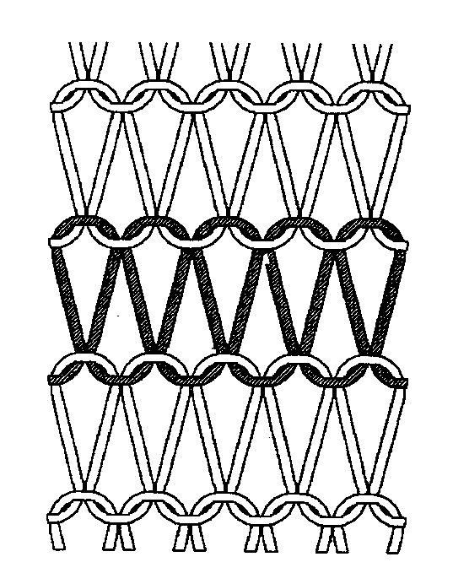  Weft Knitting: Image source: Spencer, 2001 | 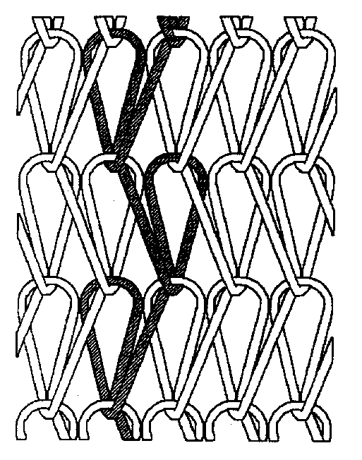  Warp Knitting: Image source: Spencer, 2001
Fabric can be formed with a few yarns  supplied in the form of a cone. | Fabric can be formed with a large number of yarns supplied from a warp beam.
They possess low dimensional stability; thus, weft-knitted fabrics are easily stretched. | Exhibit much higher structural stability. Due to the strong, loop-based connection at the fabric joints, warp-knitted fabrics can be produced in a wide range of mesh structures.
The loops of yarn trap air which retains body heat to keep us warm. | It can be cut and sewn easily as it lies flat when cut. It is mainly used with synthetic filament yarns.
It can be heavy gauge (thick for outerwear) or very fine gauge (used for underwear). | It can be cut and sewn easily as it lies flat when cut.
The fabric can unravel and will ladder if a stitch is dropped, or the yarn is broken. | The fabric does not unravel or ladder.
Typical products: T-shirts, jumpers, cardigans, sweatshirt fabrics. | Typical products: Net curtains, swimwear  terry towels, patterned tights, lace fabrics.
Tab: 2 Weft and Warp knitted patterns
(Images sources: https://www.textileschool.com/251/knitted-fabrics-and-types/ and Blaga, 2016.

Type of fabric | Fabric’s name | Description | Picture
Weft | Jersey knit | Jersy, plain or single knit, is a structure family which has one side consisting only of face stitches, and the opposite side consisting of back stitches  Jersey knit has visible flat vertical lines on the front and dominant horizontal ribs on the back of the fabric.  A major disadvantage of regular flat knits is their tendency to "run" when a thread breaks.  The flat or jersey stitch can be varied by using different yarns or double loop stitches of different lengths to make terry, velour and plush fabrics. This stitch is very much used in the manufacture of men's and women's underwear and T-shirts. | 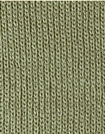  Face side  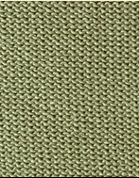  Reverse side
 | Rib knit | When the fabric is viewed from one side, it exhibits one wale made of face loops, one wale made on reverse loops and so on. The fabric is very elastic in the width direction.  Rib knitting is used for the bottom edges of sweaters, for the cuffs of sleeves and for the neckline. It is a reversible fabric, as it looks identical on both sides of the fabric. | 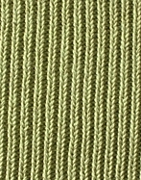  Face/reverse side
 | Purl knit | In a basic 1x1 purl fabric, one course is made of face loops while the next course is made of reverse loops.  It is often used for making thick sweaters and children's clothing. The fabric is reversible and identical on both sides of the fabric.  The fabric does not curl and lies flat. It is stretchable in the longitudinal direction. | 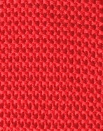  Face/reverse side
 | Full Cardigan | The Full Cardigan is made of a repeat of one course of all knit on front needles and all tuck on back needles, the second course of all tuck on front needles and all knit on back needles.  It looks identical on both sides. Excessive tuck loops make the fabric bulky and thick, appropriate for sweaters and fashion garments. | 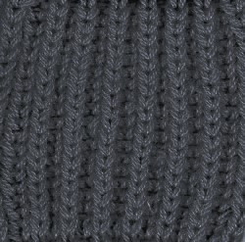  Face/reverse side
 | Half Cardigan | The Half Cardigan is made of one course of all knit on both needle beds and second course of all knit on front needles and all tuck on back needles. The tuck loops present in the fabric reduce the stretch in width direction.  It is not a reversible fabric. The spaces between the wales on the face of the fabric are closer together than those of the Full Cardigan. | 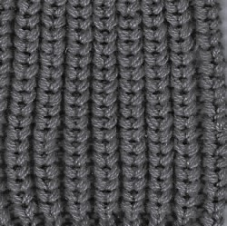Face side
 | Interlock Knit | Interlock fabric is a type of double-knit fabric. This type of knit results in thicker, stronger, stretchy, and more durable fabric than other types of knit fabric. While the construction of interlock fabrics makes the fabric feel very firm, it also has a soft and smooth texture Interlock knit fabric is very comfortable and can be used for a variety of things (T-shirts, turtlenecks, casual skirts and dresses, and children’s wear). | 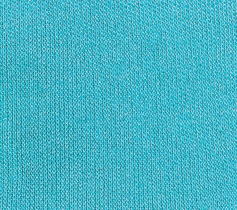  Face/reverse side
 | Cable  Knit | Cable fabric is a double-knit fabric made by the special loop transfer technique. Wales in the fabric have a rope-like an appearance, where plaits are based on the transfer of loops with adjacent wales.  The fabric has an interesting surface texture like braids as the loops cross each other. It is widely used as sweater fabric. | 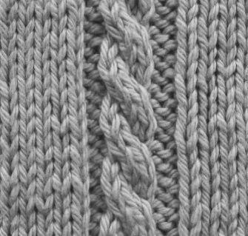  Face side
 | Pointelle | Pointelle is a type of double-knit fabric. The fabric has patterned miss stitches.  The fabric looks like lace, with holes created by these transferred stitches.  The feminine look of the fabric makes it ideal for women’s tops and children's clothing. | 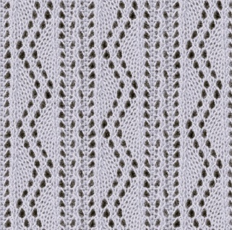  Face side
 | Jacquard Knit | Jacquard is a term that comes from weaving. In simple terms, it is a process of combining two or more colours by knitting one colour onto either the front or back of the fabric to create a visual pattern.  Jacquard are fabrics made on knitting machines with a jacquard mechanism to select different coloured stitches from different threads in the same row. Jacquard knit fabrics are suitable for tops, skirts, dresses, sturdy leggings and cardigans. Jacquard knits are thicker than most knits and are perfect for structured tops, jackets, skirts and dresses. | 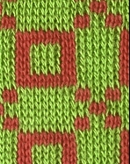  Face side  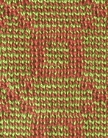  Reverse side
 | Knitted Velour | Knitted Velour are pile jersey fabrics having soft protruding fibers on the fabric surface. Like knit terry, they are also made of an additional set of yarns making pile loops on the fabric surface. In Velour, these pile loops are sheared evenly and brushed. They are used in luxurious apparels like jackets, blouses, dresses. | 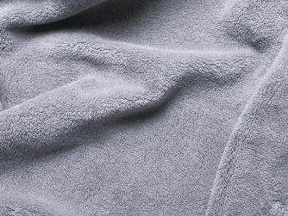  Face side
Warp | Tricot Knit | Tricot knits are made almost exclusively from filament yarns because uniform diameter and high quality are essential yarn characteristics for use with the very high-speed Tricot knitting machines.  Fabrics constructed by the tricot knitting machine are usually plain or have a simple geometric design. The front surface of the fabric has clearly defined vertical wales, and the back surface has crosswise courses. | 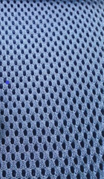  Face/reverse side
 | Raschel Knit | Raschel knits are produced from spun or filament yarns of different weights and types.  Most Raschel knits can be identified by their intricate designs, the open-space look of crochet or lace, and an almost three-dimensional surface effect design. | 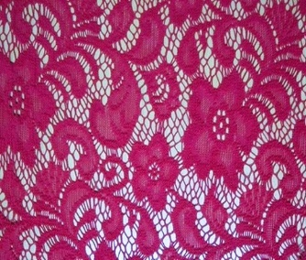  Face side

Compared to other fabrics, knit fabrics are much more elastic, which is why they have always been used for stockings and other garments that require a change in shape. Knit fabrics can stretch up to 500 percent of their original size, depending on the material and knitting pattern. The elasticity of knitted fabrics gives them excellent drapability, but this is offset by their generally greater thickness compared to woven fabrics (Ray, 2022).

Knitting technology can be used to produce products with outstanding properties, such as: knitting in shape, great flexibility in manufacturing (geometry, shape and yarns), controlled mechanical properties, excellent formability, stretch ability. Knitted fabrics are used worldwide for a variety of apparels, household, and industrial purposes (Blaga, 2022).
There are four main reasons why clothing brands have opted for knitted rather than woven fabrics.

Softness - This salient characteristic is what makes knitwear so special. The soft feel of the textile on both sides helps manufacturers create comfortable clothing.
Elasticity - Knitted fabrics have impressive flexibility, as different types of yarn can be combined, and are often used for sportswear. In addition, fabrics blended with spandex yarns stretch, allowing you to move freely during workouts.
Wrinkle resistance - Knitwear is elastic and keeps its shape even after sitting or moving. Therefore, it does not need to be ironed, which is much more convenient and saves a lot of time.
Breathability - The structure of the knitted fabric ensures that the clothes dry quickly due to the space between the connected threads. The fabric is very moisture wicking and comfortable to wear without sticking.
The production methods of knitted garments manufactured on flat knitting machines are described below and displayed in Figure 1 (Peterson 2012, Blaga, 2022).

1) Cut & sew, in which the pieces for the front, back and sleeves are knitted in a rectangular shape and then cut into shape. Both cutting and sewing are processes after knitting that take place outside the knitting machine.
2) Fully-fashioned or shape knitting is a production method in which the front, back and sleeve pieces are knitted in the final shape directly in the knitting machine (Raz, 1993). The cutting process is either minimal or eliminated altogether, but some cutting after knitting may still be necessary;
3) Integral knitting is a method in which trimmings, pockets, buttonholes and other design features are knitted directly into the finished produced pieces. Both the quality and appearance of the finished garment can be improved by this method of incorporating decorations into panels directly in the knitting process, minimizing both cutting waste and after knitting processes.
4) Complete garment, is the method of knitting the entire garment directly in the flat knitting machine. The advantage of this technique is that no material is wasted and no expensive post-knitting operations are required. With the seamless technique, manufacturing processes are reduced and consequently the production time.

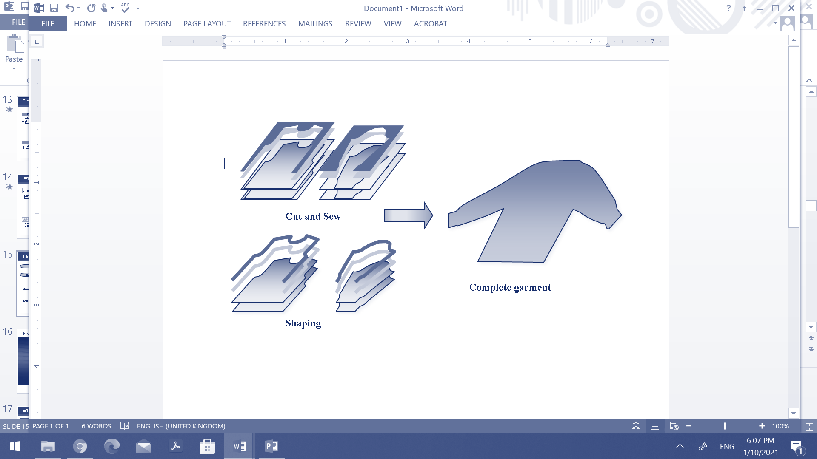

Figure 1: Methods of producing fabrics on flat bed weft knitting machines (Image source: adapted from Nakamura, 2014)

Task 1.1: Identify materials in your closet and household textiles that are made by weft and warp knitting. Assign them to the appropriate category after studying Table 1.
Task 1.2: Read carefully the description and associated images of the most popular categories of knitwear from Table 2, for getting familiar with the most known knitted materials and their trade names.
Task 1.3: Search the internet for knitted fabric products and consider a specific use based on the appearance and structure, after studying the description of the most common knitted structures.

Lesson module 2:
Topic: Environmental impact of the fashion industry
Worksheet 2: Environmentally friendly fibers for sustainable knitwear

Aspects of the environmental impact of fast fashion

It is well known that the fashion industry is the second largest polluter in the world right after the oil industry. And environmental damage is increasing as the industry grows. However, there are solutions and alternatives to mitigate these problems. The first step is to create awareness and a willingness to change.
Some of the environmental problems are related to the raw materials used to produce textile materials by different technologies or to dye/print them. Therefore, it is good to be informed about what the solutions are and how we, the consumers, can contribute to a sustainable planet.
In most countries where garments are manufactured, polluted wastewater from textile mills is discharged directly into rivers without treatment, which is extremely harmful to aquatic life. Another major source of water pollution is the use of fertilizers to grow cotton, which heavily pollutes runoff and evaporative waters. We can choose clothes made in countries with stricter environmental regulations for factories and choose organic and natural fibers that do not require chemicals for their production. 20% of the industrial water pollution comes from textiles treatment and dyes (https://www.sustainyourstyle.org).
The fashion industry is a major water consumer. A huge quantity of freshwater is used for the dyeing and finishing process for all of our clothes (up to 200 tons of freshwater per ton of dyed fabric). Cotton needs a lot of water to grow and heat, around 9,700 liters are needed to produce just 1kg of cotton. This generates tremendous pressure on this precious resource, already scarce, and has dramatic ecological consequence. 5 trillion liters of water are used by the fashion industry each year. We can choose fibers with low water consumption such as linen, recycled fibers, etc (https://www.sustainyourstyle.org).
Microfibers pollution of the fashion industry happens every time we wash a synthetic garment (polyester, nylon, etc.), about 700,000 individual microfibers are released into the water, making their way into our oceans. Scientists have discovered that small aquatic organisms ingest these microfibers. These are then eaten by small fish, which in turn are eaten by larger fish, allowing plastic to enter our food chain. 190,000 tons of textile microplastic fibers are going into the oceans each year. We have the option of using products made of natural or semi-synthetic fibers, to wash clothes only when you need to and to wash clothes at a lower temperature, i.e. 30ºC (https://www.sustainyourstyle.org).
The fashion industry's waste problem has become a serious issue, with a family in Europe throwing away an average of 11 kg of clothing each year. Only 15% is recycled or donated, the rest ends up directly in landfills or is incinerated. Synthetic fibers, such as polyester, are plastic fibers and therefore non-biodegradable, and can take up to 200 years to decompose. Synthetic fibers are used in 69% of our clothing. Every second, the equivalent of 1 garbage truck is wasted with textiles. Synthetic fibers, such as polyester, are plastic fibers, therefore non-biodegradable, and can take up to 200 years to decompose. Synthetic fibers are used in 69% of our clothing. We should, therefore, choose natural or semi-synthetic fibers, buy less, buy better quality and recycle (https://www.sustainyourstyle.org).
Chemicals in the fashion industry are one of the main components of our clothing. They are used in fiber production, dyeing, bleaching and wet processing of each of our garments. The massive use of chemicals in cotton farming leads to disease and premature death among cotton farmers, as well as massive pollution of freshwater and oceans and degradation of soil quality. 24% of the world's insecticides and 11% of pesticides are used in cotton production. We can choose organic fibers and sustainable brands, always wash new clothes before wearing them for the first time, and look for garments with certification marks that control chemical content, such as OEKO-TEX®, GOTS®, or BLUESIGN® (https://www.sustainyourstyle.org).
Greenhouse gas emissions from the fashion industry, accounting for between 5% and 10% of global greenhouse gas emissions. The global fashion industry generates a lot of greenhouse gases due to the energy used in the production, manufacturing and transportation of the millions of garments purchased each year. Synthetic fibres (polyester, acrylic, nylon, etc.) used in most of our garments are made from fossil fuels, so production is much more energy intensive than natural fibres. 70 million oil barrels are used every year to produce polyester. We have the option of choosing natural fibers, to buy less, buy better quality, mend clothes and buy clothes made in countries powered by more renewable energy (https://www.sustainyourstyle.org).
Soil degradation caused by the fashion industry is a serious problem because we need healthy soils for food production, but also for CO2 sequestration. Massive, global soil degradation is one of the most important environmental issues currently facing our planet. It poses a major threat to global food security and also contributes to global warming. The fashion industry contributes to soil degradation in several ways: Overgrazing of pastures by cashmere goats and sheep raised for their wool; degradation of soils due to massive use of chemicals to grow cotton; deforestation due to wood-based fibers like rayon. If nothing changes, food production will decrease by 30% in the next 20-50 years because soils are degraded. Therefore, we should opt for soil- friendly fibers (https://www.sustainyourstyle.org).
Rainforest destruction caused by the fashion industry, because every year, thousands of hectares of endangered and ancient forests are cut down and replaced by plantations of trees used to make wood-based fabrics such as rayon, viscose, and modal. This loss of forests is threatening the ecosystem and indigenous communities, as in Indonesia where large-scale deforestation of the rainforests has taken place over the past decade. 200 million trees are cut down each year to make our clothes. 30% of rayon and viscose clothing comes from endangered and ancient forest. 6% of the global apparel industry uses forest-based fabrics (https://www.sustainyourstyle.org).
Task 2.1 As a class, discuss some environmental issues related to the fashion industry in your country or in the region where you live. Give students the time they need to discuss and share their prior knowledge and related knowledge.
Task 2.2 Make a list of things you could do as a consumer to help preserve the environment by thinking about the aspects you read above.
_______________________________________________________________________________________________________________________________________________________________________________________________________________________________________________________________________________________________________________________________________________________________________________________
Environmentally friendly fibers for sustainable knitwear
Considering all these facts about the textile and fashion industry, conscious choices should guide us through our daily lives, where textiles have become indispensable. Thus, it is very useful to have information about the fibers and yarns used, especially the eco-friendly fibers whose production process has a low impact on the environment.
The global network https://www.sustainyourstyle.org has conducted a comprehensive study and selected the sustainable fiber categories that are presented below and recommended when choosing a textile material and product.
Recycled Fibers made with waste material (Adapted from https://www.sustainyourstyle.org/en/fiber-ecoreview)

Name of the fiber | Environmental benefits | Example of products/Brands
Recycled polyester (rPET) is made from recycled plastic bottles. The production of recycled polyester (PES) requires far fewer resources than virgin fiber and produces fewer CO2 emissions. However, it is still not biodegradable and takes years to disappear once it is thrown away. Moreover, it still releases microfibers made of plastic. | Between 45% and 70% less CO2 emissions generated during rPet production compared to virgin polyester (PES).  60% less energy is required to produce rPet compared to virgin polyester. | 100% recycled polyester fleece. Fair Trade Certified™ sewn https://eu.patagonia.com
Recycled nylon avoids waste in landfills and uses less resources in its production than new nylon, including water, energy, fossil fuels. Recycled nylon is derived from old fishing nets, nylon carpets and pantyhose. It is still more expensive than new nylon, but has many environmental benefits. Research is necessary to increase the quality and reduce the cost of the recycling. | 46% of the plastic in the ocean is made up of nylon fishing nets.  640.000 tons of fishing gears including nylon nets, are dropped every year in the oceans. | Palomar Crop Top is made out of 80% recycled nylon and 20% spandex fabric, rated UPF 30+ to 50+ https://www.outerknown.com
Recycled cotton prevents additional textile waste and requires far fewer resources than conventional or organic cotton. Cotton can be recycled from old garments or textile scraps. The quality of the cotton can be lower than that of new cotton, therefore, is usually mixed with new cotton. The production of recycled cotton is still very limited. | 2783 liters of irrigation water can be saved per kilo of cotton recycled | Recycled blanket - made from GRS (Global Recycle Standard) certified Recycled Cotton and Recycled Polyester. 100% recycled yarn https://wawwaclothing.com
Recycled wool is also a very sustainable option. Aside from keeping garments made from used wool out of landfills, it saves a significant amount of water, reduces land use for sheep grazing, and avoids the use of chemicals for dyeing. Recycled wool helps reduce air, water and soil pollution. There are few certification marks that guarantee consumers that wool is recycled, such as the Global Recycled Standard (GRS). | Up to 94% of CO2 emissions reduction  using recycled wool instead of virgin wool. | Knitted sweater made with 100% recycled merino, from pre-consumer textile waste. Soft feel and designed to keep you warm.  https://organicbasics.com
Recycled textiles  Currently, a lot of research is being done to make textiles from textile waste. Since we generate so much textile waste pre-consumer and post-consumer, it makes sense to reuse it instead of throwing it away. However, due to the difficulty of separating the fiber blend and other technological challenges, this type of textile is not yet readily available. | 11 kg textile waste is generated per person per year in the EU in average. | Circulose®, https://circulo.se  NuCycl™, https://www.evrnu.com/nucycl  LivaReviva, https://www.birlacellulose.com/liva-reviva.php  Textloop™, https://circularsystems.com/texloop

Task 2.3 Look at your closet and household textiles and find out which ones are made from recycled fibers. Study the label of the product to get more information. Write down at least 3 examples.
_________________________________________________________________________________________________________________________________________________________________________________________________________________________________

Plant-based fibers with low environmental impact
(Adapted from https://www.sustainyourstyle.org/en/fiber-ecoreview)

Name of the fiber | Environmental benefits | Example of products/Brands
Organic cotton solves most of the environmental problems faced by conventional cotton production, and the fabric has the same quality as conventional cotton.  It is grown from seeds without the use of pesticides, insecticides or fertilizers. Unlike conventional cotton, organic farmers use traditional farming methods such as crop rotation, mixed cropping or no-till to preserve the soil. | Only 1,4% of global cotton production is organic.  Several organizations have established certifications for organic cotton, such as GOTS, USDA-NOP, Organic Content Standards, IVN and Naturland, confirming that a product is truly organic. | -Regular fit jeans made in dry selvage denim woven in the legendary denim-town Kojima, in Okayama, Japan  https://www.nudiejeans.com/  -Socks - 75% Organic Cotton, 23% Polyamide, 2% Spandex. Fairtrade, GOTS, and Vegan Certified.  https://consciousstep.com/
Linen is a natural fiber obtained from the flax plant. It uses far fewer resources than cotton or polyester, such as water, energy, pesticides, insecticides, and fertilizers. Flax can grow in poor soils that are not used for food production. Flax plants also have a high carbon absorption rate. | 1 hectare of flax absorbs more than 3.7 metric tons of CO2.  60% less water is required to grow flax compared to cotto. | Sleeveless Dress - 100% Organic certified Linen  https://www.peopletree.co.uk/
Hemp fibre is obtained from the plant of the same name, which is one of the fastest growing plants and requires little water, energy or fertilizers. The plant is very good for the soil, it can be grown for many years in the same place without depleting it. | Hemp produces 3 times more fiber per acre than cotton.  A 1/4 of the water  needed to grow cotton is needed to grow hemp. | Women - hemp shoes engineered in Portugal. Super Strong Hemp fibers, world's 1st Hemp Insoles, Algae Bloom soles.  https://www.8000kicks.com

Task 2.4 Look at your closet and household textiles and find out which ones are made from plant-based fibers. Study the label of the product to get more information. Write down at least 3 examples.
_________________________________________________________________________________________________________________________________________________________________________________________________________________________________
Task 2.5 Search the Internet for other brands that use plant-based fibers for their products.

Animal-based fibers produced in sustainable way
(Adapted from https://www.sustainyourstyle.org/en/fiber-ecoreview)

Name of the fiber | Environmental benefits | Example of products/Brands
Alpaca fiber is obtained from the fleece of the animal of the same name. Alpacas are much more environmentally friendly than cashmere goats because they cut the grass, they eat instead of pulling it out. Alpacas need very little water and food to survive. | Alpacas produce 4 to 5 sweaters per year while cashmere goats need 4 years to produce only 1 sweater.  Alpacas eat only 1% to 2% of their weight daily while cashmere goats eat 10% of their body weight daily. | 100% Alpaca Reversible Beanie Hat  https://alpacaproducts.co.uk/
Responsible Wool Standard (RWS), ensures that farms use best practices to protect the land and treat animals decently. | Certified organic wool is still quite rare on the market. GOTS is the only organization that certifies organic wool and that no pesticides are used on the pastures or on the sheep themselves. | Freja Organic Wool Tights (organic merino wool)  https://swedishstockings.com/
Sustainable Cashmere  Conventional cashmere has significant environmental consequences. There are some sustainable cashmere options that address these environmental issues and allow us to buy cashmere. | 4 years are necessary for 1 goat to grow enough hair to produce just 1 sweater.  Goats eat 10% of their body weight. | The Cashmere Sweater, made from post-consumer recycled cashmere  https://www.asket.com/
Sustainable leather  Leather can be eco-friendly. There are some options in the market, Ecolife™ by Green Hides, which creates eco-friendly, chrome-free leather in Italian tanneries that recycle and purify wastewater. | Conventional leather is heavily criticized for the environmental impact of the tanning process. | https://www.leatherworkinggroup.com/

Task 2.6 Search the Internet for other brands that use eco-friendly animal-based fibers for their products.

Semi-synthetics with low environmental impact
(Adapted from https://www.sustainyourstyle.org/en/fiber-ecoreview)

Name of the fiber | Environmental benefits | Example of products/Brands
Lyocell (Tencel®)  “Lyocell” is the generic name of the manufacturing process and the fiber, which is more environmentally friendly than its relative’s modal and viscose. Tencel® is the brand name of Lyocell sold by Lenzing AG. Tencel® is made from eucalyptus from certified forests. | Just like rayon and viscose, Lyocell is 100% biodegradable.  Lyocell is produced in a closed-loop system that recycles almost all of the chemicals used.  Eucalyptus trees grow quickly without the use of pesticides, fertilizers or irrigation. | Essential Bra - 95% Tencel modal, 5% Elastane  https://www.savaraintimates.com/
Sustainable viscose  Conventional viscose is usually not very sustainable, due to many chemicals are used in its production, which pollute the environment a lot when they get into the waste water. | There are few sustainable options on the market that are worth mentioning, such as ENKA®, Eastman Naia™. | LENZING™ ECOVERO™ branded viscose fibers are the new standard for environmentally friendly viscose, with much smaller ecological footprint.  https://www.lenzing.com/
Cupro is an artificial cellulose fiber made from Cotton wastes. All the process is made in closed-loop. The large quantities of water and chemicals used in the production of Cupro are therefore constantly reused until they are completely exhausted. | Cupro is biodegradable, so it considers a good eco-friendly alternative to viscose.  The chemicals used are free of toxic or dangerous compounds for health and the environment. | https://www.asahi-kasei.co.jp/fibers/en/bemberg/

Task 2.7 Look at your closet and household textiles and find out which ones are made from eco-friendly synthetic fibers. Study the label of the product to get more information. Write down at least 4 examples.

Task 2.8 Search the Internet for other brands that use eco-friendly synthetic fibers for their products.

Lesson module 3:
Topic: Recycling post- consumer knitting waste
Worksheet 3: Let’s make new products from old knitwear

Post-consumer waste is disposed of by the consumer at the end of product’s use or life and is largely collected in a separate system. Largely, post-consumer cannot be easily collected because they are coming from many different users and thus, require significant levels of sorting. When collected, it is first sorted into two broad categories: unwearable for recycling and wearable for re-use.
Individually, if we look into our own closets, we will find, for sure, left behind or old-fashioned clothes, which can be transformed into more design attractive pieces or have other end uses.
Tips to keep in mind when analysing knitwear for recycling

If you want to use a used or old product for recycling, you should pay attention to some details that will help you in the next steps.

- Construction: it's important that the parts of the jumper have been shaped on knit and not made from knitted fabric that has been shaped on cut;
- Type of seams: look for seams that unravel easily, they look like a small column of Vs;
- Fibre content: look at the label to determine the fibre content of the jumper, it is preferable wool and wool blends;
- Weight: It's best to look for heavier sweaters because they can be transformed into a yarn suitable for hand knitting patterns;
- Sweaters: commercial cardigans with button plackets often have the yarn cut off where the buttonholes are made, so you end up with several shorter pieces of yarn when you unravel a cardigan;
- Felting: If the fabric is felted, it won't unravel. So, look for fabric that has spaces and rows when stretched horizontally and vertically. This makes it more likely that you'll be able to successfully unravel the fabric.

Let’s make new products from old knitwear

Look in your closet and find a sweater, jacket, or cardigan that you haven’t used in a while and think is old-fashioned. The example shown here is a classic jacket made from a blend of acrylic and wool yarns, with long sleeves and patch pockets on the front.

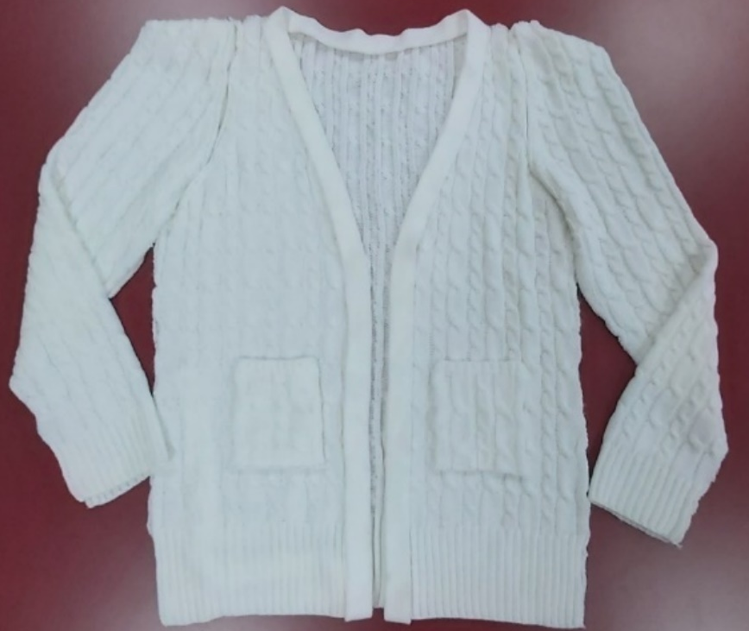

After analyzing the product, you should identify and separate the parts of the sweater without destroying them. The jacket is made of shaped panels and can be easily disassembled by carefully pulling apart the sewn parts. We can separate the two front and one back, two sleeves, two pockets and one decorative collar.

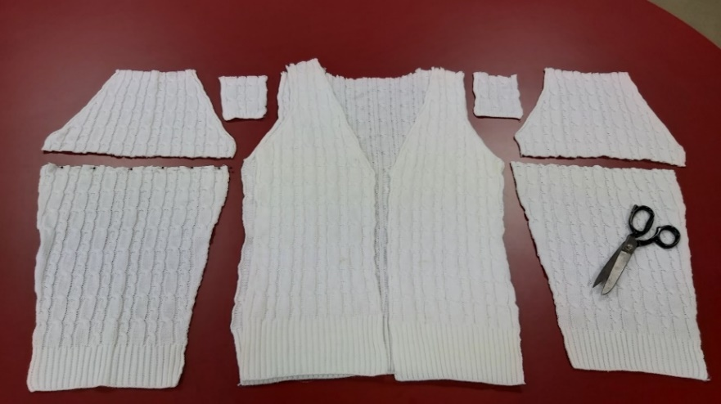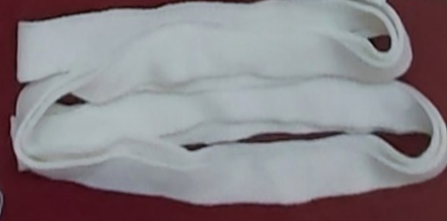

CC-BY-SA-NC Blaga

We can make a pair of leggings out of the sleeves by cutting off the tops. The idea is to use the edges of the panels, which are made of a ribbed structure that is very elastic and therefore easy to shape around the leg. You will need scissors, a few pins and sewing thread, which can also be of a different color if you want to make a colorful border.

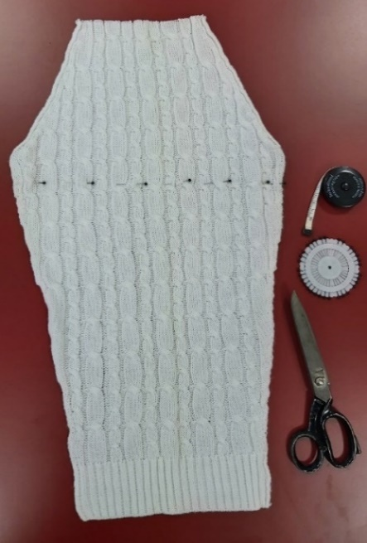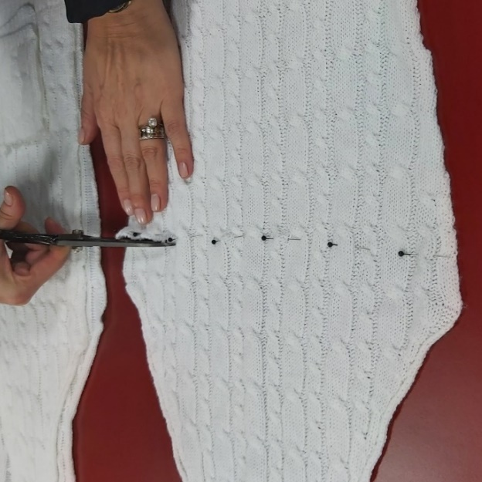

We can either use a sewing machine or hand sewing. If we use a sewing machine, we should make a normal seam on the upper edge and a closing seam in the form of a tube on the back. Then turn the tubes on the front side and use them.
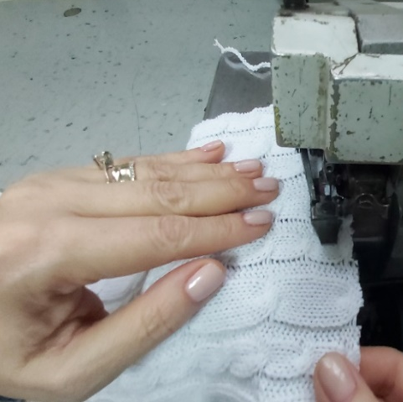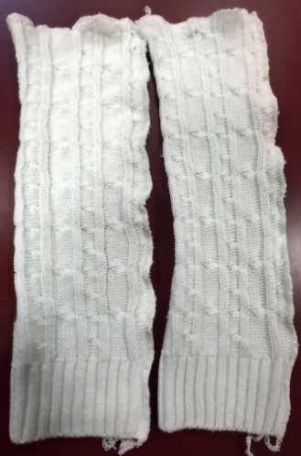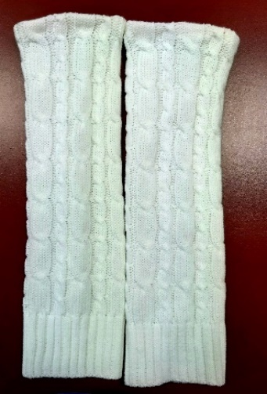
CC-BY-SA-NC Blaga

From the lower part of the front and back we can make a skirt, using the elasticity of the material and the opening of the older jacket. Besides scissors, threads, pins, we need an elastic band, for fixing the skirt on the waist and enriching the design of the new product.

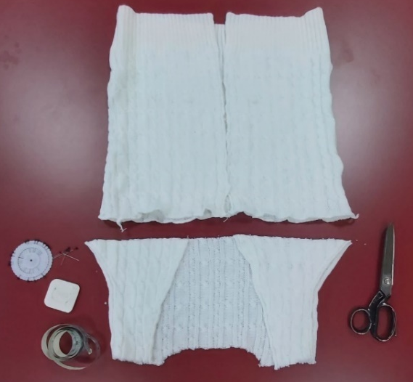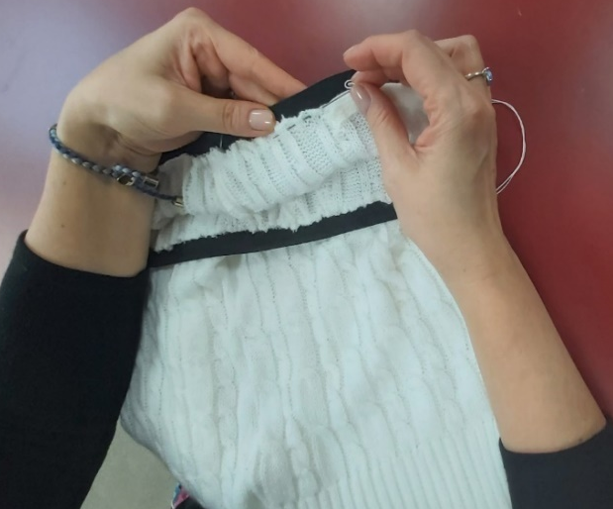

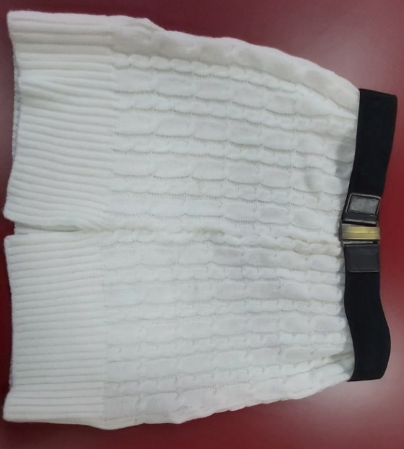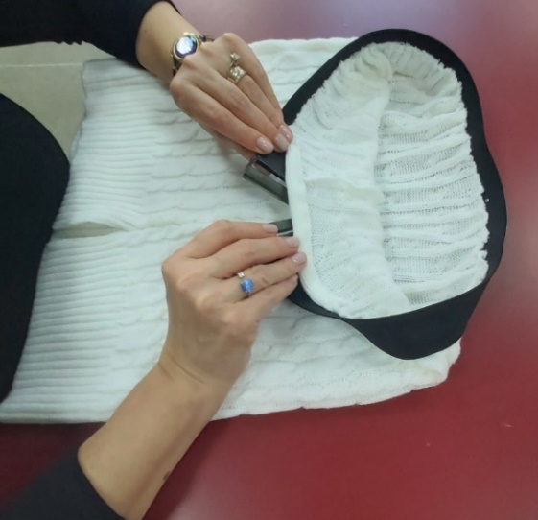

A decorative cable can be used for the trimmings of the skirt, as exemplified.

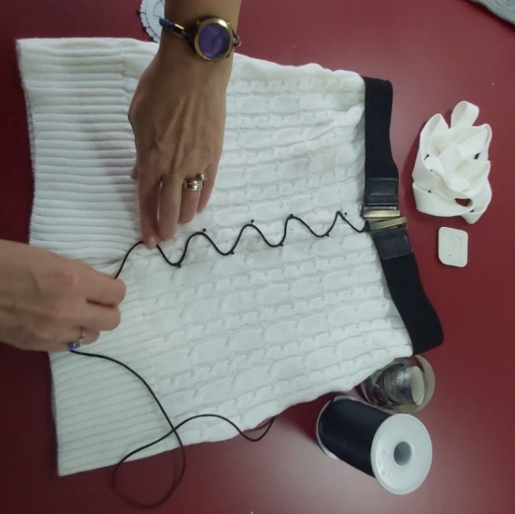
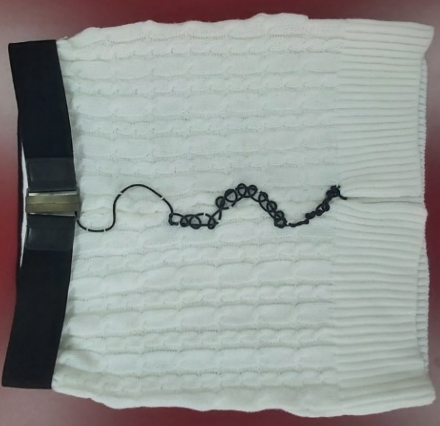

CC-BY-SA-NC Blaga

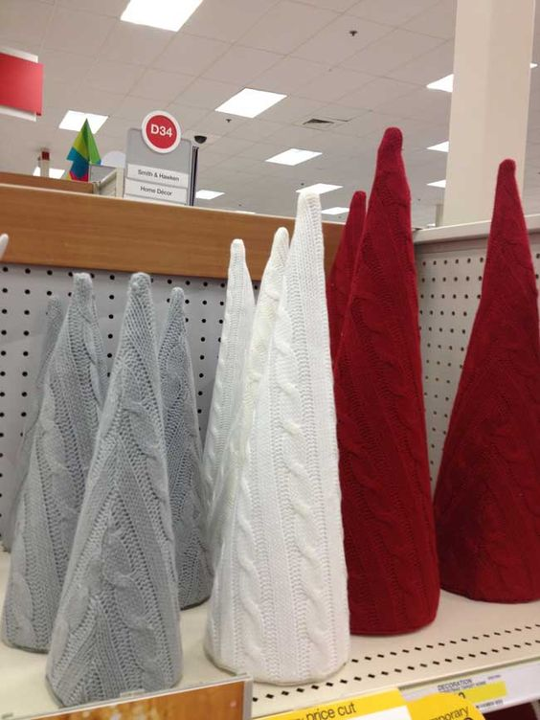
The upper parts of the front and back can be turned into decorations, such as miniatures of Christmas trees. The columns simulated by the cable design are very useful to suggest the tree leaf. The different colors of the fabrics, white, red and green, beautifully enhance the seasonal decoration.
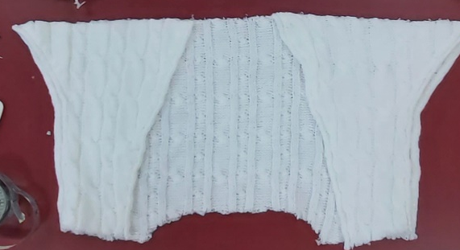

CC-BY-SA-NC Blaga
All parts can be used, so the pockets can be nicely and easily turned into useful cup holders. By doubling the material, you can get an attractive double face and thicker coup holder, trimmed by a colored seam.

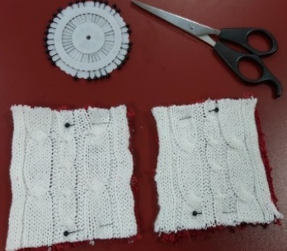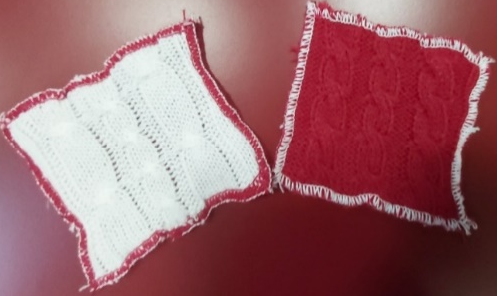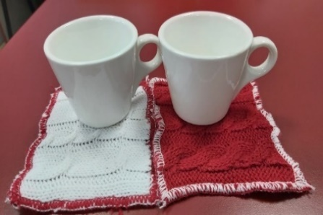

CC-BY-SA-NC Blaga
Below is a similar example from a student’s project who recycled an old sweater and made a new outfit out of it, consisting of: leggings, skirt and a short-sleeved scarf.

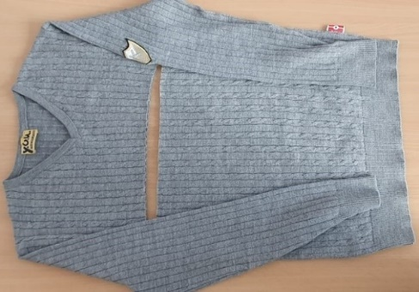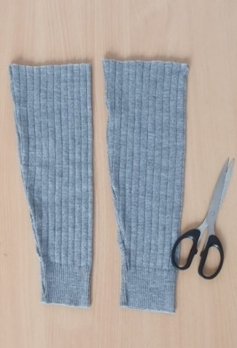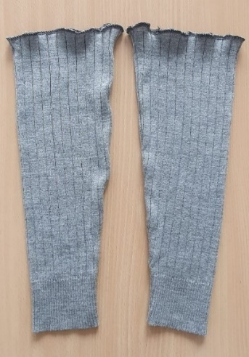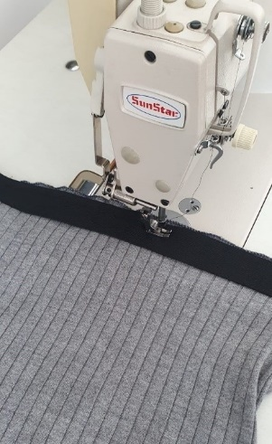

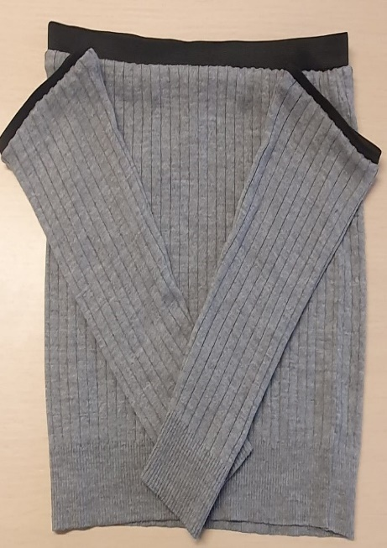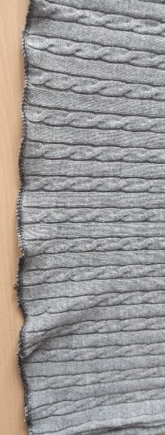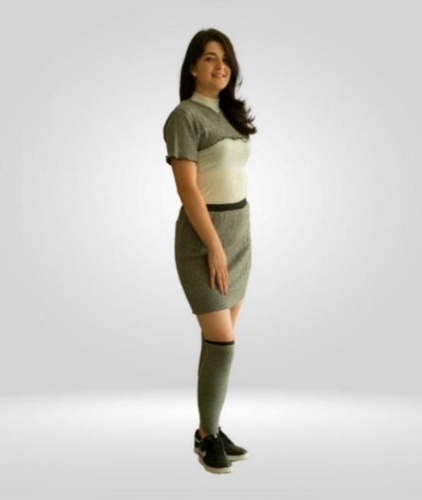

CC-BY-SA-NC Hurjui Mihai

Task 3.1 After looking at these examples and the selected tutorials from the list at the beginning, look around for products you don’t use. Let your creativity run wild and create new products! Have fun with it! Also consider if this can be a business for you!
Lesson module 4:
Topic: Recycling pre-consumer knitting waste
Worksheet 4: Sketch your own idea for a new product design

Pre-consumer material in general, is material diverted from waste in the manufacturing process (ISO, 2016) and is the easiest waste to sort because it is mostly generated during the manufacturing process. This waste, generated before it reaches the consumer, requires limited sorting, but still needs to be processed before it can be used in remanufacturing or recycling streams.

Sketch your own idea for a new product design

1st example of a student’ project: designing an Easter Egg

In automatic flat knitting technology, waste can be generated by the panels produced on the machines for experimental purposes, by faulty panels, or by leftovers from an old production.

In this example, the panels produced in the applications of CAD for the knitting course were considered for recycling or upcycling to create unique products and in this way, in addition to the technical skills, to develop the creativity of the students.

During the course CAD, students practiced jacquard structures in the software and on the knitting machines and made small panels on the theme of Easter. Each panel had the student's touch and vision on the theme. The students used the same colors and the same structure of the panel, the bird's eye back. Some examples of individual patterns are shown for example.

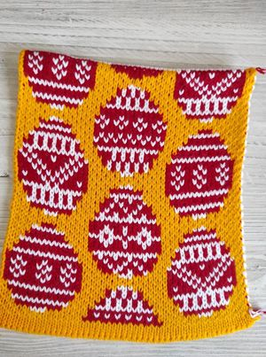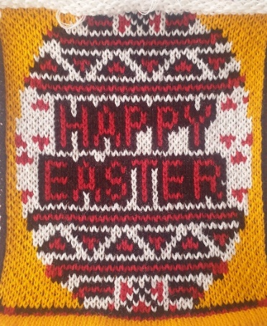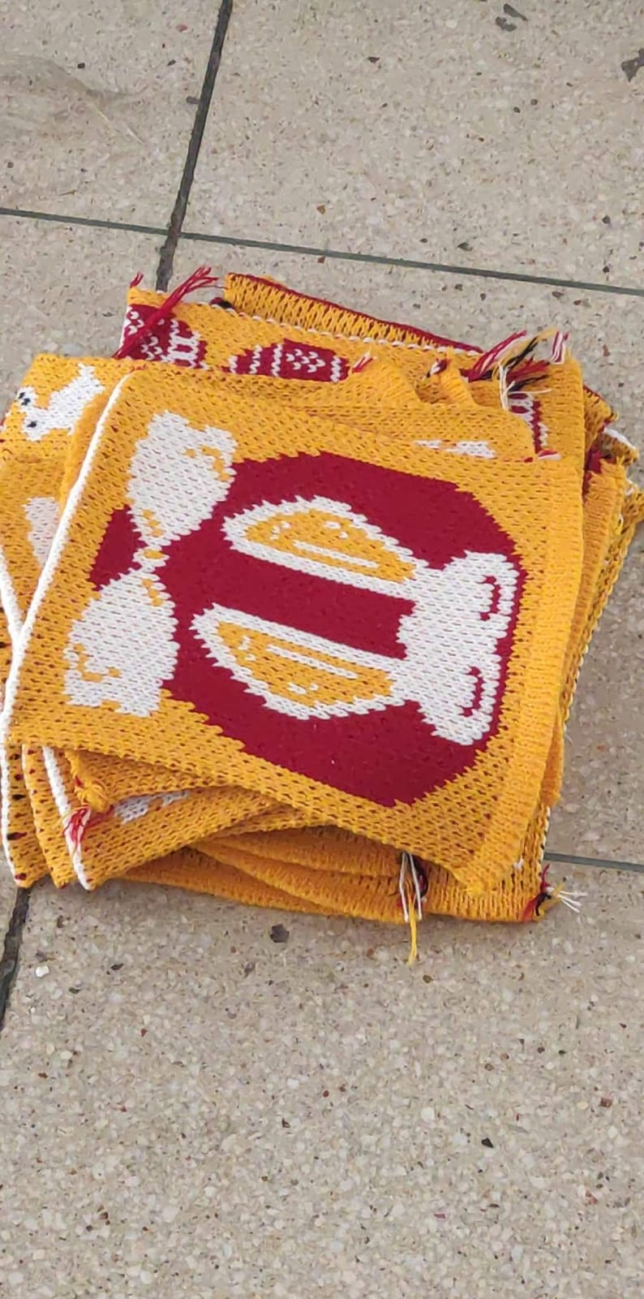

The students’ idea was to build a large Easter egg by assembling the individual parts developed for their project. They collected old packing boxes and first made a holder for the object. Then they used other boxes to develop a round shape that served as a support for the large egg.

With this frame, the pieces of fabric were glued together one by one to form the round shape of the egg. The result is an impressive egg with a height of 1 m and a diameter of 70 cm. It was decorated with a collar made of interlock fabric and lace left over from other products. It was exhibited in the foyer of the faculty on the occasion of Easter.
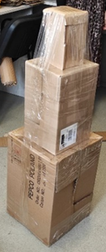
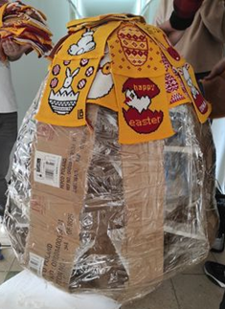

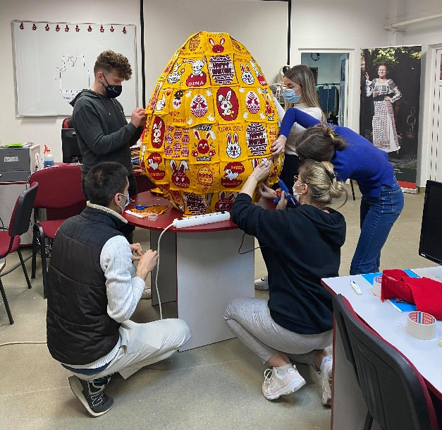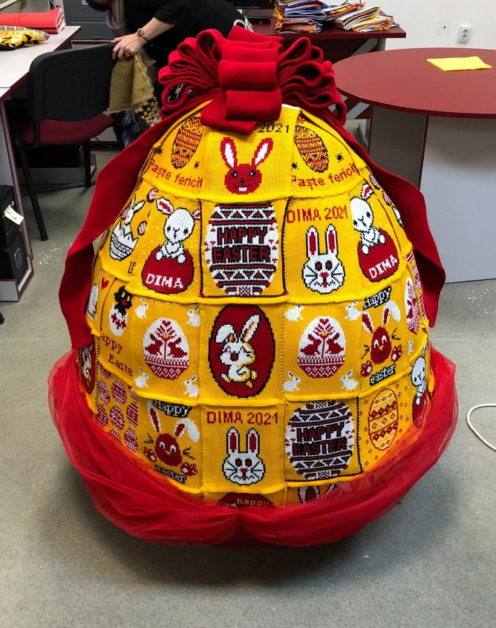

CC-BY-SA-NC Blaga

2nd Example of a student project: design of cup packaging

Panels produced on automatic flat knitting machines are provided with a separating zone, which is automatically produced together with the fabric. This can be separated from the panel by pulling off the separating thread, leaving a narrow piece of fabric for knitting when the individual panels are produced. This piece is a waste and usually is not used. Since it is a relatively small piece, some small decorative items could be made.

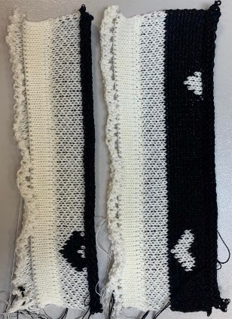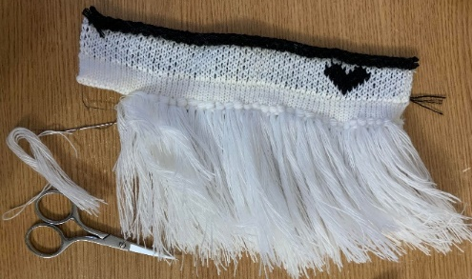
CC-BY-SA-NC Costețchi Vica
The narrow pieces were cut and decorated with fringes and adapted as bridal pair cups.

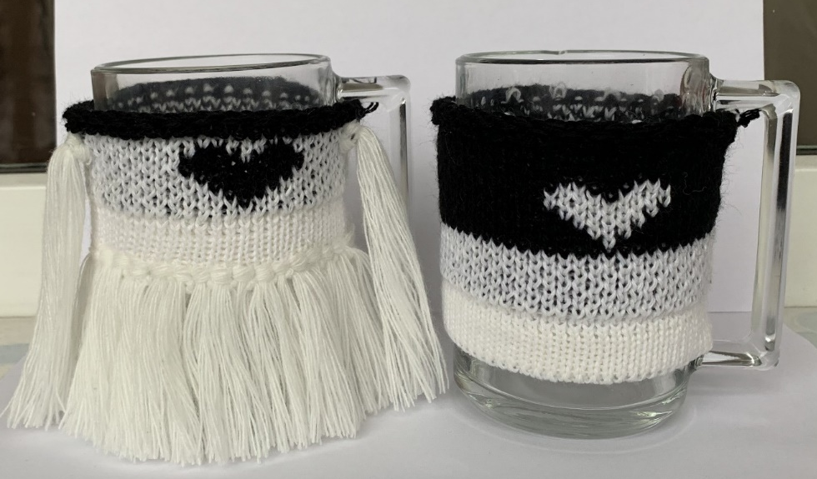

CC-BY-SA-NC Costețchi Vica

3rd Example of a student project: design of a fashion bag

Students will learn to design knitting patterns in Stoll's special M1plus® software and make rectangular or shaped areas on the knitting machines for practice. In addition to patterned fabrics, ribs can also be knitted as individual pieces on the machines. In this example, the student used a panel of two-color jacquard with transfer, an old piece of a monochrome fabric, and a rib from the other color of fabric. She folded the jacquard fabric lengthwise, made an inside pocket from the single-color fabric, and a pocket handle from the rib.

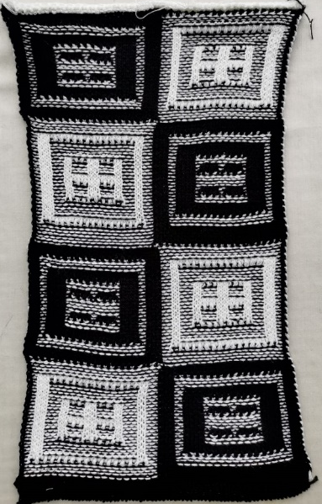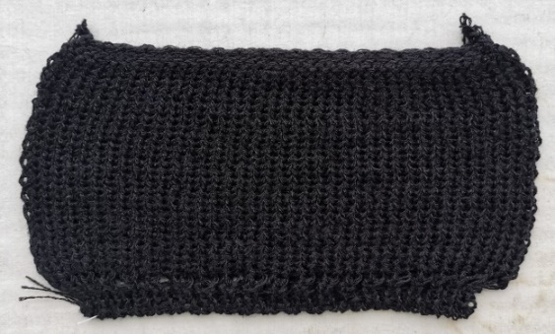

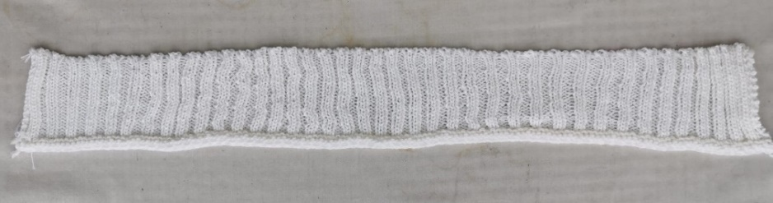

CC-BY-SA-NC Peter Czenge

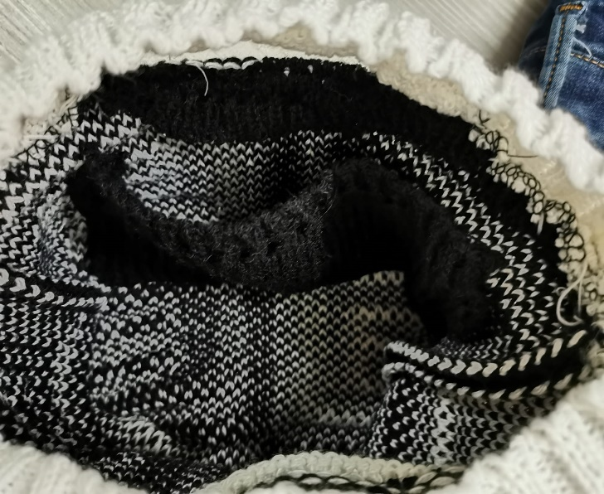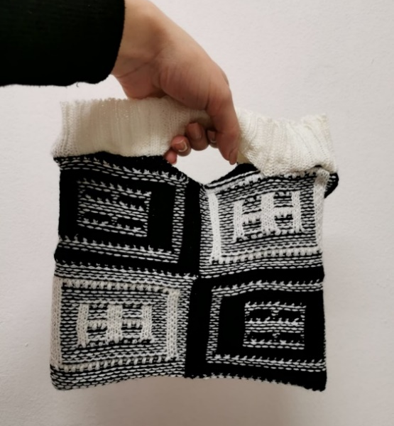

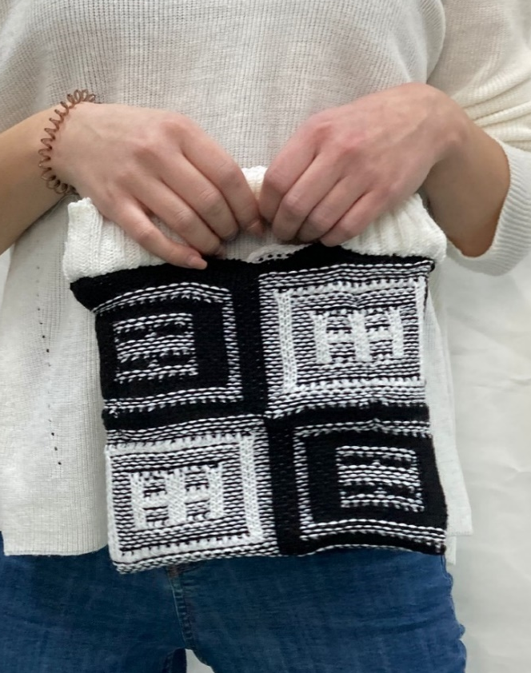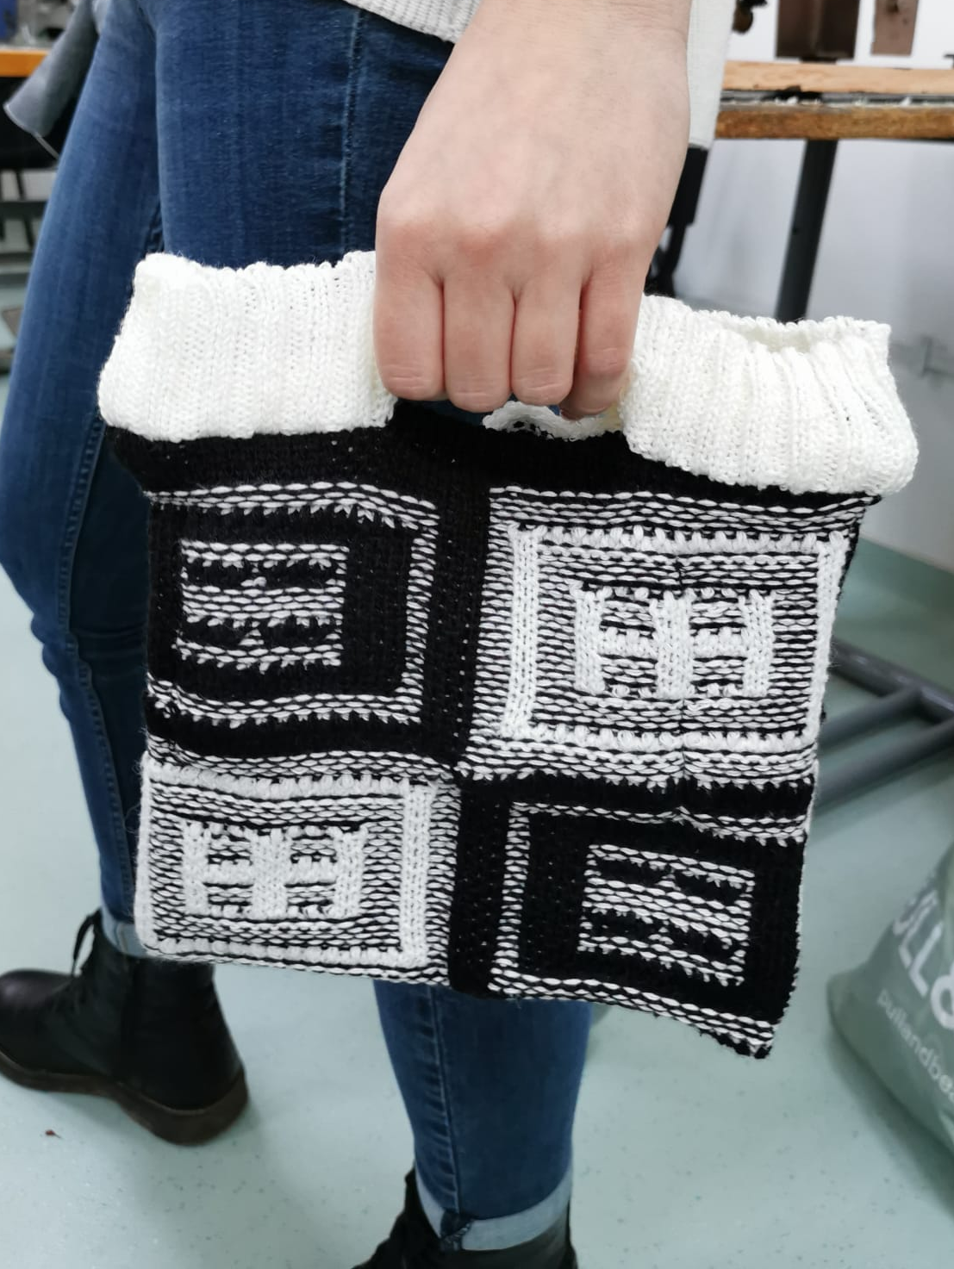

CC-BY-SA-NC Peter Czenge

Task 4.1 Collect old knitwear from stores, companies or from your closet, disassemble the individual parts and make your own fashion bag!

Lesson module 5:
Topic: Upcycling knitwear
Worksheet 5: Use your creativity to design a new product

Upcycling, also known as creative reuse, is the process of converting by-products, waste materials, useless or unwanted products into new materials or products that are perceived as having higher value, such as artistic or environmental value [https://en.wikipedia.org/ wiki/Upcycling]. Upcycled clothing refers to clothing items that are made by reusing and repurposing the same fabric materials such as old clothing, textiles and discarded fabrics. The whole process is turning these materials into something with added value and creating unique fashion items. Upcycling processes are considered the most effective way to reuse old clothes.

Use your creativity to design a new product

The upcycling project presented here comes from the student Andrea Sion, who breathed a new design and life into an old personal dress made of acrylic yarns in a cardigan structure. It is a voluminous piece of knitwear made on a coarse-meshed flatbed knitting machine for the cold season.

CC-BY-SA-NC Sion Andreea

Following her passion for painting, her source of inspiration was a famous painting, The Kiss, an oil painting on canvas with gold, silver and platinum leaf by Austrian symbolist painter Gustav Klimt (https://en.wikipedia.org/). Having a solid knowledge of automatic flat knitting technology, she reproduced the painting digitally by making a jacquard fabric in six colors, taking advantage of the technical capabilities of the CMS 503 E2,5.2 Stoll machine available at the knitting laboratory of TUIASI, Faculty of Industrial Design and Business Management, from Iasi, Romania.
This panel can be applied to any old product to give it a new design. This panel can be attached by various means to any old product to give it a new design, providing flexibility of constant change, at hand.
Variation in the size and appearance of the panel was possible because the knitting programme developed with the special M1plus® software could be used on other machine gauges from 5E to 12E available in the laboratory. As a technical solution, the panel was attached to the back of the dress with a zipper, giving the outfit a new design.

CC-BY-SA-NC Sion Andreea
During the production phase of the custom panels, several attempts were made to make them. The left was used to create a beautiful backpack with an original design.

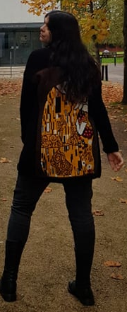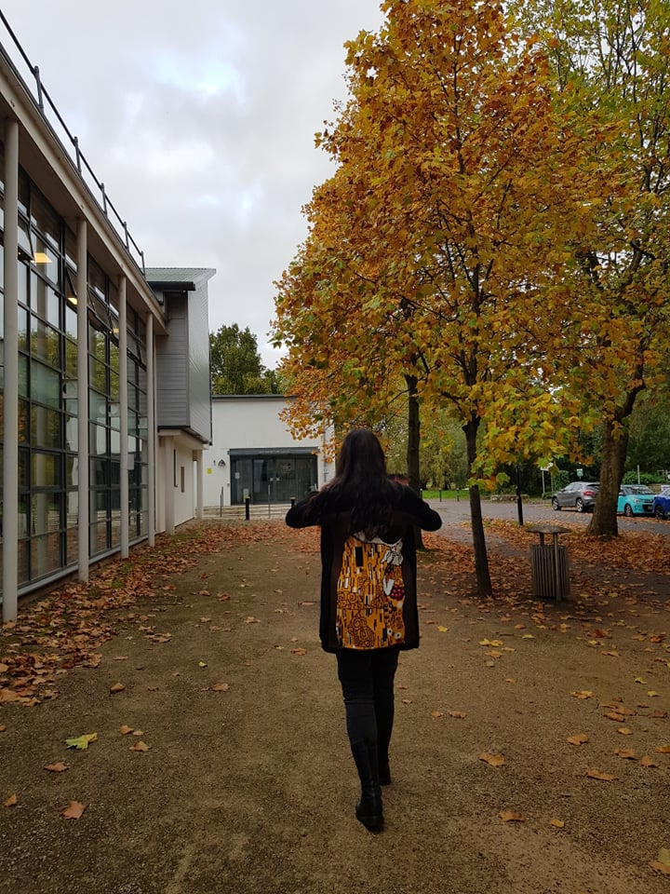

CC-BY-SA-NC Sion Andreea

The panel can also be framed and become a beautiful wall decoration, can be converted into a pretty bag or can also decorate other items of clothing. There are no limits to creativity!

Task 5.1: Look around for your old clothes that deserve a new life and try to upcycle them to help reduce consumption. Plus, you will be wearing a unique design that you created yourself, which can also have a positive impact on your self-esteem!

