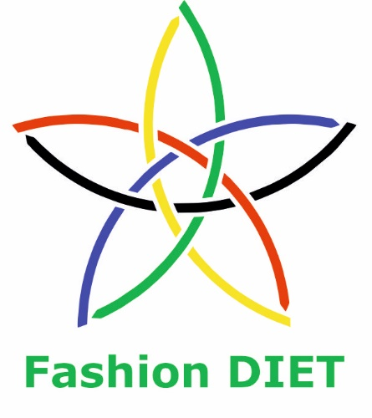

Sustainable Fashion Curriculum at Textile Universities in Europe  
 –   
Development, Implementation and Evaluation of a Teaching Module for Educators

Project: 2020-1-DE01-KA203-005657

Tite of the teaching

unit: Showing the flag, but how? - Craftivism as a way of expressing sustainability goals

Author: Dr. Dorit Köhler

Contact: University of Education Freiburg

Institute of Everyday Culture, Sports and Health

Department Fashion and Textile

E-mail: [dorit.koehler@ph-freiburg.de](mailto:dorit.koehler@ph-freiburg.de)



 Ein Bild, das Text enthält.  

Introduction to the teaching and learning materials

**Brief description of the content:**

This unit’s focus is on the phenomenon of craftivism. The term is a neologism that combines aspects of craft with activism. Typically, politically relevant issues, such as anti-capitalism, environmentalism, solidarity, pacifism, and feminism, are taken up and made public. Usually, textile objects are designed and produced as they are visible, thus calling for joint action. Sometimes activists also distribute objects with messages that call for reflection and action in cloak-and-dagger operations. This includes, for example, knitted and crocheted graffiti, which enriches the streetscape.

Closely related to craftivism are participatory art projects (also with textile materials), in which exhibition visitors are invited to participate in the creation of the artwork and become part of it during the exhibition or in advance.

**Competencies and Learning Content:**

After this lesson, students should be able to

* describe the phenomenon of craftivism and participatory art and carry out or participate in their own actions.
* become aware of one’s personal responsibility for political action and, ideally, act in this sense.
* name representatives of craftivism and participatory art as well as their actions and participate in them if desired.
* use different textile techniques and apply them as design elements.

Overview of working materials

*Teaching module 1*

*Topic 1: Craftivism as a phenomenon*

*Worksheet: A 1 Making Protest Visible through Textiles – Craftivism and Knitted Graffiti*

*Teaching module 2*

*Topic 2: Performative art projects*

*Worksheet: A2 Crocheting for Corals – The art project to participate and change the world*

*Teaching module 3*

*Topic 3: Design and create embroidered protest patches*

*Worksheet: A3* *That's what I'm for! - Embroidering Protest Patches*

*Work materials: Embroidery hoop, fabric for embroidery, embroidery thread, embroidery needle; optional: beads, stones, etc.*

*Teaching module 4*

*Topic 4:* *Arpilleras – tradition and own production of textile picture stories*

*Worksheet: A4/1 Arpilleras – South American everyday life and resistance on sackcloth*

*Worksheet: A4/* *What should change – picture stories on political topics as mixed media*

*Work materials: Paper, pencils, solid base material (jute, felt, etc.), fabrics for appliqué, yarn, realia (metal, plastic, glass, etc.), paint, and brushes*

*Teaching module 5*

*Topic 5: T-shirts as a carrier of meaning*

*Worksheet: A5/1 I wear the message on my chest – T-shirts as carriers of meaning*

*A5/1 That's what I want to say – T-shirts with self-printed messages*

*Work materials: Cotton T-shirt, cotton fabric, letter stamps, stamp pad with fabric paint, foam rubber, wooden blocks, scissors, glue*

Literature

Cristo Vive Europa e.V. (2021, 17 March). *Arpirella-Ausstellung in Berlin* [Arpirella exhibition in Berlin]*.* <https://cristovive.de/arpillera-ausstellung-in-berlin/>

Blödorn, C. (2002). Arpilleras. Stoffbilder, die bedeutsame Geschichten erzählen [Fabric pictures that tell meaningful stories]. *HTW-Praxis*, *54*(7-8), 19-20.

Corbett, S. (2017). *How to be a Craftivist: The Art of Gentle Protest*. Unbound.

Greer, B. (2008). *Knitting for Good! A Guide to Creating Personal, Social, and Political Change Stitch by Stitch.* Roost Books.

Greer, B. (2014) *Craftivism: The Art of Craft and Activism.* Arsenal Pulp Press.

Greer, B., & Lothian, S. (2018). *Guerrilla Kindness and Other Acts of Creative Resistance: Making A Better World Through Craftivism (Knitting Patterns, Embroidery, Subversive and Sassy Cross Stitch, Feminism, and Gender Equality).* Mango.

Kittelmann, U. (Ed.). (2022). *Crochet Coral Reef. Wert und Wandel der Korallen* [Value and change of corals]. *Christine und Margaret Wertheim.* Museum Frieder Burda.

Köhler, D. (2022). Mit gemeinschaftlicher Textilarbeit die Welt retten. Das partizipative Kunstprojekt „Baden-Baden Satellite Reef“ als Teil einer Bildung für nachhaltigeEntwicklung [Saving the world with collaborative textile work: The participatory art project "Baden-Baden Satellite Reef" as part of education for sustainable development].*PH-FR. Zeitschrift der Pädagogischen Hochschule Freiburg*, (1), 38-40.

Lemire, S. & Gram, L. (2022). *Feministik kreabog* [Feminist creation book]. Gads Forlag.

Mandell, H. (Ed.). (2021). *Crafting Dissent. Handicraft and Protest form the American Revolution to the Pussyhats.* Rowman & Littlefield.

Mayer, A. (2015). Communities in Radical Reflection: The Satellite Reef Program. M. Wertheim & C. Wertheim (Eds.), *Crochet Coral Reef. A project by the institute for figuring* (pp. 138-152). The Institute For Figuring.

Neel, L. & Marano, H. (2017). *Crafting the Resistance: 35 Projects for Craftivists, Protestors, and Women Who Persis.* Skyhorse.

Sawer, A. (2020). *Mitmachen und mitgestalten – Vermittlung ökologischer Themen durch partizipative Kunstprojekte* [Participate and shape *–* communicating ecological issues through participatory art projects]. https://www.kubi-online.de/artikel/mitmachen-mitgestalten-vermittlung-oekologischer-themen-durch-partizipative-kunstprojekte.

Stein, L. (2021). *Shedding the Shackles: Women’s Empowerment Through Craft.* Herbert Press.

Tapper, J. (2011). *Craftivism. People. Ideas, and projects from the new community of handmade and how you can join in.* Potter Craft.

Warner, G. (2017). *Protest Knits: Got needles? Get knitting!* Herbert Press.

Image Sources

Fig. 1: Coral reef Wyk on Föhr, NearEMPTiness, CC-BY-SA-3.0, https://upload.wikimedia.org/wikipedia/commons/thumb/4/42/The_F%C3%B6hr_Reef_in_T%C3%BCbingen.JPG/1920px-The_F%C3%B6hr_Reef_in_T%C3%BCbingen.JPG

Fig. 2: Example: T. Schwering, University of Education Freiburg

Photo: CC BY-SA-NC-ND Dorit Köhler

Fig.3: Sex Pistols i Norge, 1977, Odd Amundsen / Riksarkivet, CC0,

https://commons.wikimedia.org/wiki/File:Sex_Pistols_i_Norge,_1977_(6263353228).jpg

Photos in the tables: CC BY-SA-NC-ND Dorit Köhler

*Worksheet:* *A 1 Making Protest Visible through Textiles – Craftivism and Knitted Graffiti*

Non-commercial handicrafts in the field of textiles are closely linked to gender identity, the socialisation of women, and the role expectation of the *good housewife*. This determined and still determines the education of young girls in the field of textile handicrafts. The young woman doing needlework became a metaphor for female education and virtue, as she combines endurance, patience, precision, uniformity in execution, and manual dexterity. For centuries, the display cabinet with self-sewn or self-embroidered linen and clothing as well as the embroidered sampler were considered products of a specifically female *quality criterion*, which were also publicly exhibited. An activity that otherwise tended to take place in the domestic sphere served as a sign that the socially determined role expectation had been fulfilled (Köhler, 2022, p. 38).

In the Craftivism movement (e.g., Corbett, 2017), the stereotypical and archetypal image of women and textile handicrafts is questioned and transformed into a means of expression, in which needlework takes place decidedly in public space and is associated with a political statement. The Knitting in Public (KIP) movement aims to irritate through the public practice of a quiet activity that is traditionally more associated with the home (Mandell, p. 1ff). With the bright pink self-knitted *pussyhats*, which function as a protest sign against Donald Trump (Lemire, 2022, p. 118ff), women set an example for women’s and human rights "by promoting dialogue and innovation through the arts, education and intellectual discourse" (Lemire, 2022, p. 118).

Craftivism, as a connection between “craft” and “activism”, can be defined as a “way of looking at life where voicing opinions through creativity makes your voice stronger, your compassion deeper and your quest for justice more infinite” (Greer, 2014):

Sarah Corbett, the London-based founder of the Craftivism Collective, describes the aim as “to expose the scandal of global poverty and human rights injustices though the power of craft and public art. This will be done through provocative, non-violent creative actions” (Corbett, 2017, p. 45). With *The craftivism manifesto* she manifests global claims.

Corbett speaks of *public art* and thus places the public, *craft* and *art* in one context. In the art scene, the discussion of ecological issues and current environmental problems is also perceived as a public process. In participatory art projects, the experience and engagement with issues are intensified through one’s involvement (Sawer, 2021, p. 10).

Task 1: Research craftivism projects and present two examples in text and drawing or as a collage.

Task 2: Create a mind map on possible topics for your project.

Task 3: Develop your own project that you represent as a picture.

*Worksheet: A2 Crocheting for Corals – The art project to participate and change the world*

One of the world’s largest participatory art and science projects is the Crochet Coral Reef. It has so far involved more than 10,000 people in twelve countries and the exhibition has been seen by more than two million people in various locations.

Local organisers work towards the basic organisational requirements of the project in terms of a public venue (often a museum), funding, marketing and more. They call for crocheting coral elements from textile or other materials that, like plastic, illustrate the pollution of the oceans even more vividly, and organise workshops to learn the technique and the community work (Köhler, 2022, p. 39). The organisers assemble the coral elements to form a reef that can have a wide variety of shapes. The coherent reef combines different aesthetic dimensions and is associated by the organisers with different environmental actions (Mayer, 2015, p. 138).

The aim of performative art projects is to convey a sense of community and the importance and responsibility for the preservation of valuable living spaces for the individual. When making one’s own piece, each person takes responsibility for his or her own project; it only becomes whole when the pieces are put together. Putting together a small part to form a large whole in a community is what gives it its strength. The aim is to convey the courage to get involved in socially relevant fields of action in a creative and action-oriented way.

Fig. 1: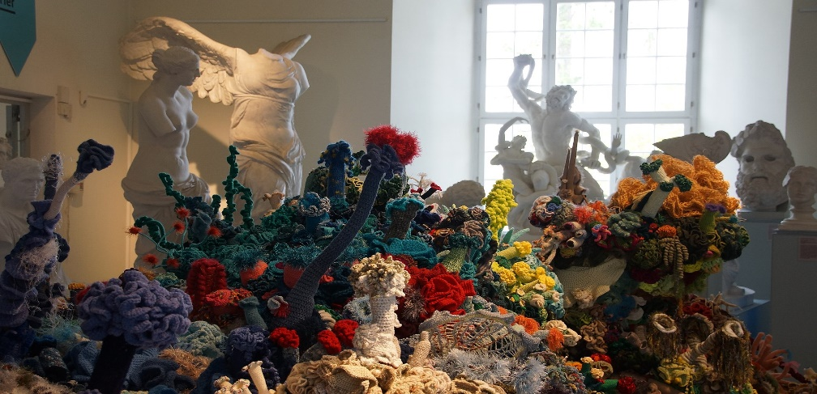 Coral reef Wyk on Föhr

CC-BY-SA-3.0 NearEMPTiness

Task 1: In which fields could performative art projects create change?  
Search for examples and think about how such a project could be initiated concretely. Let's go!

*Worksheet: A3 That's what I'm for! - Embroidering Protest Patches*

|  |  |
| --- | --- |
|  | Make a design for a round or square patch and transfer the lines with a transfer pen to a neutral fabric background.  Example: J. Gessner, University of Education Freiburg |
|  | Embroidering contours: backstitch/lockstitch  Cut out, skip fabric threads to the right, stitch in, double the number of skipped fabric threads to the left and stitch in. |
|  | Embroider contours: stem stitch  Stitch out, skip fabric threads to the right, stitch in, and work left to about half of the previous stitch, stitch out. Always leave the work thread on the same side of the needle. |
|  | Embroidering contours: Chain stitch  Stitch out, stitch close to this point in again, make a loop, stitch out below the point of stitching, pull the thread through; stitch in next to the point of stitching out, make a loop, and so on.  Secure the loop with a catch stitch on the last stitch. |
|  | Fill an area: satin stitch  Embroider in an embroidery hoop. This stitch consists of parallel stitches next to each other. Their direction determines the effect of the area. |
|  | Examples: Several students, University of Education Freiburg |

Photos: CC BY-SA-NC-ND Dorit Köhler

*Worksheet: A4/1 Arpilleras – South American everyday life and resistance on sackcloth*

Arpillera is a Spanish word that translates as burlap. Arpilleras are fabric paintings embroidered on burlap, mainly produced in South America. They depict everyday life from neighbourhoods and villages. Women come together in groups and make the arpilleras by handicrafts. This work gives them the opportunity to bring oppressive experiences into the picture and to inform and process what they have experienced.

At the time of dictator Augusto Pinochet's government in Chile (1973-1990), the economy declined, resulting in famine. People were persecuted by the secret service and political murders took place. In Santiago, poor neighbourhoods were surrounded by police and residents were arrested. Prisoners were tortured, taken to notorious camps, or disappeared. All this, but also the resistance of the population against oppression and mismanagement, was put into pictures using Arpilleras.

The arpilleras were made in women’s groups initiated by the Vicaría de la Solidaridad (Vicariate of Solidarity) from 1976 to 1990. The Vicaría was an institution of the Catholic Church that provided legal assistance and concrete help to the persecuted population. The Vicariate also cared for the unemployed and organised groups for women who could do handicrafts and thus receive money to support their families. (Cristo Vive Europa e.V., 2021).

After mass protests flared up in 2019 following the increase in bus and train ticket prices, life in Chile has not settled down. Calls for social justice and constitutional change grew louder. Despite violent attempts by President Piñeira’s government to intimidate and silence the people through the military and police, the people prevailed. On 25 October 2020, there was a referendum in which 78% of the people voted in favour of changing the constitution. Now a group of representatives from different political camps and social organisations will work on a draft constitution. It will be a long road, but the first and decisive step towards a new and more just social order has been taken (Cristo Vive Europa e.V., 2021).

Ein Bild, das Kinderkunst, Kunst, Bild, Cartoon enthält.

Fig. 2: Example: T. Schwering, University of Education Freiburg

Photo: CC BY-SA-NC-ND Dorit Köhler

Task 1: Summarise essential features of the arpilleras.

Task 2: Research for pictures of arpilleras and print or draw them.

Task 3: Create a mind-map of issues about sustainability and political change that you would present on an arpillera.

*Worksheet: A4/2 What should change – picture stories on political topics as mixed media*

|  |  |
| --- | --- |
|  | Make a design.  Cut the base (felt, jute, etc.) into a rectangle, eventually sew on a neutral cotton fabric in the same format and transfer the design.  Example: E. Haag, University of Education Freiburg |
|  | Design a picture: Painting and printing  Or else: Creating a picture by painting and printing |
|  | Design a picture: Appliqué |
|  | Design a picture: Machine embroidery |
|  | Design a picture: Hand embroidery |
|  | Example: N. Sommer, University of Education Freiburg |

Photos: CC BY-SA-NC-ND Dorit Köhler

*A5/1 I wear the message on my chest – T-shirts as carriers of meaning*

The T-shirt’s history starts close to humans: as underwear for men. Back then the T-shirt was covered by outerwear and was only visible during physical work. Examples were the Navy matrons who were allowed to wear the T-shirt while working on deck. In 1913, a white cotton T-shirt became the official underwear.

As a sign of rebellion against the establishment, the white T-shirt then gained value as a protest garment of youth culture with actors like James Dean and Marlon Brando wearing it. However, it did not yet have a print.

Since the 1960s, the T-shirt has increasingly become a space for political, promotional, or humorous messages. Thanks to screen printing, it became easier and cheaper to print on fabric since the early 1960s. As a result, personalised T-shirts were available from the 1970s onwards and their potential as a merchandising product was recognised quickly.

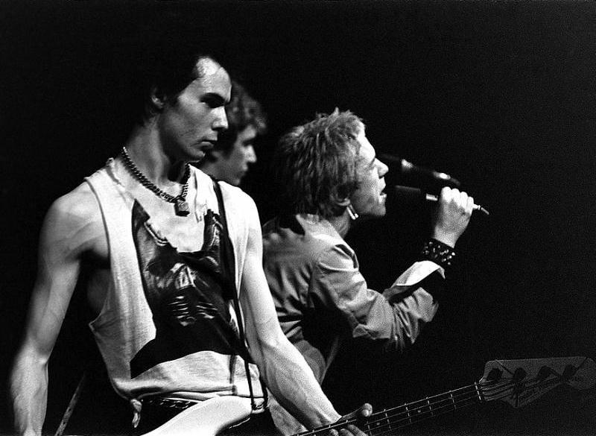At the same time, ragged T-shirts or those with provocative prints and designs (e.g., with chicken bones) became an essential clothing feature of the punk subculture. This subculture was essentially co-determined by Vivienne Westwood. Her action of producing an iconic shirt for Queen Elizabeth II’s Jubilee showing a portrait of the Queen with a safety pin poking through her lip became legendary.

Fig. 3: Sex Pistols, 1977

CC0 Odd Amundsen / Riksarkivet

The fashion designer Katherine Hamnett used slogan T-shirts in the 1980s to make statements against nuclear weapons and social injustices on the body in public.

Task 1: Research the history of the T-shirt as a carrier of meaning.

Task 2: Think about which messages would be on your T-shirt. Collect them first, then decide on one and make drafts for the realisation.

*A5/2 That's what I want to say – T-shirts with self-printed messages*

|  |  |
| --- | --- |
|  | Think of a text. Stamp it onto a cotton fabric or directly onto the T-shirt.  Iron the fabric hot to set the colour. |
|  | Fold the sides 1cm inwards and iron the edges.  (Only follow this step, if you have not put the stamp on your t-shirt directly.) |
|  | Sew the fabric to the T-shirt.  (Only follow this step, if you have not put the stamp on your t-shirt directly.) |
|  | For a self-made stamp, cut out a motif from foam rubber and glue it onto a wooden block. |
|  | Colour the surface with paint and print on fabric. You can also combine the motifs with the letter stamps. |

Photos: CC BY-SA-NC-ND Dorit Köhler