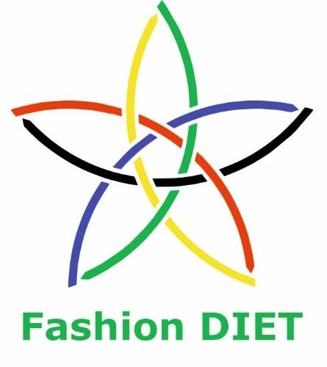

Sustainable Fashion Curriculum at Textile Universities in Europe
–
Development, Implementation and Evaluation of a Teaching Module for Educators

Project: 2020-1-DE01-KA203-005657

Title of the Lesson: Silk Painting in Sustainable Fashion

Authors: Prof. Dr. Zlatina Kazlacheva, Mariya Koleva
Contact Data: Trakia University of Stara Zagora,
Faculty of Technics and Technologies, Yambol, Bulgaria
E-mail: zlatinka.kazlacheva@trakia-uni.bg


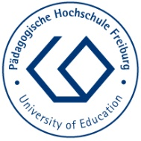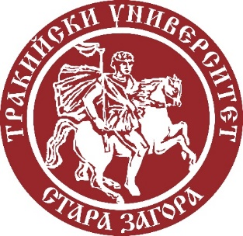

Introduction to the Teaching and Learning Materials

Short Description of the Content:

The focus is on the creation of sustainable fashion clothes and accessories application of silk painting technics in the context of different aspects of sustainability. The batik silk painting technique is presented. The design of silk painted scarves in the context of slow fashion is studied. The basic stages of silk painting are shown. The course finishes with invitation to the learners to create their own silk painting designs.

Competences and Learning Objectives:

After this unit the student should be able to …

- describe connection between silk painting and different aspects of sustainable fashion;
- recognize batik silk painting technique, used materials and tools;
- describe ornaments on slow fashion silk painted scarves and clothes;
- apply batik silk painting technique in creation of slow fashion products;
- design your sustainable fashion silk painted product.

Overview of Working Materials

Lesson module 1:
Topic: Silk Painting in Sustainable Fashion
Worksheet 1: Silk Painting in Sustainable Fashion

Lesson module 2:
Topic: What is batik?
Worksheet 2: What is batik?

Lesson module 3:
Topic: Silk painted scarves
Worksheet 3: Silk painted scarves

Lesson module 4:
Topic: Let’s make silk painted scarves!
Worksheet 4: Let’s make silk painted scarves!
Working materials: natural or artificial silk fabrics, special paints for silk, gutta or wax, silk contours, different types and sizes brushes, tools for waxing, and a stretching frame.

Lesson module 5:
Topic: And it is time for your design!
Worksheet 5A: Sketch your idea
Worksheet 5B: Sustainability of your design
Working materials: graphic pencils, color pencils, pen

Sources

Staniforth, S. (2010). Slow Conservation. Studies in Conservation, 55(2), 74-80. https://doi.org/10.1179/sic.2010.55.2.74.

Marquis, Ch. (2021). What Does Slow Fashion ‘Actually’ Mean?. Forbes. https://www.forbes.com/sites/christophermarquis/2021/05/14/what-does-slow-fashion-actually-mean/?sh=63114e1273b4.

Clark, H. (2008). SLOW + FASHION – an Oxymoron – or a Promise for the Future …?. Fashion Theory, 12(4): 427–446.

Kuusk, K., Tomico, O., Langereis, G., Wensveen, S. (2012). Crafting smart textiles – a meaningful way towards societal sustainability in the fashion field?. The Nordic Textile Journal, 1, 6–15. http://hb.diva-portal.org/smash/get/diva2:869634/FULLTEXT01.pdf.

Hill M. (2023). What is Circular Fashion? Good on you. https://goodonyou.eco/what-is-circular-fashion/.

Genova, K., Kazlacheva, Z., Ruseva, I. (2023). The Slow Fashion – a Review. ARTTE Applied Researches in Technics, Technologies and Education, 10(4), 207-216.

The history of painting on silk. TransARTformatsiya. http://art.blog.libvar.bg/istoriyata-na-risuvaneto-vrhu-koprina/.

Gaffney, D. What is Batik?. TheBatikGuilt. https://www.batikguild.org.uk/batik/what-is-batik.

Karla, J. (2021). Batik for Beginners. Guide To Types Of Batik, Strategy And Lots More. ISBN 979-8786945233.

Image Sources

Lesson module 2

Processing "nembok", traditional way to make batik tulis (handmade batik). CC BY-SA 4.0 Ardyansa Nugraha. https://en.wikipedia.org/wiki/Batik.

A batik craftsman making batik. Malaysian batik are usually patterned with floral motifs with light colouring. CC BY 2.0 Shubert Ciencia. https://en.wikipedia.org/wiki/Batik.

Lesson modules 3 and 4

All Images: CC BY Koleva. Images are from a Master class on silk painting in the context of sustainability, given by Mariya Koleva, a co-author of this lesson, a student of Fashion Design and Technology Bachelor Programme at the Faculty of Technics and Technologies of Yambol, Trakia University, Bulgaria. The Master class was organized in the frame of Fashion DIET project and was held on March 10, 2023. Mariya Koleva presented silk painting on scarves. The video record of the Master class (in Bulgarian) is available online at: https://youtu.be/dXrdiSA98Ec.

Worksheet 1: Silk Painting in Sustainable Fashion

What is the application of painting on silk fabrics, natural and artificial ones, in sustainable fashion design? Let’s see it according to several aspects of sustainability in fashion.
The Slow fashion is an aspect of sustainable fashion and is the opposite concept of the fast fashion. The slow fashion offers sustainable fashion solutions, which are based on new strategies for design, manufacturing, consumption, use and re-use that challenge the global fashion system. The slow fashion involves a fashion awareness of the production and resources required to create clothing. The slow fashion promotes the purchase of higher-quality clothes with trendless design that will last longer, and fair treatment of people, animals, and the environment.
The clothes and accessories made by painting on silk are wearable arts. They are practically independent on trends and they are always on fashion. For this reason hand felted garments and accessories belong to slow fashion. Also, no matter how beautiful a long life garment (a cloth made by classic technologies) is, it gets tired at some point. For this reason, we can combine slow fashion clothes with fashion accessories high artistic value. Silk painted scarves and other accessories belong to accessories with high artistic value and can made one long life fashion ensemble different and more artistic.
The Recycled fashion and Circular fashion. The Recycled fashion is created using recycled materials, promoting material reuse and waste reduction. The circular fashion is a system where our clothing and personal belongings are produced through a more considered model, in which the production of an item and the end of its life are equally as important. This system considers materials and production thoughtfully, emphasising the value of utilising a product right to the end, then going one step further and repurposing it into something else. The focus is on the longevity and life cycle of our possessions, including designing out waste and pollution. The “circular” comes as a response to previous economic and societal models that have been “linear” to date, and harmful on the planet along the way.
Painting can be realized using recycled silk type fabrics and discarded natural and artificial silk fabrics with defects in coloring. Silk painting can be combine with “nuno” and “boro” felting techniques using silk fabrics with defects is structure.
The Environmental fashion or "green" fashion prioritizes environmentally sustainable materials and production methods, minimizing the impact on natural resources and reducing waste. The connection between the silk painting and the environmental fashion is in the use of discarded fabrics with defects in structures and coloring.

Tasks:

Task 1a: Describe connection between silk painting and the slow fashion.
Task 1b: Describe connection between silk painting and the recycled and circular fashion.
Task 1c: Describe connection between silk painting and the environmental or "green" fashion.

Question:

Question 1a: Can a silk painted fashion product belong to more than one aspect of sustainable fashion? Give examples.

Worksheet 2: What is batik?

One of the contemporary technique of silk painting is based on the batik.
Batik is an art of color decorating cloth, using wax and dye. Batik is usually made on a fabric surface, such as cotton, silk, linen, etc., but batik techniques can also be used on paper, wood, leather, ceramic, etc.
Batik has been practiced from ancient times in many parts of the world including China, Japan, India, Europe, etc.: Linen clothes decorated with drawings were found during excavations in Egypt. They date from the 5th century BC. In the Thracian tombs (from the 15th-14th centuries BC) on the Bulgarian lands, drawings of noble Thracians whose clothes were decorated with exquisite drawings were found. 8th century silk screens made by Chinese artists have been discovered in Japan. In Indonesian island of Java, the batik is a part of an ancient tradition, and some of the finest batik cloth in the world is still made there. Batik is believed to have been created in China around 6th century and carried to Japan, Central Asia, the Middle East and India along the Silk Road. The method has been adopted and adapted most enthusiastically in Indonesia. On the island of Java, they make the honey vessel in which the melted wax is placed, with which the dividing lines and the various figures are drawn. The tool is called “canting”, and the technique is applied to fabrics made of natural silk, cotton and linen. Batik style clothes are the national costume of the island of Java.
The word batik is of Javanese origin and a derivative of the words amba ("write") and titik (from Indonesian "point"). The origin of the name came from the old batik, which was performed by small dots of wax that were made on the fabric. Batik is both a verb and a noun – to batik and a batik, or the action of creation, and a product made by batiking.
To make a batik, selected areas of the cloth are blocked out by applying hot wax over them, a dye is applied on top and the parts covered in wax resist the dye and remain the original colour. A simple batik may be just one layer of wax and one dye, but this process of waxing and dyeing can be repeated many times if necessary to create more elaborate and colourful designs. After the final dyeing the wax is removed, usually in hot water, and the cloth is ready for wearing. The artist may use a wide variety of techniques to apply the wax and the dyes: spraying, etching, discharging, cracking, marbling, and use all sorts of different tools: stamps, brushes, stencils. The artist may also use wax recipes with different resist values: soya wax, beeswax, paraffin wax and work with natural and synthetic dyes on all kinds of surfaces. Special water-based paints have been created that can be applied to the silk fabric with a brush or roller and fixed with an iron. Some batik techniques are wax-resistant one, crumpled fabric effect, wax batik imitation technique, etc. An easy technique is indiscriminate wax pouring, by which random shapes are made and then the paint is applied. The result is an interesting drawing from the accidental mixing of the applied paints. The hidden figures technique uses spray paints and templates with interesting shapes. When the fabric dries and sets, the illusion of internal figures embedded between layers of paint is created. With the salt technique or the so-called crystal technique, special effects are achieved and rich colors are used. The main principle of the crystal salt technique is that salt attracts and absorbs moisture. When crystal salt is placed on freshly painted silk, the salt attracts the wet paint from different directions and creates spiral shapes.
The modern batik materials allow more and more people to realize their creative ideas, some of them in the field of sustainable fashion.
Picture 1 presents "nembok", traditional way to make batik tulis (handmade batik). Picture 2 shows a batik craftsman making Malaysian batik, which are usually patterned with floral motifs with light colouring.
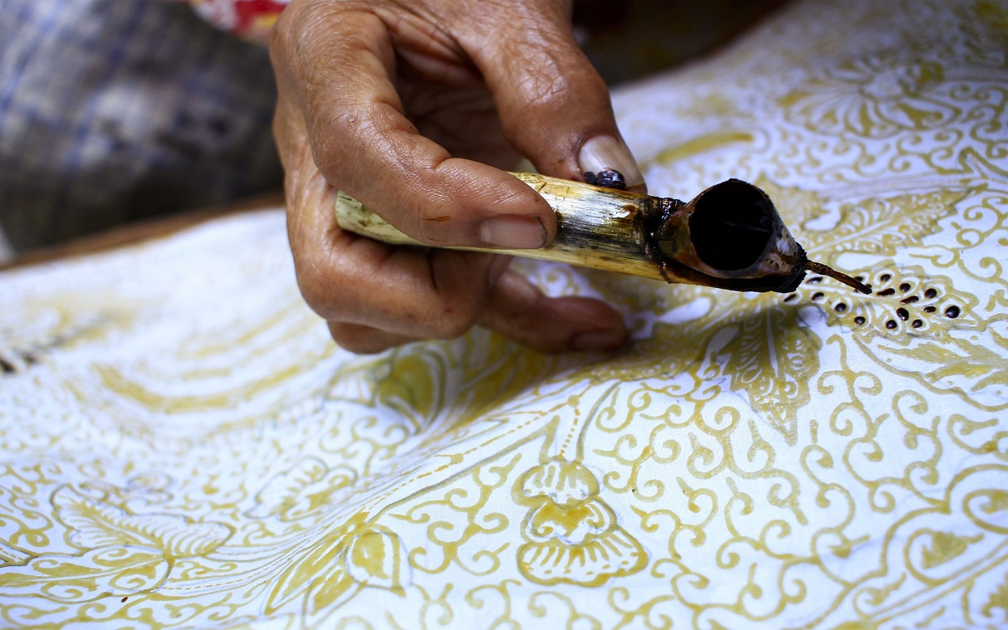

Picture 1. Processing "nembok", traditional way to make batik tulis (handmade batik).
CC BY-SA 4.0 Ardyansa Nugraha

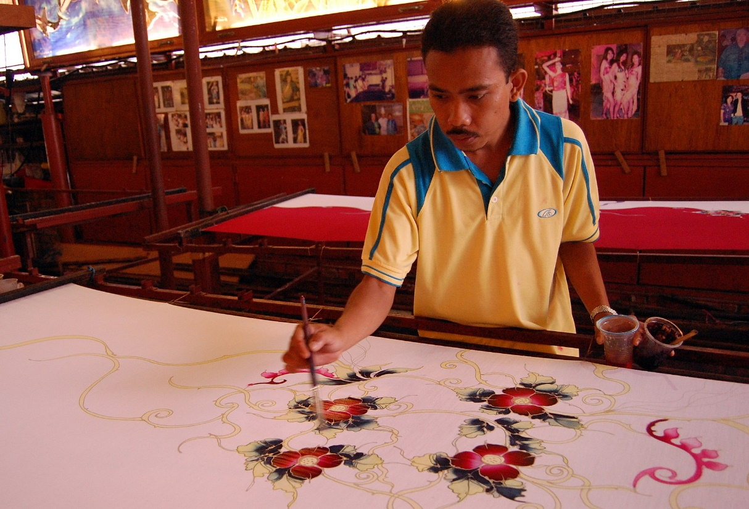

Picture 2. A batik craftsman making batik. Malaysian batik are usually patterned with floral motifs with light colouring. CC BY 2.0 Shubert Ciencia

Tasks:

Task 2a: Research for more information on batik technique.
Task 2b: Research for more information on application of batik in contemporary fashion in the context of sustainability.
Worksheet 3: Silk painted scarves

The scarves are maybe the most popular silk painted fashion products, which belong to the wearable art and the slow fashion. The batik is the most popular technique of painting of silk scarves. The batik painting is made on natural and artificial silk fabrics using special paints for silk, gutta or wax, silk contours, different types and sizes brushes, tools for waxing, and a stretching frame.
In silk painting, the ornaments are mostly floral and abstract, but animal and geometric ones are also applied.
Picture 3 presents combination between floral, an iris, and geometric ornaments, spirals and circles, and abstract forms.
Picture 4 shows animal ornaments, stylized insects.
Picture 5 presents geometric ornaments, spirals and circles, and abstract forms.
The same ornaments can be applied in design of slow fashion silk painted clothes.

Tasks:

Task 3a: Research for more information on silk and other fabrics used for batik painting.
Task 3b: Research for more information on materials and tools used for batik silk painting. What is difference between gutta and wax? What is difference between gutta and contour?
Task 3c: Describe the types of ornaments applied in silk painting of fashion products.

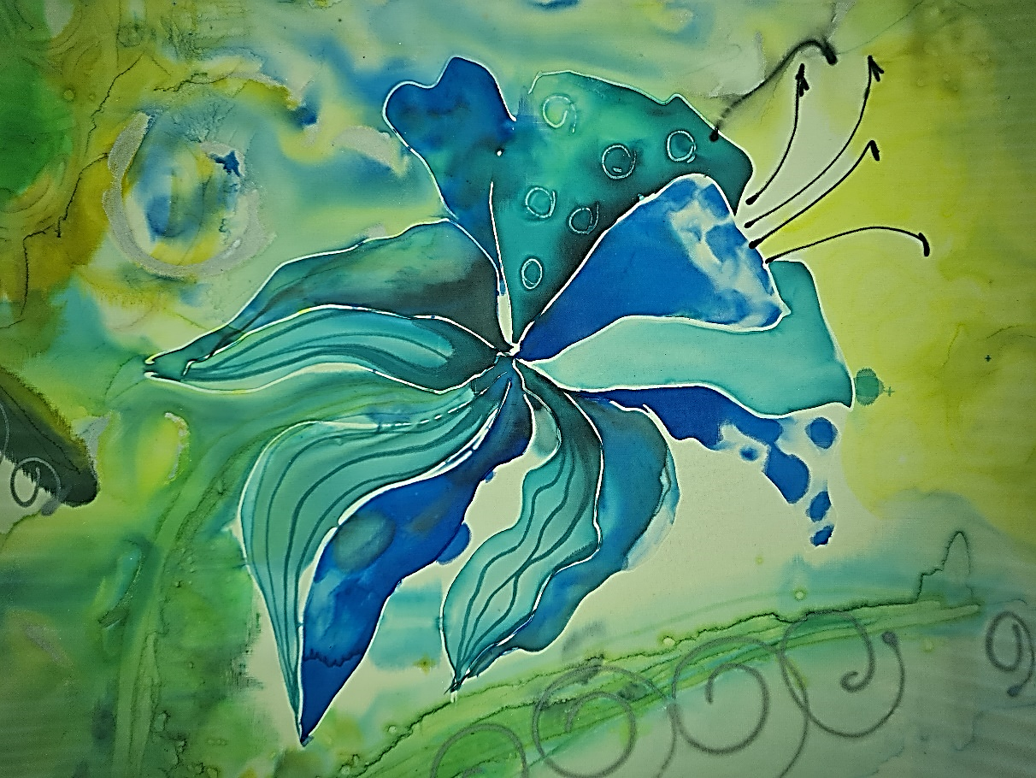

Picture 3. Combination between floral, an iris,
and geometric ornaments, spirals and circles, and abstract forms.
CC BY Koleva

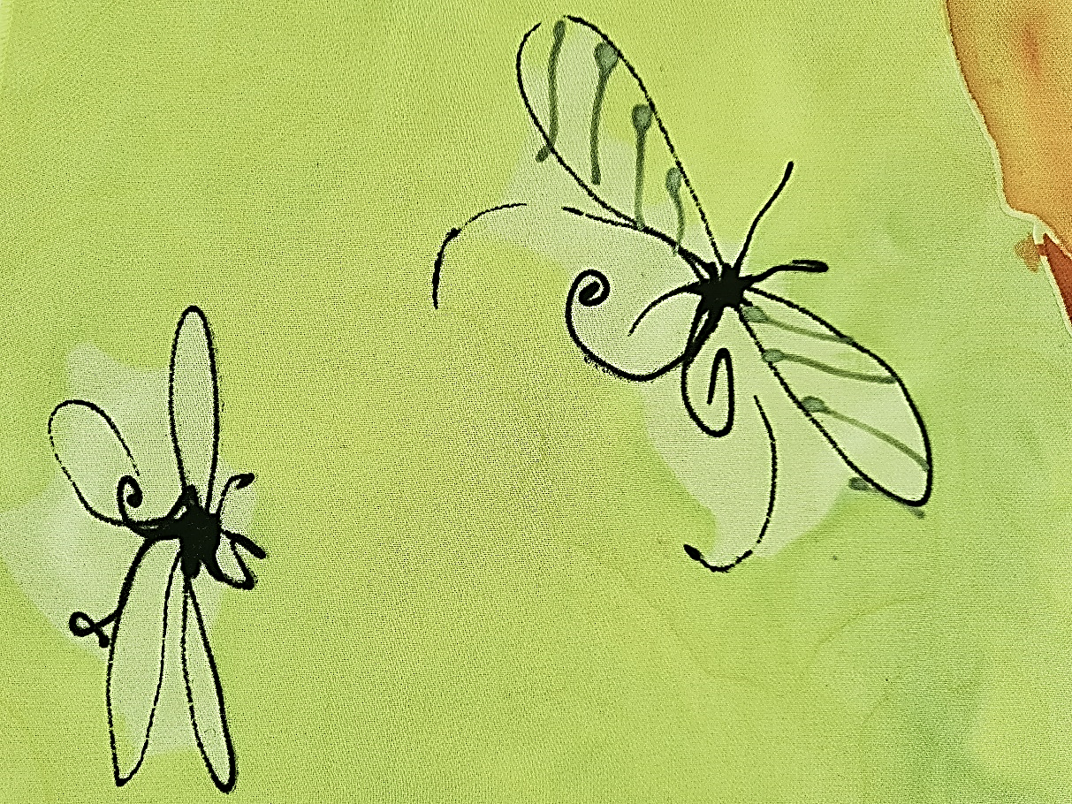

Picture 4. Animal ornaments, stylized insects. CC BY Koleva

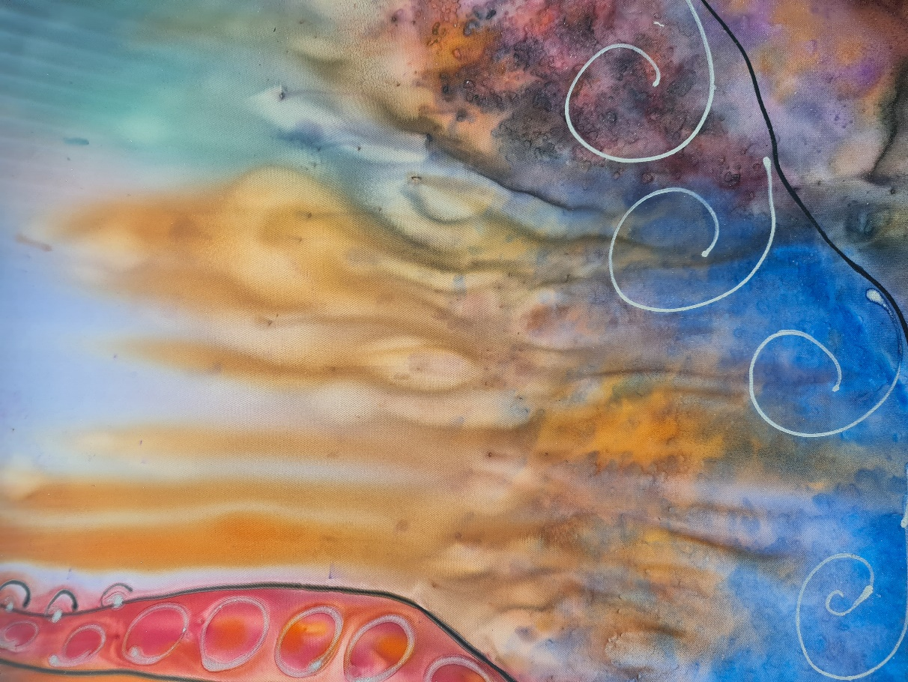

Picture 5. Geometric ornaments, spirals and circles, and abstract forms.
CC BY Koleva

Worksheet 4: Let’s make silk painted scarves!

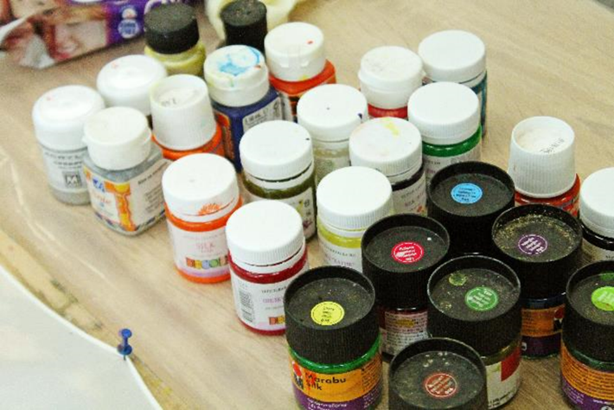 | 1. Batik paints, guttas and contours are used for silk painting.
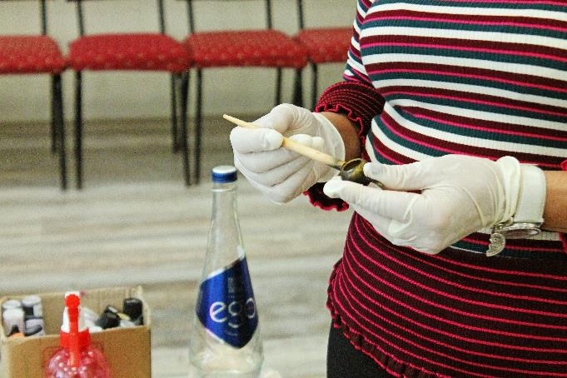 | 2. A traditional bowl tjanting tool is used to apply wax to fabric.
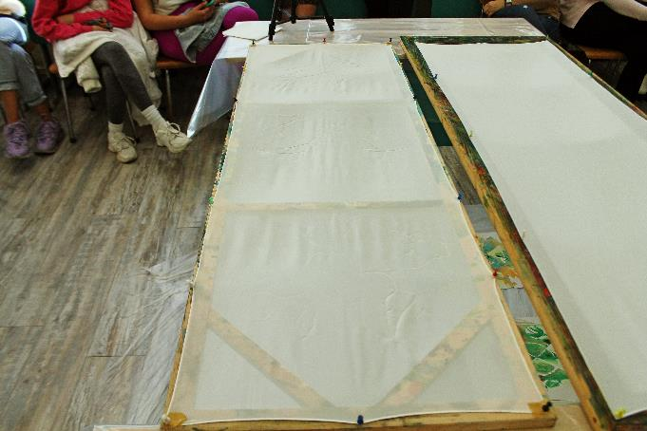 | 3. Preparing the silk for painting. The silk fabric must be pinned and stretched on a frame. The stretched silk fabric must be flat and smooth, so that the colors spill where we want. Then we outline the shape to limit it from the background.
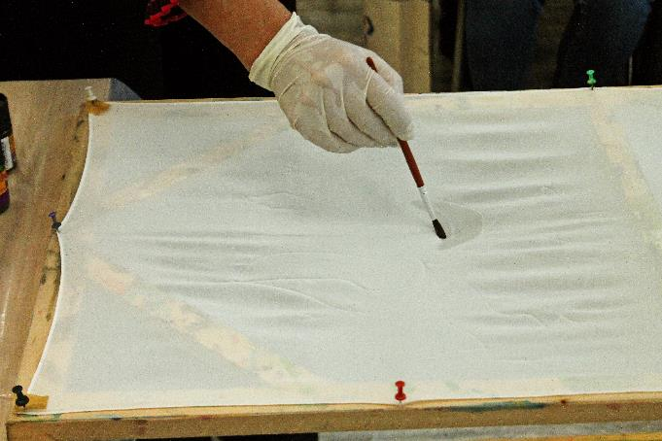 | 4. The places or forms are wetted with a brush and water before we start applying and overflowing the colors.
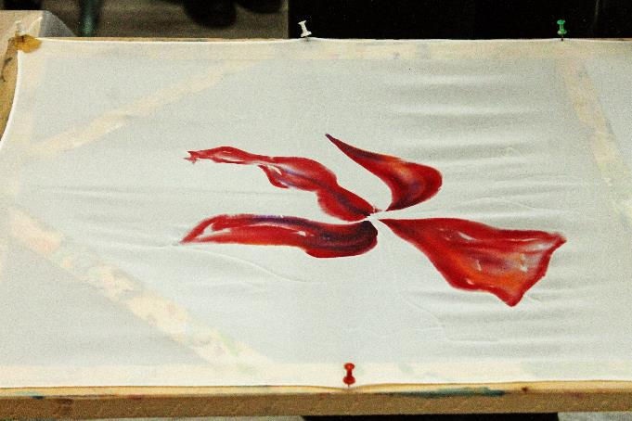 | 5. The scarf is painted part by part, starting with the main colors, then finishing the elements.
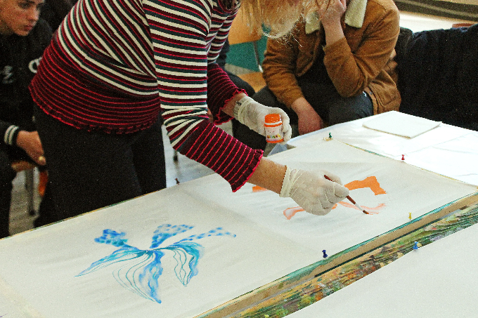 | 5. The scarf is painted part by part, starting with the main colors, then finishing the elements.
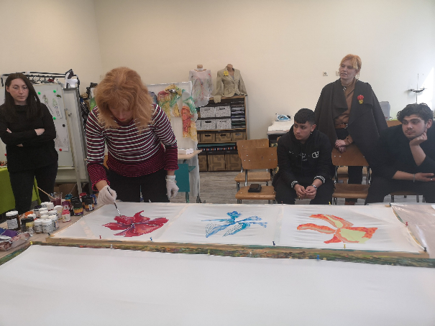 | 5. The scarf is painted part by part, starting with the main colors, then finishing the elements.
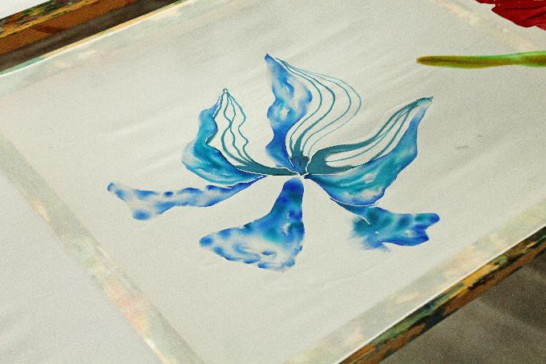 | 6. Watercolor effects are produced when water-based paints are dissolved in more water and applied with a wet brush.
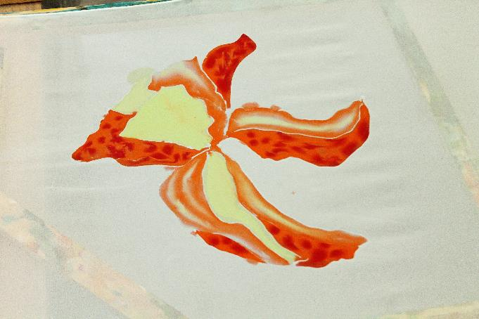 | 7. Аfter the primary colors of the form, the secondary colors are applied, and thus the multicolor of the scarf is gradually created.
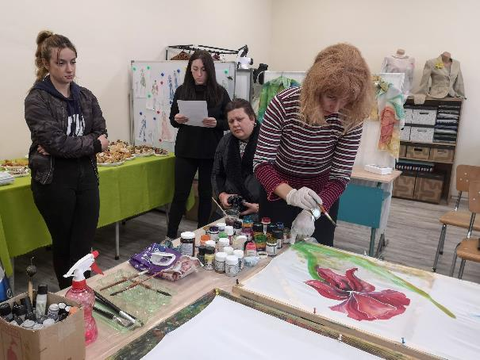 | 8. Different effects require different sized brushes.
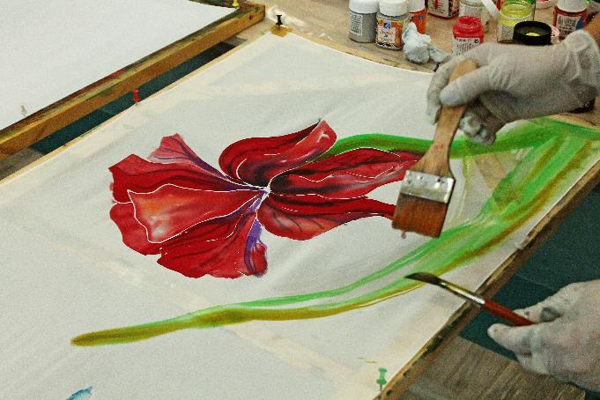 | 8. Different effects require different sized brushes.
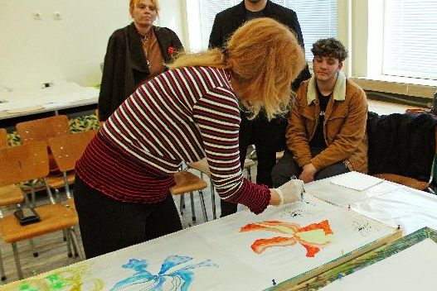 | 9. The finishing touches are finer and gentler contours applied with gutta. Effects with mother of pearl and gold, and adding a spiral element around the main shapes, in this case flowers, connect and unite the elements of the drawing.
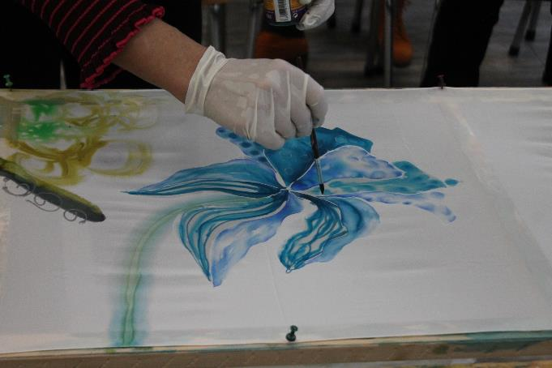 | 10. Finer brushes for fine finishing elements of shapes, in this case a flower.
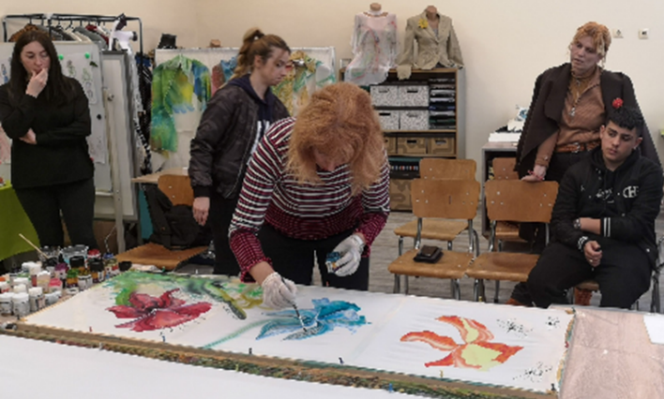 | 10. Finer brushes for fine finishing elements of shapes, in this case a flower.
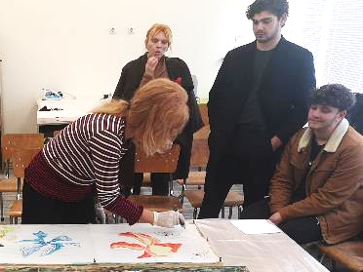 | 11. The finishing touches are finer and gentler contours applied with gutta. Effects with mother of pearl and gold, and adding a spiral element around the main shapes, in this case flowers, connect and unite the elements of the drawing.
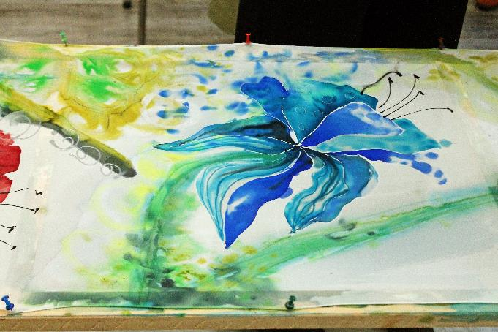 | 11. The finishing touches are finer and gentler contours applied with gutta. Effects with mother of pearl and gold, and adding a spiral element around the main shapes, in this case flowers, connect and unite the elements of the drawing.
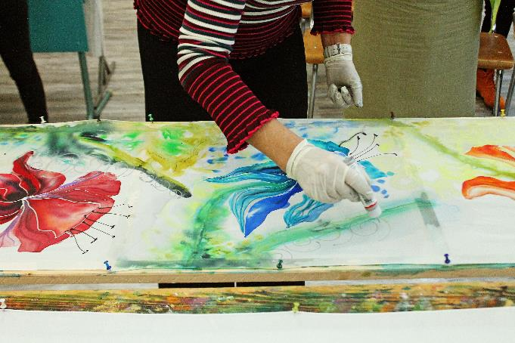 | 12. Contours applied with gutta add forms to unwanted spills outside the main shape. Thus, the defect becomes an effect.
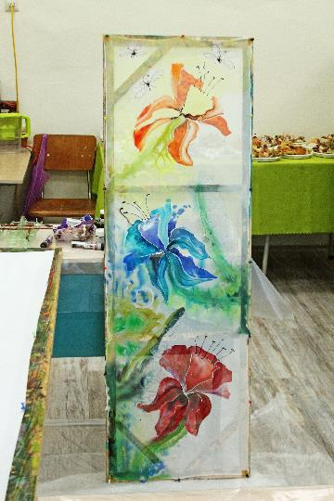 | 13. The scarf with floral elements is ready.
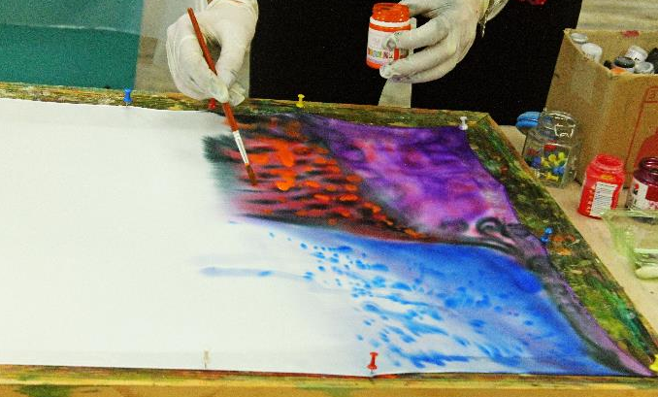 | 14. The other way of painting is by spilling the colors on the silk without an outline. The shapes are again obtained from paint and water: Abstract geometric shapes, undefined shapes, and irregular circles in various compositions.
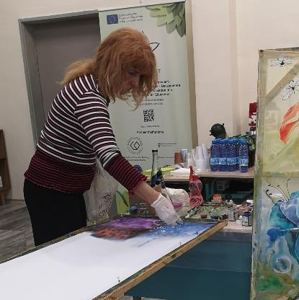 | 15. Special effects are achieved with the use of salt crystals.
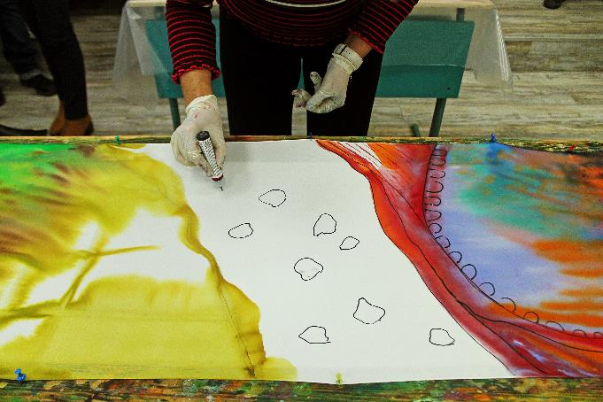 | 16. The forms of the abstract drawing are joined and united with irregularly shaped elements in a neutral color and with a very fine and delicate stroke.
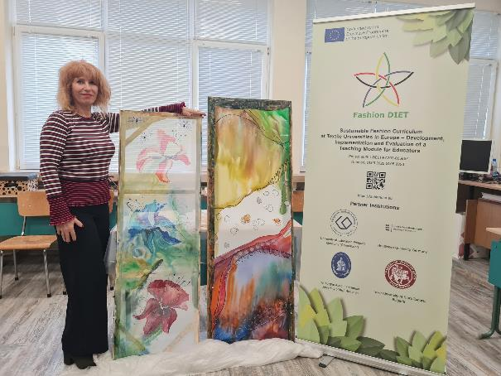 | 17. The ready scarves – floral and abstract ones.

Photos: CC BY Koleva

Worksheet 5A: And it is time for your design! Sketch your idea

Make a sketch of your design idea for sustainable silk painted scarf or cloth.

Worksheet 5B: Sustainability of your design

Describe your design idea in the context of sustainable fashion.

_________________________________________________________________________________________________________________________________________________________________________________________________________________________________________________________________________________________________________________________________________________________________________________________________________________________________________________________________________________________________________________________________________________________________________________________________________________________________________________________________________________________________________________________________________________________________________________________________________________________________________________________________________________________________________________________________________________________________________________________________________________________________________________________________________________________________________________________________________________________________________________________________________________________________________________________________________________________________________________________________________________________________________________________________________________________________________________________________________________
___________________________________________________________________________

And now… Maybe it is time for realizing of your design idea. Are you ready for silk painting? Try it!

