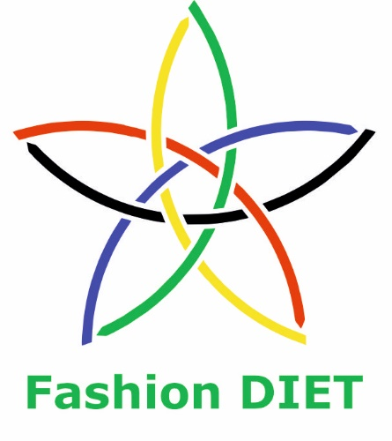

Sustainable Fashion Curriculum at Textile Universities in Europe  
 –   
Development, Implementation and Evaluation of a Teaching Module for Educators

Project: 2020-1-DE01-KA203-005657

Title of the Teaching Unit:  
Something is floating, and something is piling up – garbage and garbage avoidance

Author: Dr. Dorit Köhler

Contact: University of Education Freiburg

Institute of Everyday Culture, Sports and Health

Department Fashion and Textile

E-mail: [dorit.koehler@ph-freiburg.de](mailto:dorit.koehler@ph-freiburg.de)

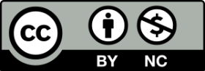

 Ein Bild, das Text enthält.  

Introduction to the teaching and learning materials

**Brief description of the content:**

This unit’s focus is on strategies for waste avoidance. Sources of waste will be identified and possibilities for action in terms of the responsible use of raw materials and the environment. Thereby, it should be shown that this does not imply focusing on renunciation but on creativity and design possibilities instead.

**Competencies and Learning Content:**

After this lesson, students should be able to

* understand and recognise the excessive amount of waste and its problematic nature.
* identify the microplastic pollution of the oceans as one dimension of education for sustainable development.
* recognise possibilities of avoiding waste, e.g., in the area of packaging, and act in the sense of sustainability.
* recognise opportunities that show that waste prevention is about acting creatively and responsibly instead of relinquishing.
* master various textile techniques and apply them as a design element.

Overview of working materials

*Teaching module 1*

*Topic 1: Waste as a phenomenon*

*Worksheet: A 1 What is rubbish? And what is waste?*

*Teaching module 2*

*Topic 2: Generation of plastic waste*

*Worksheet: A2 That adds up to quite a lot – plastic waste in Europe*

*Teaching module 3*

*Topic 3: Microplastics*

*Worksheet: A3/1 Microplastics – inconspicuous and everywhere*

*A3/2 Microplastics from textile fibres*

*Teaching module 4*

*Topic 4: Gift packaging*

*Worksheet: A4/1 Looks nice, but does not create any waste – sewing gift bags*

*Work materials: fabric scraps (need to be hotly ironable), sewing thread, sewing machine, cord/tape.*

*Teaching module 5*

*Topic 4: Shopping without a bag*

*Worksheet A5/1: Crochet a shopping net*

*Work materials: about 100g cotton yarn (thickness 3.5-4), crochet hook of appropriate thickness, and darning needle for sewing the threads.*

Literature

Assmann, D.-C. (Ed.). (2018). *Narrative der Deponie. Kulturwissenschaftliche Analysen beseitigter Materialitäten* [Narratives of the landfill: Cultural analyses of eliminated materialities].Springer.

Bundesministerium für Bildung und Forschung [Federal Ministry of Education and Research] (n.d.). *Plastik in der Umwelt* [Plastic in the environment]. https://bmbf-plastik.de/de/veranstaltung/webinar-4-Plastikemissionen-in-der-Textilindustrie

DeStatis Europa (n.d.). *Abfallaufkommen* [Waste production]. https://www.destatis.de/Europa/DE/Thema/Umwelt-Energie/Abfallaufkommen.html

Cole, M., Lindeque, P., Halsband, C., & Galloway, T. S. (2011). Microplastics as contaminants in the marine environment: A review. *Marine Pollution Bulletin, 62*(12), 2588–2597. https://doi.org/10.1016/j.marpolbul.2011.09.025

Eisenbrand, J., Hoffmann, M., & Kries, M. (Eds.). (2022). *Plastik: die Welt neu denken* [Plastics: Rethinking the world]. Vitra Design Museum.

Fletcher, K. (2012). *Sustainable Fashion and Textiles*. Routledge

Greenpeace (2017). *Mikrofasern*. *Gefahr aus dem Kleiderschrank* [Microfibres: Danger coming from the wardrobe]. https://www.greenpeace.de/sites/default/files/publications/i03971-20170718-greenpeace-flyer-mikrofaser.pdf

Mäusbecher, A. (2022). *Kids for the Ocean: Strategien & Initiativen aus dem Alltag gegen die Vermüllung der Ozeane: Anregungen für Pädagogen und Familien* [Kids for the ocean: Everyday strategies & initiatives against ocean litter: suggestions for educators and families]. Erlanger Verlag für Mission und Ökumene.

Moisi, L. (2020). *Die Politisierung des Abfalls: Elemente einer Kulturtheorie häuslicher Müllentsorgung* [The Politicisation of Waste: Elements of a cultural theory of domestic waste disposal]. De Gruyter.

NABU (n.d.). *Kunststoffe und Bioplastik* [Plastics and bioplastics]. https://www.nabu.de/umwelt-und-ressourcen/ressourcenschonung/kunststoffe-und-bioplastik/25222.html

Raidt, G. (2019). *Müll* [Waste]*. Alles über die lästigste Sache der Welt* [All about the most annoying thing in the world]. Beltz und Gelberg.

Recycling Entsorgung & Logistik GmbH (n.d.). *REL. Wir können Abfall auch erklären* [REL: We can explain waste too]. https://www.recycling-entsorgung-logistik.de/abfall/

Schickling, K. (2020). *Der Konsum Kompass. Was Sie wirklich über Plastikverpackungen, Neuseelandäpfel & Co. wissen* müssen [The consumption compass: What you really need to know about plastic packaging, New Zealand apples & Co.]*.* Mosaik.

Smarticular (Ed.). (2019). *Plastik Sparbuch. Mehr als 300 nachhaltige Alternativen und Ideen, mit denen wir der Plastikflut entkommen* [Plastic savings book: More than 300 sustainable alternatives and ideas to help us escape the plastic flood]. Smarticular.

Stadtwerke Singen (n.d.). *Was ist eigentlich Müll?* [What is waste, actually?] https://www.stadtwerke-singen.de/pdf_koffer/abfallkoffer/klasse_1_4/1_abfallentstehung/12_was_ist_muell.pdf

Thompson, M. (2021). *Mülltheorie*. *Über die Schaffung und Vernichtung von Werten* [Waste theory: On the creation and destruction of values]. New edition. Ed. by M. Fehr. transcript.

Trentmann, F. (2017). *Die Herrschaft der Dinge*. *Die Geschichte des Konsums vom 15. Jahrhundert bis heut*e [The rule of things: The history of consumption from the 15th century to today]. Deutsche Verlags-Anstalt.

Vorlauf, A. (2022). *Alles im Fluss: Abschlussbericht zum Bildungsprojekt / gefördert durch die Deutsche Bundesstiftung Umwelt (DBU)* [Everything in the river: final report on the education project / funded by the Deutsche Bundesstiftung Umwelt (DBU)]. EUCC - Die Küsten Union Deutschland e.V. (EUCC-D). https://www.dbu.de/OPAC/ab/DBU-Abschlussbericht-AZ-33327_01-Hauptbericht.pdf

Witt, O. (2019). *Ein Leben ohne Müll*. *Mein Weg mit Zero-*Waste [A life without waste: My journey with Zero-Waste]. Tectum

Figures

Stastista Research Department (14.04.2023). *Plastikverpackungsabfall in ausgewählten EU-Ländern je Einwohner in den Jahren 2019 und 2020* [Plastic packaging waste in selected EU countries per inhabitant in 2019 and 2020].https://de.statista.com/statistik/daten/studie/786353/umfrage/plastikverpackungsabfall-in-ausgewaehlten-eu-laendern-je-einwohner/

Mikroplastik und andere Müllpartikel aus Sedimenten mitteleuropäischer Flüsse [Microplastics and other waste particles from sediments of Central European rivers], Martin Wagner, CC BY 4.0, https://de.wikipedia.org/wiki/Mikroplastik#/media/Datei:Microplastics_in_sediments.jpg

Source:

Wagner, M., Scherer, C., Alvarez-Muñoz, D., Bennholt, N., Bourrain, X., Buchinger, S., Fries, E., Grosbois, C., Klasmeier, J., Marti, T., Rodriguez-Mozaz, S., Urbatzka, R., Dick Vethaak, A., Winther-Nielsen, M., & Reifferscheid, G. (2014). *Microplastics in freshwater ecosystems: what we know and what we need to know.* *Environmental Sciences Europe,* 26(12), 1-9. https://doi.org/10.1186/s12302-014-0012-7

*Worksheet: A 1 What is rubbish? And what is waste?*

Colloquially, the terms rubbish and waste are used interchangeably. However, in technical language, waste refers to things that are defined by law as the substances or objects that a person discards as (s)he wants or must do so. The decision about what is still usable and what is already unusable is very individual and cannot be clearly defined.

According to preliminary estimates, Germany generated an average of 646 kilograms of municipal waste per inhabitant in 2021. This was significantly higher than the EU average of around 530 kilograms per inhabitant. Only Luxembourg (793 kg), Denmark (786 kg), and Belgium (759 kg) had even higher waste quantities than Germany. Especially in the eastern EU countries, waste generation was significantly lower. The lowest quantities per inhabitant were recorded in Romania (302 kg) and Poland (362 kg) (DeStatis Europe, n.d.).

Municipal waste includes the following materials: paper, cardboard and paper products, plastics, glass, metals, food, and garden waste as well as textiles. It is the waste generated in households, trade, commerce, offices as well as institutional facilities. It also includes bulky waste, leaves and tree cuttings, street sweepings, and the contents of waste containers (DeStatis Europe, n.d.).

Task 1: Formulate your personal definition of waste.

Task 2: Where and how does waste arise in your household? What can you do to reduce it, besides cutting down on your consumption?

Task 3: Make a table of your amount of waste in one week and think about alternatives.

Tab. 1: My amount of waste in one week

|  |  |  |
| --- | --- | --- |
| **Type of waste** | **Alternative purchase** | **Alternative use** |
| Plastic packaging for fruit | Unpacked fruit / shopping net |  |
| Discarded blouse |  | Patches/fabric stock for quilting |
| … |  |  |
| … |  |  |

*Worksheet: A2 That adds up to quite a lot - plastic waste in Europe*

The table below shows the amount of plastic produced in kilograms per inhabitant in selected EU countries in 2020. It covers every type of plastic material which is consumed and then disposed of.

Fig. 2: Plastic packaging waste per inhabitant (in kg) in selected EU countries in 2020 (EU average: 34.55 kg).

Source: Statista Research Department, 2023

Task 1: Create a mind map of the areas where plastic waste is created. Then search the Internet for figures showing the percentage distribution in your country.

Task 2: Look at the table. Then think about which countries have a particularly high and which a particularly low amount of plastic packaging.

Task 3: Consider why this might be the case and formulate at least one reason.

W*orksheet: A3/1 Microplastics – inconspicuous and everywhere*

Microplastics are ubiquitous nowadays. Tiny particles of ground-up plastic material can be found in oceans and rivers, but also in fields, food, and the stomachs of animals.

The term microplastic is usually used when speaking of plastic particles that measure less than five millimetres. However, there is still no scientific definition or legally defined term for this phenomenon. This makes comparing the results of studies difficult while also making greenwashing easier for companies.

NABU (n.d.) calls for all input pathways of microplastics to be examined for their reduction potential and measures developed for all sources. This goes hand in hand with the precautionary principle.

Fig. 3: Microplastics in sediments

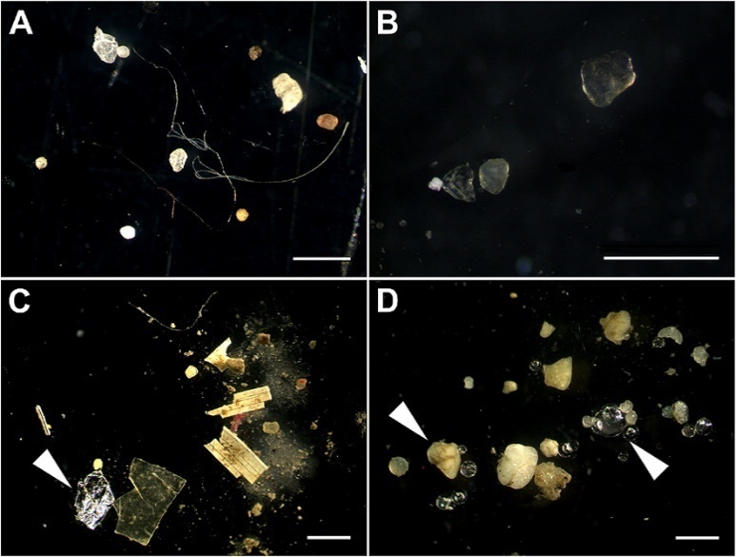

Microplastics in the sediment of the rivers Elbe (A), Moselle (B), Neckar (C), and Rhine (D). (Note the diverse shapes (filaments, fragments, and spheres) and that not all items are microplastics (e.g., aluminum foil (C), glass spheres and sand (D), white arrowheads). The white bars represent 1 mm.)

CC BY 4.0 Martin Wagner

Task 1: Search the internet for the sources of microplastics and their share in Europe. Write down at least three sources.

Task 2: Research alternatives and possible actions to reduce microplastics. Formulate at least two alternative actions that you would implement.

*A3/2 Microplastics from textile fibres*

Ein Bild, das Kleidung, Färbung, Textilfaser, Stoff enthält.
More than one third of the microplastics in the seas come from textiles. This is because synthetic fibres from clothing dissolve when washed and end up in the sea. A single fleece jacket can release up to one million fibres per washing cycle, and a pair of nylon socks another 136,000. According to an EU study, Europe’s washing machines alone flush 30,000 tonnes of synthetic fibres into the wastewater every year (Greenpeace 2017).

Fig. 4: Fibres as a source of microplastics, CC BY-SA Anne-Marie Grundmeier

Synthetic fibres are polymer fibres produced synthetically from petroleum. They are used as filaments or staple fibres to produce many textiles and make up more than half of the world’s fibre consumption.

Pictures of plastic accumulations on the shore or garbage patches in the oceans go around the world. However, it seems to be less recognised that similar tragedies are taking place in the microscopic world of plankton (Greenpeace, 2017).

Some of the fibres can be retained in sewage treatment plants. However, a large part ends up in rivers and seas. Since textiles made of synthetically produced fibres are not biodegradable, they break down into even smaller particles and accumulate in the water. They also enter the food chain of animals and ultimately humans. It has not yet been conclusively investigated what damage the smallest particles can cause to health. However, studies show that marine animals do not thrive as well when they ingest plastic particles (Cole et al., 2011).

To date, there is no sign of a reduction in fibre use. There are calculations that the clothing industry can increase its use of synthetic fibres by another 62 per cent by 2030. Thus, the world’s population will consume 102 million tonnes of clothing. This amount is equivalent to 500 billion T-shirts. These textiles will be made up of almost 70 per cent synthetic fibres (Greenpeace, 2017).

Fig. 5: Fleece as a source of microplastics

Ein Bild, das Textil, nähen, Handarbeit, Muster (Modedesign) enthält.

CC BY-SA Anne-Marie Grundmeier

Task 1: Research the advantages of synthetic fibres compared to natural fibres. Name and justify at least one advantage.

Task 2: Which alternatives do you think are possible? Think for yourself and search the internet to see what solutions can be found. Describe one solution in detail.

*Worksheet: A4/1 Looks nice, but does not create any waste – sewing gift bags*

|  |  |
| --- | --- |
| Ein Bild, das Text, Muster, Rechteck, Muster (Modedesign) enthält.  Automatisch generierte Beschreibung | Cut a rectangle of fabric. The size is arbitrary, so fabric scraps can be reused very well. |
| Ein Bild, das Kleidung, Stoff, Muster, Textil enthält.  Automatisch generierte Beschreibung | Mark 2 and 5cm on both sides of the fabric piece for the fold/cover. |
| Ein Bild, das Muster, Stoff, Textil, nähen enthält.  Automatisch generierte Beschreibung | Press the fold over so that the edge of the fabric meets the 2cm mark. |
| Ein Bild, das Stoff, Kleidung, Muster, Textil enthält.  Automatisch generierte Beschreibung | Press the cover over so that the fold meets the 5cm mark. |
| Ein Bild, das Muster, Textil, Muster (Modedesign), nähen enthält.  Automatisch generierte Beschreibung | Fold up the pressed edges and sew the side seams with a seam width of 1cm. |
| Ein Bild, das Text, Muster, Muster (Modedesign), Textil enthält.  Automatisch generierte Beschreibung | Neaten the seam edges together. If you want to create a tunnel, neaten the upper 5cm separately. |
| Ein Bild, das Textil, Muster, Kunst, Im Haus enthält.  Automatisch generierte Beschreibung | Fold back the hoop edges and topstitch them close to the edge.  If you want to create a tunnel, leave the upper seam edges folded apart when folding over and stitching down. Open the side seam at the top over 2cm so that a cord or ribbon can be pulled in here. |
| Ein Bild, das Schleife, Bastelei, Geschenk, Geschenkverpackung enthält.  Automatisch generierte Beschreibung | Done! |

Photos: CC BY-SA-NC-ND Dorit Köhler

*Worksheet A5/1: Crochet a shopping net*

|  |  |
| --- | --- |
|  | Cast on 5 chain crochets and close the crochets to a round with 1 slip crochet, as shown in the picture. |
|  | Crochet solid crochets in rounds, increasing at the following rate:  Mark the beginning of the round.  Double every crochet in the first round.  Double every other crochet in the second round.  Double every third crochet in the third round, etc. |
|  | After the fifth round, switch from solid crochets to double crochets and continue to increase. |
|  | Crochet air crochet arcs. When the circle has reached the desired size for the bottom: Make 3 chain crochet and skip 1 crochet. Crochet a solid crochet and continue crocheting in rounds until the desired height is reached. |
|  | Handle: Make solid crochets along the top edge to where you want the handle to begin.  Make a chain of chain crochets in your desired length, attach it to the other side with a slip stitch, turn it, and crochet 2 rows of solid crochets on top of it.  Make solid crochets along the top edge to the other side where you want the handle to start. Repeat this process with solid crochets at the beginning, cut the thread, and sew.  The net is finished! |

CC BY-SA-NC-ND Dorit Köhler