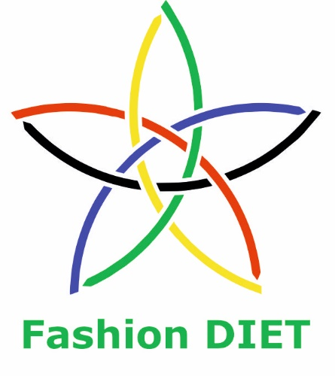

Sustainable Fashion Curriculum at Textile Universities in Europe
–
Development, Implementation and Evaluation of a Teaching Module for Educators

Project: 2020-1-DE01-KA203-005657

Title of the Lesson: Sustainable Raw Materials in the Textile Chain

Author: Prof. Dr. Anne-Marie Grundmeier
Contact: University of Education Freiburg
Institute of Everyday Culture, Sports and Health
Department Fashion and Textile
E-mail: grundmeier@ph-freiburg.de


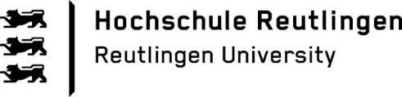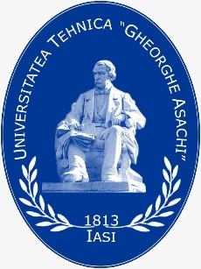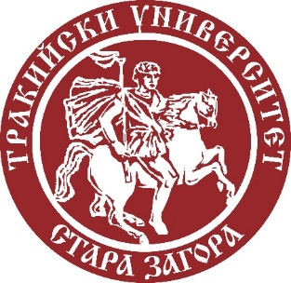
Introduction to the Teaching and Learning Materials

Short Description of the Content:

Students will engage in an insightful exploration of raw materials that serve as fundamental building blocks in the textile chain. Materials covered include cotton, wool, lyocell, polyester and more. Through this unit, students will gain a deeper understanding of each material’s unique characteristics and versatile applications within the textile chain and fashion industry.

Competences and Learning Objectives:

After this unit the student should be able to …

- Identify and describe different raw materials used in textile production.
- Recognize the properties and characteristics of various textile materials.
- Differentiate between natural and chemical fibres.
- Understand the environmental impact of different raw materials in the textile chain and fashion industry.
- Compare and contrast the advantages and disadvantages of using specific textile materials also regarding sustainability aspects.

Overview of Working Materials

Worksheet 1: Group Work: What do the pictures have in common?

Worksheet 2: Plant Fibre: Cotton

Worksheet 3: True or False (Cotton)

Worksheet 4: Natural Fibre: Flax / Linen

Worksheet 5: True or False (Flax / Linen)

Worksheet 6: Animal Fibre: Wool

Worksheet 7: True or False (Wool)

Worksheet 8: Animal Fibre: Silk

Worksheet 9: True or False (Silk)

Worksheet 10: Cellulosic Chemical Fibre: Viscose / Modal

Worksheet 11: True or False (Viscose / Modal)

Worksheet 12: Cellulosic Chemical Fibre: Lyocell

Worksheet 13: True or False (Lyocell)

Worksheet 14: Synthetic Chemical Fibre: Polyester

Worksheet 15: True or False (Polyester)

Worksheet 16: Synthetic Chemical Fibre: Elastane

Worksheet 17: True or False (Elastane)

Worksheet 18: Systematic Overview of Fibres

Worksheet 19: World Fibre Market

Worksheet 20: Future Fashion Walk – Planning a Sustainable Fashion Tour
Literature

Eberle, H., Gonser, E., Hornberger, M., Kilgus, R., & Kupke, R. (2022). Fachwissen Bekleidung [Specialist knowledge clothing] (12th ed.). Europa-Lehrmittel.

Eberle, H., Hornberger, M., Menzer, D., Gonser, E., Kilgus, R., Moll, A., Hermeling, H., Kupke, R., & Ring, W. (2014). Clothing Technology … from fibre to fashion (6th ed.). Europa-Lehrmittel.

Fontaine, A. (2017). Technologie für Bekleidungsberufe. Grundstufe und Fachstufen [Technology for clothing professions: Basic level and specialist levels] (16th ed.). Bildungsverlag Eins.

Hauser, B. (2018). Die textile Welt im Fokus. Werkstoffkunde, Textiltechnologie, Warenkunde, Textilveredelung [The textile world in focus: Materials science, textile technology, fabric science, textile finishing]. Trauner.

Lewin, M., & Sello, S. (Eds.). (2017). Handbook of Fiber Science and Technology: Volume 1. Routledge. https://doi.org/10.1201/9780203719275

McIntyre, J. E. (Ed.). (2004). Synthetic Fibres: nylon, polyester, acrylic, polyolefin. Woodhead Publishing.

Muthu, S. S. (Ed.). (2014). Roadmap to Sustainable Textiles and Clothing: Eco-friendly Raw Materials, Technologies, and Processing Methods. Springer.

Textile Exchange (2022, October). Preferred Fiber and Materials Market Report. https://textileexchange.org/wp-content/uploads/2022/10/Textile-Exchange_PFMR_2022.pdf

Image Sources

Worksheet 1:

Sheep: No title, Judith Prins, https://unsplash.com/license, https://unsplash.com/photos/AJa7S1fjy-I
Wood: No title, Sonia Rose, https://unsplash.com/license, https://unsplash.com/photos/azdKdNj3YRU
Cotton: No title, Marianne Krohn, https://unsplash.com/license, https://unsplash.com/photos/RNqZbnBnMQk
Silkworm: https://unsplash.com/photos/RNqZbnBnMQkBombyx_mori1.jpg: Zivyaderivative work: Linksfuss, CC BY-SA 3.0 <https://creativecommons.org/licenses/by-sa/3.0>, via Wikimedia Commons

Worksheet 8:

Cotton Fibres, CC-BY-SA-NC Grundmeier

Worksheet 10:

Flax Fibres, CC-BY-SA-NC Grundmeier

Worksheet 12:

Wool Fibres, CC-BY-SA-NC Grundmeier

Worksheet 14:

Silk Cocoons, CC-BY-SA-NC Grundmeier

Worksheet 16:

Viscose Fibres, CC-BY-SA-NC Grundmeier

Worksheet 18:

Lyocell Fibres, CC-BY-SA-NC Grundmeier

Worksheet 20:

Polyester Fibres, CC-BY-SA-NC Grundmeier

Worksheet 21:

Illustration Future Fashion Walk, composed by Kim Frank, CC-BY-SA-NC-ND, with reference to:
Landscape of a city, Mahij16902
https://www.canva.com/policies/content-license-agreement/
People Protesting with Sign Half Body, sketchify
https://www.canva.com/policies/content-license-agreement/
Space Earth Planet Flat Style Icon, iconsy
https://www.canva.com/policies/content-license-agreement/
Dynamic Lined Shopping Bag, Lemuel Taytay
https://www.canva.com/policies/content-license-agreement/

Worksheet 22:

Elastane Fibres, CC-BY-SA-NC Grundmeier
Teacher Material: Worksheet 1
Introduction into the topic: Guessing the topic and activating pre-knowledge!

Group Formation:

Divide the class into small groups of 4 to 5 students each.

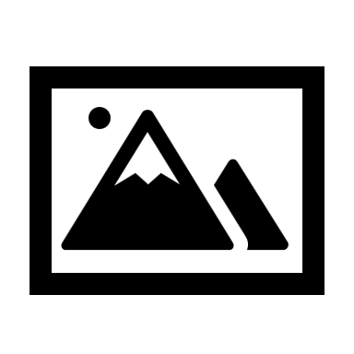Picture Analysis:

Distribute the four pictures of the silkworm, wood, sheep, and cotton to each group.
Instruct them to carefully study the images and take notes of any elements or connections they can think of.

Group Discussion:

Give the groups time to discuss and share their ideas, pre-knowledge, and related knowledge they might have.
Encourage the students to write down questions they may have regarding the topic as well.

Presenting:

Each group presents their findings, ideas, pre-knowledge, and their questions to the class.

After all groups have presented, reveal the correct answer that ties the pictures together.

Answer: The common factor is that all the pictures represent raw materials or sources used in the textile chain to produce textiles and fabrics. Textiles and fabrics can be made from plant or animal fibres or are manufactured from resources such as wood.

Suggested solutions to the worksheet tasks are in light blue font.

Worksheet 1: Group Work: What do the pictures have in common?

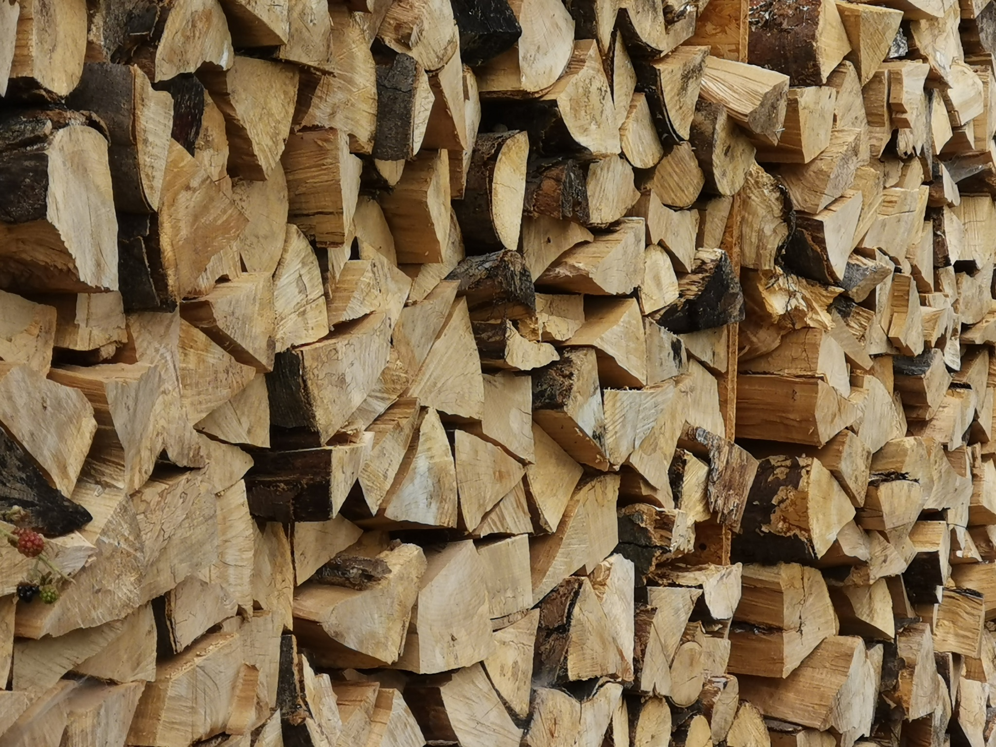
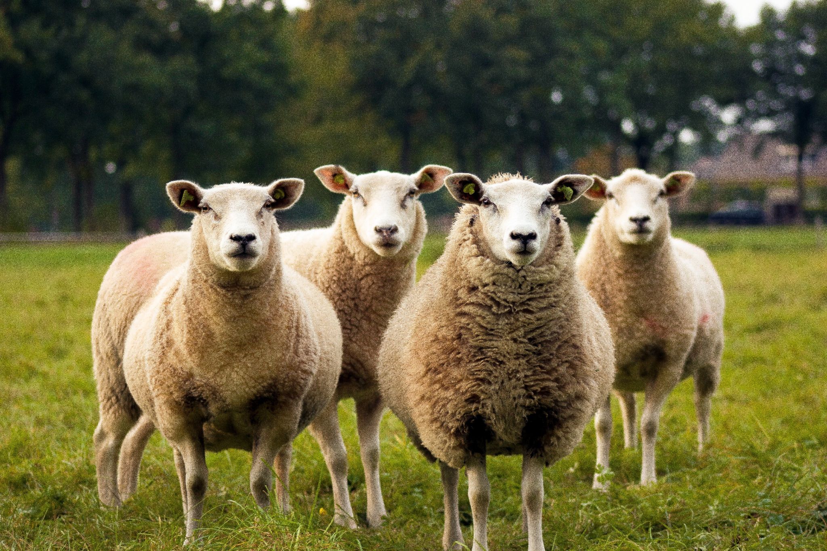
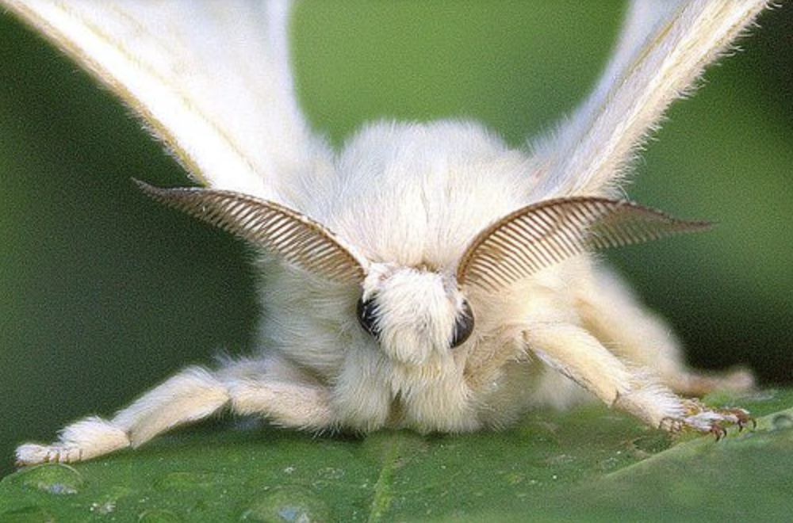
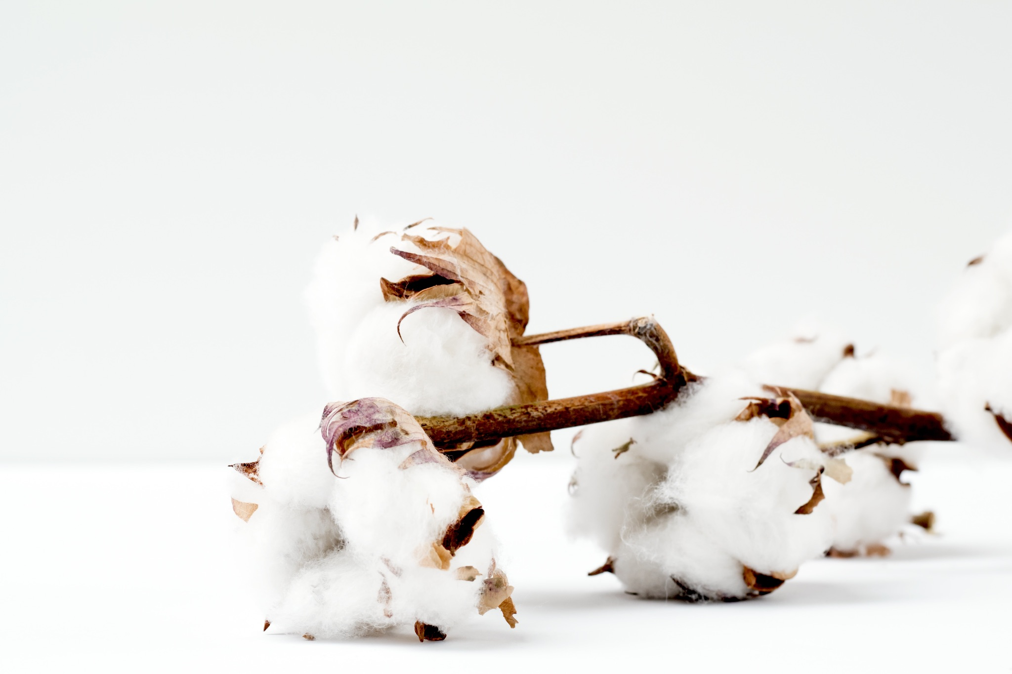

Work on the following tasks within your group:

- Get together with your group and talk about what the pictures have in common.

- Do some brainstorming and gather everything you already know about the topic and write it down. Are there any related processes or related facts / information you already heard of? Collect your ideas.

- Create a short and informative presentation about the topic using the information you already have.

- Write down any questions you have about the topic and incorporate them at the end of your presentation.

Worksheet 2: Plant Fibre: Cotton
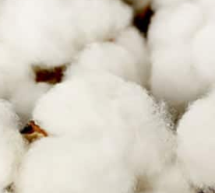
Cotton is a plant fibre and the most widely produced natural fibre on the planet. It consists of seed fibres in the fruit capsules of cotton bushes. Today, cotton accounts for less than a third of all fibrous materials in the global market. It is by far the most important natural fibre. The cotton plant needs a hot climate, which is why it is mainly grown in China, India, Brazil, Pakistan and the Southern United States of America, the so-called Cotton Belt. These main producing countries supply about 80% of the world’s cotton.

The cotton plant needs a lot of water to grow, and dryness is important during the ripening period and harvest. The Aral Sea between Kazakhstan and Uzbekistan has been deprived of 80% of its water to water the cotton plants. To protect the plants from pests such as the boll weevil, pesticides are used, which are very dangerous to both health and the environment. Only the planting of organic cotton avoids the use of chemical fertilisers, pesticides, and genetic engineering. Genetically modified cotton plants are grown on about 75% of the fields. However, organic cotton accounts for only about 1% of the cotton grown worldwide.

Before cotton fibres can be spun into yarns they need to be separated from the seeds. Each cotton fibre is a single cell and reaches a length up to 5 cm. To make yarns for fabrics the fibres are overlapped and twisted around each other in a spinning process. Longer fibres are more valuable than short ones, because they require less overlap and can therefore be spun into finer yarns.

Tasks:
- Read the text and fill in the gaps in the text by using the word list:
climate, organic, pesticides, water, yarns.
- If you have difficulties or want to gather more information, inform yourself with the help of websites on cotton.
- Have a look at your wardrobe and household textiles and see which of them are made of cotton. Give at least four examples:

1. ________________________________ t-shirt
2. ________________________________ jeans
3. ________________________________ underwear
4. ________________________________ bath towel

! Did you know that the Mayans in Mexico and the Incas in Peru grew cotton over 7,000 years ago?
Worksheet 3: True or False (Cotton)
- Do some research to identify the European countries that hold importance in the cotton production. After conducting your research, which three countries emerged as the most important in cotton production?

1. ________________________________ Greece
2. ________________________________ Spain
3. ________________________________ Bulgaria

- Answer these true or false questions by ticking the right answer.

TRUE | FALSE
□ | □ | 1. | True or false: Cotton cultivation is a highly water-intensive process. (True)
□ | □ | 2. | True or false: Cotton is a renewable resource, as it can be harvested year after year. (True)
□ | □ | 3. | True or false: Cotton fibres are spun into yarns, which are then woven into fabric. (True)
□ | □ | 4. | True or false: Cotton is known for its softness, breathability, and moisture absorption properties. (True)
□ | □ | 5. | True or false: Cotton cultivation requires careful fertilisation and irrigation to ensure a successful yield. (True)
□ | □ | 6. | True or false: Cotton is used to make products such as t-shirts, jeans, bed sheets, and towels. (True)
□ | □ | 7. | True or false: Cotton is a synthetic fibre made from chemical processes. (False)
□ | □ | 8. | True or false: Cotton cultivation has a low environmental impact compared to other natural fibres. (False)
□ | □ | 9. | True or false: Cotton is commonly used in various art and craft projects due to its versatility. (True)

Worksheet 4: Natural Fibre: Flax / Linen
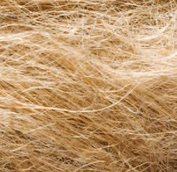
Flax is a plant that was already processed by humans into so-called linen fibres, yarns and strings more than 35,000 years ago. Today, it is largely cultivated in France, Belgium and Russia, but also in the Netherlands and England. Compared to cotton cultivation, the flax plant only needs about a quarter of the water. It is also rather undemanding in terms of soil quality. The plant needs only a small amount of fertiliser.

Before the fibres are extracted from the plant, the capsules must be separated from the stalks. The capsules contain the linseeds, from which linseed oil, for example, is made. To produce linen fibres, however, the fibre bundles are needed, which have to be removed from the stalks.

For the harvesting and fibre extraction, the stalks are stacked in bundles in the field to dry out. During the retting process, moisture and heat cause fungi to develop, which degrade the woody part of the stems, so that the fibre bundles can be released in further steps. First, the flax straw is broken, coarse wood residues and the fibre bundles are loosened and separated from each other. The remaining plant and woody parts as well as very short fibres are removed by scutching, followed by a combing process. These processes result in longer and shorter fibres. The latter can be converted into very fine fibres in chemical mechanical processes.

Tasks:
- Read the text and fill in the gaps in the text by using the word list:
capsules, fertiliser, fibre bundles, linen, stalks.
- If you have difficulties or want to gather more information, inform yourself with the help of websites on flax/linen.
- Have a look at your wardrobe and household textiles and see which of them are made of linen. Give at least four examples:

1. ________________________________ shirt
2. ________________________________ dress
3. ________________________________ kitchen towel
4. ________________________________ tablecloth
! Did you know that several thousand years ago the Egyptians called flax “woven moonlight” and used flax to make the clothes of priests, pharaohs and as the shrouds of mummies?
Worksheet 5: True or False (Flax / Linen)
- Answer these true or false questions by ticking the right answer.

TRUE | FALSE
□ | □ | 1. | True or false: Flax is also known as linen due to its historical use in making linen yarns. (True)
□ | □ | 2. | True or false: Flax requires the same amount of water as cotton cultivation. (False)
□ | □ | 3. | True or false: To extract fibres from the flax plant, the capsules containing linseeds are left intact during the process. (False)
□ | □ | 4. | True or false: Flax was processed by humans into linen yarns and strings more than 35,000 years ago. (True)
□ | □ | 5. | True or false: Flax is undemanding in terms of soil quality and requires only a small amount of fertiliser. (True)
□ | □ | 6. | True or false: The spinning process involves the scutching and combing of the processed flax stalks, resulting in linen fibres. (True)
□ | □ | 7. | True or false: Flax is also known as linen due to its historical use in making linen yarns. (True)
□ | □ | 8. | True or false: As part of the harvesting and fibre extraction, the stalks must be dried out before further processing. (True)
□ | □ | 9. | True or false: Moisture and heat prevent the development of fungi that dissolve the glue between plant layers, making it challenging to release the fibre bundles. (False)

Worksheet 6: Animal Fibre: Wool
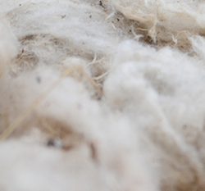
A sheep’s hair is called wool. Wool is a protein fibre that is very similar to human hair, known as keratin. On the outer layer of the wool fibre there is a structure of scales arranged like roof tiles. The outer layer of scales, which is covered with wool grease (lanolin), protects against external moisture. Water drops roll off the surface. Water vapour, on the other hand, passes through the scaly layer. The wool fibres can absorb up to a third of their own weight in moisture and release it back into the environment without becoming damp to the touch.

To preserve the wool fleece, the sheep are sheared with electric shears at least once a year. If done carefully, this does not hurt the animals and the sheepskin grows back again. First, the wool has to be washed, because the valuable wool grease, but also plant residues and dirt cling to the fibres. The wool grease is used for ointments. Once the wool has been washed, the wool fibres are spun into yarns.

The wool fibres can become permanently interlocked with their scaly layer under the influence of heat, moisture and mechanics; this process is called felting.

Wool is produced in about 100 countries worldwide. Today, most wool comes from Australia, followed by China, New Zealand, and Turkey. Australia is also known for producing the best merino wool, which is used for fine clothing. Further popular animal fibres (hairs) are alpaca, camel, cashmere and mohair from angora goats. Angora hair from rabbits is mainly used for thermal underwear.

Tasks:
- Read the text and fill in the gaps in the text by using the word list:
felting, keratin, sheep, sheepskin, wool grease.
- If you have difficulties or want to gather more information, inform yourself with the help of websites on wool.
- Have a look at your wardrobe and household textiles and see which of them are made of wool. Give at least four examples:

1. ________________________________ scarf
2. ________________________________ knitted jumper
3. ________________________________ carpet
4. ________________________________ blanket

! Did you know that wool is used as insulation and as a low-flammability material in car seats or aeroplanes?
Worksheet 7: True or False (Wool)
- Do some research to identify the European countries that hold importance in the wool production. After conducting your research, which three countries emerged as the most important in wool production?

1. ________________________________ United Kingdom
2. ________________________________ Spain
3. ________________________________ Romania

- Answer these true or false questions by ticking the right answer.

TRUE | FALSE
□ | □ | 1. | True or false: Wool is a synthetic fibre made from chemical processes. (False)
□ | □ | 2. | True or false: The outer layer of wool fibres cannot protect from external moisture. (False)
□ | □ | 3. | True or false: Merino wool is known for its softness, breathability, and moisture absorption properties. (True)
□ | □ | 4. | True or false: Wool is commonly used in various art and craft projects due to its versatility. (True)
□ | □ | 5. | True or false: Wool is a renewable resource, as it can be harvested year after year. (True)
□ | □ | 6. | True or false: Wool fibres are typically spun into yarns and used to make various clothing items. (True)
□ | □ | 7. | True or false: Wool is naturally insulating and helps to keep the body warm. (True)
□ | □ | 8. | True or false: Wool can felt and shrink when exposed to washing and heat. (False)
□ | □ | 9. | True or false: Wool is biodegradable, making it environmentally friendly. (True)

Worksheet 8: Animal Fibre: Silk
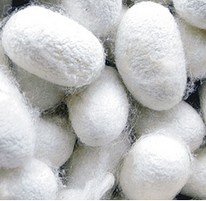
Silk is an animal fibre obtained from the cocoons of the silkworm. With the help of a spinneret at their heads, which is fed by two glands, they spin a very long double thread, which they wrap around themselves in rollercoaster-like movements (up to 300,000 times). This process is called “pupation”. The silkworms produce a tangle of loose silk fibre to secure the position of the cocoons in the straw. In 14 days, they undergo a complete metamorphosis from pupa to moth.

The silk thread consists of the protein fibroin and the silk glue (sericin) surrounding it. The fibres can have a length of up to 3,000 metres. Since the filament of a cocoon is very, very fine, usually 8 to 10 are processed into a silk thread. It takes about 3,000 cocoons to make 250 g of silk thread.

The best-known silk is obtained from the cocoons of the larvae of the mulberry silkworm Bombyx mori, which is reared in captivity. Silk is produced by various insects, but only the filament of the moth caterpillar has been used for textile manufacturing for about 5,000 years.

Silk originally comes from China and even today China is the main producer. Brazil, India and Japan are also important producer countries. Beside the mulberry silkworm, there are further wild species of which the Tussah is the most important.

Tasks:
- Read the text and fill in the gaps in the text by using the word list:
caterpillar, cocoons, producer, protein, silkworms.
- If you have difficulties or want to gather more information, inform yourself with the help of websites on silk.
- Have a look at your wardrobe and household textiles and see which of them are made of silk. Give at least four examples:

1. ________________________________ blouse
2. ________________________________ lingerie
3. ________________________________ wedding dress
4. ________________________________ bed linen
! Did you know that the so-called Silk Road – a trade route from China to Europe – got its name from the export of silk?
Worksheet 9: True or False (Silk)
- Answer these true or false questions by ticking the right answer.

TRUE | FALSE
□ | □ | 1. | True or false: Silk is an animal fibre obtained from the cocoons of the silkworm. (True)
□ | □ | 2. | True or false: Silkworms spin a very long double thread around themselves during the pupation process. (True)
□ | □ | 3. | True or false: Silk originally comes from India, and even today India is the main producer. (False)
□ | □ | 4. | True or false: The silk thread consists of the protein fibroin and the silk glue (sericin) surrounding it. (True)
□ | □ | 5. | True or false: Usually, 30 to 80 cocoons are processed to create a silk thread. (False)
□ | □ | 6. | True or false: It takes about 1,000 cocoons to make 500 g of silk thread. (False)
□ | □ | 7. | True or false: A single cocoon’s fibre can have a length of up to 5,000 metres. (False)
□ | □ | 8. | True or false: Silk is the only naturally occurring continuous fibre that people use in large quantities for textiles and clothing. (True)
□ | □ | 9. | True or false: Silk is one of the most precious fibres we know. (True)

Worksheet 10: Cellulosic Chemical Fibre: Viscose / Modal
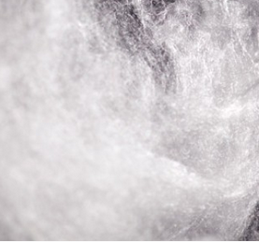
Viscose and modal are cellulosic chemical fibres. That means that the fibre consists of the plant material cellulose, but it is produced chemically. They are mainly made from wood types such as beech, spruce, eucalyptus, pine and bamboo, the trees which are grown in large plantations. After removing the bark, the wood is chipped into fragments with the length of matches.

To obtain the viscose or modal fibre, a very complex chemical process is necessary. A large amount of chemicals is used, most of which contain sulphur, so that elaborate wastewater and exhaust air purification is necessary to avoid polluting the water and air. In addition, a lot of water and energy are needed for the process.

The cellulose is scarcely altered by the spinning process, but the cellulose molecules are much shorter than those of cotton, and their organisation in the fibres is different. The spinning process of modal is more advanced than the one of viscose fibres. On the one hand, it results in longer cellulose molecules, and, on the other hand, the structure and the orientation of the crystalline areas are improved which yields a higher strength.

Viscose is mainly produced in China, India and Indonesia, but there is also production of cellulosic man-made fibres in Europe. One of the world’s leading companies is Lenzing AG in Austria.

Tasks:
- Read the text and fill in the gaps in the text by using the word list:
beech, cellulose molecules, plantations, polluting, sulphur.
- If you have difficulties or want to gather more information, inform yourself with the help of websites on viscose and modal.
- Have a look at your wardrobe and household textiles and see which of them are made of viscose and modal. Give at least four examples:

1. ________________________________ blouse
2. ________________________________ top
3. ________________________________ handkerchiefs
4. ________________________________ hygiene textiles
! Did you know that cellulose-based fibres are also called artificial silk because they have a silky shine, are very soft and have a flowing drape.
Worksheet 11: True or False (Viscose / Modal)
- Answer these true or false questions by ticking the right answer.

TRUE | FALSE
□ | □ | 1. | True or false: Viscose is a natural fibre obtained directly from plant materials. (False)
□ | □ | 2. | True or false: Viscose is produced through a chemical process using cellulose from wood. (True)
□ | □ | 3. | True or false: The pulp for cellulose used in viscose is mainly obtained from animal sources. (False)
□ | □ | 4. | True or false: Modal is a cellulosic man-made fibre made from beech wood. (True)
□ | □ | 5. | True or false: Viscose is mainly made from wood types such as beech, spruce, eucalyptus, pine, and bamboo. (True)
□ | □ | 6. | True or false: Viscose is primarily produced in China, India, and Indonesia. (True)
□ | □ | 7. | True or false: Elaborate wastewater and exhaust air purification are not necessary during the production of viscose. (False)
□ | □ | 8. | True or false: Viscose production does not require a significant amount of water and energy. (False)
□ | □ | 9. | True or false: Lenzing AG in Austria is one of the world’s leading companies producing viscose. (True)

Worksheet 12: Cellulosic Chemical Fibre: Lyocell
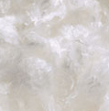
Lyocell is a cellulosic man-made fibre. The brand name of Lenzing AG, which produces this fibre, is Tencel™. The cellulose is mainly extracted from beech wood, sourced from certified sustainable forestry. Cellulose sheets are broken into squares measuring approximately one inch across. They are placed in pressurised and heated vats of amine oxide, which is the direct solvent used to make lyocell fibres.

Once the cellulose has dissolved into a clear liquid, it is filtered and pumped through spinnerets. As the cellulose is forced through spinnerets, it is turned into long, thin fibres. The resulting filaments are immersed in a vat of diluted amine oxide to set, and they are then washed with water.

Unlike modal and viscose, no sulphur-containing chemicals or others are used in this closed loop production process, and the water required can be released back into the water cycle. The solvent, which is not harmful to health or the environment, can also be recycled at a rate of over 99%. Therefore, the spinning process of lyocell transforms wood pulp into cellulosic fibres with high resource efficiency and low ecological impact.

Lyocell can be produced in various thicknesses and can therefore be used in a wide variety of textiles, ranging from durable woven fabrics to knitwear.

Tasks:
- Read the text and fill in the gaps in the text by using the word list:
beech wood, ecological, liquid, viscose, water cycle.
- If you have difficulties or want to gather more information, inform yourself with the help of websites on lyocell.
- Have a look at your wardrobe and household textiles and see which of them are made of viscose and modal. Give at least four examples:

1. ________________________________ shirt
2. ________________________________ functional underwear
3. ________________________________ sportswear
4. ________________________________ bed linen
! Did you know that lyocell is biodegradable with the help of microorganisms? The company Lenzing AG itself states a decomposition time of 100% in 16 weeks.
Worksheet 13: True or False (Lyocell)
- Answer these true or false questions by ticking the right answer.

TRUE | FALSE
□ | □ | 1. | True or false: Lyocell is a synthetic fibre made from crude oil by means of chemical processes. (False)
□ | □ | 2. | True or false: Lyocell is a cellulosic man-made fibre derived from plants. (True)
□ | □ | 3. | True or false: Lyocell is biodegradable and environmentally friendly. (True)
□ | □ | 4. | True or false: Lyocell is commonly used in the production of fire-resistant clothing. (False)
□ | □ | 5. | True or false: Lyocell is known for its high elasticity and wrinkle resistance. (False)
□ | □ | 6. | True or false: Lyocell is made from wood pulp, usually sourced from eucalyptus, beech or bamboo. (True)
□ | □ | 7. | True or false: Lyocell production requires the use of harmful chemicals that pollute the environment. (False)
□ | □ | 8. | True or false: Lyocell is a non-absorbent fibre, making it unsuitable for clothing. (False)
□ | □ | 9. | True or false: Lyocell is also known as “Tencel™”, both terms referring to the same fibre. (True)

Worksheet 14: Synthetic Chemical Fibre: Polyester
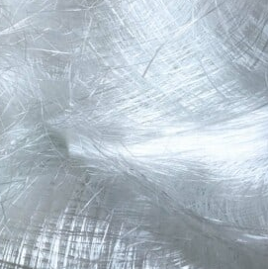
Polyester is the most important chemical fibre in terms of quantity and versatility. It is made of the synthetic polymer polyethylene terephthalate, more commonly known by the abbreviation PET. The so-called PET bottles (plastic bottles) are made from the same raw material. The basic building materials of PET are mainly petroleum, chalk, hard coal and natural gas.

PET is cast and cut into chips, which are melted and extruded in the spinning process. Based on the shape of holes in the spinneret, polyester can imitate other fibres. The filaments are often textured and cut into staple fibres to blend them with cotton, wool and other fibres.

Due to its versatile use, polyester has become increasingly popular since the 1950s. Textiles made of polyester are hard-wearing, easy to care for, and dry quickly. Polyester fibres have a high tensile strength, what makes them suitable for sewing threads. They hardly absorb any moisture, can be made water-repellent and are therefore used for everything from functional underwear to weatherproof clothing.

The major ecological disadvantage of polyester and other synthetic fibres is their high resistance to microorganisms; unlike natural fibres and cellulosic man-made fibres, they do not biodegrade.

Tasks:
- Read the text and fill in the gaps in the text by using the word list:
absorb, biodegrade, chips, petroleum, water-repellent.
- If you have difficulties or want to gather more information, inform yourself with the help of websites on polyester.
- Have a look at your wardrobe and household textiles and see which of them are made of polyester. Give at least four examples:

1. ________________________________ sportswear
2. ________________________________ outdoor clothing
3. ________________________________ backpack
4. ________________________________ tent
! Did you know that polyester fibres are spun as hollow fibres so that they provide optimal thermal insulating properties just like the polar bear’s fur?
Worksheet 15: True or False (Polyester)
- Answer these true or false questions by ticking the right answer.

TRUE | FALSE
□ | □ | 1. | True or false: Polyester is a natural fibre derived from plants. (False)
□ | □ | 2. | True or false: Polyester is made from a combination of materials, mainly petroleum, but also including coal, limestone, and natural gas. (True)
□ | □ | 3. | True or false: Polyester is popular in the textile industry due to its versatility, stability, and low cost. (True)
□ | □ | 4. | True or false: Polyester is hardly used in blends with other fibres, especially cotton and wool. (False)
□ | □ | 5. | True or false: Polyester fibres are produced through a spinning process involving melting chips. (True)
□ | □ | 6. | True or false: Polyester can imitate various other fibres based on the shape of the holes in the spinneret. (True)
□ | □ | 7. | True or false: Polyester is biodegradable and can decompose naturally over time. (False)
□ | □ | 8. | True or false: Polyester fabric is known for its excellent wrinkle resistance and quick-drying properties. (True)
□ | □ | 9. | True or false: Polyester fibres are commonly used for sewing threads in clothing. (True)

Worksheet 16: Synthetic Chemical Fibre: Elastane
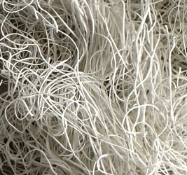
Elastane is a synthetic fibre, which is known for its exceptional stretchiness and only produced as filament yarn. According to the Textile Labelling Act, a fibre is called elastane as soon as it consists of at least 85% polyurethane (this substance provides the strength of the fibres) and polyethylene glycol, which gives the fibre its high stretchability.

The molecular structure is that of a block copolymer with alternating hard and soft segments. The fibres are produced by several spinning technologies. Typically, a concentrated solution of the polymer is drawn through spinnerets at temperatures where the solvent evaporates.

They are added to other fibres (in percentages of 2 to 30%) to increase the elasticity of fabrics. Elastane can be stretched to eight times its original length and then reverts to its former shape. The higher the proportion of elastane, the better the stretch.

Elastane is similar to rubber in its qualities but unlike rubber it has greater strength and is also more durable. The filaments can be used as such or are covered by other fibres. The bare fibre is used in larger amounts up to 45% in stockings, hosiery, sportswear, and swimwear. Covered yarns are used in e.g., cotton textiles at a level of 2 to 5% for a shape-holding elasticity.

Tasks:
- Read the text and fill in the gaps in the text by using the word list:
elastane, molecular structure, rubber, strength, stretched.
- If you have difficulties or want to gather more information, inform yourself with the help of websites on elastane.
- Have a look at your wardrobe and textiles at home and see which of them are made of elastane. Give at least four examples:

1. ________________________________ socks
2. ________________________________ shorts shirt
3. ________________________________ leggings
4. ________________________________ swimsuit
! Did you know that a bathing suit, for example, needs up to 30% elastane? With jeans, on the other hand, 2% is enough to ensure a skin-tight fit.
Worksheet 17: True or False (Elastane)
- Answer these true or false questions by ticking the right answer.

TRUE | FALSE
□ | □ | 1. | True or false: Elastane is a natural fibre. (False)
□ | □ | 2. | True or false: Elastane is added to other fibres to increase the elasticity of fabrics. (True)
□ | □ | 3. | True or false: Elastane can only be stretched twice its original length. (False)
□ | □ | 4. | True or false: Elastane has similar qualities to rubber but is less durable. (False)
□ | □ | 5. | True or false: Elastane is suitable for stockings, hosiery, sportswear, and swimwear. (True)
□ | □ | 6. | True or false: The higher the proportion of elastane, the better the shape-holding elasticity. (True)
□ | □ | 7. | True or false: According to the Textile Labelling Act, a fibre is called elastane if it consists of at least 65% polyurethane. (False)
□ | □ | 8. | True or false: Elastane is a block copolymer with hard and soft segments. (True)
□ | □ | 9. | True or false: In stretch jeans cotton is blended with elastane. (True)

Worksheet 18: Systematic Overview of Fibres

Overview of Textile Fibres, CC-BY-SA-NC Grundmeier

Tasks:
- Complete the systematic overview table with the appropriate fibres:
cotton, elastane, flax, polyester, silk, wool, and viscose/modal into the systematic overview.

- Fill in the gaps:

Solar energy is the basis of life and of all fibres. Fibres are constructed from large polymer molecules, which lie alongside and are bonded to each other.

Fibres from plants and animals are constructed from natural polymers such as cellulose, which is the basic scaffolding substance of all plants and is formed through photosynthesis.

The food taken-in by animals is transformed into fibre-forming proteins.

Cellulosic man-made fibres are formed from cellulose, which is mainly extracted from wood, dissolved, and then forced through spinnerets.

Synthetic fibres are derived from petroleum and other non-renewable energy resources.

Worksheet 19: World Fibre Market

Source of rounded percentage values: Textile Exchange, 2022

Pie Chart of World Fibre Market, CC-BY-SA-NC Grundmeier

In 2021, around 113 million tonnes of fibres were produced. The pie chart shows what percentage of total fibre production each fibre accounts for.

Tasks:
- Sort the fibres according to their percentage of the total fibre production. Start with the highest share.

- What can you observe when comparing the share of natural fibres with that of synthetic fibres? Try to find reasons for the different shares.

- Have a look at the pie chart and fill in the gaps:

Synthetic fibres account for more than half of the total fibre production. In contrast, natural fibres are very underrepresented, except for cotton. Cotton nearly accounts for a quarter of the total fibre production, which is very high for a natural fibre. The cellulosic chemical fibres have a share of only more than 6%, which is very little in comparison.

- Discuss the different shares of fibres in the world in regard to a sustainable future of the textile and fashion market.
Worksheet 20: Exercise: Future Fashion Walk –
Planning a Sustainable Fashion Event
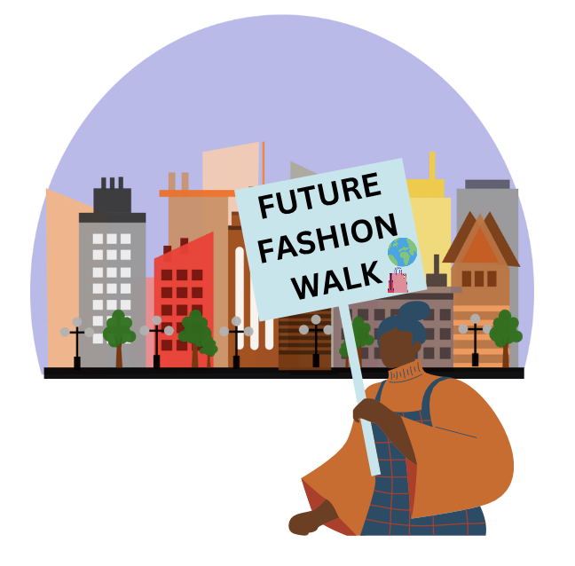
Future, Fashion Walk, CC-BY-SA-NC-ND Kim Frank
In this exercise, you will collaborate with your classmates to plan an exciting event called the “Future Fashion Walk”, a sustainable fashion event focused on promoting eco-friendly fashion choices. You will create a route through your city and identify locations offering future fashion options, such as eco-friendly fashion stores, second-hand shops, and clothing lending places, supporting the future of fashion in your city!

Through this event, you’ll encourage sustainable consumption, raise awareness about eco-friendly fashion, and support local businesses making a positive impact.

Instructions:

Research and Mapping:

Form small groups and delve into researching specific areas of your city. Identify and map locations that offer future fashion options, such as eco-friendly stores, second-hand shops, and clothing lending stores. Your keen exploration will unearth the wonderful places aligned with your sustainable fashion vision.

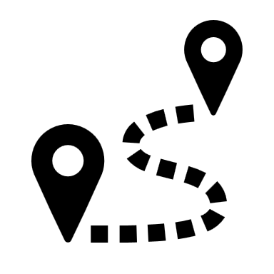Planning the Route:
Collaboratively, share your findings with the team to craft an engaging route connecting the best eco-friendly fashion spots.
Event Activities:
Envision captivating activities that will add charm to the event. Consider sustainable fashion workshops, discussions on eco-friendly materials, and demonstrations of upcycling or clothing repair techniques. Your imaginative ideas will elevate the event’s appeal!
Promote the Event:
A dedicated group will be tasked with promoting the Future Fashion Walk. Utilise your creativity to design eye-catching posters and implement impactful social media campaigns to spread the word throughout the city.
Event Logistics:
Another responsible team will manage the event’s logistics. They will ensure to liaise with the locations on the route and ensure a seamless flow on the event day.
Present and Improve:
Each group will present their well-prepared plans to the class. Feedback and suggestions will be provided to enhance the event and make it an extraordinary experience.
Event Day:
The much-awaited day has arrived! Hosting the Future Fashion Walk, you will explore the remarkable eco-friendly fashion spots with your peers. Extend invitations to friends, family, and fellow advocates of sustainable fashion to partake in this meaningful event.
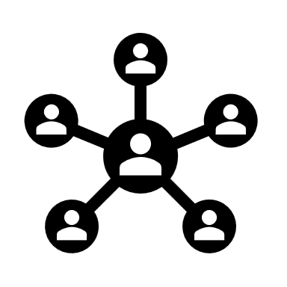Reflection:
Following the event, engage in a reflective session to assess the impact achieved. Evaluate how the Future Fashion Walk inspired others to embrace eco-friendly fashion choices. Celebrate the success of your event in promoting sustainable fashion!

This exercise offers valuable insights into event planning, research, marketing, and the significance of environmentally conscious fashion choices.
As you lead the Future Fashion Walk, you will emerge as fashion leaders and influential change-makers in your city.
Together, let’s make a difference with the Future Fashion Walk, fostering a brighter and sustainable future for fashion!

