

Sustainable Fashion Curriculum at Textile Universities in Europe
–
Development, Implementation and Evaluation of a Teaching Module for Educators

Project: 2020-1-DE01-KA203-005657

Titel of the Lesson: The Golden Ratio and Fibonacci Sequence in Sustainable Fashion Design

Authors: Prof. Dr. Zlatina Kazlacheva,
Asst. Prof. Dr. Julieta Ilieva
Contact Data: Trakia University of Stara Zagora, Faculty of Technics and Technologies, Yambol, Bulgaria
E-mail: zlatinka.kazlacheva@trakia-uni.bg, zhulieta.ilieva@trakia-uni.bg



Introduction to the Teaching and Learning Materials

Short Description of the Content:

The focus is on the creation of sustainable fashion clothes and accessories with application of the golden ratio and Fibonacci sequence proportions, forms and tiles. Information about the golden ratio and Fibonacci sequence is given. Forms and tiling based on the golden ratio and Fibonacci sequence are presented. Application of the sustainable golden ratio and Fibonacci sequence proportions in fashion design and pattern making of women’s clothes is shown. Application of golden ratio and Fibonacci sequence tiles in sustainable fashion design is presented. Realized designs with application of golden ratio and Fibonacci sequence tiles and forms based on them are presented.

Competences and Learning Objectives:

After this unit the student should be able to …

- recognize the golden ratio and Fibonacci sequence as sustainable proportions;
- recognize geometric figures and tiles based on the golden ratio and Fibonacci sequence;
- apply the sustainable golden ratio and Fibonacci sequence in fashion design and pattern making of women’s clothes as direct proportions or by use of geometric figures;
- apply the golden ratio and Fibonacci sequence tiles in sustainable fashion design;
- realize designs with application of golden ratio and Fibonacci sequence tiles and forms based on them.

Overview of Working Materials

Lesson module 1:
Topic: Sustainable Proportions of the Golden Ratio and Fibonacci Sequence
Worksheet 1: Sustainable Proportions of the Golden Ratio and Fibonacci Sequence

Lesson module 2:
Topic: Golden Ratio and Fibonacci Sequence Geometric Figures and Tiles
Worksheet 2: Golden Ratio and Fibonacci Sequence Geometric Figures and Tiles

Lesson module 3:
Topic: Application of the Sustainable Golden Ratio and Fibonacci Sequence Proportions in Fashion Design and Pattern Making
Worksheet 3: Application of the Sustainable Golden Ratio and Fibonacci Sequence Proportions in Fashion Design and Pattern Making
Working materials: drawing instruments, graphic pencils, color pencils

Lesson module 4:
Topic: Application of Golden Ratio and Fibonacci Sequence Tiles in Sustainable Fashion Design
Worksheet 4: Application of Golden Ratio and Fibonacci Sequence Tiles in Sustainable Fashion Design
Working materials: drawing instruments, graphic pencils, color pencils

Lesson module 5:
Topic: Realized Designs with Application of Golden Ratio and Fibonacci Sequence Tiles and Forms Based on Them
Worksheet 5: Realized Designs with Application of Golden Ratio and Fibonacci Sequence Tiles and Forms Based on Them
Working materials: fabrics, recycled materials

Sources

Jirousek, Ch. (1995). Art, Design and Visual Thinking. Cornell University. http://char.txa.cornell.edu/.

Hom, E. J. (2013). What is the Golden Ratio?. LifeScience. http://www.livescience.com/37704-phi- golden-ratio.html.

Hom, E. J. (2013). What is the Fibonacci Sequence?. LifeScience. http://www.livescience.com/37470-fibonacci-sequence.html.

Baird, E. (2009). Fibonacci Series Tiling, with Triangles. ErkDemon. http://erkdemon.blogspot.com/2009/06/fibonacci-series-tiling-with-triangles.html.

Kazlacheva, Z., Ilieva, J. (2013). The Golden Triangle in Fashion Design. Proc. of International Symposium in Knitting and Apparel - ISKA 2013, Iasi, Romania: 187-193.

Kazlacheva, Z. (2014). Fibonacci Squares in Fashion Design. ARTTE Applied Researches in Technics, Technologies and Education, 2(2): 91-98.

Kazlacheva, Z. (2014). Fibonacci Rose in Fashion Design. ARTTE Applied Researches in Technics, Technologies and Education, 2(3): 224-230.

Kazlacheva, Z. (2017). An investigation of application of the golden ratio and Fibonacci sequence in fashion design and pattern making. IOP Conf. Ser.: Mater. Sci. Eng. 254 172013. https://doi.org/10.1088/1757-899X/254/17/172013.

Ilieva, J., Kazlacheva, Z., Dineva, P., Indrie, L. and Florea-Burduja, E. (2021). A study on application of the golden and Fibonacci geometry in design of fashion accessories. IOP Conf. Ser.: Mater. Sci. Eng. 1031 012026. https://doi.org/10.1088/1757-899X/1031/1/012026.

Rissanen, T., McQuillan, H. (2016). Zero Waste Fashion Design. Bloomsbury Academic, ISBN: 978-1-3500-9483-3.

Kazlacheva, Z., Ruseva, I. (2022). A study on applying of golden ratio and Fibonacci sequence tilings in sustainable fashion design and pattern making. AIP Conference Proceedings 2889 (in print).

Image Sources

All Images are created by both authors Zlatina Kazlacheva and Julieta Ilieva:
CC0 Kazlacheva; CC BY-SA-ND Kazlacheva; CC BY Kazlacheva; CC BY Kazlacheva, Ilieva; CC BY Ilieva.

Worksheet 1: Sustainable Proportions of the Golden Ratio and Fibonacci Sequence

In creation of sustainable fashion products, the designers must not compromise on the application of the design principles.
There are many examples of zero waste fashion designs, upcycled designs, circular designs, etc., which are with not so good aesthetic value. The balance have to be found between a sustainable fashion conception and the applying of the design principles, which are symmetrical and asymmetrical balance, proportions, rhythm, emphasis, unity.
There is a principle, which is strongly connected with sustainability. It is the proportion. The proportions in combination with symmetrical or asymmetrical balance determine the next principles of rhythm, emphasis, and unity.
The Golden ratio and Fibonacci sequence are applied as proportions in design as expressers and symbols of beauty and harmony.
Their symbolism is a result of strong connections in their mathematical nature.
The golden ratio has been applied as harmonic proportion in the art and architecture since the ancient times. In more recent times, the relations between Fibonacci numbers have been also beginning to be used as harmonic proportions. Therefore, the proportional relations of the golden ratio and Fibonacci sequence are the best examples of sustainable proportions.

The Golden Ratio. The Golden ratio is a number, introduced with Greek letter φ, which is found by dividing a line into two parts, as it is seen in Figure 1, as the longer part divided by the smaller part is equal as the whole length of longer and smaller parts divided by the longer part, or

φ = a/b = (a+b)/a = 1.61803398874989484…

Sometimes the Golden ratio is presented in a turned way in which the number is equal to the division of the smaller by the longer part equal to the division of the longer part by the whole length of the line, or

b/a = a/(a+b) = 0.61803398874989484…

Figure 1.
The golden ratio. CC0 Kazlacheva

Caryatids of Athens’ Acropolis, shown in Figure 2, are one of the oldest example of the applying of the golden ratio in clothing. The peplos of the chiton divided the woman’s body in golden proportions.

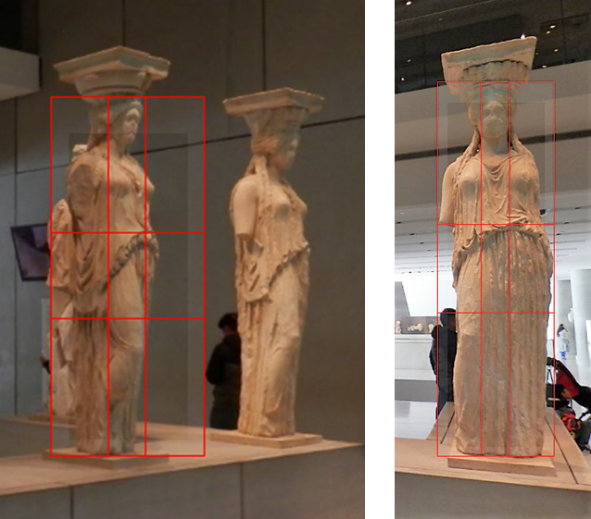

Figure 2.
Caryatids of Athens’ Acropolis, one of the oldest example of the applying of the golden ratio in clothing. The peplos of the chiton divided the woman’s body in golden proportions.
CC BY-SA-ND Kazlacheva

Fibonacci Sequence. Fibonacci numbers are the sequence of numbers defined by the linear recurrence equation

F_{n} = F_{n-1} + F_{n-2}

with F₁ = F₂ = 1. As a result of the definition, it is conventional to define F₀ = 0.
The Fibonacci numbers for n = 1, 2, ... are 1, 1, 2, 3, 5, 8, 13, 21, ...

In fashion design the golden ratio and Fibonacci sequence can be used in creation of beautiful and harmonic forms directly or with the help of geometrical figures and tiles.

Questions:

Question 1a: What is the golden ratio?
Question 1b: What is Fibonacci sequence?
Question 1c: Can you see any similarity between the golden ratio and Fibonacci sequence?

Worksheet 2: Golden Ratio and Fibonacci Sequence Geometric Figures and Tiles

The geometrical figures, based on the golden ratio, are:
- The golden triangle, presented in Figure 3: an isosceles acute-angled triangle with golden proportion φ between the lengths of both same sides and the base, which is equal to 1,618…;
- The golden rectangle: a rectangle with golden proportion φ between the lengths of the sides;
- The golden ellipse: an ellipse with golden proportion φ between both axes.
Figures in Fibonacci numbers proportions can be created similarly to the golden ones.

The tiles are a way of integration of the golden ratio and Fibonacci sequence in fashion design. The tilings are created with geometric figures: triangles, squares and rectangles with ratio between sizes of their sides, equal to the golden and Fibonacci proportions. These tiles can be applied in design of clothes and accessories not only for applying of sustainable aesthetic and harmonic proportions, but they give possibilities of utilization of small pieces of fabrics. The most appropriate golden and Fibonacci tilings are:
- The golden triangle tiling;
- Fibonacci series tilings with squares (both types);
- Fibonacci sequence tiling with quilateral triangles (Fibonacci rose).

The Golden Triangle Tiling. The acute-angled golden triangle, shown in Figure 3, is a base of a tilling in which obtuse-angled golden triangles form a spiral. The obtuse-angled golden triangle is an isosceles triangle with golden ratio between the lengths of both same sides and the base, equal to 0,618…

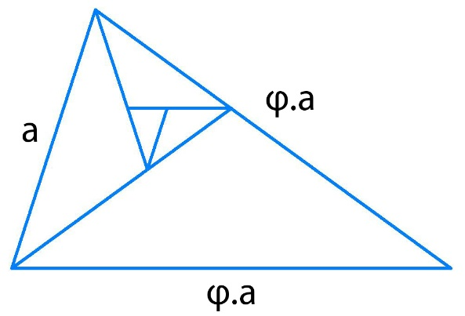

Picture 3. The golden triangle and the golden triangle tiling. CC0 Kazlacheva

Fibonacci Series Tilings with Squares. There are two types of Fibonacci sequence tiles with squares, one, in which squares form a spiral (Figure 4.1) and one with squares, which are set in two perpendicular linear directions (Figure 4.2). In both tiles, the ratio between consecutive set squares is equal to Fibonacci numbers.
Fibonacci series tiling with squares in a spiral pattern is used as a base of creating of Fibonacci spiral, presented in Figure 5. Similarly, to Fibonacci spiral, the Golden spiral is created based on a tiling in a spiral form made by golden rectangles. Fibonacci series tiling with squares in a spiral pattern and Fibonacci spiral can be used in creation in different forms.

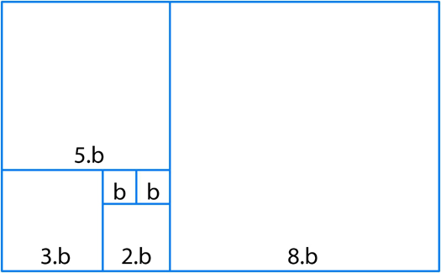 | 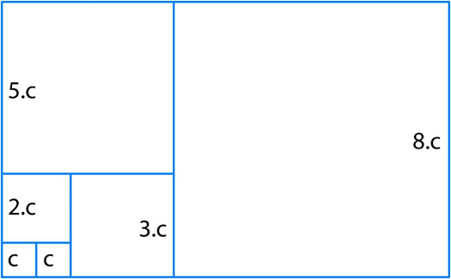
Figure 4.1.  Fibonacci sequence tiling with squares, which form a spiral. CC0 Kazlacheva | Figure 4.2. Fibonacci sequence tiling with squares, which are set in two perpendicular linear directions. CC0 Kazlacheva

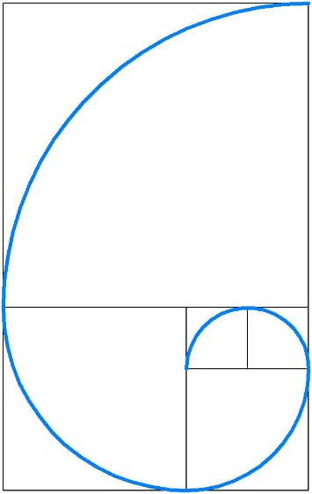

Figure 5. Fibonacci spiral. CC0 Kazlacheva

Two Fibonacci spirals in connection of a bilateral symmetry create a form of stylized butterfly, named Fibonacci butterfly, shown in Figure 6.

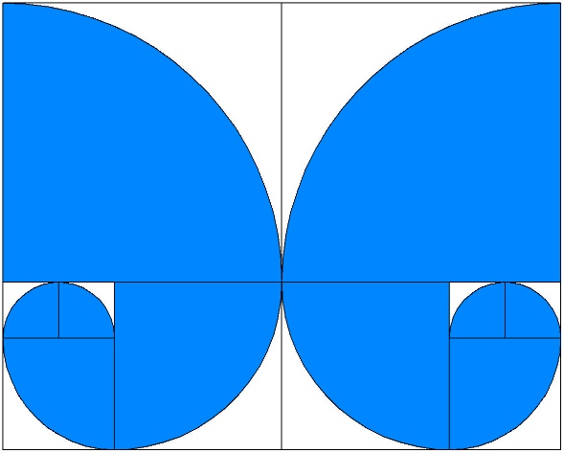

Figure 6. Fibonacci butterfly. CC0 Kazlacheva

Fibonacci series tiling with squares in a spiral pattern can be used as a base of creating of spiral forms with different geometric elements or figures included in the tiling frame. Two Fibonacci spirals, made by diagonals of the squares of Fibonacci square spiral tiling in connection of a bilateral symmetry create a form of stylized hearth, named Fibonacci heart, presented in Figure 7.

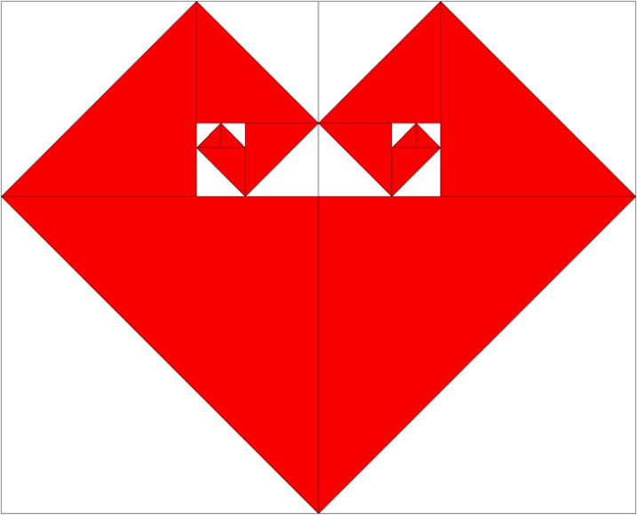

Figure 7. Fibonacci heart. CC0 Kazlacheva

Fibonacci Series Tiling with Triangles. Figure 8 presents the only one possible Fibonacci sequence tiling with equilateral triangles, known as Fibonacci rose. In Fibonacci rose, the equilateral triangles with sides in proportional relationship of Fibonacci sequence, form two spirals.
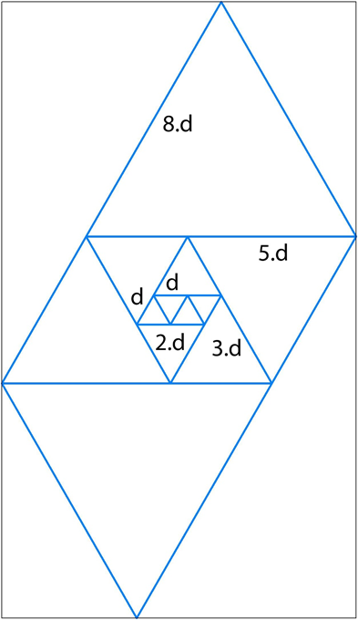

Figure 8. Fibonacci series tiling with triangles, known as Fibonacci rose. CC0 Kazlacheva

Tasks:

Task 2a: Describe the difference between the golden and Fibonacci spiral.
Task 2b: Research for more information on geometric figures and tiles based on the golden ratio and Fibonacci sequence.
Task 2c: Draw different forms, created on the base geometric figures and tiles based on the golden ratio and Fibonacci sequence.

Worksheet 3: Application of the Sustainable Golden Ratio and Fibonacci Sequence Proportions in Fashion Design and Pattern Making

Based on the information, presented in the Worksheets 1 and 2, examples of application of the sustainable golden ratio and Fibonacci sequence proportions in fashion design and pattern making are shown in Figures between 9 and 14.
Figure 9 presents use of the golden triangle in fashion design and pattern making of women’s dresses and jackets. The golden triangle is applied directly or as a frame of creation of elements of the designs and constructions.

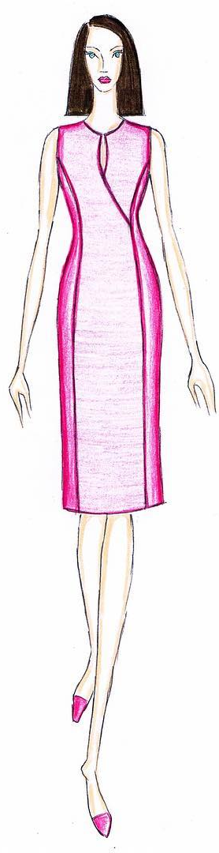 | 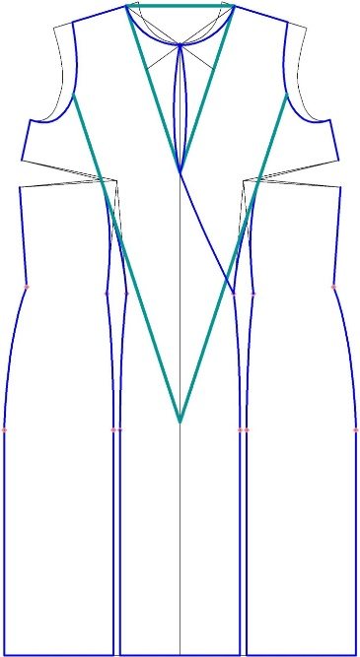 | 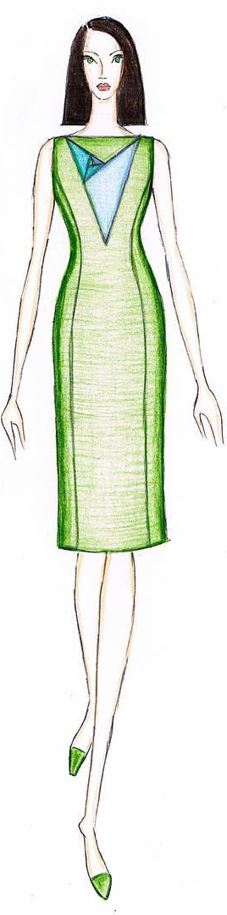 | 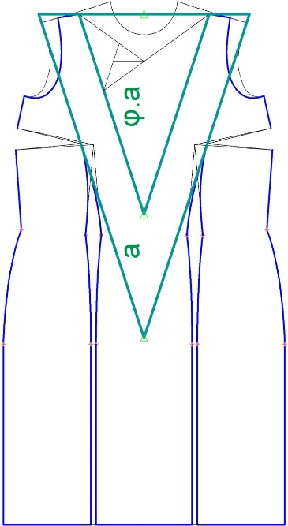

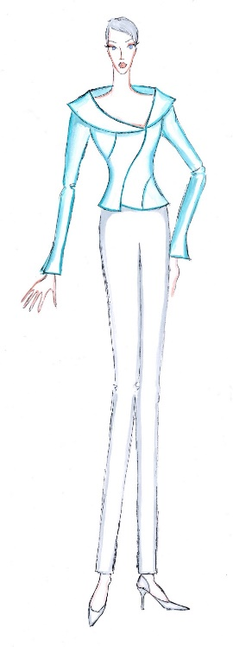 | 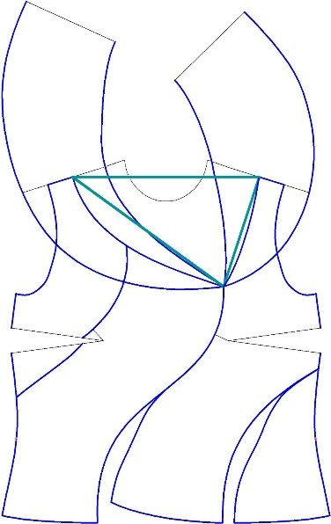 | 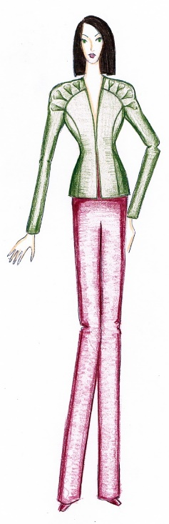 | 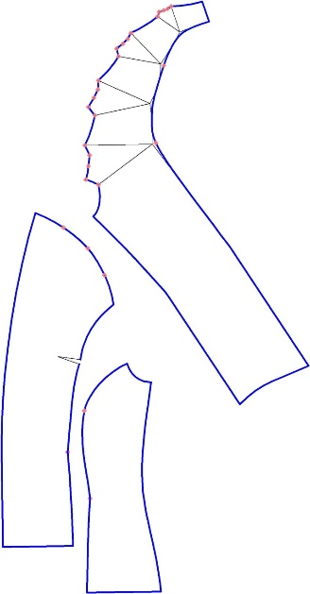

Figure 9. Use of the golden triangle in fashion design and pattern making of women’s dresses and jackets. CC BY Kazlacheva

Figure 10 shows applying of the golden rectangle in fashion design and pattern making of women’s dresses. The golden rectangle is applied directly or as a frame of creation of elements of the designs and constructions.

 | 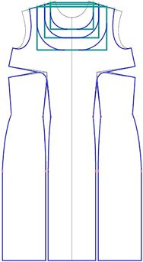 | 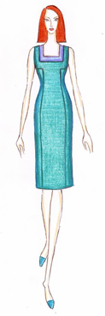 | 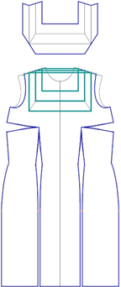

Figure 10. Applying of the golden rectangle in fashion design and pattern making of women’s dresses. CC BY Kazlacheva

Figure 11 presents applying of the golden ellipse fashion design and pattern making of a women’s jacket. The golden ellipse is used directly in creation of elements of the designs and constructions.

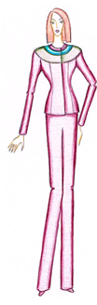 | 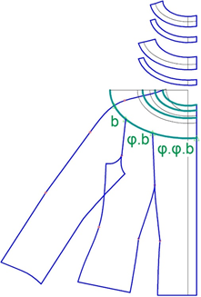 | 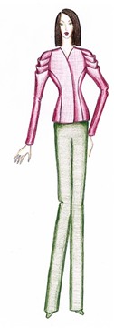 | 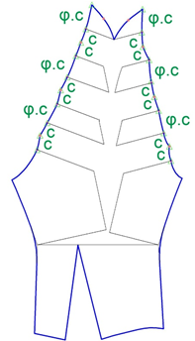
Figure 11. Applying of the golden ellipse fashion design and pattern making of a women’s jacket. CC BY Kazlacheva |  | Figure 12. Design and pattern making of a women’s jacket’s draped sleeves using the golden proportion. CC BY Kazlacheva
Figures 12 presents design and pattern making of a women’s jacket’s draped sleeves using the golden proportion. The proportion between the distances between tucks and their width is equal to the golden ratio.
Figure 13 and 14 show fashion design and pattern making of a dress with combined 3D element with the use of golden proportions. The ruffles divide the neck opening in proportions of the golden ratio.

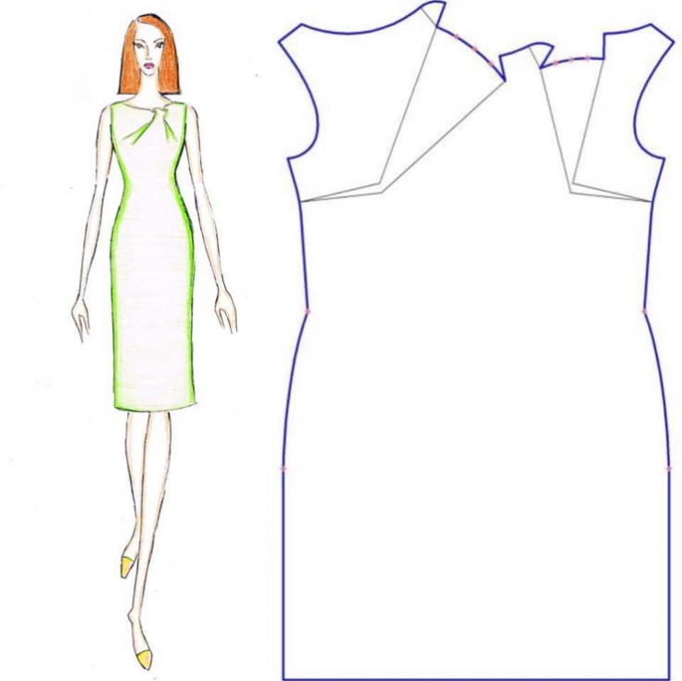

Figure 13. Fashion design and pattern making of a dress with combined 3D element with the use of golden proportions. CC BY Kazlacheva

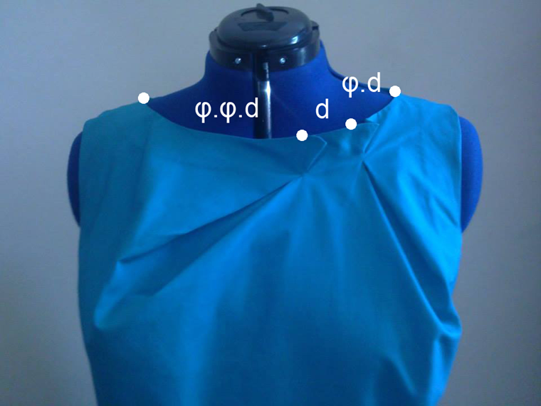
Figure 14. The ruffles in the design, presented in Figure 13, divide the neck opening in proportions of the golden ratio: d, φ.d, and φ2.d (or φ.φ.d). CC BY Kazlacheva

Task:

Task 3a: Create fashion designs with the golden ratio and Fibonacci sequence proportions.
Worksheet 4: Application of Golden Ratio and Fibonacci Sequence Tiles in Sustainable Fashion Design

Designs with the golden ratio and Fibonacci sequence tilings combine both minimizing waste and the sustainable design principles. Based on the sustainable proportions of the golden ratio and Fibonacci sequence, tilings with geometric figures are constructed. These tiles can be applied in fashion not only in design of clothes with applying of golden and Fibonacci proportions as sustainable aesthetic and harmonic ones, but the golden section and Fibonacci series tilings give possibilities of utilization of small pieces of fabrics in patchwork or another similar style.
Figures from 15 and 18 show application of golden ratio and Fibonacci sequence tiles, presented in the Worksheet 2, in sustainable fashion design of women’s dresses.
Figure 15 presents applying of the golden triangle tiling. Figure 16 shows use of Fibonacci sequence tiling with squares, which are set in two perpendicular linear directions. Figure 17 presents application of Fibonacci sequence tiling with squares, which form a spiral. Figure 18 shows use of Fibonacci series tiling with triangles, known as Fibonacci rose.

Task:

Task 4a: Create fashion designs with application of the golden ratio and Fibonacci sequence tilings.

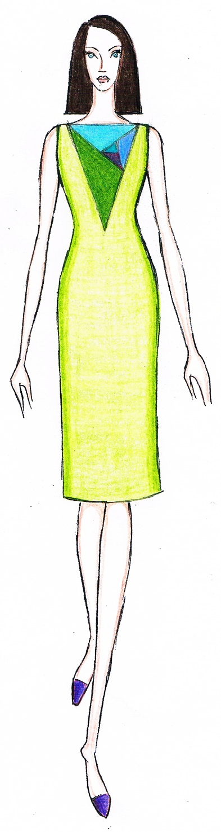 | 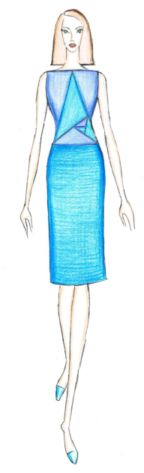 | 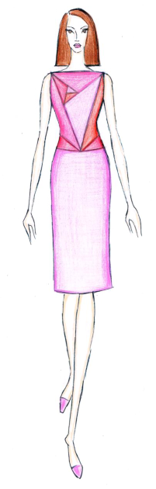 | 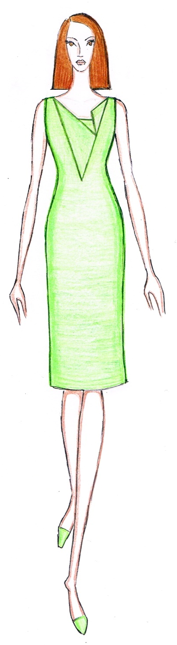

Figure 15.
Designs of women’s dresses with applying of the golden triangle tiling.
CC BY Kazlacheva

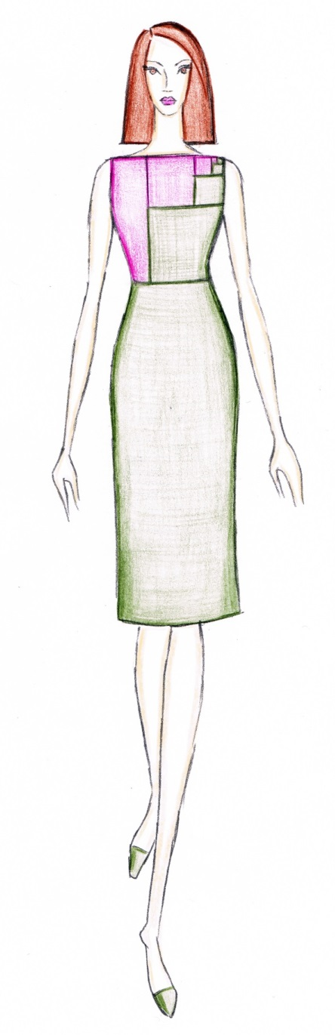 | 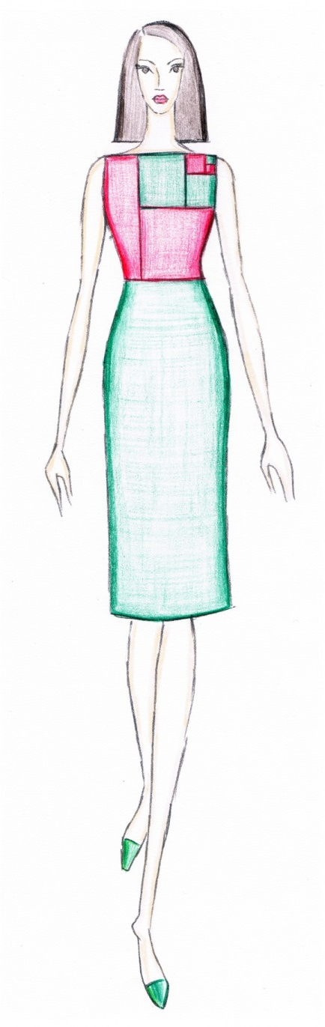 | 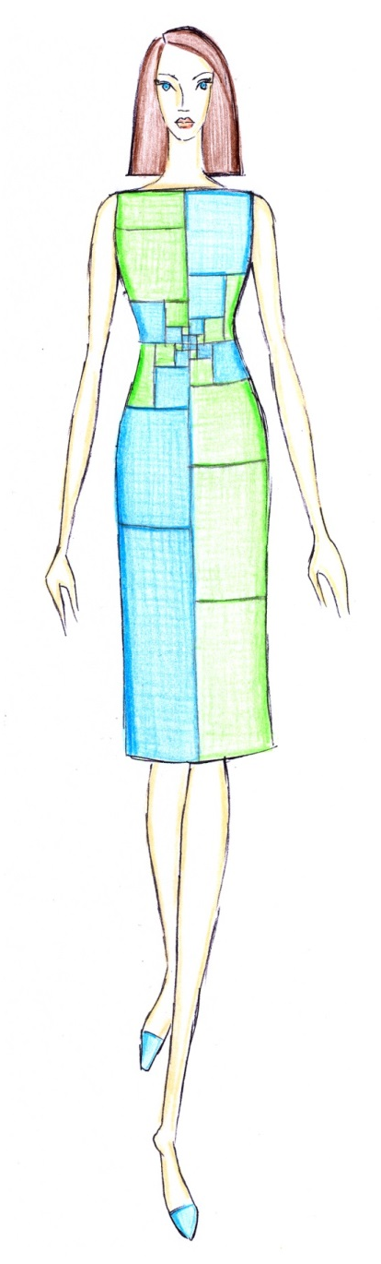 | 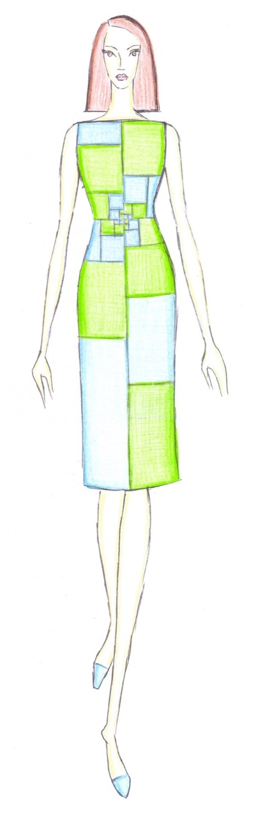

Figure 16. Designs of women’s dresses with application of Fibonacci sequence tiling with squares, which are set in two perpendicular linear directions. CC BY Kazlacheva

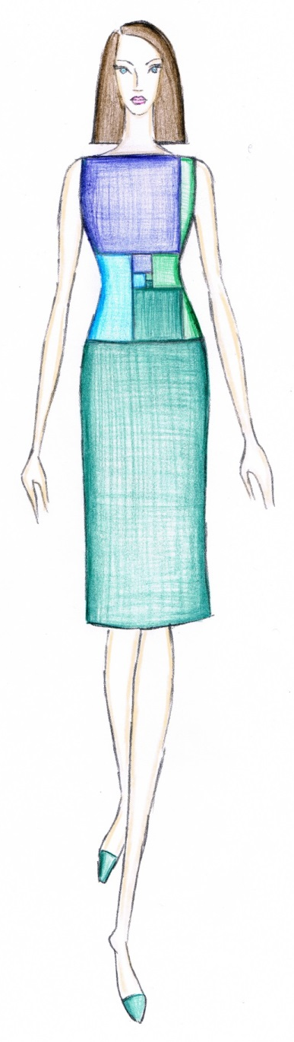 | 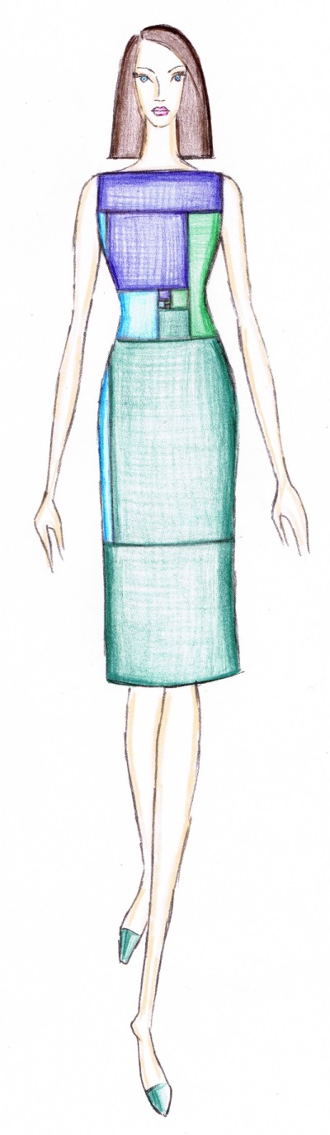 | 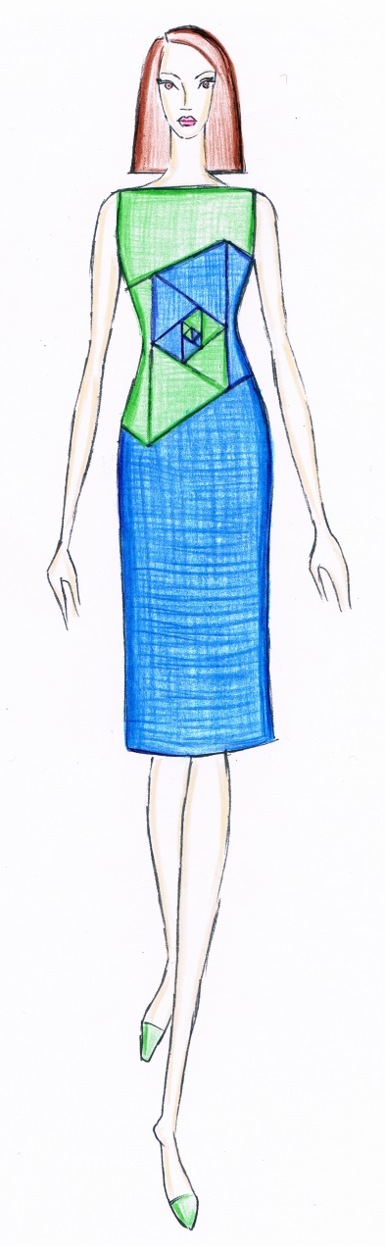 | 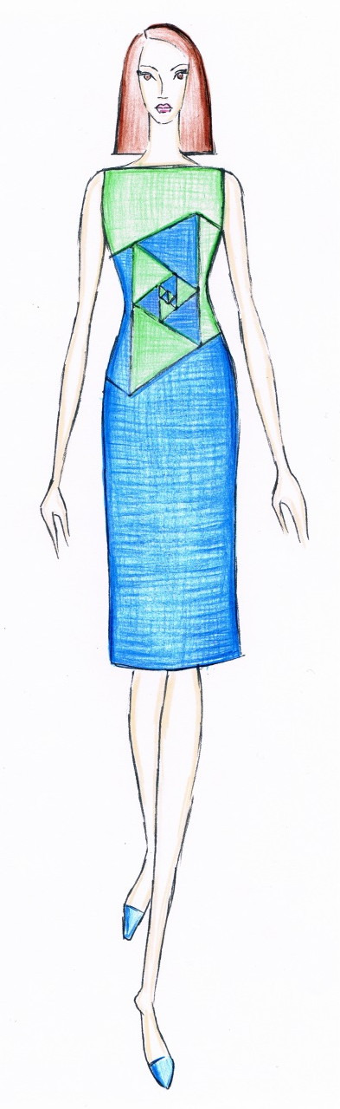
Figure 17. Designs of women’s dresses with use of Fibonacci sequence tiling with squares, which form a spiral.  CC BY Kazlacheva |  | Figure 18.  Designs of women’s dresses with use of Fibonacci series tiling with triangles, known as Fibonacci rose. CC BY Kazlacheva
Worksheet 5: Realized Designs with Application of Golden Ratio and Fibonacci Sequence Tiles and Forms Based on Them

Figure 19 presents a women’s dress, which is made with application of Fibonacci heart in style patchwork.

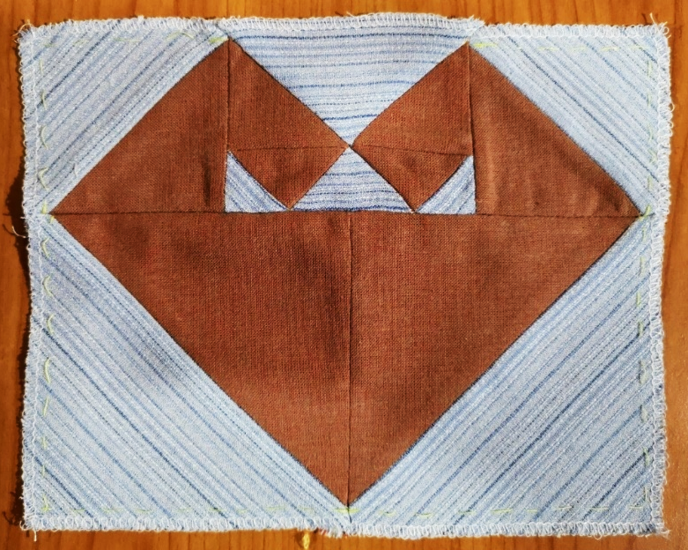

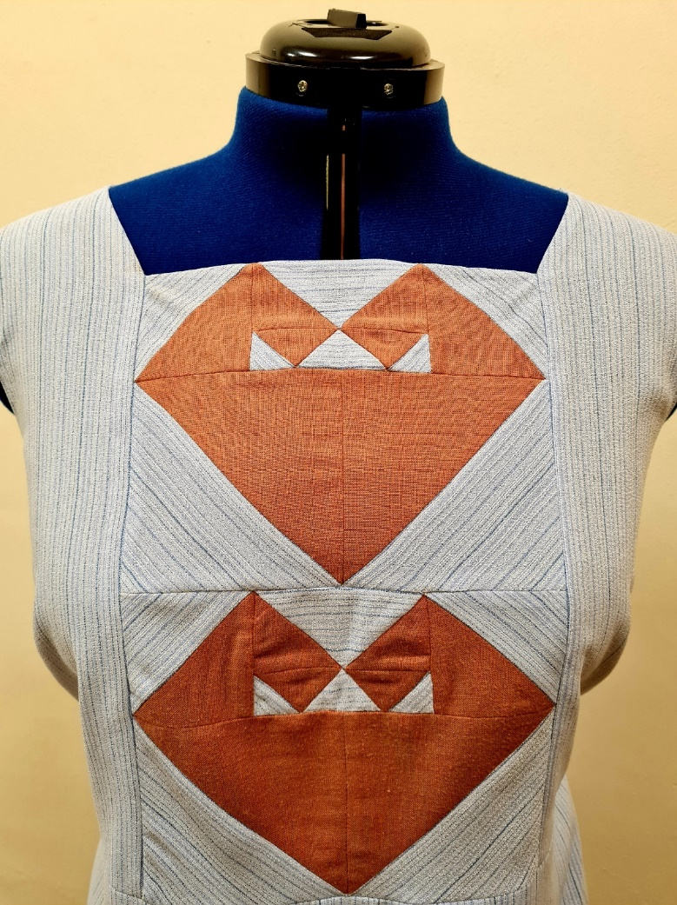

Figure 19. A women’s dress, made with application of Fibonacci heart in style patchwork.
CC BY Kazlacheva

Figure 20 shows a handbag, which is made with application of Fibonacci rose in style patchwork.

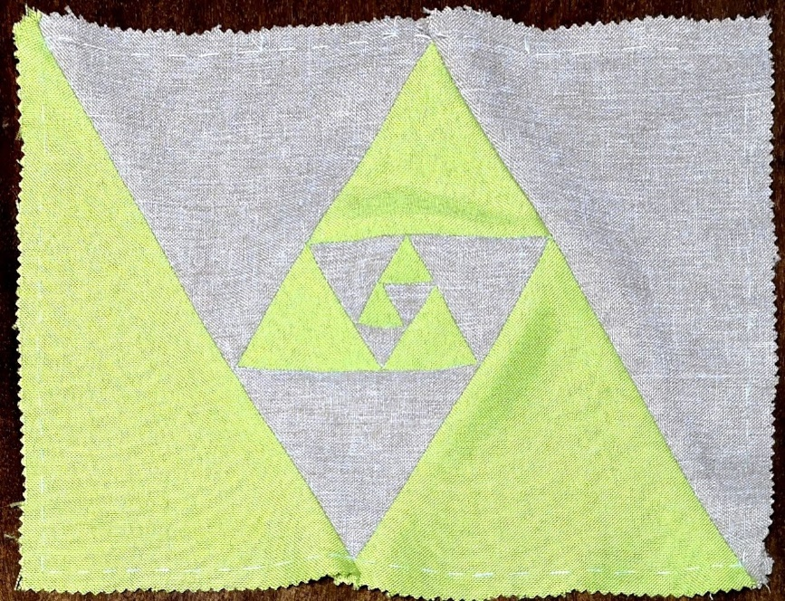

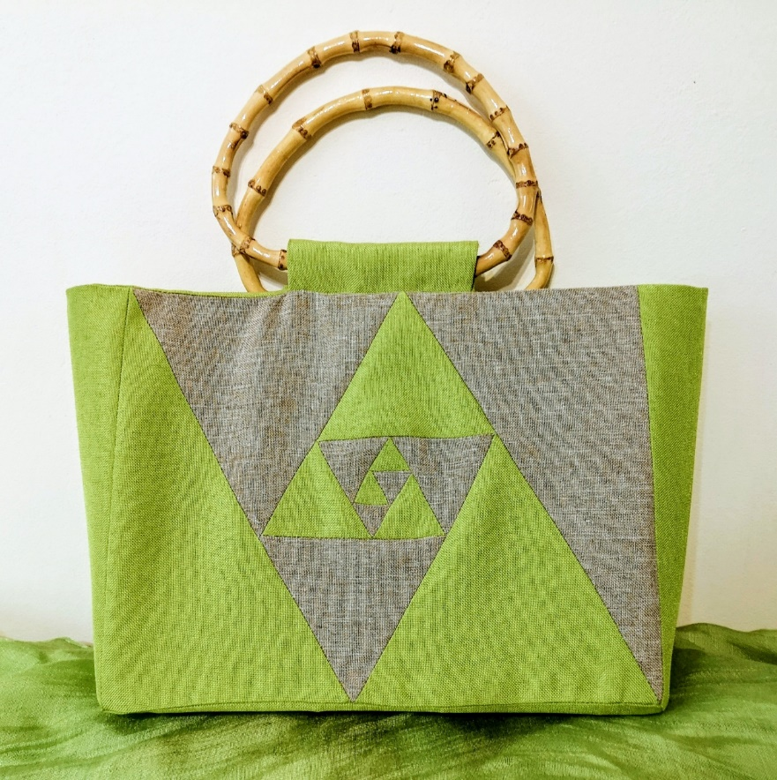

Figure 20.
A handbag, which is made with application of Fibonacci rose in style patchwork.
CC BY Kazlacheva

Figure 21 presents jewels and accessories in form of Fibonacci butterfly, made by recycled materials.

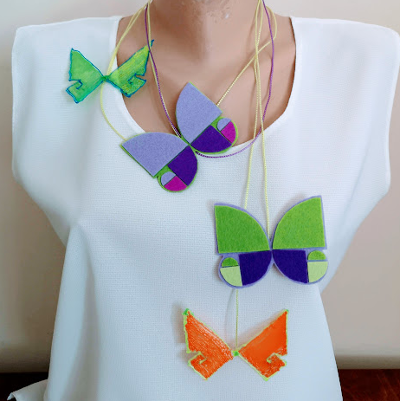

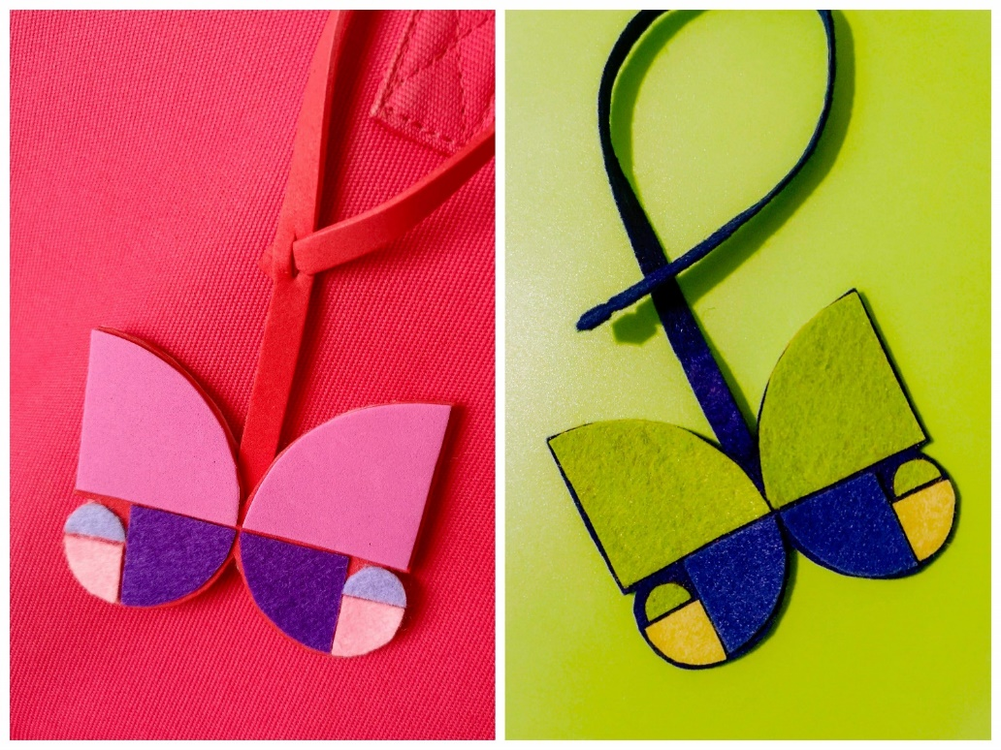

Figure 21.
Jewels and accessories in form of Fibonacci butterfly, made by recycled materials. CC BY Kazlacheva, Ilieva

Designs can be realized with the help of the personalization. The ornament of golden butterfly and its application as print in personalized designs of a bag, a watch, a laptop case, and a face mask are presented in Figure 22.
For personalization web-based services are used: https://studio.shopvida.com, https://artofwhere.com, https://www.zazzle.com, etc.



Figure 22.
The ornament of golden butterfly, applied as print in personalized designs of a bag, a watch, a laptop case, and a face mask. CC BY Ilieva

And now… Maybe it is time for realization of your design ideas with applying of the golden ratio and Fibonacci sequence proportions, forms or tiles. Are you ready? Try it!

