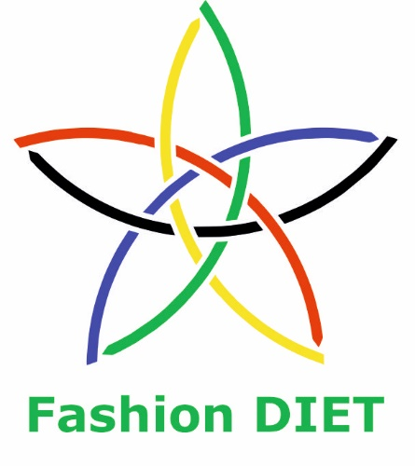

Sustainable Fashion Curriculum at Textile Universities in Europe
–
Development, Implementation and Evaluation of a Teaching Module for Educators

Project: 2020-1-DE01-KA203-005657

Title of the Lesson: Upcycling in fashion:
Advantages and students’ approaches

Author: Prof. Dr. Antonela Curteza
Contact Data: The “Gheorghe Asachi” Technical University of Iasi
Faculty of Industrial Design and Business Management
Department of Knitting and Clothing Engineering
E-mail: acurteza@gmail.com



Introduction to the Teaching and Learning Materials

Short Description of the Content:

The amount of waste created by the fashion industry is truly significant. Much of this waste still ends up in landfills or is incinerated. This represents a loss from a production effort which uses millions of tons of water and kilowatts of energy, and countless hours of human labour that could be salvaged, and has a negative impact on the environment. In this context, upcycling is a valuable way to reduce this huge amount of textile waste and the negative impacts it has. Upcycling is the creative recovery of materials of any kind, fabrics or garments, that can become the starting point for different products and new creations. Turning the old products into new ones is at the heart of the circular economy and upcycling is a perfect example of how that can be done.

Competences and Learning Objectives:

After this unit the student should be able to:

- describe and analyse the impact of the waste in the fashion industry;
- recognise that upcycling is a way of reducing these huge amounts of waste;
- understand the differences between recycling and upcycling;
- recognise that upcycling is a way of acting in the sense of sustainability and a step towards circular economy;
- describe the main advantages of upcycling clothes;
- analyse different aspects and recommendations for the practice of upcycling;
- apply different approaches and techniques in upcycling clothes.

Overview of Working Materials

Lesson module 1:
Topic: Too much waste in fashion!
Worksheet: The impact of waste in fashion (industry).

Lesson module 2:
Topic: The importance of recycling in fashion.
Worksheet: Upcycling and recycling.

Lesson module 3:
Topic: Why upcycling?
Worksheet: The main advantages of upcycling.

Lesson module 4:
Topic: What to be done in upcycling!
Worksheets: Recommendations for the practice of upcycling.

Lesson module 5:
Topic: The wonderful world of upcycling…
Worksheet: A practical example of upcycling – “Pymp my trashion” the students’ project.
Working materials: Worksheet, clothes, fabrics, scissors, tools for drawing and pattern cutting (possibly), needles, sewing machine.

Sources

1. Shim, S., Kim, J. & Na, Y. (2018). An exploratory study on up-cycling as the sustainable clothing life at home. Fashion and Textiles 5, 14. https://doi.org/10.1186/s40691-018-0129-1.

2. Chan, L., Fu, N. (2022). Sustainable Fashion: Upcycling and the Rise of Recycled Fabrics, RESEARCH, Analysis and News – Analysis.

3. Aus, R. At al. (2021). Designing for circular fashion: integrating upcycling into conventional garment manufacturing processes. Fashion and Textiles, 8:34
https://doi.org/10.1186/s40691-021-00262-9.

4. Wu, D.; Zhuang, M.; Zhang, X.; Zhao, Y. (2023). Towards Circular Fashion: Design for Community-Based Clothing Reuse and Upcycling Services under a Social Innovation Perspective. Sustainability, 15, 262. https:// doi.org/10.3390/su15010262.

5. Zhi, Y. (2022). The Upcycling and Reconstruction of Garments and Fabrics. Art and Design Review, 10, 72-102. https://doi.org/10.4236/adr.2022.101007.

6. Sustainable Jungle (2023). What Is Upcycled Clothing & Why Is Upcycled Fashion a Timeless Trend? https://www.sustainablejungle.com/sustainable-fashion/what-is-upcycled-clothing/.

7. Han, S., Tyler, D., Apeagyei, P. (2015). Upcycling as a design strategy for product lifetime optimisation and societal change, PLATE conference Nottingham Trent University 17-19 June 2015, Conference: Product Lifetimes and The Environment, Nottingham, Volume: Conference Proceedings.

8. Eladwi, M. M. T. et all. (2016). Upcycling Used Garments to Recreate Sustainable Fashion Designs Treated by Soil Release Finishing. International Journal of Advanced Engineering, Management and Science (IJAEMS), Vol-2, Issue-8, 1285-1290. ISSN : 2454-1311.

9. Mastronardo, G. (2022, 22. April). What’s Old is New Again: Upcycling in the Fashion Industry. https://thesustainablemag.com/fashion/whats-old-is-new-again-upcycling-in-the-fashion-industry/.

Tutorials

What Is Upcycled Clothing? Why It's Important & How to Make It. [Video]. Youtube. Last accessed on March 13th 2023, available at: https://www.youtube.com/watch?v=mLOqDyvNAzU

Can Upcycled Fashion Save the World? [Video]. Youtube. Last accessed on March 13th 2023, available at: https://www.youtube.com/watch?v=lOjDKQgiiSQ

Sustainable Fashion: Upcycling and Repurposing with Vintage Threads (Valentino, Lilli Ann, and More). [Video]. Youtube. Last accessed on March 13th 2023, available at: https://www.youtube.com/watch?v=PVf7KXvYxlw

Upcycled fashion destined for landfill earns accolades for talented seamstress | ABC Australia. [Video]. Youtube. Last accessed on March 13th 2023, available at: https://www.youtube.com/watch?v=6nVuDWOyz6s

How to Upcycle Clothes: Beginner Tips. [Video]. Youtube. Last accessed on March 13th 2023, available at: https://www.youtube.com/watch?v=NY-xF5l3Nb4

https://www.youtube.com/watch?v=maFS1oRFln4
The Curious Art of Upcycling Your Clothes

https://www.youtube.com/watch?v=DqOnS55AIHQ
The Upcycle Project: Tips

https://www.youtube.com/watch?v=wyB3YXpTsls
Upcycling workshop

https://www.youtube.com/watch?v=VFmYrFXg3vI
Wardrobe surgery: upcycled clothing in London's Hackney

https://www.youtube.com/watch?v=2qqiKNzwHMg
Zero Waste Daniel Turns Clothing Scraps Into Fashion | NowThis

https://www.youtube.com/watch?v=AQGQfO-NAqk
WeDoReDo - Upcycle Workshop at Bristol Textile Recyclers - Made in Bristol TV

Worksheet 1: The impact of waste in fashion (industry)

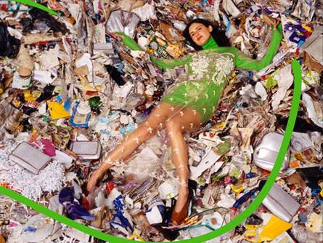

Image Source : https://www.fibre2fashion.com/industry-article/8736/fashion-waste-is-rubbish-yes-but-this-is-not-the-issue

The fashion and textile industry is one of the world’s most polluting industries, mainly because its volume of production and waste. Textiles production requires a lot of land for crops and uses a lot of water, energy, chemicals and other resources leaving often untreated pollution behind and has a highly negative environmental, economic and social footprint (Fletcher, 2008; GFA & BCG, 2017; Hiller Connell & Kozar, 2017; Leal et al., 2019; Remy et al., 2016) [1].

Nicholas Fu, Economist (Global Research) at HKTDC Research, pointed out that the volume of garments produced worldwide has surged from 5 billion pieces in 2000 to 10 billion pieces in 2020. According to market estimates, the volume of garments purchased globally will increase from 6.2 billion metric tons at present to 17.5 billion metric tons by 2050 [2].
The amount of waste created is truly signifcant, as the European Union (EU) textile industry alone generates around 16 million tonnes of textile waste annually (European Commission, 2017). Much of this waste today still ends up in landfills or is incinerated. This represents a loss from a production efort which uses millions of tonnes of water and kilowatts of energy, and countless hours of human labour that could be salvaged (Leal et al., 2019) [3].

Repetition of intemperate production and consumption has led to various problems and resource waste, and clothing wastes became a social issue. The issue of clothing wastes requires urgent reconsideration as 3% of wastes discharged from each household is clothing (Fletcher 2008). Nowadays, more than 80 billion pieces of clothing are produced each year globally, while 80% of them are directly discarded into landfills, causing permanent environmental pollution [4]. As clothing wastes weigh signifcant impact not only on environment but also on economic loss, fundamental solution is required and sustainable clothing life draws attention. In order to maximize sustainability in the clothing industry, the producers as well as the role of consumers and especially the role of households are now very important [1, 3].
Tasks:
Task 1a: Describe the fashion waste impact or other negative aspects.
Task 1b: Do you see other ways of presenting these negative effects of the waste in fashion?
Make references and formulate them in writing.
Worksheet 2: Upcycling and recycling

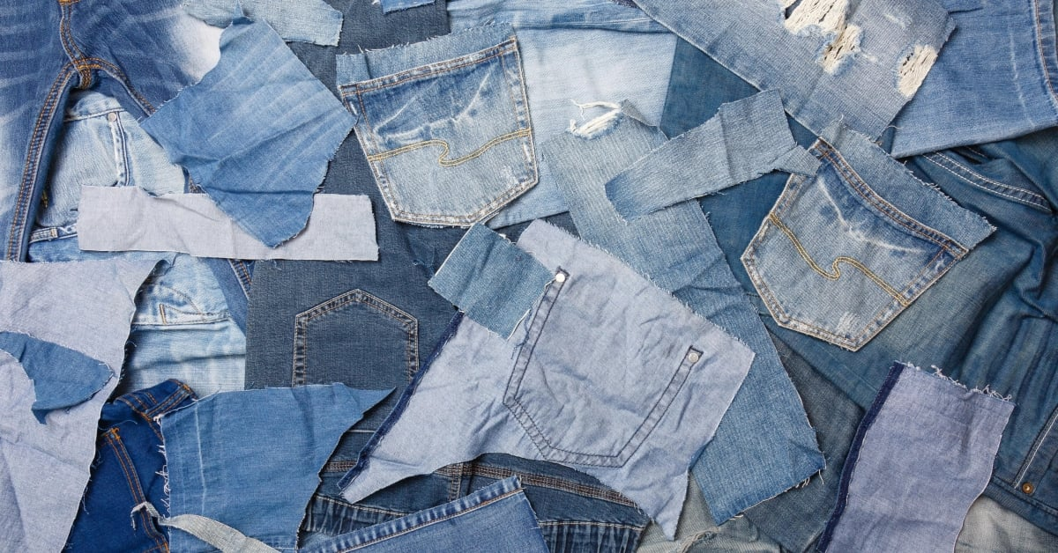

Image Source : https://www.weavabel.com/blog/brands-that-are-embracing-fashion-upcycling

Over the last decade the term ‘upcycling’ has been coined and worked into the discourse of sustainability efforts. The term up-cycling was first used by Reiner Pilz in 1994, when he gave the meaning ‘to grant more value to old product’. On the other hand, upcycling is defined as the type of ‘recycling in rise in value’ (Choi et al. 2014) [1].

It first appeared in William McDonough’s book, Cradle to Cradle (McDonough & Braungart, 2002). The term has a number of definitions and practices and it has mainly been used in connection with fashion and textiles. Upcycling can be defined as a recycling approach where “waste”—textile leftovers that would usually end up in landfill or incineration—is used to create products with a higher retail value than traditional recycled products (Aus, 2011; Cassidy & Sara, 2012; Han et al., 2015, 2017; Teli et al., 2015) [3].

Upcycling is the creative recovery of materials of any kind, fabrics or garments from inventories and stocks that become the starting point for different products and new creations. Upcycled clothes are made from unwanted materials that would otherwise go to landfills or incineration.

The 1st target of up-cycling is to reduce wastes, and it repeats and circulates the life cycle of products by changing its use in the final stage of product life cycle, without going through the entire process of planning, production, and consumption of product [1].

Guldmann considers that the prolonged use of raw materials and economic resources lies in the “using” stage of clothing and wasted textiles [4]. According to the hierarchical structure of textile waste, “reusing” is usable discarded clothing being repaired and reworn without any transformation; while “upcycling” is one step after reusing, integrating, upgrading, and recycling into processes that utilize existing objects to create better ones of new usage through different designs and ideas (Kim et al., 2021) [4].

Clothing upcycling is a model to convert and remake textile waste or useless clothing into new fashion products when the original state of clothing is difficult to reuse (Park et al., 2020) [4]. Although clothing upcycling requires additional energy compared to reusing, it is also popular among commercial brands as it “eliminates the need for a new product” from raw materials, and it generate new values or meanings for clothing, according to Szaky and Sung [4]. Upcycling requires creative repair, reuse, repurposing, and other upcycling processes that may require various technical skills depending on the condition of the original clothing [4] Upcycled clothing takes old, worn out, or damaged materials and transforms them into new pieces. Upcycled garments are becoming increasingly popular in the modern fashion industry [5].

Upcycling vs Recycling
These terms are often used interchangeably and therefore incorrectly. But it’s important to understand upcycling vs recycling. The main difference between upcycled and recycled clothing is that in upcycling are used whole pieces of existing garments to create new clothing. While in the perspective of recycled clothing, materials must be broken down before they can be reused [5].

Recycling is an industrial process that takes a material, breaks it down, then creates a new material from which new products can be made. This can be done mechanically (i.e., cotton being shredded down and its fibres rewoven into a recycled cotton fabric) or chemically (i.e., PET plastic bottles or fishing nets being melted down and respun into polyester or nylon fibres, respectively). Generally speaking, the new product bears no resemblance to the recycled materials comprising it [6].

Upcycled clothing takes an existing garment and improves it, whether by combining it with other garments and materials or adding ornamental flare, like using embroidery and patchwork to mend holes [6].

Task 2: Describe what is in the picture and make guesses about of what you could practically realize from what you see.

__________________________________________________________________________________________________________________________________________________________________________________________________________________________________________________________________________________________________________________________________________________________________________________________________________________________________________________________________
Worksheet 3: The main advantages of upcycling

Task 3: Read the text and then answer the questions:

There are many environmental benefits of upcycled pieces, and not only. Upcycled clothing uses significantly fewer raw materials, which helps to reduce the harmful impacts of fashion production on the natural environment. Less water usage, fewer chemicals and carbon emissions, fewer contributions to the landfill are benefits of upcycled clothing [5]. Upcycling can provide solutions to the textile waste problem, by optimising the lifetimes of discarded products from an inefficient and unsustainable system. Upcycled fashion production utilises textile waste to create products with a higher retail value than traditionally recycled goods. The fashion industry can utilise the high volumes of textile waste to create well designed and sustainably sourced upcycled clothing [7]. The upcycled fashion garments are by nature unique. According to W. McDonough and M. Braungart (2013): ‘‘The goal of the upcycle is a delightfully diverse, safe, healthy, and just world with clean air, water, soil, and power - economically, equitable, ecologically, and elegantly enjoyed” [8].

The main benefits for the environment [6]:
• Less reliance on virgin materials:
Between deforestation, greenhouse gas emissions, microplastic pollution, soil degradation, water consumption, and water pollution, the cultivation and production of raw materials have a serious impact on the planet. Anything that can reduce the raw materials needed for clothing is valuable in the context of sustainability.
• Dealing with textile waste:
The fashion industry is responsible for vast amounts of textile waste. Globally, only 1% of clothing waste is recycled, meaning the majority of unwanted clothing and footwear end up in landfills or incinerators.
Post-consumer waste isn’t the only problem. It’s estimated that 25-40% of the fabric used in garment production is wasted, even though at least 50% of that could be upcycled into new clothing.
• A solution for mixed fabrics:
While there are an increasing number of options to recycle old clothes, not all clothes can be recycled. Some mixed fabrics, e.g., synthetic/natural blends can’t be recycled so upcycling these fabrics into new clothing is a way to give them a second life.
The main benefits for people
• Less harmful social practices:
Sweatshop labour is often applied to manufacturing across all industries, but people closely associate the term with the fashion industry in particular. Upcycling is one of the best ways to avoid the human rights abuses common in fast fashion and the damaging impact it has including on workers in the supply chain.

Turning the old into new is at the heart of the circular economy and upcycling is a perfect example of how that can be done. Upcycled items can be made from post-consumer waste (items that have been purchased, worn, and discarded) or deadstock (leftover stock). In essence it means using something that already exists and turning it into a new item, meaning no new raw materials are needed, and older clothes are kept in circulation instead of going to landfills. The benefits of shifting towards a circular economy are becoming more and more recognised not only from an environmental point of view but also considering the uniqueness and originality that distinguish upcycled garments [9].

Questions:

3a) What are the main advantages of upcycling?
3b) What does upcycling mean for the environment?
3c) Do you see other benefits of upcycling, not mentioned in the text?

Worksheet 4: Recommendations for the practice of upcycling

Some ways to reconstruct a garment [5]:
- Choose the suitable garments or collect the right domestic waste to be combined into an actual upcycled product.
- Clean the garments if these are bought second-hand or are ancient.
- Take the entire original garment apart to use the fabric differently or a flat pattern.
- Take off only pieces that will not be part of the new garment like sleeves, front plackets, collars, or patch pockets.
- Study possible combination and connection with clothing, and do some preliminary design.
- Start building the new garment and create the new design.
- Use the same construction techniques as much as possible. Some seams may need hand-stitched, topstitched, or machine stitched.
- An interface can be added if needed in new garment construction.
- Quilting will support weak areas in the original garment or any textile if needed.
- Facings or bindings can be made from other fabrics or garments if there is not enough fabric from the original garment.
- Facings may be needed to a seam. The aim is to put in a zipper or a placket for buttons or turn under to seam.
- Ruffles and more minor details can hide stains and patched areas.

Tasks:

Task 4.1: Research for more information and recommendations regarding the practice of upcycling?
Task 4.2: Find two different creative techniques used in upcycling. Describe them and underline the main advantages and issues that could raise in practice.
Worksheet 5: Practical example of upcycling - students’ approach.

The Project: Pimp my Trashion (CC-BY-SA-NC-ND Stoica Mirela, Stoica Cristina, Carp Mihaela, Teodorescu Mirela, TUIASI, former M.Sc. students)

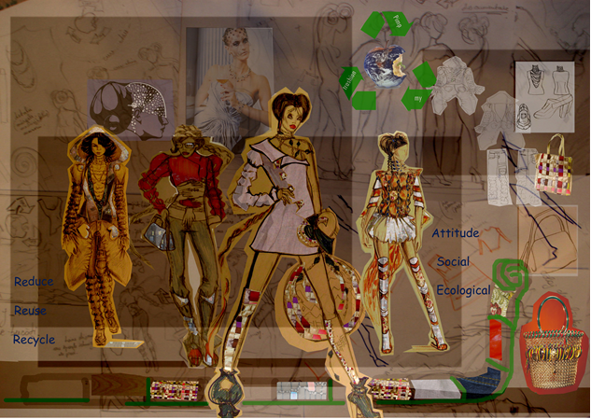

Social eco-responsability
Globalization, over-production, excessive consuming, … These are the new obsessions of the world we live in and that generate new tendencies every day. More and more enterprisers promote products and services that try to discourage excess and make us realize the true needs.
Fashion is a glittering and captivating world but at the same time an industry with shocking impact over the surrounding environment. The clothes we wear, the materials that they are made of can cause real disasters.
The only solution is that fashion industry should adopt ecological standards. So, this how we meet the eco-fashion concept that represents the sum of actions accorded to the protection of the surrounding environment, of the consumer’s health and the improvement of clothes industry conditions for its workers.

Why Upcycling?
- Upcycling reduces the need for landfill space. Textiles present particular problems in landfill as synthetic (man-made fibers) products will not decompose, while woolen garments do decompose and produce methane, which contributes to global warming.
- Upcycling results in less pollution and energy savings, as fibers do not have to be transported from abroad.
- By re-using existing fibers and textiles, there is no need to make these textiles from raw materials (such as cotton, wool, and synthetic fibers). This saves on the energy used and pollution caused during manufacturing processes like dying, washing, and scouring.

Pimp my Trashion concept
The principle behind the name “PIMP MY TRASHION” is very simple: what happens with the clothes that are no longer in fashion, do not fit or simply are not liked anymore. But what about some other things that you do not use: newspapers, magazines, interior objects and more…
You can discover the answer most of time in the trash can, in incinerators or landfill sites, the most disgusting, but also the most polluting result of a continually expanding world.
The whole “PIMP MY TRASHION” collection is composed of such undesired, dismembered, out of use, but still beautiful, still functional objects.
The collection concept is based on the antithesis between vegetal (organic) and artificial, both having an ecological print due to the transformation, recreation, reinterpretation of the already existent materials, combining different materials with different textures, giving a unique aspect to each garment, both from design and also in the manufacturing process of the products. The whole collection can be considered a puzzle; the pieces of the products are reused in an entirely different position with another function, radically changing the image the garment should have.
Each of us should take into account three things when intending to purchase a product:
® buy only what you need – reduce;
® if you already have products similar to the one you intend to buy, do not buy it - reuse;
® if what you have does not fit anymore, play with it, reinvent- recycle.
… This is the challenge …

Inspirational sources
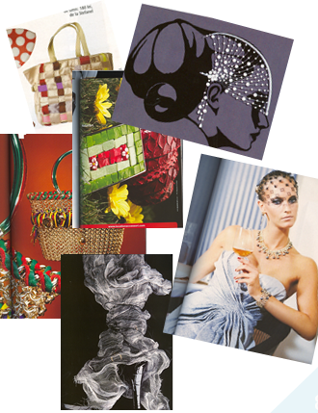
Target group

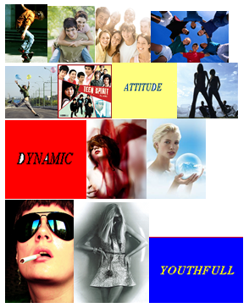

Used products and materials

- Jeans (100% cotton, 90% cotton + 10% elastane): second-hand | 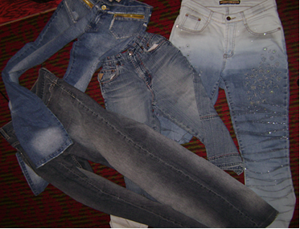
- Ski-overall (100% cotton): second-hand | 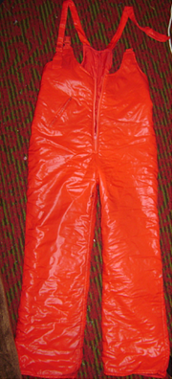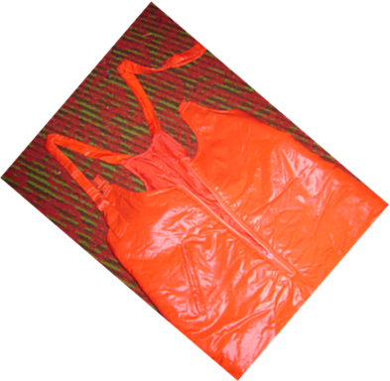
- Jacket (100% linen): second-hand | 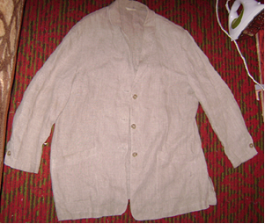
- gloves: second-hand | 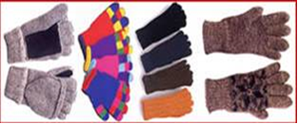
- fabrics for furniture (50% polyester + 50% cotton) | 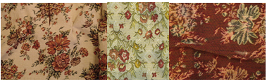
- shower curtain | 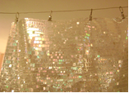
- magazines | 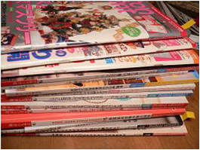
- wood | 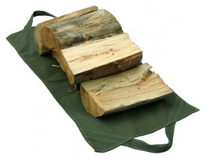

The collection

“PIMP MY TRASHION” collection expresses the affinity towards natural and normal. The articles are created from various materials that can be found in any wardrobe: jeans, gloves, jackets or even many materials that never had anything to do with clothing: fabric of furniture, shower curtain, magazines, wood etc. They are cut and designed in the desirable shape, conferring a natural accent to the clothing, sex-appeal and style through the unusual way of positioning clothing benchmarks.

The first outfit in the collection is like a tribute brought to the jeans, the most –maybe – article of clothing among the youths and not only. These can be found almost in every element of the clothing, starting with the jacket, trousers and even shoes. The whole clothing is completed with some unconventional material regarding the texture and their destination. The blouse is made of a fabric that, in an ordinary way, would wrap a chair or a sofa, ornate with beads made of magazines.  CC-BY-SA-NC-ND Stoica Mirela, Stoica Cristina, Carp Mihaela, Teodorescu Mirela | 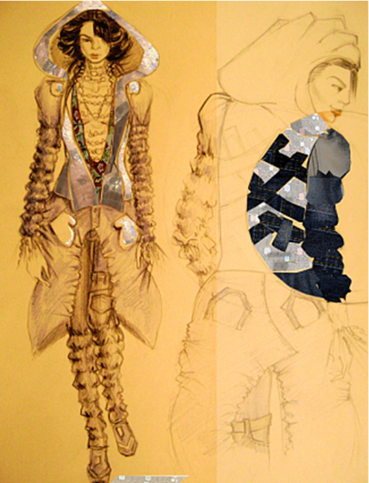
The second outfit is composed of jacket and overall-like trousers. The jacket was made of a ski overall, the bottom parts were used for the sleeves and the inset and the straps formed the body of the product. The trousers join both textures of the fabric and stockinet, the used materials being a pair of jeans and gloves for the upper part of the body.  CC-BY-SA-NC-ND Stoica Mirela, Stoica Cristina, Carp Mihaela, Teodorescu Mirela | 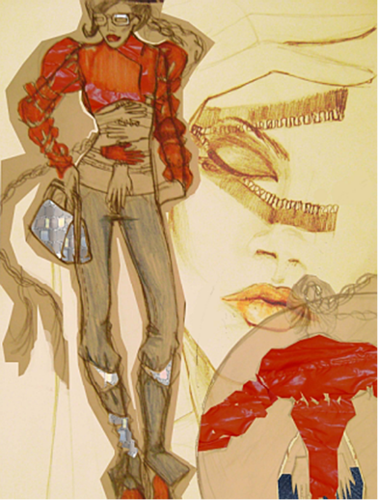
The third outfit of the collection consists of a dress made from a linen sack coat; the lapels of the sack coat became an asymmetric décolletage that covers just one shoulder. The item is accessorized with beads and strips of magazines and denim insertions which can be found on the shoes too.  CC-BY-SA-NC-ND Stoica Mirela, Stoica Cristina, Carp Mihaela, Teodorescu Mirela | 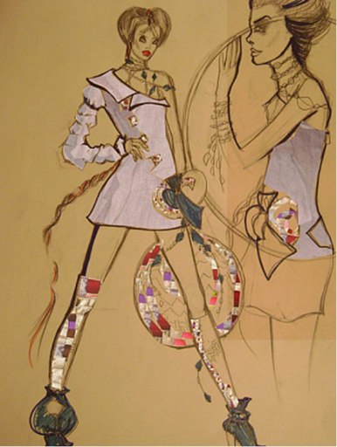
The fourth outfit joins upholstery fabrics with plastic foil, creating a dress with a bulk lower part and a train. It finishes with wooden sole high boots.  CC-BY-SA-NC-ND Stoica Mirela, Stoica Cristina, Carp Mihaela, Teodorescu Mirela | 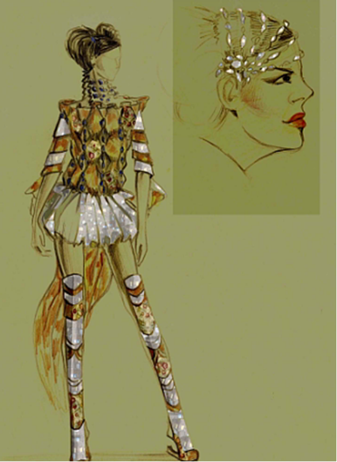

Practically made outfit

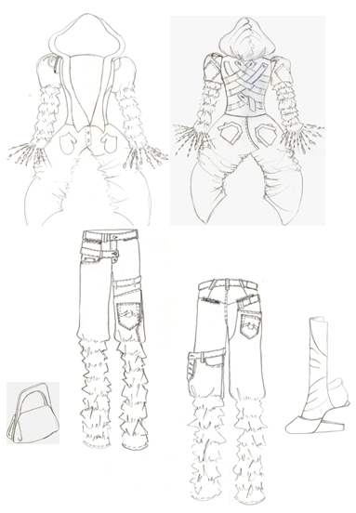

Technical drawings

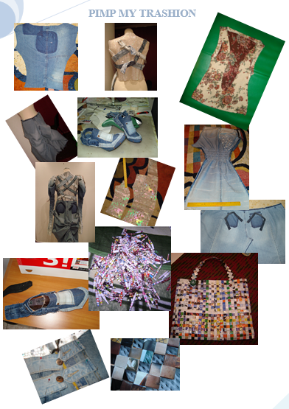

Development stages
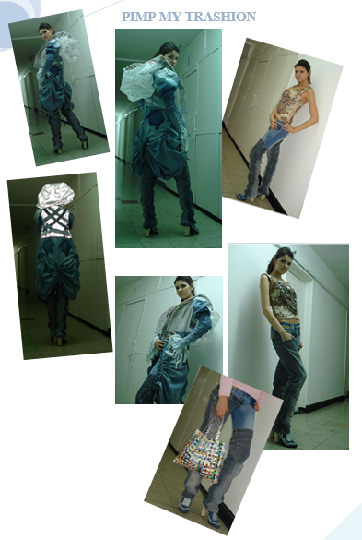

The final outfit

Conclusions

Our principle encourages you to look and live better than ever with the designs that promote your ultimate health and well-being, goodness of Earth, and respect for its inhabitants.
Never throw anything away... If it has a wonderful cut, is made from glorious fabric and makes you look and feel great when you wear it- then keep it stashed away carefully in your wardrobe. It could just as well be this season's hot piece of fashion!
It is amazing what you can create from something you thought you would never wear again with a little imagination.
Customizing your own clothes means that you can create your own unique style, to suit your taste and lifestyle. Creating your own individuality is more important than looking fashionable and with your own style- you will be fashionable.
Mix it up a little. Get some must-have items from this season but keep those clothes and accessories which have always looked great on you and put them together, see how it works and go for it!

The team:
- Stoica Mirela
- Stoica Cristina
- Carp Mihaela
- Teodorescu Mirela

Coordinating professor:
- Curteza Antonela, Ph. D.

Task 5: Try to put in practice a way/technique of upcycling clothes.

