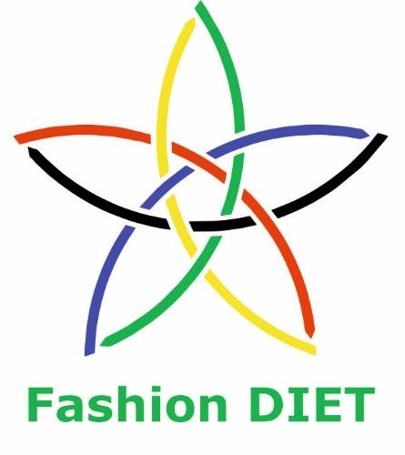

Sustainable Fashion Curriculum at Textile Universities in Europe
–
Development, Implementation and Evaluation of a Teaching Module for Educators

Project: 2020-1-DE01-KA203-005657

Title of the Lesson: Wool Felting in Sustainable Fashion

Authors: Prof. Dr. Zlatina Kazlacheva, Svetla Tsvetanova
Contact Data: Trakia University of Stara Zagora,
Faculty of Technics and Technologies, Yambol, Bulgaria
E-mail: zlatinka.kazlacheva@trakia-uni.bg




Introduction to the Teaching and Learning Materials

Short Description of the Content:

The focus is on the creation of sustainable fashion clothes, accessories and jewels with application of different wool felting techniques in the context of different aspects of sustainability. The basic wool felting techniques and their application in contemporary fashion are presented. The design of wool felted products and wool felting techniques are studied in the context of ecological fashion, slow fashion, recycled and circular fashion: used materials, natural dying, slow fashion designs. The basic stages of wet wool felting are shown. The course finishes with invitation to the learners to create their own sustainable wool felted designs.

Competences and Learning Objectives:

After this unit the student should be able to …

- describe different wool felting techniques and heir applying in the contemporary fashion;
- describe connection between wool felting and different aspects of sustainable fashion;
- recognize which types of wool felted products are sustainable fashion products;
- recognize which wool felting techniques are appropriate for creation of sustainable fashion products;
- apply wet wool felting technique in creation of sustainable fashion products;
- design your sustainable wool felted fashion product.

Overview of Working Materials

Lesson module 1:
Topic: What is wool felting?
Worksheet 1: What is wool felting?

Lesson module 2:
Topic: The wool felting in contemporary fashion
Worksheet 2: The wool felting in contemporary fashion

Lesson module 3:
Topic: The wool felting in sustainable fashion
Worksheet 3: The wool felting in sustainable fashion

Lesson module 4:
Topic: Let’s make a wet wool felted brooch!
Worksheet 4: Let’s make a wet wool felted brooch!
Working materials: multi-colored wool tops with good quality (22 microns merino is the best), natural or artificial silk fibers, bath towel, bamboo mat, bubble wrap or anti-slip mat, toll that rolls (rolling pin, wooden massager, etc.), vibrating sander (optional), tolls for forming 3D shape (optional, you can find them in the kitchen), water in a bowl, soap-based felting agent or liquid soap, spray bottle or sponge.

Lesson module 5:
Topic: And it is time for your design!
Worksheet 5A: Sketch your idea
Worksheet 5B: Sustainability of your design
Working materials: graphic pencils, color pencils, pen

Sources

Muddy Faces. Felting. Muddyfaces. https://muddyfaces.co.uk/activities/felting-1.

Browning, А. (2023). What is Felting? A Beginners Guide to Wool Felting. FiberArtsy. https://www.fiberartsy.com/felting-a-beginners-guide/.

Kostova, S. (2013). What is the Felt?. LAnAArt. http://svetlanaarts.blogspot.com/2013/10/blog-post.html.

Sikirica, J. Wearable Art. JSFiberArts. https://www.janetsikiricafiberarts.com/.

Sasaki, A. Atsuko Art. https://www.atsuko-art.com/.

Briscoe, S. (2020). The Book of Boro: Techniques and Patterns Inspired by Traditional Japanese Textiles. David & Charles.

Boros, A. Baribon. https://baribon.hu/.

Genova, K., Kazlacheva, Z., Ruseva, I. (2023). The Slow Fashion – a Review. ARTTE Applied Researches in Technics, Technologies and Education, 10(4), 207-216.

Almalki, D. K., Tawfiq, W. A. (2023). Implementation of a Sustainable Apparel Design Framework for Felted Women’s Garments Made of Local Wool. Fashion Practice. doi: 10.1080/17569370.2023.2186033.

Image Sources

Lesson modules 1 and 4

All Images: CC BY Tsvetanova. Images are from a Master class on wet wool felting in the context of sustainability, given by Svetla Tsvetanova, a co-author of this lesson, a student of Fashion Design and Technology Master Programme at the Faculty of Technics and Technologies of Yambol, Trakia University, Bulgaria. The Master class was organized in the frame of Fashion DIET project and was held on February 19, 2023. Using the wet wool felting, Svetla Tsvetanova presented the creation of a brooch. The video record of the Master class (in Bulgarian) is available online at: https://youtu.be/VZNDBNltEPw.

Lesson module 2

А “nuno” felted top, created by Debra Meyer Scott. CC BY-SA 3.0 Nimrod Scott. https://en.wikipedia.org/wiki/Nuno_felting.

A “nuno” felting scarf by Elena Kihlman. CC BY-SA 3.0 Renatogargiulo. https://en.wikipedia.org/wiki/Nuno_felting.

Atsuko Sasaki felted bag. https://knithacker.com/2020/03/fine-artist-atsuko-sasaki-makes-incredible-felt-object-bags-that-are-nothing-short-of-eye-popping/. The image use is permitted by Atsuko Sasaki.

A wet felted brooch, created by Svetla Tsvetanova. CC BY Tsvetanova. Svetla Tsvetanova is a co-author of this lesson.

A felted creation by Svetla Tsvetanova, which can be used as a jewel or a garment’s application. CC BY Tsvetanova. Svetla Tsvetanova is a co-author of this lesson.

Worksheet 1: What is wool felting?

The wool, a very ancient matter that has accompanied humanity since the dawn of its existence, is triumphantly returning in textiles, fashion and applied arts as a part of the general trend of turning to natural materials.
The felting is the process of creating a textile material (felt) by pressing, matting and condensing wool (protein or animal fibers): sheep wool, alpaca, mohair, yak, etc. or combination of wool and silk or man made fibers together. Fibers can be matted together using a felting needle or wet felted using water, soap and friction. The wool can be in any form from raw locks to processed roving or batts and there are several different methods of accomplishing this felting process. There are two basic ways of felt making: wet and dry felting.
Wet felting is the process of using a combination of friction or agitation, soap and water to make felt out of wool fibres. The hot water and soap changes the pH of the wool and allows the scales on the fibres to open up. The soap also helps provide a lubricant and allows your hands to move around the fibres easily. The wet felting can be made with raw wool fibers, washed fibers, carded batts, or processed wool roving and sliver. For decoration silk or man made fibres can be add to wool fibres. See Picture 1.
Dry felting, named also needle felting is made using special barbed needles to basically tangle the individual fibers together until they form a shape with matted surface. The continued process of poking the barbed needle in and out of the wool, pushes the fibers up and down thereby interlocking them. The dry felting can be made by hand with a single needle, or with using a multiple needles tool. See Picture 2.

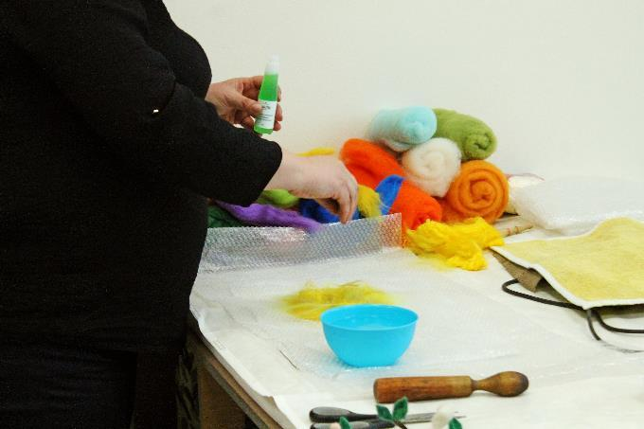 | 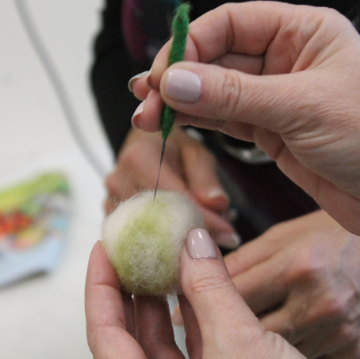
Picture 1. Wet wool felting.  CC BY Tsvetanova | Picture 2. Dry wool felting.  CC BY Tsvetanova

Tasks:

Task 1a: Research for more information on the technique of wool felting on the internet.
Task 1b: Describe the similarities and differences between wet and dry felting.
Task 1c: Do you see connection between felting and sustainable fashion? Describe it.
Worksheet 2: The wool felting in contemporary fashion

A study of application of the wool felt in contemporary fashion shows that different type of felting techniques are used in the creation of garments: coats, jackets, coats, and a pieces of clothes, accessories such as hats, bags, and scarves, and jewelry: necklaces, earrings, bracelets, brooches, etc.
The used felting techniques are: wet felting, dry felting, felting in combination with “boro” art, and the “nuno” technique.
In the more cases, the clothes are made by machine made felt fabrics.
Traditional Japanese "boro" is the art of reworking and repairing textiles in a patchwork to create a new recycled cloth.
The “nuno” art is a technique of felting raw wool, roving or fiber into weave fabrics such as silk chiffon or silk gauze.
The famous Japan designer Issey Miyake and his design studio created felted wool jackets and coats.
А “nuno” felted top, created by Debra Meyer Scott, is presented in Picture 3.

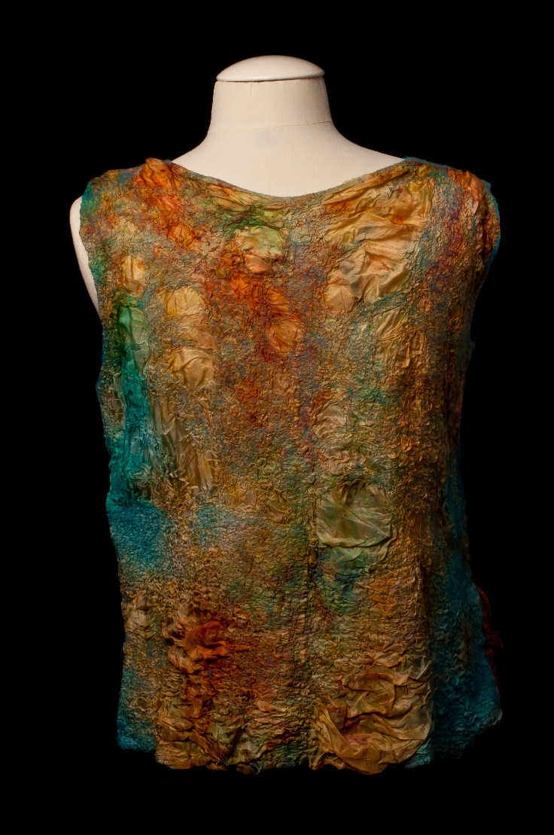

Picture 3. А “nuno” felted top, created by Debra Meyer Scott.
CC BY-SA 3.0 Nimrod Scott

Picture 4 shows a “nuno” felting scarf by Elena Kihlman.
The fashion creations of American artist Janet Sikirica combine wool felting and silk applying “nuno” and Japanese “boro” techniques. Janet Sikirica includes in her wearable art designs hand-felted collections a variety of accessories and garments. Her felted works can be viewed online at: https://www.janetsikiricafiberarts.com.
Picture 5 presents a felted bag, created by Japanese artist Atsuko Sasaki. The bags are ones of famous creations of Atsuko Sasaki. Atsuko Sasaki felted works can be viewed online at: https://www.atsuko-art.com.

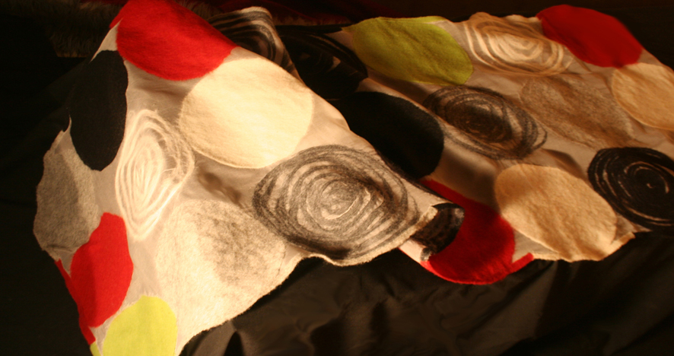

Picture 4. A “nuno” felting scarf by Elena Kihlman. CC BY-SA 3.0 Renatogargiulo

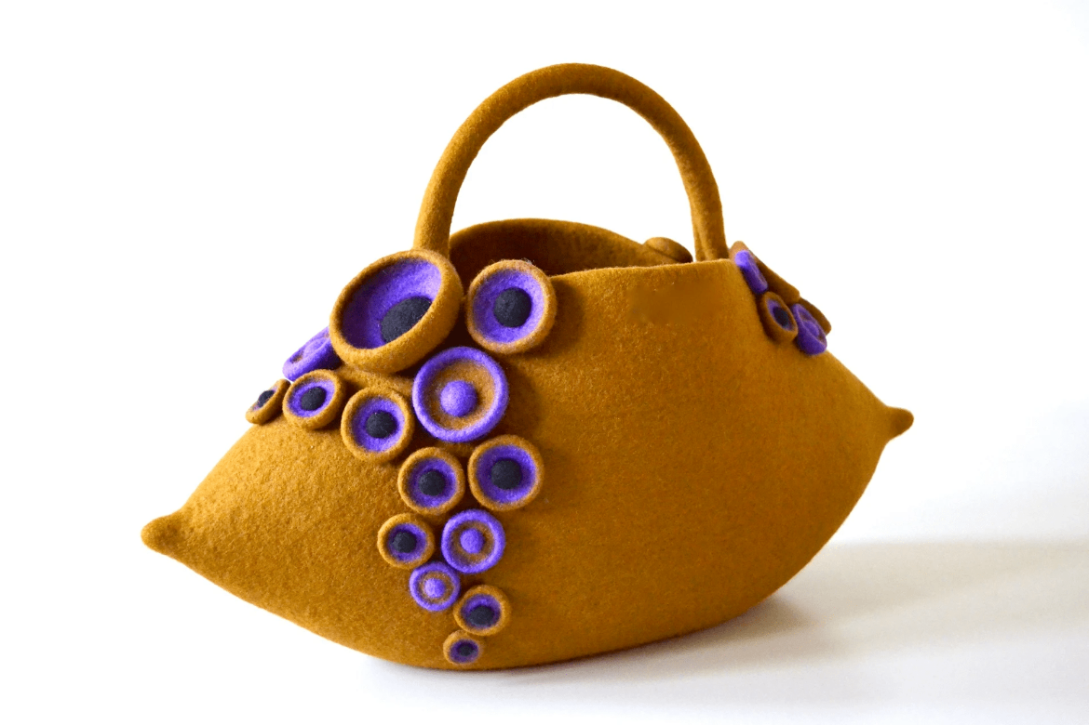

Picture 5. Atsuko Sasaki felted bag. Image Source: https://knithacker.com/2020/03/fine-artist-atsuko-sasaki-makes-incredible-felt-object-bags-that-are-nothing-short-of-eye-popping/

Bags and jewelry of Hungarian artist Anikó Boros. Anikó Boros, which combine wet felting and stones can be viewed online at: https://baribon.hu.
A wet felted brooch, created by Bulgarian artist Svetla Tsvetanova, is presented in Picture 6. A felted creation of Svetla Tsvetanova, which can be use as a jewel or as a garment’s application, is shown in Picture 7.

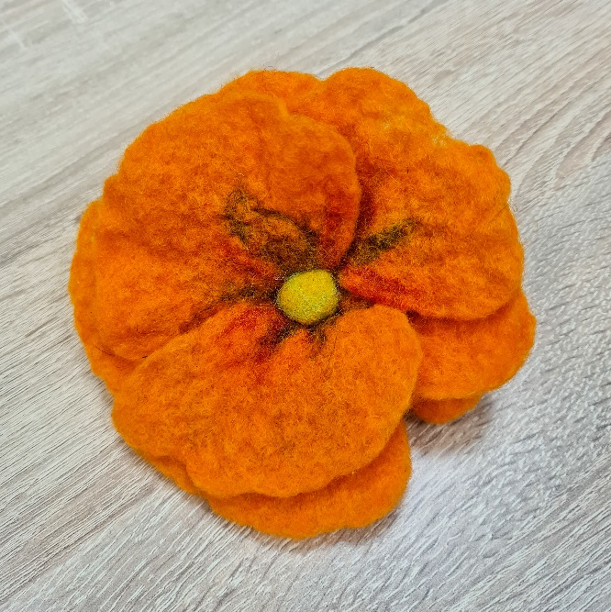 | 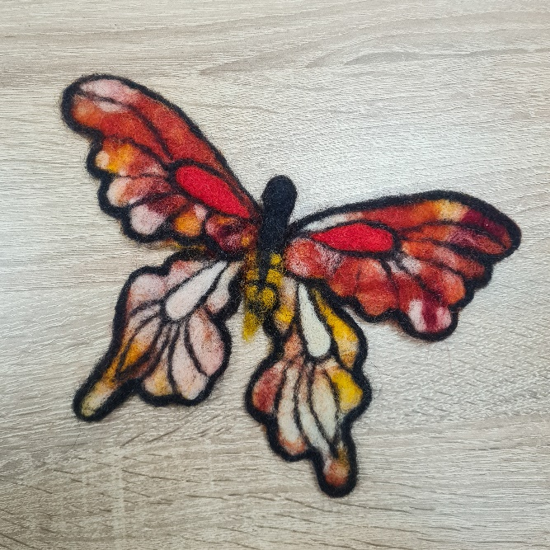
Picture 6.  A wet felted brooch, created by Svetla Tsvetanova.  CC BY Tsvetanova | Picture 7. A felted creation by Svetla Tsvetanova, which can be used as a jewel or a garment’s application.  CC BY Tsvetanova

Tasks:

Task 2a: Research for more information on application of felting in designs of famous designers.
Task 2b: Research for more information on the “boro” and “nuno” technics on the internet.

Questions:

Question 2a: Which wool felting techniques are appropriate for creation of clothes, parts of garments and scarves?
Question 2b: Which wool felting techniques are appropriate for creation of bags and hats?
Question 2c: Which wool felting techniques are appropriate for creation of jewelry?

Worksheet 3: The wool felting in sustainable fashion

What is the application of wool felting techniques in sustainable fashion design? Let’s see it according to several aspects of sustainability in fashion.
The Environmental fashion or "green" fashion prioritizes environmentally sustainable materials and production methods, minimizing the impact on natural resources and reducing waste.
The felt products can be made from different types of wool fibers that usually go to waste. Before folding the wool fibers can be dyed with natural dyes.
The Slow fashion is produced with an emphasis on quality, durability and ethical production, with a focus on minimizing waste and promoting sustainable consumption.
The more of clothes, accessories: bags, hats, scarves, etc., and different types of jewels, created by hand wool felting are not only design creations, they are wearable arts. They are practically independent on trends and they are always on fashion. For this reason hand felted garments and accessories belong to slow fashion. For example, the “nuno” felting scarf by Elena Kihlman, presented in Figure 4, and Atsuko Sasaki felted bag, which is shown in Figure 5, are sustainable slow fashion accessories, and Svetla Tsvetanova wet felted brooch, which is presented in Figure 6, is a sustainable slow fashion jewel.
What is the role of accessories and jewels in slow fashion? No matter how beautiful a long life garment (a cloth made by classic technologies) is, it gets tired at some point. For this reason, we can combine slow fashion clothes with fashion accessories and jewels of high artistic value: wool felted scarves and different type of jewels such as necklaces, earrings, bracelets, brooches, etc. For example, the “nuno” felting scarf by Elena Kihlman, which is presented in Figure 4, and Svetla Tsvetanova wet felted brooch, which is shown in Figure 6, can made a long life fashion ensemble different and more artistic.
The Recycled fashion and Circular fashion. The Recycled fashion is created using recycled materials, promoting material reuse and waste reduction. The Circular fashion promotes the reuse of discarded and recycled materials, reducing waste and promoting sustainability. Both “boro” and “nuno” techniques can be realized using discarded, such as natural and artificial silk fabrics with defects in structure and color spots and recycled materials. For example, Janet Sikirica “boro” scaves, shown in https://www.janetsikiricafiberarts.com, are hand-felted using fine Australian merino wool and carefully selected recycled sari silks from India.

Tasks:

Task 3a: Give examples of wool felted fashion products which belong to the environmental or "green” fashion.
Task 3b: Give examples of wool felted fashion products which belong to the slow fashion. Describe used wool felting technique.
Task 3c: Give examples of wool felted fashion products which belong to the recycled and circular fashion. Describe used wool felting technique.

Question:

Question 3a: Can a wool felted fashion product belong to more than one aspect of sustainable fashion? Give examples.

Worksheet 4: Let’s make a wet wool felted brooch!

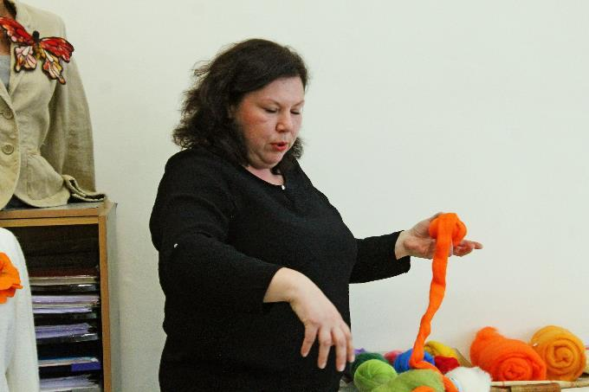 | 1. For the wet felting technique, multi-colored wool tops are used, and in particular wool with a thickness of 22 microns, due to the better arranged structure of the fibers. The fibers are better combed and can be processed more easily.
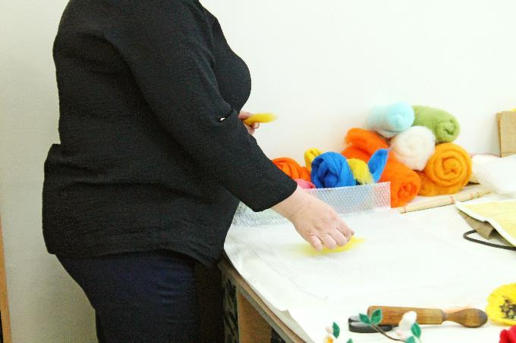 | 2. Starting shaping the brooch by placing the wool fibers in a circle and forming the desired shape.
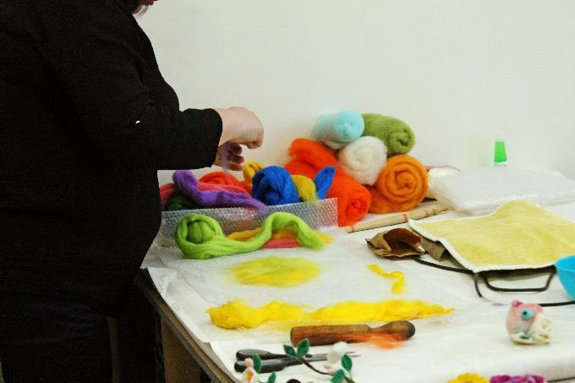 | 3. Additional decoration with different colors of woolen and viscose threads.
 | 4. After arranging the fibers, a soap-based felting agent is applied.
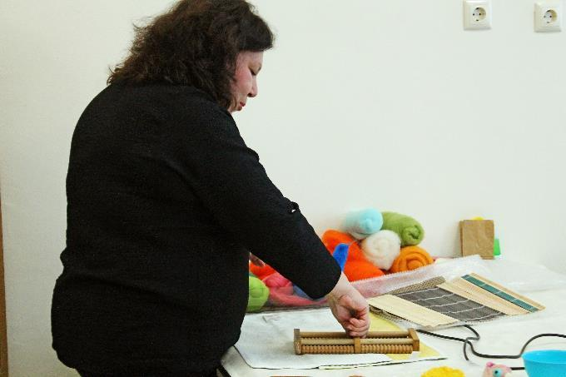 | 5. A variety of tools, that apply mechanical pressure, can be used for felting.
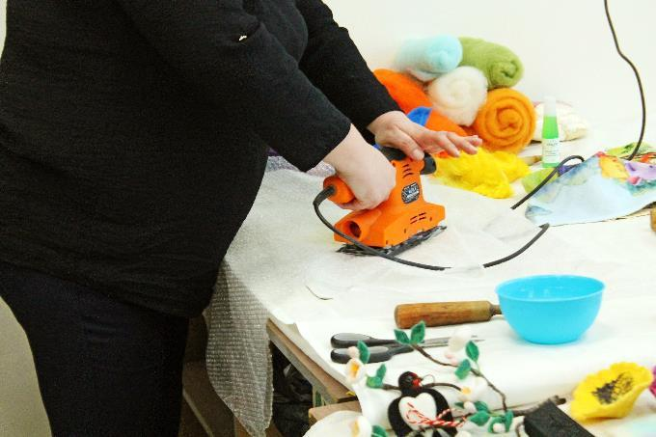 | 6. Another method of felting is through a vibrating sander, with the help of which the process is significantly accelerated and the time for processing the product is reduced.
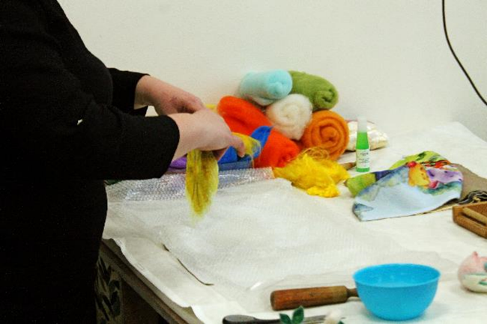 | 7. Subsequent additional processing to close the element edges.
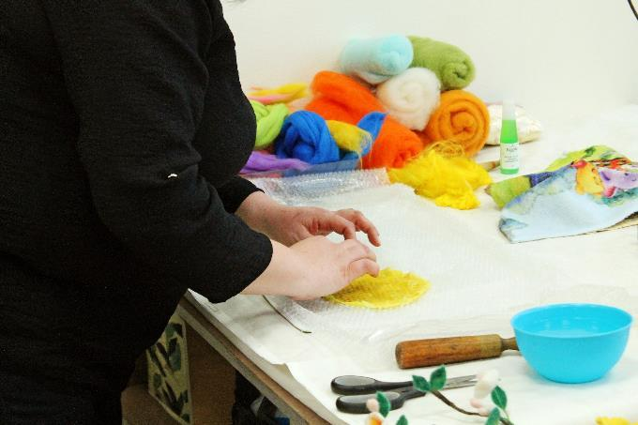 | 7. Subsequent additional processing to close the element edges.
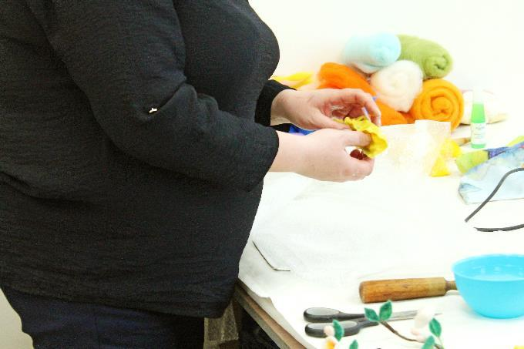 | 8. Shaping with fingers.
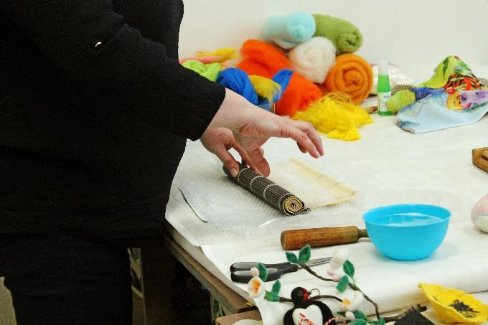 | 9. With the help of bamboo pads, excess soap is removed, which further strengthens the product.
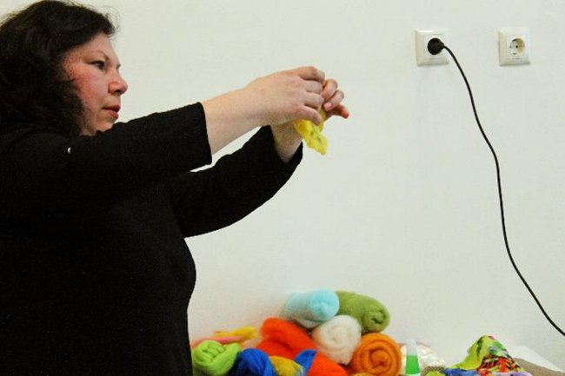 | 10. Shaping with fingers.
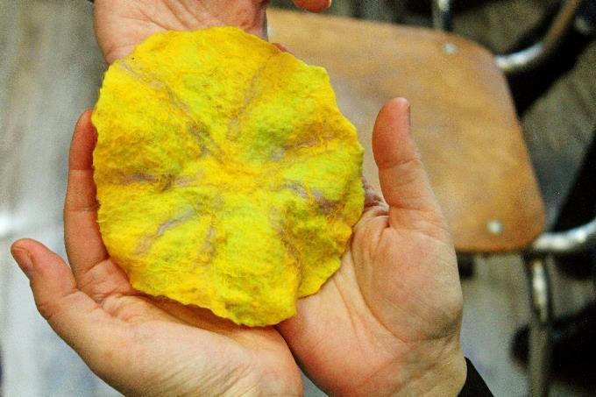 | 11. The form after fingers shaping.
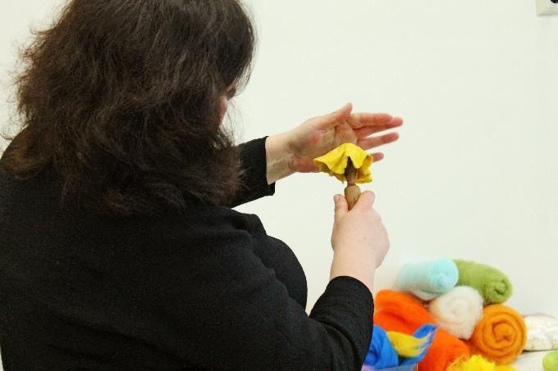 | 12. Additional processing with a hand tool, which gives a three-dimensional effect to the product.
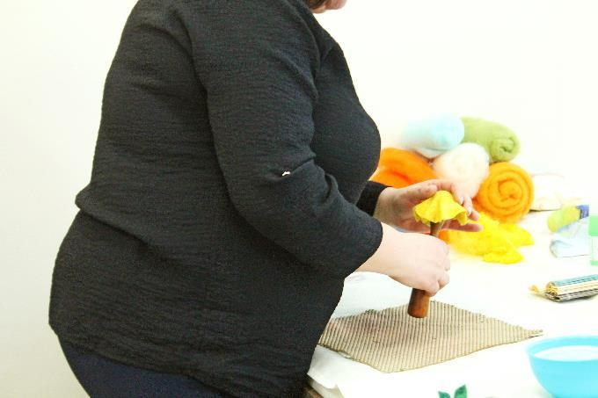 | 12. Additional processing with a hand tool, which gives a three-dimensional effect to the product.
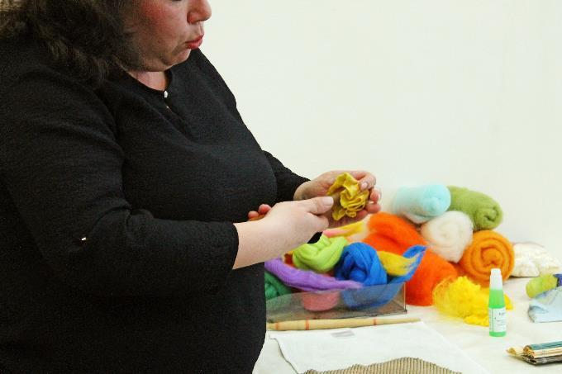 | 12. Additional processing with a hand tool, which gives a three-dimensional effect to the product.
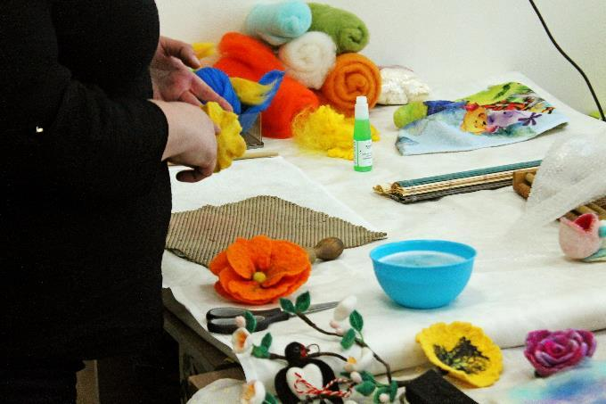 | 13. Additional fine forming with fingers.
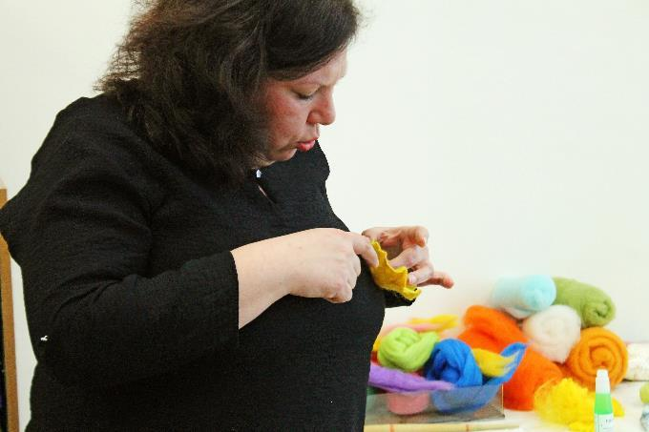 | 13. Additional fine forming with fingers.
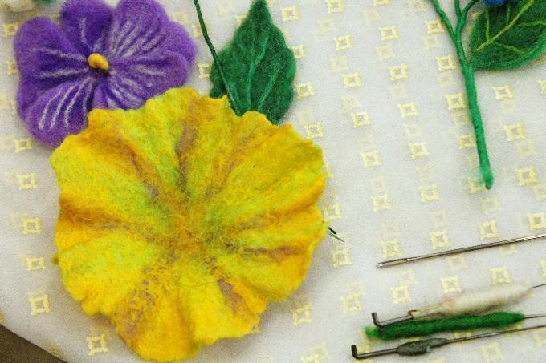 | 14. And the flower, the main part of the brooch, is ready.
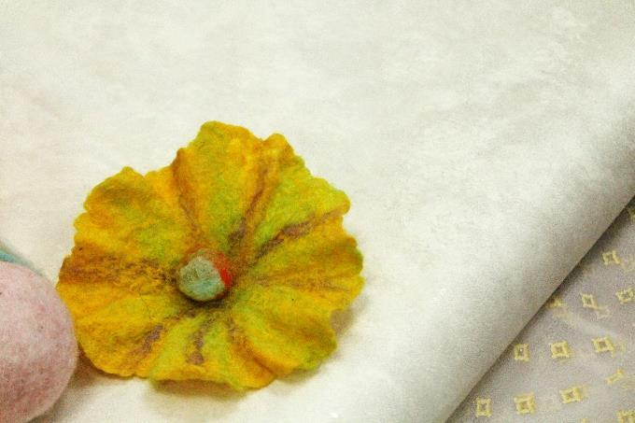 | 15. The ready brooch.
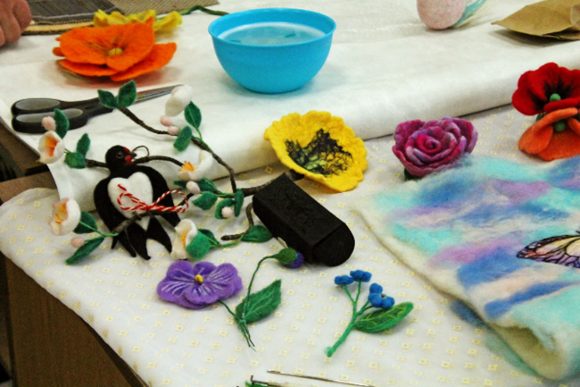 | 16. Other designs of wet wool felted brooches.

Photos: CC BY Tsvetanova
Worksheet 5A: And it is time for your design! Sketch your idea

Make a sketch of your design idea for sustainable fashion wool felted product.

Worksheet 5B: Sustainability of your design

Describe your design idea in the context of sustainable fashion.

_________________________________________________________________________________________________________________________________________________________________________________________________________________________________________________________________________________________________________________________________________________________________________________________________________________________________________________________________________________________________________________________________________________________________________________________________________________________________________________________________________________________________________________________________________________________________________________________________________________________________________________________________________________________________________________________________________________________________________________________________________________________________________________________________________________________________________________________________________________________________________________________________________________________________________________________________________________________________________________________________________________________________________________________________________________________________________________________________________________
___________________________________________________________________________

And now… Maybe it is time for realizing of your design idea. Are you ready for wool felting? Try it!

